Chapter 24 Sorting
1. Omitted.
2. Omitted.
3. Omitted.

4. A binary tree is complete if every level of the tree is full except that the last level may not be full and all the leaves on the last level are placed left-most. A heap is a binary tree with the following properties:

- It is a complete binary tree.
- Each node is greater than or equal to any of its children.

5. The return value will be null.

6.

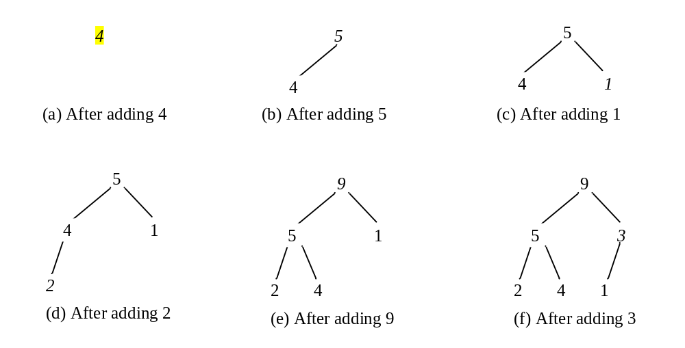

7.
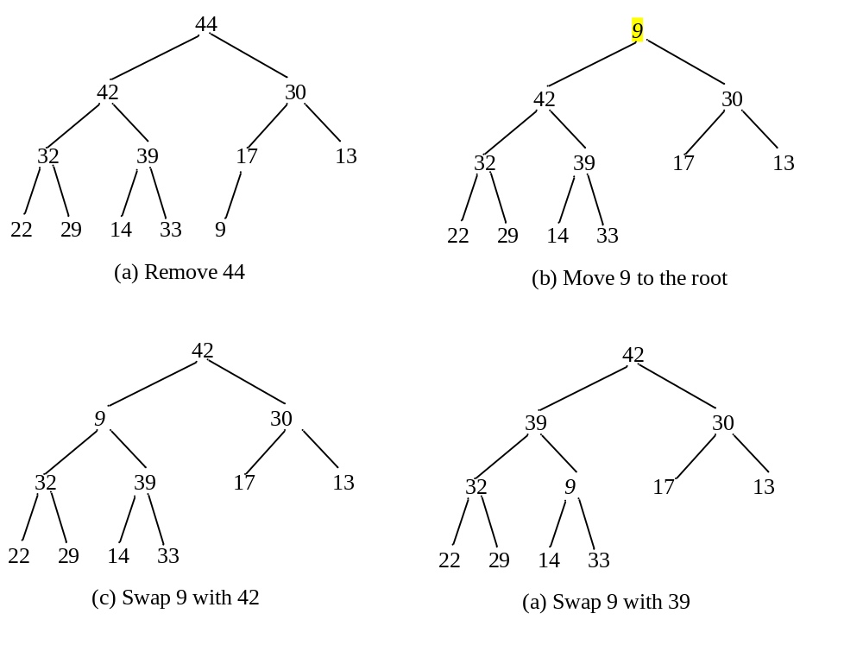
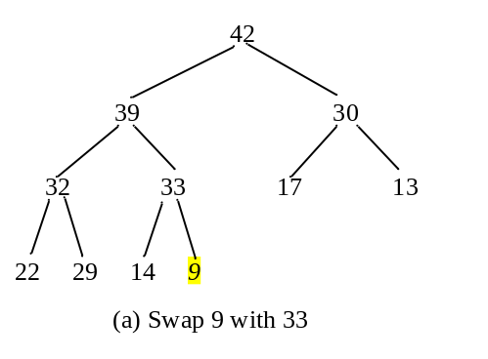
8. O(logn) for both insertion and deletion.

9. Omitted.
10. Omitted.
11. Omitted.

