Chapter 26 Binary Search Trees
1.

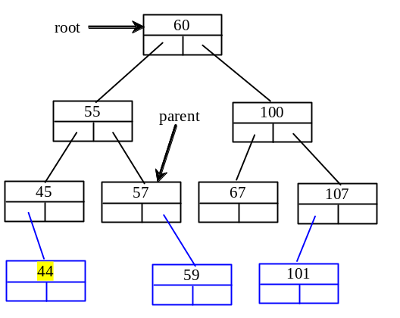

2. Inorder: A F G M R T
Preorder: G F A R M T
Postorder: A F M T R G

- If a set of the same elements is inserted into a binary tree in two different orders, will the two corresponding binary trees look the same? No. Will the inorder traversal be the same? Yes. Will the postorder traversal be the same? No. Will the preorder traversal be the same? No.

4
The time complexity of inserting an element to a binary tree is O(n).

5.

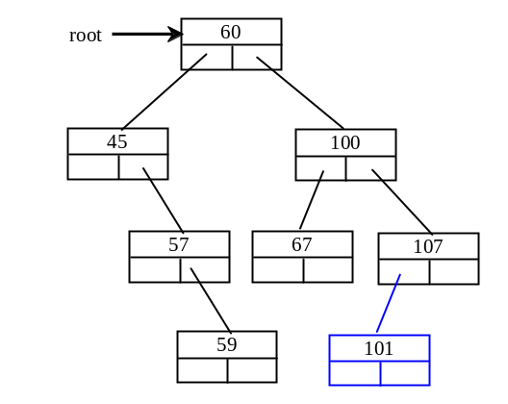

6.

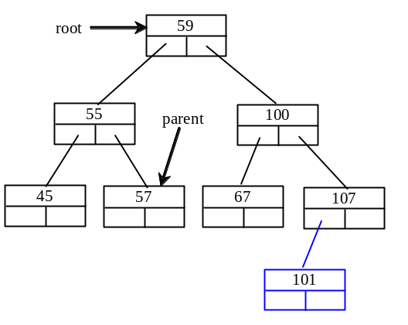

7. The time complexity of deleting an element from a binary tree is O(n).

- No. Consider the case when current is parentOfRightMost and current.left is rightMost. You have to assign rightMost.left to parentOfRightMost.left.

9. An iterator is an object that provides a uniform way for traversing the elements in a container such as a set, list, binary tree, etc.

- By implementing the java.util.Iterator interface, your iterators can be used wherever an instance of Iterator is required.

