Chapter 28 Weighted Graphs and Applications
1.
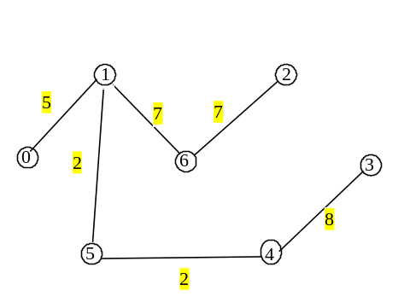
2. Yes

3. O(n^2logn), n is the number of vertices.

4. line 95 in WeightedGraph.java, the loop

while (T.size() < numberOfVertices) {

continues if T.size() < numberOfVertices. If the graph is not connected, the loop will not terminate.

Another problem is the v is set to -1 in line 98. If no edges are found to connect vertices between T and V – T, -1 will add to T in line 122. This will cause an ArrayIndexOutOfBound exception in line 101.

The way to fix it to obtain a partial MST is to replace line 122 with the following code:

if (v != -1)
T.add(v); // Add a new vertex to the tree
else
break; // The tree is not connected, a partial MST is found

5. Omitted

- No.

- O(n^2logn), n is the number of vertices.

8. line 185 in WeightedGraph.java, the loop

while (T.size() < numberOfVertices) {

continues if T.size() < numberOfVertices. If the graph is not connected, the loop will not terminate.

Another problem is the v is set to -1 in line 185. If no edges are found to connect vertices between T and V – T, -1 will add to T in line 208. This will cause an ArrayIndexOutOfBound exception in line 189.

