Group SE-2424 | Assignment 3 | Akhanov Yerdaulet, Shadiyarbek Syrym, Sabyrzhan Akylbek

Astana route estimate methodology
Status: executed ORS instrument pilot and separate exploratory Google–ORS test; Google–ORS period comparison planned; initial TomTom–2GIS comparison unperformed.
ORS analysis snapshot: 2026-10-24T11:13:51.125096+00:00. Public repository: https://github.com/SuperFlyTK/rmt-a3-travel-time-astana

Segment 1. Methodology

T1 Declare basic information
How do Google traffic-aware travel-time estimates differ from ORS control estimates on fixed Astana routes during peak and off-peak periods?
The amended question compares traffic-aware Google estimates with an ORS control that lacks live traffic. Common endpoints and defined periods make disagreement observable, but provider models and recommended streets also differ. Neither service supplies observed journeys. After the initial TomTom–2GIS design remained unperformed, the team approved this dated Google–ORS design and its aggregate-only retention. The completed exploratory cycle establishes a descriptive starting point; it does not answer the peak-versus-off-peak question.
Dated amendment: 2026-10-24T11:32:30.838148+00:00. Initial preregistered question, retained for provenance: How do TomTom and 2GIS traffic-aware travel-time estimates diverge on fixed Astana routes during evening peak compared with off-peak periods?
Item | Entry
Group and team | SE-2424 | AkhanovYerdaulet_ShadiyarbekSyrym_SabyrzhanAkylbek
Repository | https://github.com/SuperFlyTK/rmt-a3-travel-time-astana
Drive folder | https://drive.google.com/drive/folders/1hEVyoDFR0XzRWSv3yIm2EGExC427-yE6  Archive available; anyone with the link can read it
Folders | collector/: extraction; config/: fixed design; data/routes.csv: sample; data/raw/: original observations; analysis/: processing; results/: working data; figures/: evidence; report/: reproducible document; docs/: provenance and journal

T2 Record your Approach Card
The approach is quantitative secondary-data analysis using repeated observations. Researchers select requests but do not manipulate road conditions, allocate traffic treatments or recruit drivers. It is therefore observational. Repeated endpoints reduce spatial inconsistency. Purposive route selection and a short window limit generalisation, while repeated requests on one route remain dependent. ORS supplies a control without live traffic; Google uses a traffic-aware request preference. This contrast measures disagreement between complete service outputs, not the isolated causal effect of traffic.
Dimension | Declared approach
Data and purpose | Numerical API estimates; descriptive agreement planned; instrument feasibility observed
Design | Observational repeated measures; secondary data; prospective paired comparison
Strength | Fixed OD identifiers, timestamps and preserved failures support reproduction
Weakness | No ground truth; proprietary provider behavior; dependent routes and short duration

T3 Concept table
Concept | Operational definition | Measure and unit
Travel-time disagreement | For paired estimates A and B, d=A−B and m=(A+B)/2 | d and |d| in seconds; 100d/m and 100|d|/m in percent
Traffic period | Classify request timestamp in Asia/Almaty; start included, end excluded | Nominal: peak, offpeak, other
Route comparability | 100|LA−LB|/((LA+LB)/2) ≤ 5; length proxy only | Ratio: percent; nominal: comparable yes/no
Instrument reliability | Valid route responses and elapsed request time | Ratio: success proportion, latency seconds

T4 What exactly was observed
Observation element | Entry
Unit | One provider response for a fixed OD pair at a recorded request start
Observed | ORS estimate, distance, geometry, status, timestamps and elapsed request time; separate aggregate Google–ORS disagreement
Not observed | Actual trips, driver behavior, independently measured traffic conditions or TomTom–2GIS disagreement
Comparison unit planned | Same route and cycle, provider request starts ≤ 60 seconds apart; same period and date

T5 Define your Research strategy
The strategy is a bounded Astana case study with purposive sampling of public arterial corridors and landmarks. Common endpoints specify a requested journey, not a common returned path. Similar distance cannot prove street-level equivalence. The initial design planned pair-level sensitivity analysis; the amended protocol instead reports aggregate disagreement and the proportion of lengths within five percent of the pair mean. Permitted ORS geometry remains available, while Google individual outputs are transient. Differences cannot be interpreted as provider error.

T6 Define sample, dataset or cases
Item | Entry
Population or case set | Fixed public OD pairs on selected Astana arterial corridors; not all city trips
Planned sample | 20 routes; 3 full pilot cycles; 768 nominal scheduled ORS requests
Achieved ORS snapshot | 68 raw rows; 68 unique requests; 68 usable observations; 0 initial TomTom–2GIS pairs
Selection strategy | Purposive route and endpoint selection against public-road and corridor criteria
Source | https://github.com/SuperFlyTK/rmt-a3-travel-time-astana/blob/main/data/routes.csv  https://github.com/SuperFlyTK/rmt-a3-travel-time-astana/tree/main/data/sources

Coordinates were fixed before research collection using public OpenStreetMap endpoint records. Reverse directions are distinct cases because access and road direction can differ. The expected-length column is a spherical straight-line lower bound, not a measured driving distance. It supports a geographic plausibility check and must not be substituted for the returned route length. The sample contains named corridors rather than personal origins. Selection does not give every Astana journey a known probability of inclusion, so the intended conclusions remain conditional on these cases.
Amended Google–ORS date | Local eligibility window | Period | Planned pairs
24 Oct 2026 | 17:30–19:30 | peak | 20
24 Oct 2026 | 22:00–00:00 | offpeak | 20
25 Oct 2026 | 10:00–12:00 | offpeak | 20
25 Oct 2026 | 17:30–19:30 | peak | 20
25 Oct 2026 | 22:00–00:00 | offpeak | 20

One prospective batch of 20 pairs is eligible in each window, at the first available worker check; the total cap is 100 further Google requests. Actual timestamps determine coverage. Missed windows are not backfilled. Planning a batch does not count it as observed; actual counts appear in Segment 4.
Amended protocol and storage rules: https://github.com/SuperFlyTK/rmt-a3-travel-time-astana/blob/main/docs/google_followup_protocol.json

T7 Procedure actually followed
First, the team reviewed earlier assignments and separated credential checks from research data. Second, it inspected documentation and publication terms, then disabled the original TomTom and 2GIS adapters. Third, route definitions, period rules and expectations were fixed on 24.10.2026. Fourth, the ORS collector recorded pilot requests and unsuccessful attempts. Fifth, processing produced an audited working file, coverage tables and original figures. The journal identifies the operator and later changes.
The pilot plan uses 3 complete cycles with 300 seconds between the end of one cycle and the next. The scheduled plan rotates 4 routes every 15 minutes within a bounded 48-hour window. Each route therefore has a nominal 75-minute revisit. Scheduler delays remain visible through actual request times. No past observation is backfilled. Reproduction uses the versioned configuration and dependency file; Python 3.12.14 processed this snapshot. A future provider pair must use the same endpoints, car mode and closely aligned request starts.
Figure 1 distinguishes successful requests from recorded failures.
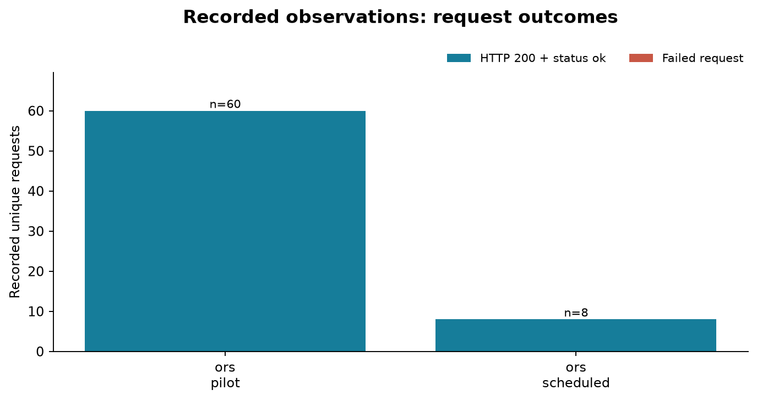
Figure 1. Recorded request outcomes by provider and collection phase. Exact duplicate rows are counted once. HTTP success does not itself imply a usable route. Source: results/request_quality.csv. © openrouteservice by HeiGIT | Data from OpenStreetMap.
Figure 2 checks which predefined periods actually received usable observations.
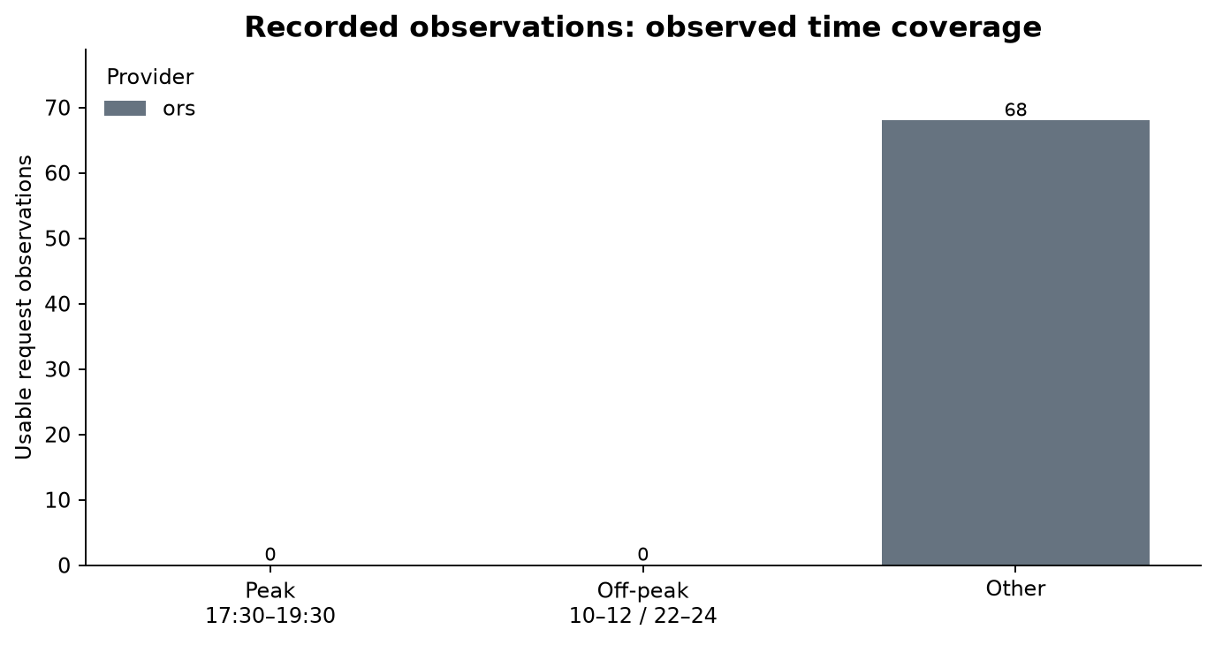
Figure 2. Usable observations classified by Asia/Almaty request time. Intervals include their start and exclude their end. A zero bar is observed absence, not a missing plot. Source: results/observations.csv. © openrouteservice by HeiGIT | Data from OpenStreetMap.
Figure 3 compares recorded control estimates across the fixed route identifiers.
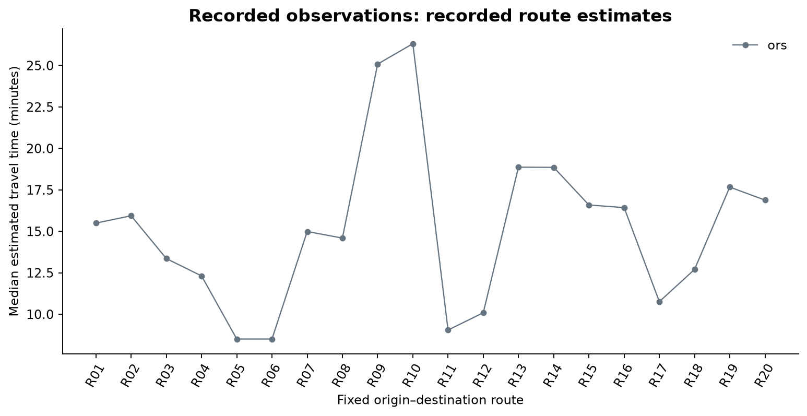
Figure 3. Median recorded duration per provider and fixed origin–destination route. ORS is a control without live traffic. This instrument summary cannot establish peak traffic disagreement or travel-time accuracy. Source: results/observations.csv. © openrouteservice by HeiGIT | Data from OpenStreetMap.
Figure 4 checks the relationship between returned distance and estimated duration.
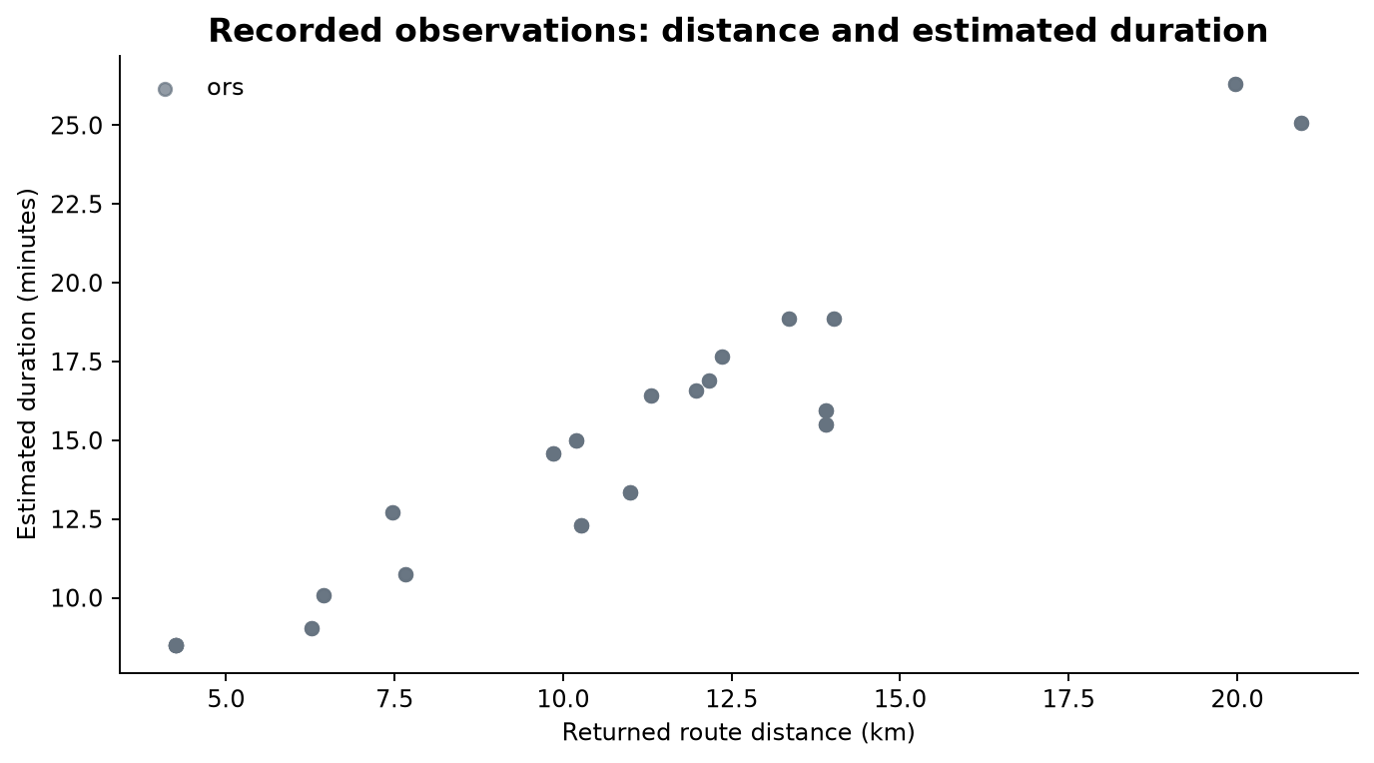
Figure 4. Recorded estimated durations plotted against returned route distances. Values are API outputs, not measured journeys. Repeated values may overlap; no jitter or artificial observations are added. Source: results/observations.csv. © openrouteservice by HeiGIT | Data from OpenStreetMap.
Figure 5 shows the request-time evidence used for the instrument latency expectation.
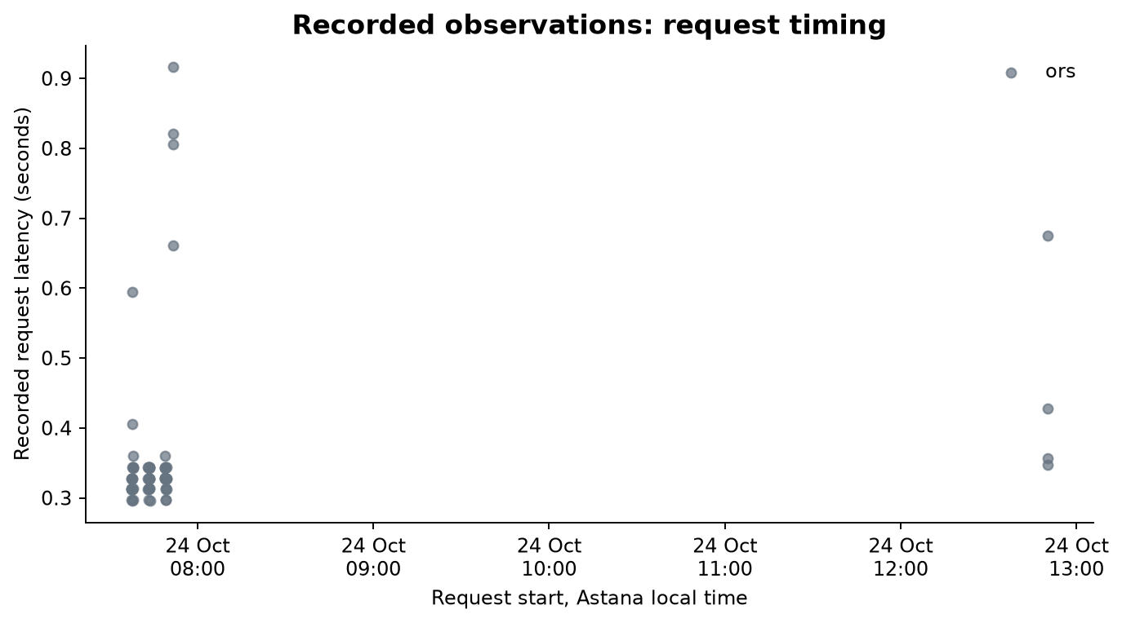
Figure 5. Recorded API request latencies by request start time. Latency is instrument performance and is distinct from estimated journey duration. Failed requests remain eligible if their timing was recorded. Source: results/observations.csv. © openrouteservice by HeiGIT | Data from OpenStreetMap.
Figure 6 preserves a readable extract of the actual observation file.
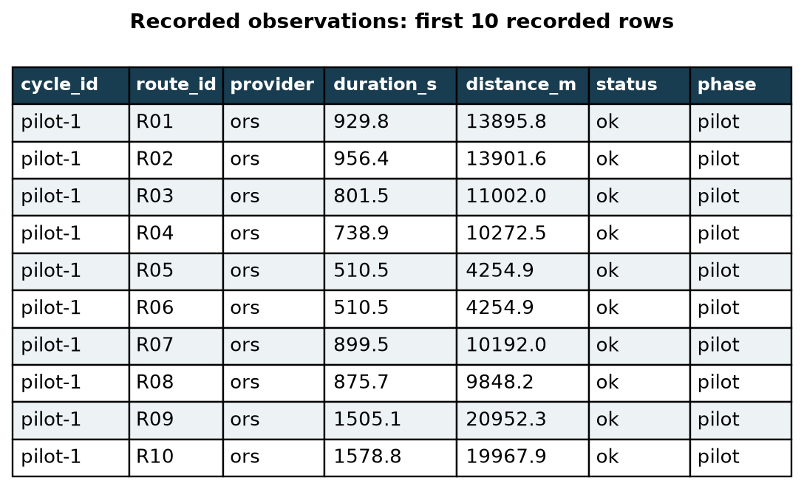
Figure 6. Verbatim selected raw fields from the first recorded CSV rows, retained in observations.csv with source filename and line number. The rendered table is an evidence view, not a screenshot of a separate application. Source: results/observations.csv. © openrouteservice by HeiGIT | Data from OpenStreetMap.
Figure 7 maps saved ORS paths for the fixed endpoints; these are modeled routes rather than tracked journeys.
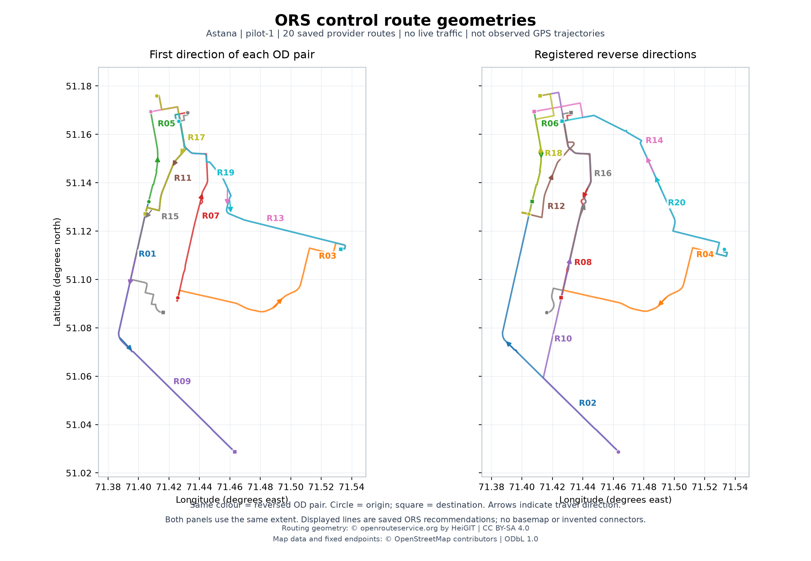
Figure 7. ORS control route geometries for the complete pilot-1 cycle: 20 directed routes displayed as ten forward and ten reverse OD directions on identical scales. Lines are actual saved openrouteservice LineString responses, not live-traffic routes or observed GPS trajectories. Endpoint labels follow data/routes.csv; recommended routes are not constrained to specified arteries. Routing geometry attribution: openrouteservice.org by HeiGIT, CC BY-SA 4.0; map data and endpoints: OpenStreetMap contributors, ODbL 1.0. Source: figures/route_map_manifest.json. © openrouteservice by HeiGIT | Data from OpenStreetMap.
Figure 8 documents the team-operated instrument and its recorded execution.
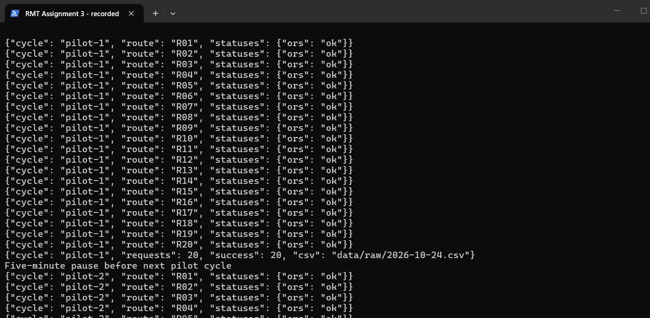
Figure 8. Actual PowerShell view of the saved collector console log, showing the completed first ORS pilot cycle and the start of the second. Captured with .NET CopyFromScreen; this is a viewport excerpt, not a fabricated console. Source: docs/pilot_console.log. Team-produced execution evidence.
Figure 9 documents the team-operated instrument and its recorded execution.
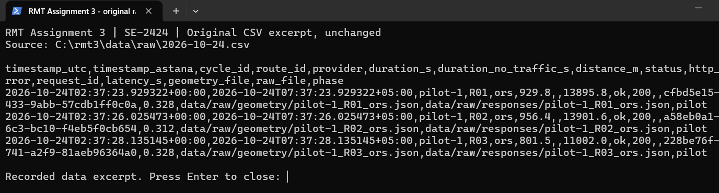
Figure 9. Actual PowerShell display of the original raw CSV header and first three records. The viewport wraps and clips long lines; the linked CSV contains the complete unchanged records. Source: data/raw/2026-10-24.csv. Team-produced execution evidence.
Figure 10 documents the team-operated instrument and its recorded execution.
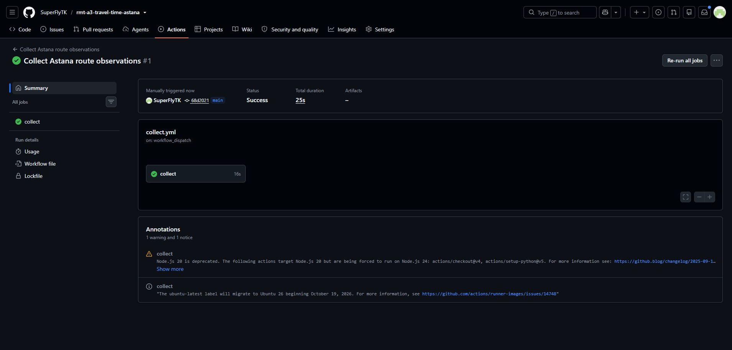
Figure 10. Successful cloud collector run on GitHub-hosted infrastructure. The workflow was manually dispatched for verification; the same workflow has a fifteen-minute schedule and a fixed end time. Source: docs/cloud_run.json, docs/cloud_run.log. Team-produced execution evidence.
A separate protocol was recorded at 2026-10-24T11:24:15.506607+00:00, after a successful Google Demo credential check and before the exploratory cycle. It paired the same public endpoints with Google TRAFFIC_AWARE_OPTIMAL and the ORS control. Requests ran concurrently, with a maximum permitted start gap of 60 seconds. The bounded cycle is descriptive; its 20 valid pairs are separate from the 68-record ORS snapshot and do not enter the primary expected-results tests.
Local cycle: 24 October 2026 16:24:54 to 16:25:36 (Asia/Almaty); classified period: other.
Exploratory aggregate | Recorded result
Attempted / valid pairs | 20 / 20; successful Google responses 20, ORS responses 20
Cycle interval (UTC) | 2026-10-24T11:24:54.664964+00:00  to 2026-10-24T11:25:36.748530+00:00
Largest request-start gap | 0.032 s
Median signed / absolute difference | 730.5 / 730.5 s; signed = Google minus ORS
MAE / RMSE as disagreement | 741.72 / 783.63 s
Mean symmetric absolute difference | 57.58%
IQR of signed differences | 270.2 s
Lengths within 5% of pair mean | 15 pairs (75%); not proof of identical paths

Protocol: https://github.com/SuperFlyTK/rmt-a3-travel-time-astana/blob/main/docs/google_control_protocol.json
Aggregate evidence: https://github.com/SuperFlyTK/rmt-a3-travel-time-astana/blob/main/results/google_control_benchmark.csv
Figure 11 summarizes the separate Google–ORS instrument comparison using aggregate metrics only.
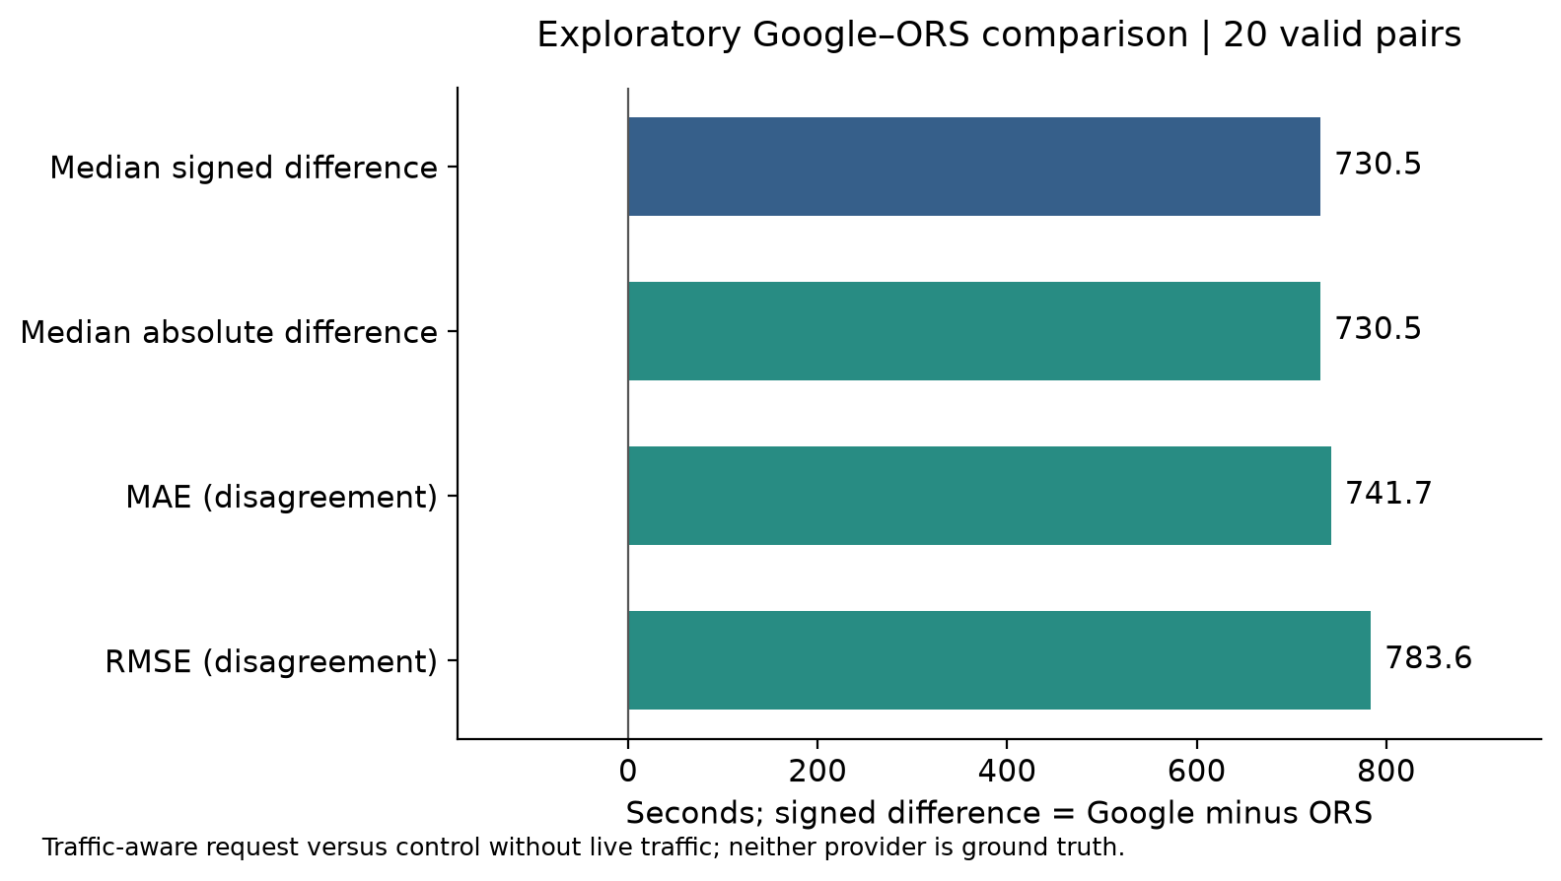
Figure 11. Original aggregate disagreement metrics for one separate exploratory cycle. Google used TRAFFIC_AWARE_OPTIMAL; ORS has no live traffic. These are not accuracy measures or the primary peak-period comparison. Source: results/google_control_benchmark.csv. Team-computed comparative-test results; ORS control: © openrouteservice by HeiGIT | Data from OpenStreetMap.

T8 Ethics, privacy and data handling
No human participant supplies a personal journey or identity, so participant consent is not applicable to this public-coordinate instrument. API access still has contractual conditions. Technical success was insufficient to authorize a public comparison: TomTom requires written approval for benchmarking, while the applicable 2GIS Kazakhstan demo redistribution terms remain unresolved. ORS results are shared under current CC BY-SA terms with attribution. Secrets remain outside version control. The team retains failed requests and exclusion reasons to make limitations visible, while avoiding account identifiers and credential-bearing URLs in public evidence.
Google terms address publication of comparative-test results in section 3.2.4 and separately restrict storage of Maps content in section 3.2.3. The exploratory protocol therefore processes Google values transiently and publishes original aggregate metrics, status records and request methods. Individual Google estimates and geometry are not retained. Those aggregates cannot be recalculated from saved Google responses; repeating the protocol samples new live outputs.
Item | Entry
Consent | Not applicable: no recruited people or personal journeys
Anonymization | Public route identifiers only; no individual tracks
Not collected | Names of drivers, home addresses, device identifiers or actual travel histories
Storage, access and retention | Private local secrets; public licensed research files and code. Public links must remain available through exam weeks.
Accepted risk | Model estimates may be incomplete or inconsistent; records describe agreement and instrument behavior, not navigation advice

T9 Expected Results
The expectation record is fixed before the first research observation. Earlier credential checks established access only and did not supply Astana outcomes. Expectations about provider disagreement remain unchanged when collection becomes restricted. Instrument expectations are separately falsifiable through valid-response counts, latency and route coverage. The six scenarios describe possible outcomes rather than simulated findings. A later amendment must carry its own date and reason; it cannot silently replace the existing thresholds after results become visible. Objectives retain the earlier project sequence, which Assignment 2 did not separately renumber.
The table below preserves the original expected-results wording. ER1–ER4 concern the initial TomTom–2GIS design and are not directly tested by Google–ORS control data. ER5–ER8 still describe the recorded ORS instrument. The dated amendment gives a separate descriptive expectation: Peak-window median absolute Google-ORS disagreement will exceed off-peak-window median absolute disagreement. The earlier 1.5 ratio is retained as a prospective descriptive reference, not a revised original ER.
No. | Expected result | Objective | Falsification | Confidence and reason
ER1 | The peak to off-peak ratio of median absolute TomTom-2GIS difference is at least 1.5. | O4 Compare periods | Ratio below 1.5 after both periods exist | Low; directional H1 has no local pilot evidence
ER2 | At least 70% of eligible primary pairs have lengths within 5% of their pair mean. | O3 Quantify disagreement | Proportion below 70% | Low; endpoint equality need not produce the same path
ER3 | Median signed difference TomTom minus 2GIS is positive in the completed sample. | O3 Quantify disagreement | Median at most zero | Low; exploratory directional expectation, not prior fact
ER4 | The peak IQR of signed differences exceeds the off-peak IQR. | O5 Describe route and time variation | Peak IQR at most the off-peak IQR | Low; hypothesis about variation is unverified
ER5 | Fewer than 2% of ORS instrument requests fail to return a valid route. | O2 Collect auditable observations | Failure proportion at least 2% | Medium; one previous technical check succeeded
ER6 | At least 95% of ORS instrument requests finish within 10 seconds. | O2 Collect auditable observations | Proportion below 95% | Medium; network and service delays can defeat it
ER7 | All 20 routes produce at least one valid ORS result during the three pilot cycles. | O1 Fix routes and periods | Fewer than 20 routes have any valid pilot observation | Medium; public road endpoints still require routing verification
ER8 | At least 90% of the 768 nominal ORS scheduled requests are recorded in the 48-hour window. | O2 Collect auditable observations | Fewer than 692 attempts after the window ends | Medium; Actions scheduling may delay or skip runs

Outcome | Possible scenario
bad | Traffic-provider permissions remain unavailable; only control-instrument evidence exists and H1 cannot be tested.
bad | At least 2% of ORS requests fail or fewer than 20 routes work; revise the instrument in a dated amendment.
medium | All routes work but fewer than 90% of scheduled attempts are recorded; retain actual times and describe incomplete coverage.
medium | Primary collection later becomes permitted but period contrast is below 1.5; report evidence against ER1 without editing it.
good | The ORS pilot covers all routes and fewer than 2% of requests fail; the data pipeline is ready for a permitted primary comparison.
good | A later permitted primary sample spans both periods and reaches the ER1 threshold with interpretable route-aware uncertainty.

Fixed date: 24.10.2026. Timestamp: 2026-10-24T02:32:16.123968+00:00. Expected-results file SHA-256: e1a7ad664d3f3a6caa524098fc4073812d29de0a88239a87f4e10181fec27d1a. Preregistration commit: b4614355903efdc800f870d2678d2416e0490f81.

T10 State your method-related expectations
Method | Declaration before analysis
Data analytics / secondary data | Current descriptive expectation: larger per-window median absolute Google–ORS disagreement during peak; the initial 1.5 ratio is a prospective reference, not a rewritten ER. No route/day significance test is supported by aggregate-only Google retention. Instrument expectations: <2% invalid routes, ≥95% requests within 10 s, all 20 pilot routes represented. Missing optional baselines, failed responses, duplicates and implausible implied speeds are recorded. API agreement cannot establish actual travel-time accuracy.

Segment 2. Data Collection Instrument

T1 Provenance information
The design adapts repeated route and time sampling from Elnaggar et al. (2025) and fixed OD comparison from Fu et al. (2023). It does not reproduce their cities, datasets or validation claims. Hodson (2022) motivates giving each difference measure a defined role. The collector is self-developed because synchronized requests, explicit failures, route identifiers and permission controls must share one audit trail. Its command-line interface writes CSV and licensed response files; it has no participant frontend or personal-data database. Confidence comes from recorded pilot outputs and deterministic validation, not from calling the software a methodology.
Element | Source | Status | Taken | Changed or justified
Overall design | Elnaggar et al. (2025); Fu et al. (2023) | Adapted | Repeated route/time observations; common OD comparisons | Astana cases; explicit disagreement target; ORS-only pilot
Sampling | Elnaggar et al. (2025) | Adapted | Defined urban corridors and departure periods | Public endpoints; rotating bounded schedule
Instrument | Team; informed by Fu et al. (2023) | Self-developed | Programmatic route estimates | Schema audit, failures, quotas and publication gate
Scales or items | Not applicable | Not applicable | No questionnaire or psychometric scale | Numerical measures operationalized in Segment 1
Metrics | Hodson (2022) | Adapted | Absolute and squared difference summaries | Agreement interpretation; neither provider is truth
Dataset | Team collection | Self-developed | No published dataset copied | Public-coordinate ORS estimates with recorded provenance

T2 Replication status
This is an original study informed by earlier methods, rather than a full or partial replication of one published protocol. The team combines its question, route set, collection controls and evidence pipeline. No paper supplies an exact template whose result is being reproduced. Derrow-Pinion et al. (2021) and Soon et al. (2023) provide forecasting context, not evidence that the reviewed providers deploy identical algorithms. The ten-paper Assignment 2 corpus is retained so that design provenance remains traceable without claiming implementation details that those sources do not establish.
Declaration | What was developed
Original study | Astana question, purposive sample, auditable collection instrument and descriptive analysis. No single published study was used as the replication template.

T3 Your research is original study
Element | Entry
Question or hypothesis | How do Google traffic-aware travel-time estimates differ from ORS control estimates on fixed Astana routes during peak and off-peak periods?  Descriptive expectation: Peak-window median absolute Google-ORS disagreement will exceed off-peak-window median absolute disagreement. The earlier 1.5 ratio is retained as a prospective descriptive reference, not a revised original ER.
Methodology and design | Observational repeated secondary-data comparison; ORS instrument pilot executed; separate bounded Google–ORS exploratory test
Population, sample and size | 20 fixed Astana OD routes; 68 unique ORS requests at snapshot; 20 separate exploratory pairs
Instrument | Versioned collector, route CSV, configuration and raw request records
Technical procedure | HTTP requests with timeout and no redirects; recorded errors; immutable licensed raw inputs
Analysis | ORS validation and missingness; descriptive per-window Google–ORS aggregate comparisons; no route/day inference from aggregate-only results
Main reported result | 68 usable ORS observations; initial TomTom–2GIS comparison not performed; separate exploratory aggregate disagreement reported in Segment 1 T7

T4 Your research is partial replication
Not applicable. No partial-replication claim is made; adaptations are declared in the provenance table.

Segment 3. Research Evidence

T1 Instrument register
Instrument | Platform | Collects or defines | Public link
ORS collector | Python CLI | Licensed estimates, geometry, status and timing | https://github.com/SuperFlyTK/rmt-a3-travel-time-astana/blob/main/collector/collect.py
Route register | CSV | Fixed OD coordinates and source links | https://github.com/SuperFlyTK/rmt-a3-travel-time-astana/blob/main/data/routes.csv
Scheduled workflow | GitHub Actions | Bounded recurring collection and logs | https://github.com/SuperFlyTK/rmt-a3-travel-time-astana/tree/main/.github/workflows
Processing | Python | Audited ORS observations and descriptive summaries | https://github.com/SuperFlyTK/rmt-a3-travel-time-astana/blob/main/analysis/process.py
Google–ORS follow-up | Python / Actions | One bounded batch per window; aggregate metrics and request status | https://github.com/SuperFlyTK/rmt-a3-travel-time-astana/blob/main/collector/google_followup.py

T2 Log journal and data storage
The storage layout separates original records from the working copy used for interpretation. Raw CSV rows retain source files and request identifiers; processing adds validation decisions instead of overwriting observations. A version manifest records input hashes and software versions. This makes a later report reproducible even when new scheduled records arrive. The research journal records what was done, by whom, what failed and what changed. The current report is a dated snapshot, while the processed observations and documented procedures form the evidence base for Assignment 4.
Exact snapshot reproduction uses frozen inputs rather than later arriving raw files. Follow the saved instructions and input hashes at https://github.com/SuperFlyTK/rmt-a3-travel-time-astana/blob/main/docs/reproduce_report.md
The frozen ORS analysis remains independently recalculable. The separate exploratory archive contains Google request status and timestamps, ORS responses and original aggregate metrics. Its Google numerical inputs are intentionally absent, so its aggregate recalculation has a different reproducibility limit.
Item | Location and purpose
Research journal | https://github.com/SuperFlyTK/rmt-a3-travel-time-astana/blob/main/docs/research_log.md
Raw data | https://github.com/SuperFlyTK/rmt-a3-travel-time-astana/tree/main/data/raw  Original CSV plus licensed ORS response and geometry files
Working copy | https://github.com/SuperFlyTK/rmt-a3-travel-time-astana/blob/main/results/observations.csv  Audited observations; raw values retained
Version record | https://github.com/SuperFlyTK/rmt-a3-travel-time-astana/blob/main/results/version_manifest.json
Public repository | https://github.com/SuperFlyTK/rmt-a3-travel-time-astana
Cloud folder | https://drive.google.com/drive/folders/1hEVyoDFR0XzRWSv3yIm2EGExC427-yE6  Archive available; anyone with the link can read it

T3 Artefacts you developed
Artefact | Study role | Public link | Evidence
Collector and pilot runner | Execute fixed requests and preserve failures | https://github.com/SuperFlyTK/rmt-a3-travel-time-astana/tree/main/collector | Raw files and research journal
Analysis and figures | Audit data and generate original evidence | https://github.com/SuperFlyTK/rmt-a3-travel-time-astana/tree/main/analysis | Results CSV and numbered figures
Report builder | Bind narrative to a reproducible snapshot | https://github.com/SuperFlyTK/rmt-a3-travel-time-astana/blob/main/report/build_report.py | Report snapshot and word count
Protocol and expectations | Record rules fixed before research collection | https://github.com/SuperFlyTK/rmt-a3-travel-time-astana/tree/main/docs | Timestamp, file hash and preregistration commit

T4 Find your block and complete
The selected method is Data analytics / secondary data, so Block E applies. Technical execution supports extraction; it does not turn this study into model training or an experimental treatment comparison.

E.0 Requirements
For a conceptual road graph G=(V,E) at a fixed traffic snapshot, path cost is T(P,t)=Σ w_e(t), summed over edges e in P; each weight is in seconds. Route selection seeks a permitted low-cost path. This abstraction explains why endpoints alone do not determine an estimate: road access, path choice and time weights may differ. It does not identify TomTom or 2GIS source code. ORS documentation describes a speed model based on mapped road properties; its public service does not supply live traffic. The study evaluates returned quantities without reverse-engineering a proprietary solver.
For an eligible pair, signed difference is A minus B and absolute difference removes its direction. MAE averages absolute differences, whereas RMSE gives larger differences greater influence. Relative difference uses the pair mean as denominator, avoiding a claim that either provider is the reference truth. Quartiles describe spread. The initial design specified route-cluster uncertainty procedures. The amended design retains only Google aggregates and therefore compares dated window summaries descriptively; it cannot reproduce the original route-by-day Wilcoxon analysis. A hundred planned requests do not become a hundred independent cases. The current other-period pilot supplies no peak-versus-off-peak contrast.
Quantity | Definition | Interpretation
Signed difference | d=A−B; seconds | Positive means A gives the longer estimate
Absolute difference and MAE | |d|; MAE=Σ|d|/n | Magnitude and average magnitude of disagreement
RMSE | sqrt(Σd²/n); seconds | Quadratic summary sensitive to large differences
Relative difference / sMAPE | 100d/m; 100|d|/m; m=(A+B)/2 | Symmetric percentage disagreement
IQR | Q3−Q1; linear-interpolated sample quartiles | Spread of the stated distribution
Length comparison | 100|LA−LB|/((LA+LB)/2) | ≤5% length agreement is not geometric identity

Extraction excerpt from the saved collector; the complete request construction and error handling are at https://github.com/SuperFlyTK/rmt-a3-travel-time-astana/blob/main/collector/collect.py
if provider=='ors':
first=data['features'][0]
s=first['properties']['summary']
return s['duration'],'',s['distance'],first['geometry']

E.1 Source register
Source | Owner | Access date | Version | Licence / scope | Full URL
ORS results | HeiGIT | 24 October 2026 | Directions v2; build metadata in saved response | CC BY-SA 4.0; attribution; active instrument | https://account.heigit.org/info/tos
Endpoint facts | OpenStreetMap contributors | 24 October 2026 | Saved Overpass extract and manifest | ODbL; public geographic data | https://www.openstreetmap.org/copyright
TomTom docs | TomTom | 24 October 2026 | Routing v1 | Documentation only; comparison/storage blocked | https://docs.tomtom.com/legal/terms-and-conditions
2GIS docs | 2GIS | 24 October 2026 | Routing 7.0.0 global | Documentation only; applicable demo rights unresolved | https://docs.2gis.com/en/api/navigation/routing/overview
Study records | Project team | 24 October 2026 | 2026-10-24T11:13:51.125096+00:00 | Derived ORS outputs retain CC BY-SA attribution | https://github.com/SuperFlyTK/rmt-a3-travel-time-astana/tree/main/data
Google test | Google / project team | 24 October 2026 | Routes v2; Demo key | Original benchmark aggregates only; no saved Google response values | https://cloud.google.com/maps-platform/terms

E.2 Data dictionary
The dictionary distinguishes absent optional fields from missing measurements. An empty no-traffic duration is expected for ORS and is not replaced by a fabricated baseline. Empty error and exclusion fields indicate a successful unflagged record, not poor data quality. Missing counts use each named dataset as their denominator. A paired dataset with no records has no observed missingness percentage. The inventory includes every raw, audited and paired column generated by the processing script.
Dataset / column | Type | Unit | Considered values or range | Missing count / %
raw  timestamp_utc | interval | ISO 8601 UTC | Timezone-aware request start | 0 / 0.0% (n=68)
raw  timestamp_astana | interval | ISO 8601 Asia/Almaty | Same instant in Astana; UTC+05 for study dates | 0 / 0.0% (n=68)
raw  cycle_id | nominal | identifier | One collection cycle | 0 / 0.0% (n=68)
raw  route_id | nominal | identifier | Fixed OD route register | 0 / 0.0% (n=68)
raw  provider | nominal | category | tomtom | dgis | ors | 0 / 0.0% (n=68)
raw  duration_s | ratio | seconds | >0 finite; estimated travel time | 0 / 0.0% (n=68)
raw  duration_no_traffic_s | ratio | seconds | >0 finite when returned; provider-specific baseline, not interchangeable | 68 / 100.0% (n=68)
raw  distance_m | ratio | metres | >0 finite; provider returned route length | 0 / 0.0% (n=68)
raw  status | nominal | category | ok | http_error | transport_error | invalid_response | 0 / 0.0% (n=68)
raw  http_code | nominal | HTTP status | 100..599 or missing if transport failed | 0 / 0.0% (n=68)
raw  error | nominal | text | Sanitized collector error; blank on success | 68 / 100.0% (n=68)
raw  request_id | nominal | identifier | Unique collector request ID | 0 / 0.0% (n=68)
raw  latency_s | ratio | seconds | >=0 finite | 0 / 0.0% (n=68)
raw  geometry_file | nominal | relative path | Saved geometry; optional, absence not a synthetic geometry | 0 / 0.0% (n=68)
raw  raw_file | nominal | relative path | Saved sanitized provider response | 0 / 0.0% (n=68)
raw  phase | nominal | category | pilot | scheduled | manual | 0 / 0.0% (n=68)
observations  timestamp_utc | interval | ISO 8601 UTC | Timezone-aware request start | 0 / 0.0% (n=68)
observations  timestamp_astana | interval | ISO 8601 Asia/Almaty | Same instant in Astana; UTC+05 for study dates | 0 / 0.0% (n=68)
observations  cycle_id | nominal | identifier | One collection cycle | 0 / 0.0% (n=68)
observations  route_id | nominal | identifier | Fixed OD route register | 0 / 0.0% (n=68)
observations  provider | nominal | category | tomtom | dgis | ors | 0 / 0.0% (n=68)
observations  duration_s | ratio | seconds | >0 finite; estimated travel time | 0 / 0.0% (n=68)
observations  duration_no_traffic_s | ratio | seconds | >0 finite when returned; provider-specific baseline, not interchangeable | 68 / 100.0% (n=68)
observations  distance_m | ratio | metres | >0 finite; provider returned route length | 0 / 0.0% (n=68)
observations  status | nominal | category | ok | http_error | transport_error | invalid_response | 0 / 0.0% (n=68)
observations  http_code | nominal | HTTP status | 100..599 or missing if transport failed | 0 / 0.0% (n=68)
observations  error | nominal | text | Sanitized collector error; blank on success | 68 / 100.0% (n=68)
observations  request_id | nominal | identifier | Unique collector request ID | 0 / 0.0% (n=68)
observations  latency_s | ratio | seconds | >=0 finite | 0 / 0.0% (n=68)
observations  geometry_file | nominal | relative path | Saved geometry; optional, absence not a synthetic geometry | 0 / 0.0% (n=68)
observations  raw_file | nominal | relative path | Saved sanitized provider response | 0 / 0.0% (n=68)
observations  phase | nominal | category | pilot | scheduled | manual | 0 / 0.0% (n=68)
observations  source_file | nominal | path | Actual input CSV, repository-relative when inside the root | 0 / 0.0% (n=68)
observations  source_line | ratio | line | >=2, header is line 1 | 0 / 0.0% (n=68)
observations  period | nominal | category | peak [17:30,19:30); offpeak [10:00,12:00) or [22:00,24:00); other | 0 / 0.0% (n=68)
observations  date_astana | interval | local date | Calendar date in Asia/Almaty | 0 / 0.0% (n=68)
observations  speed_kmh | ratio | km/h | distance_m/duration_s*3.6; valid 2..200 inclusive | 0 / 0.0% (n=68)
observations  usable | nominal | boolean | Passed all rules needed for pairing | 0 / 0.0% (n=68)
observations  exclusion_reason | nominal | codes | Semicolon-separated validation flags; blank if usable | 68 / 100.0% (n=68)
observations  duplicate_kind | nominal | category | exact | conflicting_identity | blank | 68 / 100.0% (n=68)
pairs  timestamp_utc | interval | ISO 8601 UTC | Timezone-aware request start | 0 / N/A (n=0)
pairs  timestamp_astana | interval | ISO 8601 Asia/Almaty | Same instant in Astana; UTC+05 for study dates | 0 / N/A (n=0)
pairs  date_astana | interval | local date | Calendar date in Asia/Almaty | 0 / N/A (n=0)
pairs  phase | nominal | category | pilot | scheduled | manual | 0 / N/A (n=0)
pairs  cycle_id | nominal | identifier | One collection cycle | 0 / N/A (n=0)
pairs  route_id | nominal | identifier | Fixed OD route register | 0 / N/A (n=0)
pairs  provider_a | nominal | category | Order: tomtom, dgis, ors | 0 / N/A (n=0)
pairs  provider_b | nominal | category | Order: tomtom, dgis, ors | 0 / N/A (n=0)
pairs  comparison_role | nominal | category | primary = tomtom-dgis; control = any comparison with ORS | 0 / N/A (n=0)
pairs  period | nominal | category | peak [17:30,19:30); offpeak [10:00,12:00) or [22:00,24:00); other | 0 / N/A (n=0)
pairs  time_gap_s | ratio | seconds | Absolute request-start separation; paired <=60 | 0 / N/A (n=0)
pairs  duration_a_s | ratio | seconds | >0 | 0 / N/A (n=0)
pairs  duration_b_s | ratio | seconds | >0 | 0 / N/A (n=0)
pairs  distance_a_m | ratio | metres | >0 | 0 / N/A (n=0)
pairs  distance_b_m | ratio | metres | >0 | 0 / N/A (n=0)
pairs  mean_duration_s | ratio | seconds | (A+B)/2 | 0 / N/A (n=0)
pairs  signed_diff_s | interval | seconds | A-B; positive means A estimates longer | 0 / N/A (n=0)
pairs  abs_diff_s | ratio | seconds | |A-B|; lower indicates closer agreement | 0 / N/A (n=0)
pairs  relative_diff_pct | interval | % | 100*(A-B)/((A+B)/2); -200..200 | 0 / N/A (n=0)
pairs  smape_pct | ratio | % | 100*|A-B|/((A+B)/2); 0..200, lower is closer agreement | 0 / N/A (n=0)
pairs  length_diff_pct | ratio | % | 100*|lengthA-lengthB|/((lengthA+lengthB)/2) | 0 / N/A (n=0)
pairs  length_comparable | nominal | boolean | Length difference <=5%; proxy only, does not prove identical paths | 0 / N/A (n=0)

The separate one-row aggregate CSV uses counts for attempted/successful/valid pairs and length-comparable pairs; seconds for request gaps and difference summaries; percentages for sMAPE and length comparability; UTC timestamps for cycle bounds; and a nominal cycle identifier. Its metric definitions are in the dated protocol and aggregate() function, outside the ORS observation dictionary.

E.3 Cleaning log
Step | Rule applied | Rows before / after | What it revealed
0 | Read all top-level raw CSV files; originals unchanged | 68 / 68 | All exclusions remain visible in observations.csv  Affected rows: 0
1 | exact_duplicate | 68 / 68 | 0 flagged; 0 newly excluded from usable observations  Affected rows: 0
2 | conflicting_duplicate_identity | 68 / 68 | 0 flagged; 0 newly excluded from usable observations  Affected rows: 0
3 | duplicate_request_id | 68 / 68 | 0 flagged; 0 newly excluded from usable observations  Affected rows: 0
4 | invalid_timestamp | 68 / 68 | 0 flagged; 0 newly excluded from usable observations  Affected rows: 0
5 | timestamp_disagreement | 68 / 68 | 0 flagged; 0 newly excluded from usable observations  Affected rows: 0
6 | unknown_provider | 68 / 68 | 0 flagged; 0 newly excluded from usable observations  Affected rows: 0
7 | missing_identity | 68 / 68 | 0 flagged; 0 newly excluded from usable observations  Affected rows: 0
8 | unknown_phase | 68 / 68 | 0 flagged; 0 newly excluded from usable observations  Affected rows: 0
9 | request_failed | 68 / 68 | 0 flagged; 0 newly excluded from usable observations  Affected rows: 0
10 | invalid_duration | 68 / 68 | 0 flagged; 0 newly excluded from usable observations  Affected rows: 0
11 | invalid_distance | 68 / 68 | 0 flagged; 0 newly excluded from usable observations  Affected rows: 0
12 | speed_outside_2_200_kmh | 68 / 68 | 0 flagged; 0 newly excluded from usable observations  Affected rows: 0
13 | invalid_latency | 68 / 68 | 0 flagged; 0 newly excluded from usable observations  Affected rows: 0
14 | Optional no-traffic duration must be positive and finite when supplied | 68 / 68 | Baseline is not used in paired agreement metrics; raw value retained  Affected rows: 0

E.4 Evidence to present
Evidence | Public location | Visible content
Initial extract | https://github.com/SuperFlyTK/rmt-a3-travel-time-astana/tree/main/data/raw | Original chronological request rows and licensed ORS responses
Processed file | https://github.com/SuperFlyTK/rmt-a3-travel-time-astana/blob/main/results/observations.csv | Source links, values and validation decisions
Codings | https://github.com/SuperFlyTK/rmt-a3-travel-time-astana/blob/main/analysis/process.py | Cleaning, grouping and metric definitions
Figures | https://github.com/SuperFlyTK/rmt-a3-travel-time-astana/blob/main/figures/analysis_manifest.json | Input provenance and captions for original visual evidence

E.5 Describe the time or category coverage of the final dataset
The recorded ORS interval is 2026-10-24T02:37:23.929322+00:00 to 2026-10-24T07:50:15.083095+00:00 in UTC. Usable observations cover 1 local date(s): 2026-10-24. Classification produces 0 peak, 0 off-peak and 68 other-period observations. These are instrument coverage counts, not evidence of congestion. Phase and provider remain explicit so pilot activity cannot masquerade as scheduled coverage. The separate Google–ORS exploratory cycle is also in the other period. Its pilot data and the amended window-level summary remain separate from this ORS table; actual follow-up coverage is reported in Segment 4.
Phase | Local date | Period | Provider | Usable observations
pilot | 2026-10-24 | other | ors | 60
scheduled | 2026-10-24 | other | ors | 8

Segment 4. Expected Against Observed. Preliminary comparison

T1 Completion table
Data to be collected | Planned | Collected at snapshot
Route definitions | 20 | 20
ORS pilot requests | 60 | 60
ORS pilot routes with usable response | 20 | 20
Scheduled ORS requests | 768 nominal over 48 hours | 4 verified cron; 4 manual workflow_dispatch test records (phase: scheduled)
Initial TomTom–2GIS pairs | Unperformed; original permissions unresolved | 0
Initial TomTom–2GIS period coverage | Both required for the original H1 | Peak 0; off-peak 0; other 0
Amended Google–ORS follow-up | 5 windows; at most 100 pairs | 0 recorded windows; 0 valid windows; 0 pairs in valid windows

Amended period | Planned / recorded windows | Valid windows | Pairs in valid windows | Median of window median |d| (s)
peak | 2 / 0 | 0 | 0 | Not estimable
offpeak | 3 / 0 | 0 | 0 | Not estimable

Follow-up summary timestamp: 2026-10-24T11:36:46.249129+00:00. Window summaries require at least five valid pairs. The period statistic is a median of window medians, not a pooled route-level median. Source: https://github.com/SuperFlyTK/rmt-a3-travel-time-astana/blob/main/results/google_followup_period_summary.csv
Peak/off-peak difference and ratio are not estimable until both periods have valid windows. No missing period is represented by zero.
Separate exploratory protocol: at most 20 Google–ORS pairs planned; 20 attempted and 20 valid. These are excluded from the completion counts and ER verdicts above.

T2 Comparison
Expected result | What actual data shows | Verdict | Evidence location
ER1: The peak to off-peak ratio of median absolute TomTom-2GIS difference is at least 1.5. | 0 initial TomTom–2GIS pairs. The amended Google–ORS control design does not directly test this original expected result. | cannot judge | results/summary.json; results/pairs.csv
ER2: At least 70% of eligible primary pairs have lengths within 5% of their pair mean. | 0 initial TomTom–2GIS pairs. The amended Google–ORS control design does not directly test this original expected result. | cannot judge | results/summary.json; results/pairs.csv
ER3: Median signed difference TomTom minus 2GIS is positive in the completed sample. | 0 initial TomTom–2GIS pairs. The amended Google–ORS control design does not directly test this original expected result. | cannot judge | results/summary.json; results/pairs.csv
ER4: The peak IQR of signed differences exceeds the off-peak IQR. | 0 initial TomTom–2GIS pairs. The amended Google–ORS control design does not directly test this original expected result. | cannot judge | results/summary.json; results/pairs.csv
ER5: Fewer than 2% of ORS instrument requests fail to return a valid route. | 0/68 unique ORS requests failed the valid-route screen (0%). | trending toward | results/observations.csv; results/request_quality.csv
ER6: At least 95% of ORS instrument requests finish within 10 seconds. | 68/68 unique ORS requests finished within 10 seconds (100%). | trending toward | results/observations.csv; figures/analysis_request_latency.png
ER7: All 20 routes produce at least one valid ORS result during the three pilot cycles. | 20/20 routes have a usable pilot response; 3/3 pilot cycles are represented. | trending toward | results/observations.csv; figures/analysis_provider_durations.png
ER8: At least 90% of the 768 nominal ORS scheduled requests are recorded in the 48-hour window. | 4 verified cron-triggered attempts; 4 manual workflow_dispatch verification records (collector phase scheduled); collection window still open. | cannot judge | results/observations.csv; docs/cloud_run.json; config/study.json

T3 Answer in continuous text
The ORS records test extraction, completeness, timing and provenance against ER5–ER8. The separate Google–ORS pilot demonstrates measurable output disagreement, but all its pairs fall outside the defined peak and off-peak windows. The amended period contrast is not yet estimable because both periods do not have valid window summaries. ER1–ER4 remain untested expectations for the initial TomTom–2GIS design. The absence of that comparison is not evidence of equal services, absent congestion or accurate journey prediction.
Access and publication terms changed the feasible design. The main collector remains an ORS instrument, while the later approved protocol adds five bounded Google–ORS windows under aggregate-only retention. This is an explicit change of comparator and analysis, not a retrospective rewriting of the original expectations. The route set and period definitions remain fixed. Future interpretation will compare per-window summaries descriptively, retain actual dates and sample counts, and report missed windows instead of filling them.
The dated Google pilot protocol produced 20 valid exploratory pairs. Its median Google-minus-ORS difference was 730.5 seconds. This is disagreement under the chosen request settings, not measured error. Different paths, speed models and traffic inputs can all contribute; ORS is not a Google traffic-off counterfactual. One cycle cannot test a peak-versus-off-peak hypothesis. Retaining only aggregate Google results also prevents independent numerical reconstruction from saved responses. The bounded test is not a test of either the initial or amended period hypothesis.
The earlier literature supports this restraint. Bastarianto et al. (2025) and Valero et al. (2025) distinguish calculated from reported journeys; neither kind can simply be treated as error-free truth. Boeing and Zhou (2026) and Verma et al. (2025) demonstrate useful reference comparisons without removing that distinction. Mansurova et al. (2025) provide local bus data, but its mode and stopping behavior do not validate private-car estimates. Future interpretation must therefore separate model agreement, sampling coverage and independent journey validation instead of using one as a substitute for another.

References
2GIS (2026) Routing API overview. Available at: https://docs.2gis.com/en/api/navigation/routing/overview (Accessed: 24 October 2026).
2GIS (2026) WebAPI licence offer. Available at: https://law.2gis.ru/offer-license-agreement-webapi (Accessed: 24 October 2026).
Bastarianto, F.F., Hancock, T.O., Ilahi, A., Manley, E. and Choudhury, C.F. (2025) '‘Mind the Gap’—The impact of discrepancies between Google Maps API and reported travel data in the Global South', Case Studies on Transport Policy, 21, 101508. https://doi.org/10.1016/j.cstp.2025.101508
Boeing, G. and Zhou, Y. (2026) 'Travel time prediction from sparse open data', International Journal of Geographical Information Science, 40(10), pp. 3412–3428. https://doi.org/10.1080/13658816.2026.2628193
Derrow-Pinion, A., She, J., Wong, D., Lange, O., Hester, T., Perez, L., Nunkesser, M., Lee, S., Guo, X., Wiltshire, B., Battaglia, P.W., Gupta, V., Li, A., Xu, Z., Sanchez-Gonzalez, A., Li, Y. and Veličković, P. (2021) 'ETA Prediction with Graph Neural Networks in Google Maps', Proceedings of the 30th ACM International Conference on Information & Knowledge Management, pp. 3767–3776. https://doi.org/10.1145/3459637.3481916
Elnaggar, G.R., Al-Hourani, S. and Abutaha, R. (2025) 'Real-Time Urban Congestion Monitoring in Jeddah, Saudi Arabia, Using the Google Maps API: A Data-Driven Framework for Middle Eastern Cities', Sustainability, 17(18), 8194. https://doi.org/10.3390/su17188194
Fu, X., Kakkar, D., Chen, J., Moynihan, K.M., Hegland, T.A. and Blossom, J. (2023) 'A comparative study of methods for drive time estimation on geospatial big data: A case study in USA', The International Archives of the Photogrammetry, Remote Sensing and Spatial Information Sciences, XLVIII-4/W7-2023, pp. 53–60. https://doi.org/10.5194/isprs-archives-XLVIII-4-W7-2023-53-2023
Google (2026) Google Maps Platform terms. Available at: https://cloud.google.com/maps-platform/terms (Accessed: 24 October 2026).
Google (2026) Maps Demo Key. Available at: https://developers.google.com/maps/demo-key (Accessed: 24 October 2026).
Google (2026) Maps Platform Demo Project terms. Available at: https://cloud.google.com/terms/maps-platform/demo-project-terms (Accessed: 24 October 2026).
HeiGIT (2026) Isochrone traffic data: maintainer response. Available at: https://ask.openrouteservice.org/t/isochrone-trafic-data/7875 (Accessed: 24 October 2026).
HeiGIT (2026) openrouteservice API reference. Available at: https://giscience.github.io/openrouteservice/api-reference/ (Accessed: 24 October 2026).
HeiGIT (2026) openrouteservice frequently asked questions. Available at: https://giscience.github.io/openrouteservice/frequently-asked-questions (Accessed: 24 October 2026).
HeiGIT (2026) Terms of service. Available at: https://account.heigit.org/info/tos (Accessed: 24 October 2026).
Hodson, T.O. (2022) 'Root-mean-square error (RMSE) or mean absolute error (MAE): when to use them or not', Geoscientific Model Development, 15(14), pp. 5481–5487. https://doi.org/10.5194/gmd-15-5481-2022
Mansurova, A., Mussina, A., Aubakirov, S., Nugumanova, A. and Yedilkhan, D. (2025) 'From Raw GPS to GTFS: A Real-World Open Dataset for Bus Travel Time Prediction', Data, 10(8), 119. https://doi.org/10.3390/data10080119
OpenStreetMap contributors (2026) Copyright and licence. Available at: https://www.openstreetmap.org/copyright (Accessed: 24 October 2026).
Soon, K.L., Chan, R.K.C., Lim, J.M.-Y. and Parthiban, R. (2023) 'Short-term traffic forecasting model: prevailing trends and guidelines', Transportation Safety and Environment, 5(3), tdac058. https://doi.org/10.1093/tse/tdac058
TomTom (2026) Calculate Route documentation. Available at: https://docs.tomtom.com/routing-api/documentation/tomtom-maps/v1/calculate-route (Accessed: 24 October 2026).
TomTom (2026) Portal terms and conditions. Available at: https://docs.tomtom.com/legal/terms-and-conditions (Accessed: 24 October 2026).
TomTom (2026) Pricing. Available at: https://docs.tomtom.com/pricing (Accessed: 24 October 2026).
Valero, A., Negm, H. and El-Geneidy, A. (2025) 'Exploring the (Mis)match between Reported and Calculated Commute Travel Times', Findings, August. https://doi.org/10.32866/001c.143380
Verma, R., Mittal, S. and Ukkusuri, S.V. (2025) 'Spatial Access of America: Multiple indicators of accessibility to opportunities', Scientific Data, 12(1), 1223. https://doi.org/10.1038/s41597-025-05440-8

Free-access links
Bastarianto, F.F., Hancock, T.O., Ilahi, A., Manley, E. and Choudhury, C.F. (2025): https://eprints.whiterose.ac.uk/id/eprint/228392/1/1-s2.0-S2213624X25001452-main.pdf
Boeing, G. and Zhou, Y. (2026): https://escholarship.org/content/qt4cm065kz/qt4cm065kz.pdf?v=lg
Derrow-Pinion, A., She, J., Wong, D., Lange, O., Hester, T., Perez, L., Nunkesser, M., Lee, S., Guo, X., Wiltshire, B., Battaglia, P.W., Gupta, V., Li, A., Xu, Z., Sanchez-Gonzalez, A., Li, Y. and Veličković, P. (2021): https://luisperez.me/files/eta-prediction.pdf
Elnaggar, G.R., Al-Hourani, S. and Abutaha, R. (2025): https://mdpi-res.com/d_attachment/sustainability/sustainability-17-08194/article_deploy/sustainability-17-08194.pdf
Fu, X., Kakkar, D., Chen, J., Moynihan, K.M., Hegland, T.A. and Blossom, J. (2023): https://isprs-archives.copernicus.org/articles/XLVIII-4-W7-2023/53/2023/isprs-archives-XLVIII-4-W7-2023-53-2023.pdf
Hodson, T.O. (2022): https://gmd.copernicus.org/articles/15/5481/2022/gmd-15-5481-2022.pdf
Mansurova, A., Mussina, A., Aubakirov, S., Nugumanova, A. and Yedilkhan, D. (2025): https://mdpi-res.com/d_attachment/data/data-10-00119/article_deploy/data-10-00119.pdf
Soon, K.L., Chan, R.K.C., Lim, J.M.-Y. and Parthiban, R. (2023): https://researchmgt.monash.edu/ws/portalfiles/portal/528840794/488448406_oa.pdf
Valero, A., Negm, H. and El-Geneidy, A. (2025): https://findingspress.org/article/143380.pdf
Verma, R., Mittal, S. and Ukkusuri, S.V. (2025): https://www.nature.com/articles/s41597-025-05440-8
Project evidence: https://github.com/SuperFlyTK/rmt-a3-travel-time-astana
Cloud folder: https://drive.google.com/drive/folders/1hEVyoDFR0XzRWSv3yIm2EGExC427-yE6

