Mobile Product Reporting

## last_updated  
## 1 2015/5/28

ls()

Mobile Sold-As Monthly Revenue and Cost Summary

Represents as media sold-as mobile to client.

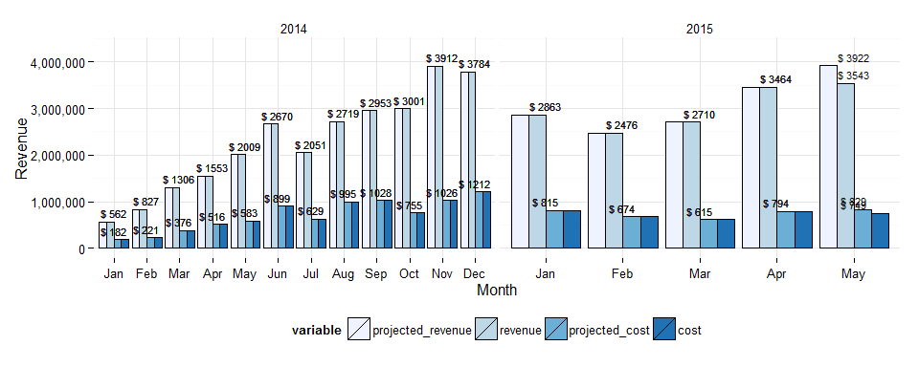

|  |  |  |  |  |  |  |  |  |
| --- | --- | --- | --- | --- | --- | --- | --- | --- |
|  | month_year | revenue | projected_revenue | cost | projected_cost | margin | count_campaigns | avg_daily_revenue |
| 14 | December 2014 | 3,783,681 | 3,783,681 | 1,212,295 | 1,212,295 | 0.68 | 410 | 122,054 |
| 15 | January 2015 | 2,862,784 | 2,862,784 | 814,644 | 814,644 | 0.72 | 370 | 92,348 |
| 16 | February 2015 | 2,475,736 | 2,475,736 | 673,828 | 673,828 | 0.73 | 327 | 88,419 |
| 17 | March 2015 | 2,710,034 | 2,710,034 | 615,026 | 615,026 | 0.77 | 374 | 87,420 |
| 18 | April 2015 | 3,463,892 | 3,463,892 | 794,491 | 794,491 | 0.77 | 457 | 115,463 |
| 19 | May 2015 | 3,542,517 | 3,922,073 | 748,703 | 828,922 | 0.79 | 486 | 126,518 |

Revenue Trend - looking at YoY % Change

Uses projected revenue for current month

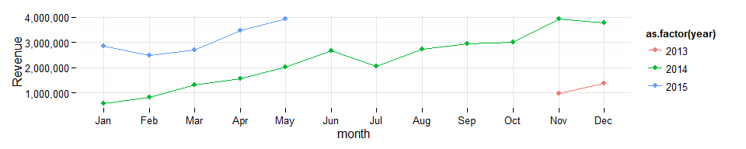

Daily Revenue Trend

Dark Blue Line is a trend line

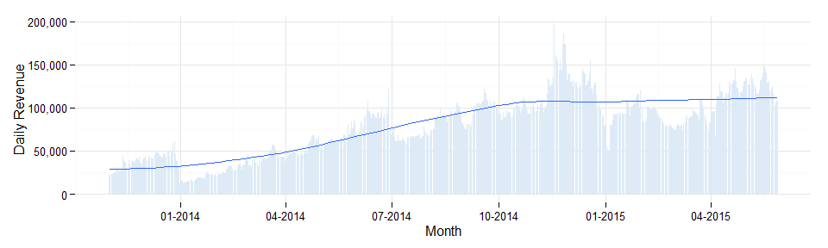

Regional Summary

|  |  |  |  |  |  |  |  |  |
| --- | --- | --- | --- | --- | --- | --- | --- | --- |
|  | month_year | Central | Channel | East | EMEA | Enterprise | Japan | West |
| 14 | December 2014 | 611,712 | 84,432 | 991,252 | 235,871 | 197,151 | 5,151 | 1,645,117 |
| 15 | January 2015 | 445,011 | NA | 961,021 | 239,003 | 151,390 | 2,768 | 1,041,998 |
| 16 | February 2015 | 528,880 | NA | 669,102 | 188,883 | 120,468 | 2,669 | 933,505 |
| 17 | March 2015 | 631,363 | NA | 705,486 | 231,289 | 102,092 | 4,118 | 951,596 |
| 18 | April 2015 | 707,709 | NA | 1,303,058 | 240,655 | 146,782 | 973 | 1,028,382 |
| 19 | May 2015 | 545,908 | NA | 1,459,956 | 185,807 | 364,487 | 947 | 960,791 |

Monthly Product Breakdown

% of total monthly mobile revenue by product

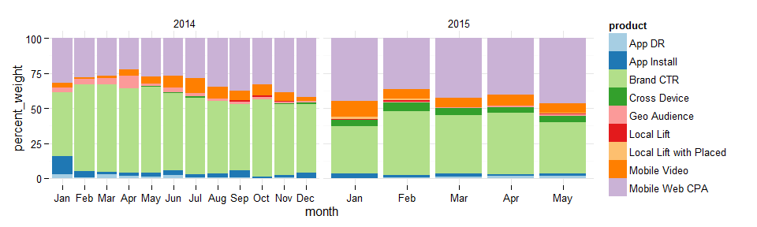

Annual Revenue by Product

|  |  |  |  |  |  |  |  |  |  |
| --- | --- | --- | --- | --- | --- | --- | --- | --- | --- |
| year | App DR | App Install | Brand CTR | Cross Device | Geo Audience | Local Lift | Local Lift with Placed | Mobile Video | Mobile Web CPA |
| 2014 | 221,624 | 878,154 | 14,985,704 | 78,113 | 709,555 | 76,616 | 8,141 | 1,736,648 | 9,386,166 |
| 2015 | 123,856 | 265,536 | 5,204,264 | 612,149 | 99,457 | 55,093 | 93,007 | 1,021,113 | 5,359,798 |

Monthlies by Mobile Initiative

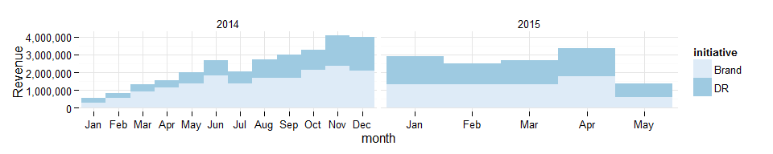

Revenue by Device

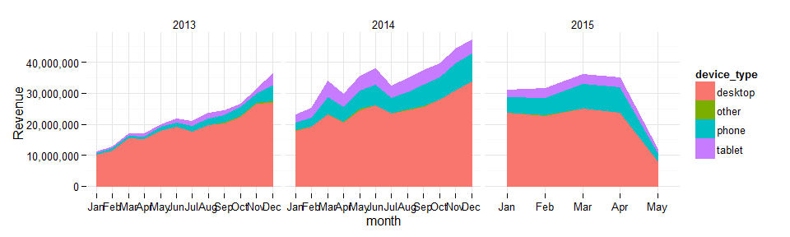

Revenue by Device Table

Based on delivery (ran-as) accross all Rocket Fuel, not mobile sold-as specific

|  |  |  |  |  |  |  |
| --- | --- | --- | --- | --- | --- | --- |
|  | year | month | desktop | other | phone | tablet |
| 24 | 2014 | Dec | 34,008,364 | 20,159.733 | 8,876,199.0 | 4,258,719.3 |
| 25 | 2015 | Jan | 23,892,368 | 25,973.644 | 4,918,153.7 | 2,243,836.5 |
| 26 | 2015 | Feb | 22,928,195 | 21,672.217 | 5,780,045.1 | 2,700,850.3 |
| 27 | 2015 | Mar | 25,106,959 | 9,142.395 | 8,048,798.2 | 3,038,107.6 |
| 28 | 2015 | Apr | 23,873,959 | 11,092.352 | 8,145,945.6 | 2,866,997.0 |
| 29 | 2015 | May | 8,278,099 | 5,926.285 | 2,705,297.7 | 1,062,665.9 |

Monthly Device Proportions

Based on delivery (ran-as) accross all Rocket Fuel, not mobile sold-as specific

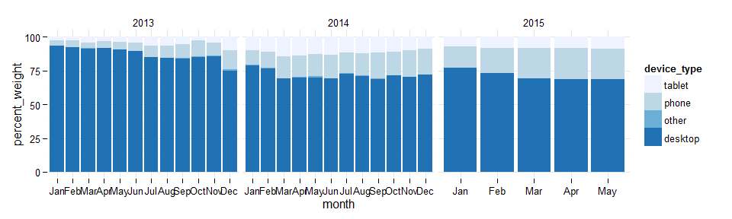

Revenue by Device (incomplete)

Let me know if seeing nominal revenue figures and growth at a device level is useful

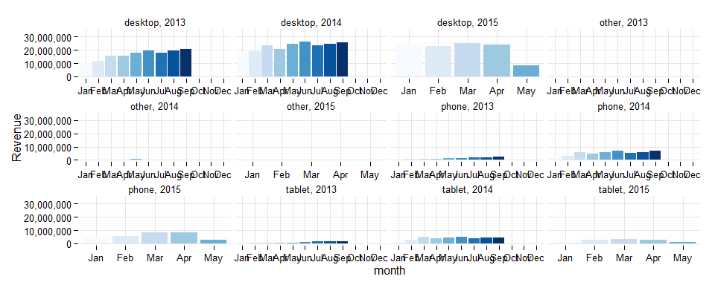

THIS HAS BEEN A TEAM DUBCAT PRODUCTION