Mobile Product Reporting

super john

Thursday, May 07, 2015

has the MySQL table been updated recently?

## last_updated  
## 1 2015/5/07

Mobile Sold-As Monthly Revenue and Cost Summary

Represents as media sold-as mobile to client.

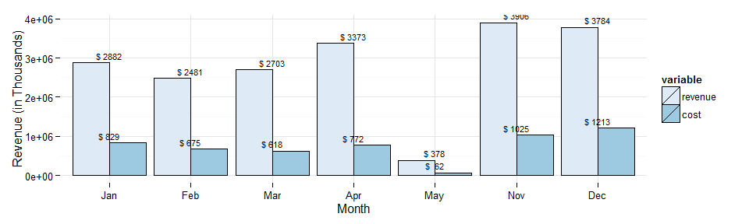 ?scale_x_datetime()

|  |  |  |  |  |  |
| --- | --- | --- | --- | --- | --- |
| month_year | num_days | revenue | cost | campaigns | avg_daily_revenue |
| November 2014 | 30 | 3905933.2 | 1025475.23 | 410 | 130197.77 |
| December 2014 | 31 | 3784048.3 | 1212603.07 | 376 | 122066.07 |
| January 2015 | 31 | 2881502.6 | 828606.25 | 284 | 92951.70 |
| February 2015 | 28 | 2480581.5 | 675438.82 | 309 | 88592.20 |
| March 2015 | 31 | 2702896.9 | 618058.04 | 351 | 87190.22 |
| April 2015 | 30 | 3372734.5 | 772248.94 | 433 | 112424.48 |
| May 2015 | 31 | 378441.4 | 62185.88 | 336 | 12207.79 |

Revenue Trend

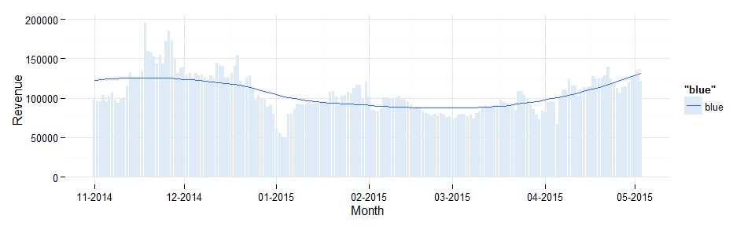

Regional Summary

|  |  |  |  |  |  |  |  |
| --- | --- | --- | --- | --- | --- | --- | --- |
| month_year | Central | Channel | East | EMEA | Enterprise | Japan | West |
| April 2015 | 699334.08 | NA | 1321402.4 | 240654.90 | 145011.60 | 973.49 | 928986.56 |
| December 2014 | 583872.56 | 85756.41 | 1151099.3 | 235870.77 | 197151.02 | 5151.06 | 1511775.60 |
| February 2015 | 487973.40 | NA | 752078.3 | 188882.70 | 120468.34 | 2668.95 | 891431.97 |
| January 2015 | 425167.87 | NA | 1040604.0 | 239002.63 | 140615.60 | 2767.58 | 993024.84 |
| March 2015 | 593656.37 | NA | 775287.8 | 231288.76 | 102091.81 | 4118.48 | 912365.73 |
| May 2015 | 60286.74 | NA | 170739.2 | 23533.99 | 19786.36 | 129.31 | 99801.62 |
| November 2014 | 568476.10 | 155982.59 | 1086911.1 | 161473.50 | 162200.31 | 7464.06 | 1711047.68 |

* facet_wrap(~ Tree)

Product Breakdown

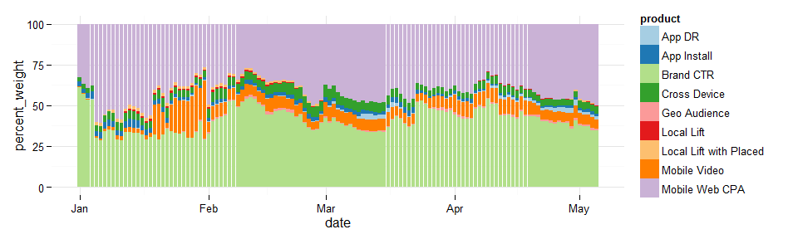

Product Breakdown Monthly

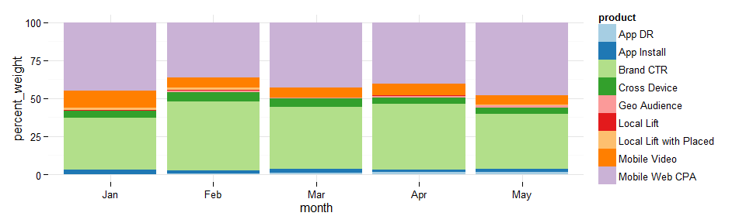

Product Trends

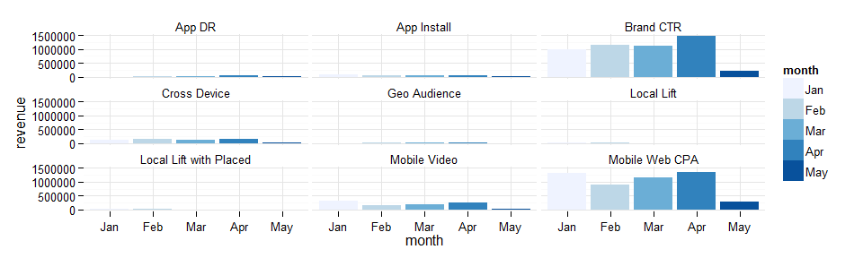

Monthlies by Mobile Initiative

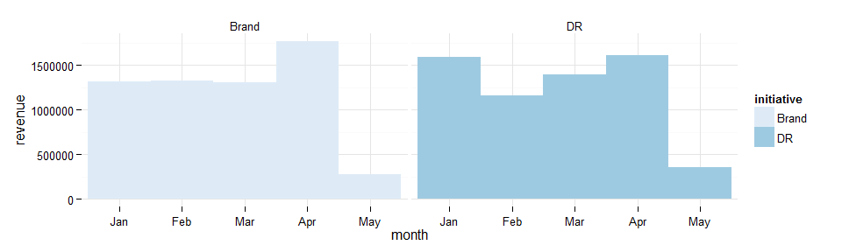

Monthly Device Proportions

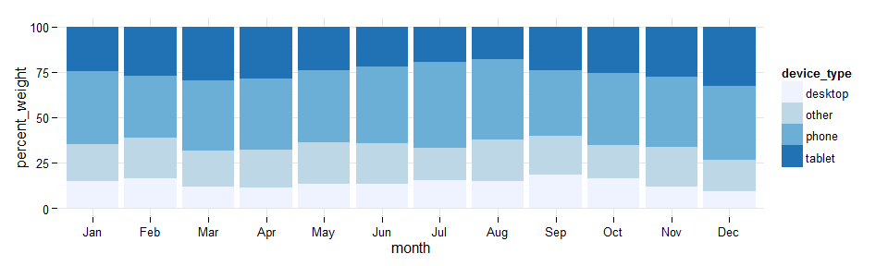

Monthly Device Type Trends

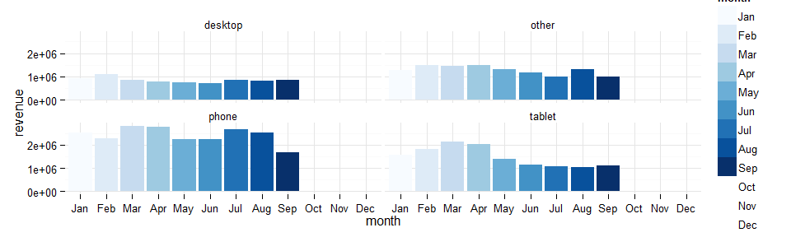

Roadmap

margin in lieu of cost in revene / cost chart(1)

product sold-as / ran-as by region, i.e. what products are driving growth? what's working where?

product by device sold-as / ran-as

sold-as vs ran-as analysis

long-term device-type trend line graph

long-term device trend line graph

revenue, margin by device

margin by product

data tables on product and device

THIS HAS BEEN A TEAM DUBCAT PRODUCTION