Mobile Product Reporting

## last_updated  
## 1 2015/5/14

Mobile Sold-As Monthly Revenue and Cost Summary

Represents as media sold-as mobile to client.

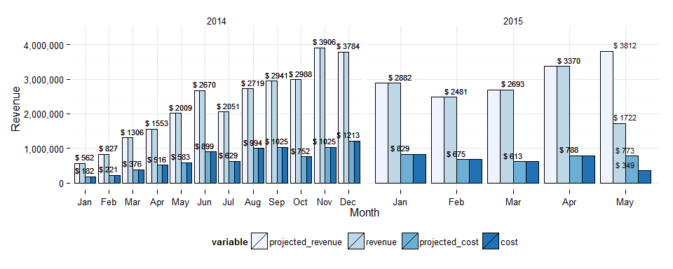

|  |  |  |  |  |  |  |  |  |
| --- | --- | --- | --- | --- | --- | --- | --- | --- |
|  | month_year | revenue | projected_revenue | cost | projected_cost | margin | count_campaigns | avg_daily_revenue |
| 14 | December 2014 | 3,784,057 | 3,784,057 | 1,212,604 | 1,212,604 | 0.68 | 411 | 122,066 |
| 15 | January 2015 | 2,881,510 | 2,881,510 | 828,607 | 828,607 | 0.71 | 371 | 92,952 |
| 16 | February 2015 | 2,480,584 | 2,480,584 | 675,440 | 675,440 | 0.73 | 328 | 88,592 |
| 17 | March 2015 | 2,693,306 | 2,693,306 | 612,645 | 612,645 | 0.77 | 374 | 86,881 |
| 18 | April 2015 | 3,370,386 | 3,370,386 | 788,047 | 788,047 | 0.77 | 458 | 112,346 |
| 19 | May 2015 | 1,721,770 | 3,812,491 | 349,154 | 773,127 | 0.80 | 430 | 122,984 |

Revenue Trend - looking at YoY % Change

Uses projected revenue for current month

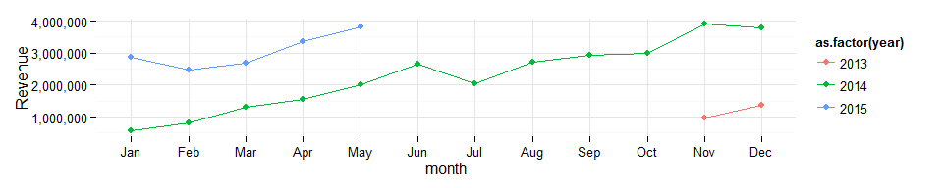

Daily Revenue Trend

Dark Blue Line is a trend line

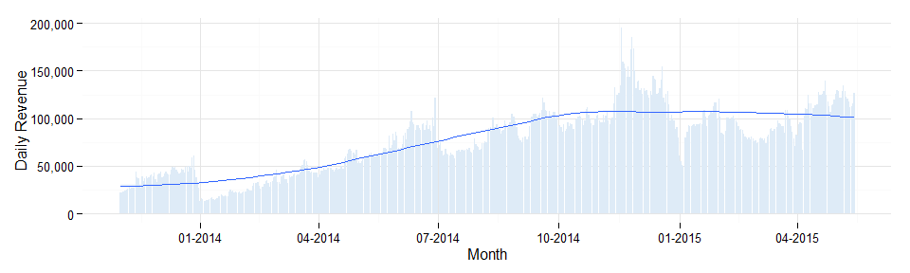

Regional Summary

|  |  |  |  |  |  |  |  |  |
| --- | --- | --- | --- | --- | --- | --- | --- | --- |
|  | month_year | Central | Channel | East | EMEA | Enterprise | Japan | West |
| 14 | December 2014 | 583,874 | 85,756 | 1,151,100 | 235,871 | 197,151 | 5,151 | 1,511,783 |
| 15 | January 2015 | 425,168 | NA | 1,040,604 | 239,003 | 140,616 | 2,768 | 993,032 |
| 16 | February 2015 | 487,973 | NA | 752,081 | 188,883 | 120,468 | 2,669 | 891,432 |
| 17 | March 2015 | 593,661 | NA | 765,692 | 231,289 | 102,092 | 4,118 | 912,366 |
| 18 | April 2015 | 704,433 | NA | 1,312,223 | 240,655 | 146,782 | 973 | 928,987 |
| 19 | May 2015 | 275,783 | NA | 715,340 | 95,425 | 184,848 | 589 | 435,087 |

Monthly Product Breakdown

% of total monthly mobile revenue by product

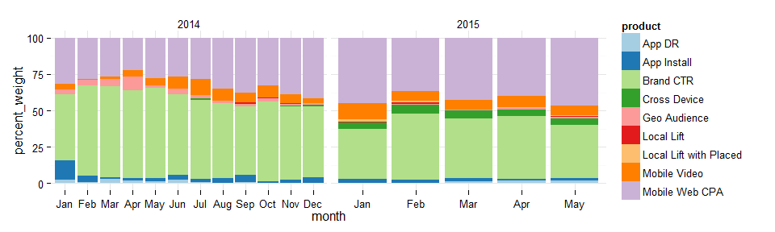

Annual Revenue by Product

|  |  |  |  |  |  |  |  |  |  |
| --- | --- | --- | --- | --- | --- | --- | --- | --- | --- |
| year | App DR | App Install | Brand CTR | Cross Device | Geo Audience | Local Lift | Local Lift with Placed | Mobile Video | Mobile Web CPA |
| 2014 | 221,624 | 878,154 | 14,985,704 | 78,113 | 709,555 | 76,616 | 8,141 | 1,736,648 | 9,386,166 |
| 2015 | 123,856 | 265,536 | 5,204,264 | 612,149 | 99,457 | 55,093 | 93,007 | 1,021,113 | 5,359,798 |

Monthlies by Mobile Initiative

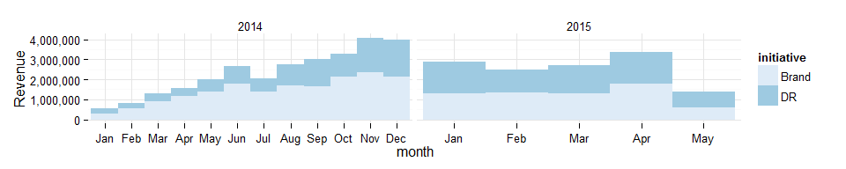

Revenue by Device

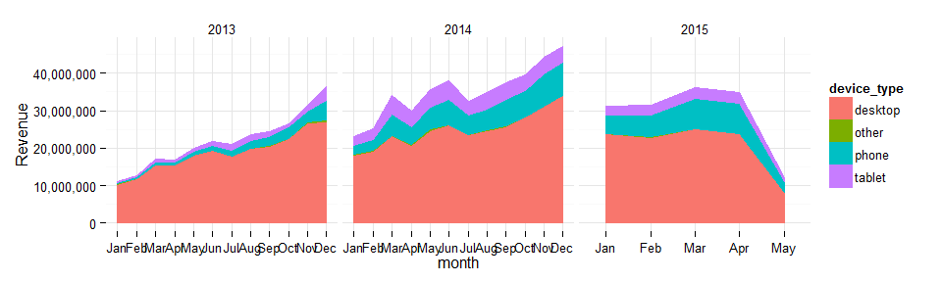

Revenue by Device Table

Based on delivery (ran-as) accross all Rocket Fuel, not mobile sold-as specific

|  |  |  |  |  |  |  |
| --- | --- | --- | --- | --- | --- | --- |
|  | year | month | desktop | other | phone | tablet |
| 24 | 2014 | Dec | 34,008,364 | 20,159.733 | 8,876,199.0 | 4,258,719.3 |
| 25 | 2015 | Jan | 23,892,368 | 25,973.644 | 4,918,153.7 | 2,243,836.5 |
| 26 | 2015 | Feb | 22,928,195 | 21,672.217 | 5,780,045.1 | 2,700,850.3 |
| 27 | 2015 | Mar | 25,106,959 | 9,142.395 | 8,048,798.2 | 3,038,107.6 |
| 28 | 2015 | Apr | 23,873,959 | 11,092.352 | 8,145,945.6 | 2,866,997.0 |
| 29 | 2015 | May | 8,278,099 | 5,926.285 | 2,705,297.7 | 1,062,665.9 |

Monthly Device Proportions

Based on delivery (ran-as) accross all Rocket Fuel, not mobile sold-as specific

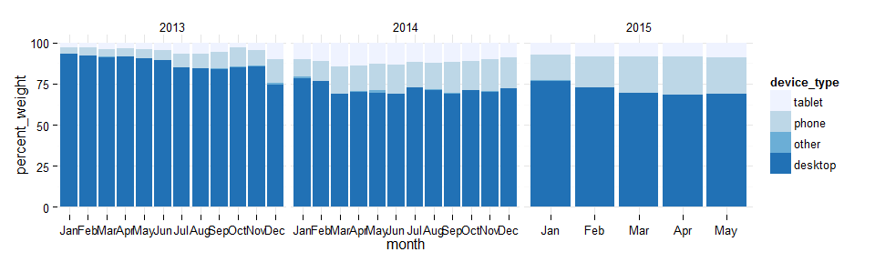

Revenue by Device (incomplete)

Let me know if seeing nominal revenue figures and growth at a device level is useful

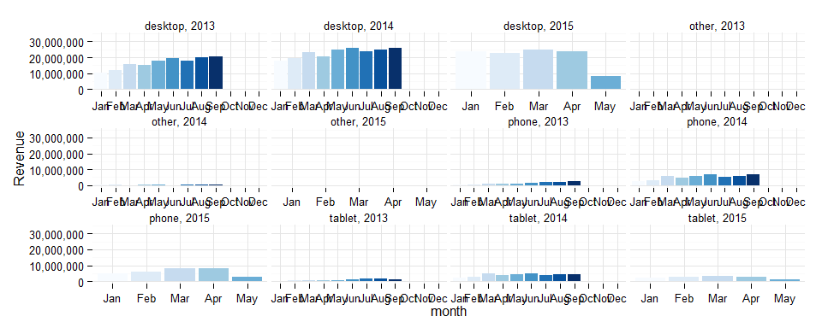

THIS HAS BEEN A TEAM DUBCAT PRODUCTION