COMPILING

There are two concepts to pay attention to, source code, and machine code. Computers only understand machine code, which is basically binary numbers, zeros and ones. In other hand, source code is what humans write, it´s the code itself, so that code needs to be “translated” to machine code so that the computer can understand it.

The software responsible for executing this task is called compiler, on C language, the GCC compiler can do this job.

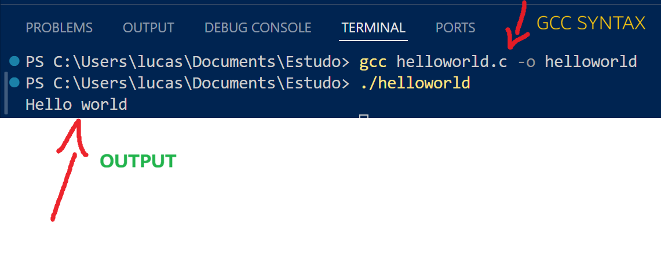

FORMAT CODES
Format codes are used to tell the compiler about the type of data to be printed or scanned.

