**Open Data Governance Plan (Template)**

*Please note that some of these items may be included in the policy that you are working on, e.g. committee membership and meeting frequency. Filling in some specifics here may help you in drafting that policy, but you should consider this a living document that may change as you go through the process of drafting and vetting the policy.

**Decision point: Vision of Open Data Program**

*Describe the reasons why you developed your city’s open data program.*

Example from Cambridge, MA:

“Our overall goal is to make government data available in easy to find and usable formats, therefore creating meaningful opportunities for the public to help solve complex challenges.

Other goals of the City’s Open Data Initiative are:

* Providing Greater Access. The City is committed to providing to the public greater access to City data by instituting an Open Data Initiative to provide the City and the public with opportunities to work collaboratively on complex challenges facing our community.
* Creating Greater Transparency. The City is committed to sharing information through this Open Data Initiative to create opportunities for greater transparency.
* Improving Delivery of City Services. The City is committed to accessing Cambridge’s diverse body of expertise to develop new analyses, insights, and findings which potentially could assist the City’s efforts in providing efficient and effective government services.
* Realizing Social and Commercial Value. Because data is a key resource for social and commercial activities, the large amount of data generated by the City can be a resource in creating innovative business and services solutions that deliver social and commercial value.”

**Decision point: Data Governance Team Composition**

*List who will be on the initial “open data leadership team” and then who you expect to invite to be on a more permanent “open data governance committee.”*

Governance Committee members typically include: Deputy Mayor, Assistant City Manager, or Senior Executive, who serves as the committee chair; Council Members or designees (if a law or ordinance was passed and sponsors expect to be engaged on an ongoing basis); Chief Counsel; Press or Communications Manager; Chief Information Officer, Chief Technology Officer, or Chief Data Officer; Project Manager; Agency or department heads or their representatives; Data coordinators or managers from all relevant agencies and departments

**Decision point: Open Data Coordinators**

*Many cities assign open data coordinators for each department. The data coordinators are often responsible for filling out the open data inventory for their department and/or uploading datasets to the city’s open data portal. In this section, describe the responsibilities of the data coordinators.   
  
Use the following table to keep track of coordinators.*

|  |  |  |  |
| --- | --- | --- | --- |
| Department | Position | Portal Role | Contact Information |
|  |  |  |  |
|  |  |  |  |

**Decision point: Meeting Frequency**

*Note how often the governance committee will meet to discuss the open data program. This may change - you could discuss this as the first meeting and get feedback.*

**Decision point: Data Governance Team Responsibilities**

*Add to or expand on items below.*

1. Short-term:
2. Review and edit draft policy
3. Gain policy buy-in
4. Develop strategy to prioritize internal datasets to release
5. Review accessibility of data
6. Review quality of data
7. Develop workflow to review datasets as they are released
8. Develop strategy to identify demand for datasets from external stakeholders
9. Review technology options

II. Long-term

1. Establish policies for data quality, user requirements, [privacy concerns](http://www.seattle.gov/tech/initiatives/privacy)
2. Automate datasets
3. Other

**Decision point: Public Engagement**

*Document plans for engaging the public in open data program development.*

* 1. Pre-launch
  2. Post-launch

**Decision point: Tracking Progress and Demonstrating Value**

*Brainstorm items that you will track to demonstrate progress on or value of the program. You may want to report on these metrics when developing your open data report. (Some open data policies require city employees to formally report on the progress of their open data initiatives. These metrics would be included in those reports.)*

*Examples are below:*

* # of departments that have completed the dataset inventory (%)
* # of departments that have completed publishing plans (%)
* Percent of inventoried datasets that are published
* Percent of datasets updated on time
* Percent of datasets with required metadata
* Percent of respondents indicating that they use the data portal to access data internally and from other departments
* Number of products made with open data
* Percent of users that are return users
* Number of dataset downloads
* Number of data portal accounts
* Number of API hits
* Number of city responses to open data suggestions
* Open data presence on social media
* Number of participants at a open data community event (hackathon, strategic plan visioning, data release party, etc.)
* Number of ad hoc data requests
* Number of FOIA requests
* Number of internal or intra-departmental data requests
* Number of staff hours responding to data requests

**Decision point: Identifying Datasets**

*This section of your governance documents should describe how the city plans to conduct its data inventory. You should include information on how frequently the inventory will be conducted. (Example: A data inventory can be done annually and/or be triggered when you purchase new software.)*

*Include the fields you plan on collecting as part of your open data inventory. Some examples can be found below:*

# Sample data inventory template - Philadelphia

|  |  |  |  |  |  |
| --- | --- | --- | --- | --- | --- |
| **Title** | **Contact Email Address** | **Contents** | **System of Record** | **Contains Sensitive Data** | **Sensitive Data Comments** |
| Human-readable name of the asset. Should be in plain English and include sufficient detail to facilitate search and discovery. Avoid acronyms. | Data Steward's email address. Who manages the data and is responsible for granting permission to access the data? Who understands what the dataset includes and can answer questions about it? | What the dataset describes. Provide a longer description of the data that can be readily understood by non-technical users. | What is the original system/application/file that houses it? Please provide additional comments as necessary. | Does the dataset contain sensitive data, such as personal phone numbers, Social Security Numbers, etc.? | What could be done to make the data shareable? |

# Sample data inventory template - Houston

|  |  |  |  |  |  |  |  |
| --- | --- | --- | --- | --- | --- | --- | --- |
| *1. Department (use drop-downs)* | *2. Dataset Brainstorm* | *3. Description of dataset* | *4. Data Source* | *5. Format* | *6. Priority* | *7. Primary Contact* | *8. Exemption / Sensitivity Notes* |

**Decision point: Prioritizing Datasets**

*Describe how you plan on prioritizing the release of data to members of the public. As you compile your datasets and fill in the fields, consider developing a measure that captures internal value, quality and availability of each dataset. Below are a series of questions around each of these characteristics. The questions and responses should be posted in order to explain the criteria for the order of release.*

*Dataset Priority Questions: Value*

* *Is the data related to a citywide goal and/or priority?*
* *Is the data related to department's mission, core function, and/or goals?*
* *Can the data foster cross-agency communication and collaboration?*
* *Does the data support policy decisions at the city or department level, or contain information that could foster productive civic engagement and policy debate?*
* *Is the data regularly or frequently requested by public through Right to Know, FOIA, or 311? Could availability of the data create specific economic opportunity?*
* *Does the data have a direct impact on the public? (e.g., hospital infection rates, food establishment inspection results, etc.).*
* *Is the data of timely interest? (related to current events, new initiatives, etc.)*

*Dataset Priority Questions: Quality*

* *Does the data have depth and breadth of years of coverage?*
* *Does the data have accompanying metadata and a data dictionary?*
* *Is the data available at its most useful granular level?*
* *Is the data accurate/complete?*

*Dataset Priority Questions: Readiness/Availability*

* *Is the data available to the public with no access restrictions and no cost?*
* *Is the dataset in a format that is machine-readable or can be easily transformed?*
* *Is the data currently online?*

*Example from Cambridge, MA:*

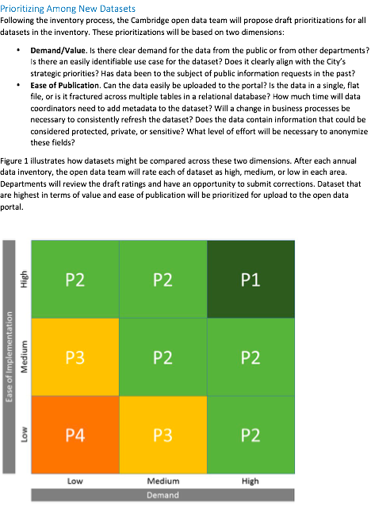

**Decision point: Publishing Data**

Describe who is responsible for uploading data to your open data portal. This may be a place to place your open data workflow that describes how data moves to the open data portal.

Example open data workflow from the Kansas City, Missouri:

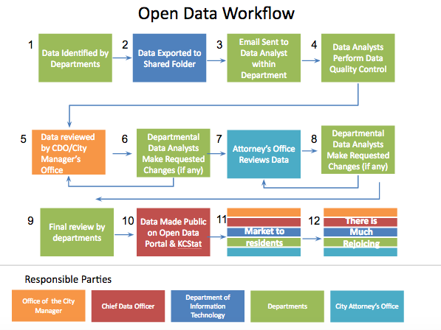

**Decision point: Quality Assessment**

*Describe what a city employee should do if they find that there are problem with any dataset. Cities should strive for the following:*

* *The dataset is the most complete, accurate, and current version appropriate for public release.*
* *The data have been spot checked for common errors such as missing and misplaced values.*
* *Any missing data points are accounted for or explained.*
* *Columns are formatted appropriately.*
* *Metadata is complete, concise, and free of jargon.*
* *Metadata explain the process used to create the data and summarize any changes.*
* *Metadata clearly explain any limitations or omissions for each dataset.*
* *Metadata clearly identify an update frequency and plan.*

**Decision point: Sensitivity Assessment**

*Outline what type of data cannot be released to the public and who should review sensitive datasets before they are published.*

**Decision point: Data Updates**

*Provide guidance to departments on how frequently data will be updated once it is uploaded on your open data portal. Think critically about how whether some uploads can be automated and the capacity to frequently update datasets you need to upload manually. The type of dataset also impacts how frequently the dataset may be updated. (For example, a dataset containing calls for service may need to be updated on a weekly or daily basis, while a dataset describing police precincts may be updated only when changes are made to boundaries.)*

**Decision Point: Purchasing and Contracting**

*Affirm that all applications and analyses produced by the city, whether in-house or procured from a third-party vendor, should produce data in an open format and capable of being published on the city’s open data portal.*

*Example:*

*GovEx’s Data Ownership and Usage Terms for Government Contracts -* [*http://labs.centerforgov.org/data-governance/data-ownership/*](http://labs.centerforgov.org/data-governance/data-ownership/)

**Decision Point: Terms of Use**

*Develop terms of use for open data portal and provide a link to the terms.*

**Decision Point: Licensing**

*Provide information on the license data will be released under and how that information will be made available to the public.*

*Example:*

*The city of San Francisco* [*releases its data*](https://datasf.org/blog/data-license-liberation-day/) *under the Public Domain Dedication License.*