

Strategic Analysis & Product Vision
Document Type | Competitive Audit & Strategic Roadmap
Version | 1.1 — Clean Architecture
Date | March 2026
Modules Analyzed | 12
Critical Gaps Identified | 9
Strategic Build Phases | 3

00 What PIRX Actually Is

PIRX (Performance Intelligence Rx) is a structural performance modelling system for competitive runners. Its closest market analogue is WHOOP — not TrainerRoad.

Like WHOOP, PIRX ingests physiological signals, training data, and personal inputs to model the user's current state. The key difference: where WHOOP answers "How recovered are you?", PIRX answers a harder and more valuable question:

"Based on your current training and physiology, what are you actually capable of running right now?"

PIRX is not a training prescription platform. It does not tell you what to do next. It models your structural potential based on what you have already built — then projects that into event-specific race readiness and predicted performance capacity.

The Intelligence Model vs. The Coach Model
Platform | Core Question Answered | Model Type
WHOOP | How recovered am I today? | Biometric state monitoring
Garmin | What does my VO2 estimate predict? | Proxy metric estimation
TrainerRoad | What should I train tomorrow? | Prescription engine
Strava | How did my workout compare? | Social performance tracking
PIRX | What is my training structurally capable of producing? | Structural potential modelling

01 Strategic Assessment — SWOT Analysis

An honest structural viability assessment of PIRX's current blueprint. This is not a features list — it is an evaluation of where PIRX has genuine market advantage and where it risks failing before reaching scale.

Genuine Strengths
What no competitor can replicate right now.

- Structural projection anchored to baseline races, not VO2 guesses. More defensible and accurate than Garmin's prediction engine because it respects the athlete's actual performance history rather than a proxy metric.
- Driver attribution measured in seconds. Telling an athlete exactly how much each training variable contributed (e.g., threshold density added 21 seconds) is unique in the market. It creates an emotional relationship with training data that pace charts and fitness scores never achieve.
- Intervention tracking as a first-class feature. No mainstream platform logs adjuncts (patches, bicarbonate, caffeine, heat exposure) and correlates them with real projection delta. The $60B supplement industry has zero objective efficacy infrastructure. This is genuine blue ocean.
- Event-specific readiness scoring. A 3000m readiness of 97/100 is more actionable for a competitive runner than WHOOP's generic recovery score. No other platform models readiness at the event level.
- Physiological log integration. Lactate, blood panels, HRV, and ferritin in one system has no direct competitor in the consumer market. This is the gateway to a clinical-grade premium tier.
- Structural identity modelling. "Threshold-Dominant athlete" profiling creates deep personalization that rewires how athletes understand their own potential — a retention and engagement mechanic with no equivalent elsewhere.

Critical Weaknesses
Things that will kill retention before you start.

- No onboarding flow defined. WHOOP's first-week experience is its highest-retention moment — the habit loop is formed in days 1–7. PIRX has no equivalent structured arc. Without it, athletes will churn before they understand what they are looking at.
- No proactive notification or nudge logic. PIRX is fully passive. Users must open the app to receive intelligence. WHOOP's morning readiness brief and evening journal are core daily-habit mechanics that PIRX currently lacks entirely.
- Projection model is opaque. A projected time of 9:53 without an explanation of how is a trust problem. WHOOP won early adopter confidence by showing the maths behind their recovery score. Athletes trained to distrust fitness apps need to understand why the number is what it is, or they dismiss it.
- No social or cohort layer. WHOOP group challenges and shared physiological benchmarks drive significant engagement. PIRX has no social architecture in the current blueprint. The beta cohort model is promising but does not scale.
- Manual data entry dependency. Requiring manual lactate and blood work entry creates friction that undermines the seamless intelligence promise. API partnerships with diagnostic labs and devices are essential from day one.

Market Opportunities
Where PIRX can own the next five years.

- Masters and competitive amateur runners. A massively underserved segment. Garmin targets everyone. WHOOP targets recovery broadly. No platform owns race projection for the serious non-elite amateur — a demographic with high disposable income and deep engagement with performance data.
- Supplement and intervention intelligence. PIRX's adjunct tracking module could become the first evidence-based supplement validation platform. Sports science brands have enormous incentive to sponsor objective efficacy measurement. This is a high-value B2B data partnership opportunity.
- Coach platform tier. Coaches managing 10–30 athletes with PIRX dashboards represents a high-ARPU B2B unlock. No platform has truly mastered the coach-athlete data relationship for track and road running.
- Wearable agnosticism as a moat. Garmin and COROS both lock athletes into their hardware ecosystem. PIRX's positioning as an intelligence layer above all hardware is genuinely differentiated and, if executed well, creates a strong competitive moat.
- Race-day prediction as a public proof moment. Danny's test-at-championships positioning — making a public prediction and measuring the result — is a brilliant go-to-market strategy. Accurate public predictions are viral and create credibility that no advertising campaign can manufacture.

Existential Threats
What can crush PIRX before it reaches scale.

- Garmin acquires or copies the model. If PIRX's projection logic is not deeply proprietary and legally protected, Garmin's 40M+ user data advantage makes imitation trivial within 18 months of PIRX gaining public visibility.
- Trust collapse from inaccurate projections. The "no hype, just mathematics" brand positioning is a double-edged sword. One high-profile public prediction miss inverts the brand proposition catastrophically. Accuracy infrastructure must be in place before any public predictions are made.
- Data privacy regulation. Blood work and lactate data are medically sensitive. Without PIPEDA (Canada), GDPR (EU), and HIPAA-adjacent (US) compliance architecture built in from inception, the physiological log feature — PIRX's most differentiated capability — cannot legally scale into key markets.
- Engagement cliff after 90 days. Without proactive nudges and a sense of ongoing discovery, users risk experiencing PIRX as an occasional reference tool rather than a daily habit. Most performance apps lose 60%+ of users in the first three months. PIRX needs retention mechanics beyond data display.

02 Competitive Benchmarking

Feature-level parity analysis against WHOOP, Garmin Connect, and TrainerRoad — the three most relevant benchmarks for the serious endurance athlete market. PIRX's position of strength and its gaps are both clearly visible.

Capability | WHOOP | Garmin | TrainerRoad | PIRX
Biometric state monitoring | ✓ | ◐ | ✗ | ✓
Fitness / potential projection | ✗ | ◐ | ✓ | ★ Best
Training prescription ("what next") | ◐ | ◐ | ✓ | ✗ Gap
Race readiness score | ◐ | ✗ | ◐ | ★ Best
Event-specific readiness (by distance) | ✗ | ✗ | ✗ | ★ Only
Zone pace personalisation | ✗ | ✓ | ✓ | ✓
Intervention / adjunct tracking | ◐ | ✗ | ✗ | ★ Best
Blood & physiology log | ✗ | ✗ | ✗ | ★ Only
Driver attribution (seconds gained) | ✗ | ✗ | ✗ | ★ Only
Athlete identity modelling | ✗ | ✗ | ✗ | ★ Only
Social / cohort layer | ✓ | ✓ | ✓ | ✗ Gap
Proactive nudges / notifications | ✓ | ✓ | ◐ | ✗ Gap

★ = unique capability or market-best implementation ◐ = partial / limited implementation ✗ Gap = missing, needs to be built

03 Gap Analysis — 9 Gaps That Must Be Closed

Prioritised by their potential to prevent PIRX from achieving world-class user retention and trust. Priority 1 gaps are existential risks for the product's first year of operation.

Priority 1 — Critical (Existential Risks)

Gap 1: Projection Explainability Layer
A projected time of 9:53 with no explanation of the reasoning is a black box. Athletes who have been burned by inaccurate fitness apps will dismiss it immediately. WHOOP's core trust mechanic is showing the math behind their recovery score — every component is visible and explained. PIRX needs an expandable "Why this number?" view that traces the projection back to each driver contribution in plain language.
→ Build: Expandable Projection Breakdown view on every Fitness Snapshot card, linking each driver (in seconds) to the overall projection number.

Gap 2: Onboarding & First-Week Experience
WHOOP's highest-retention cohort is users who complete the first 7-day streak. The habit loop is formed in the first week or never. PIRX's current blueprint has no defined onboarding arc — there is no structured sequence from install to first meaningful projection insight. Without this, expect 60–70% first-week churn before users understand what they are looking at.
→ Build: 5-screen onboarding sequence culminating in a personalised Fitness Snapshot reveal and first Driver Contribution breakdown.

Gap 3: Notification & Nudge Architecture
PIRX is currently fully passive — users must open the app to receive intelligence. WHOOP's power is in its proactive cadence: morning readiness brief, evening journal prompt, weekly summary. These are not features, they are the habit loop. Without a defined notification framework tied to projection changes, training events, and physiological signals, PIRX will become an occasional reference tool rather than a daily intelligence partner.
→ Build: Define 6 core push notification triggers — projection update, readiness shift, intervention signal detected, weekly driver summary, race approaching, and new structural insight.

Priority 2 — High Impact

Gap 4: Social & Validation Layer
Competitive runners are social by nature. WHOOP's group challenges and shared recovery benchmarks drive significant weekly active usage. PIRX has no social architecture. The beta cohort model is a promising foundation, but it needs a formal mechanic. A shareable "Race Prediction Card" would turn every competition weekend into an organic PIRX marketing event — each public prediction is a brand proof point.
→ Build: Shareable Race Prediction Card (optimised for Instagram Stories) and cohort benchmarking — "You projected 9:53. How did the cohort do?"

Gap 5: Wearable API Integration Depth
The blueprint references Garmin, COROS, and Strava without specifying integration depth. If PIRX receives only pace and heart rate summary data, the structural model's accuracy is severely limited. Full raw access to heart rate, cadence, GPS, power, and HRV data streams via Garmin Connect IQ and COROS Open Platform is foundational to the quality of every projection PIRX produces.
→ Secure: Garmin Connect IQ and COROS Open Platform developer agreements for raw data stream access before public launch.

Gap 6: Model Accuracy & Calibration Framework
"No hype, just mathematics" is a brand promise that creates enormous upside and enormous risk. One high-profile public prediction miss — particularly with Danny's race being a public test — can crater credibility before the product finds its footing. PIRX needs a published accuracy protocol: mean absolute error tracking across validation cohort, a clear update cadence for the model, and a transparent communication policy for when and why the projection changes.
→ Publish: Model Accuracy FAQ with ±7 seconds as the stated benchmark. Track and publish cohort mean absolute error openly.

Priority 3 — Strategic

Gap 7: Coach Dashboard & B2B Revenue Tier
The most defensible revenue model in endurance technology is the coach-athlete platform. PIRX's structural modelling and driver attribution is uniquely valuable to coaches managing multiple athletes simultaneously — seeing which athletes are under-developing speed exposure, which are overloading, and which are race-ready across a dashboard is a problem no current tool solves well. This tier commands premium pricing and drives organic athlete acquisition.
→ Design: Coach multi-athlete dashboard as a Phase 2 revenue tier. Target 10 beta coaches before public launch.

Gap 8: Data Privacy & Compliance Architecture
Blood work and lactate data are clinically sensitive. PIPEDA governs Canadian health data collection. GDPR governs EU users. HIPAA-adjacent frameworks apply to US scale. Without a compliant data architecture built in from the start, the physiological log — PIRX's most structurally differentiated feature — cannot legally scale into key markets. This is not a UX problem; it is a legal architecture problem that must be solved pre-launch.
→ Engage: Health data privacy counsel specialised in cross-jurisdiction digital health before any blood or lactate data is stored at scale.

Gap 9: Diagnostic Lab API Integration
The physiological log currently requires manual blood work entry — ferritin, haematocrit, testosterone, and iron entered by hand. This creates friction that will suppress adoption of PIRX's most differentiated module. Automated ingestion via LifeLabs, LabCorp, or Quest Diagnostics APIs would transform the physiological log from a manual diary into a seamless intelligence layer, and would be a meaningful competitive moat.
→ Explore: LifeLabs (Canada) and LabCorp/Quest (US) developer API programmes for automated blood result ingestion.

04 Strategic Roadmap — Three Phases to World-Class

A phased build sequence that closes critical gaps in order of retention impact while protecting and amplifying PIRX's genuine differentiators. Each phase has a clear market milestone, a retention objective, and a revenue unlock.

Phase | Key Deliverables | Milestone & Revenue Unlock
Phase 1  Now → Month 6  Trust & Habit Foundation | - 5-screen onboarding with baseline race input and Fitness Snapshot reveal  - Projection Explainability view — "Why 9:53?"  - 6 core push notification triggers  - Shareable Race Prediction Card for social validation  - Public model accuracy dashboard published  - Garmin Connect IQ + COROS raw data integration | Milestone: 500 validated beta athletes. Model accuracy published at ±7s.  Revenue: Subscription launch at $19.99/month.
Phase 2  Month 6 → 18  Social & Depth | - Cohort leaderboard and group challenge layer  - Intervention intelligence with statistical confidence ratings  - HIPAA/PIPEDA compliance architecture for clinical data  - Two-week trajectory simulation panel  - Mindset Check-In longitudinal correlation analysis | Milestone: 5,000 active users. Intervention tracking validated with statistically significant cohort data.  Revenue: Annual plan launch + enterprise coach tier.
Phase 3  Month 18 → 36  Platform & Revenue Scale | - Coach dashboard for multi-athlete projection management  - Supplement partner API for brand efficacy validation  - LifeLabs/LabCorp automated blood panel ingestion  - Running club aggregate performance modelling tier  - PIRX Intelligence API — license engine to wearable OEMs | Milestone: 25,000+ active users. Coach platform generating $500K+ ARR.  Revenue: B2B supplement validation contracts + API licensing.

05 Product Module Reference — All 12 Modules

Reference summary of all current PIRX product modules, their function within the system, and their strategic value. This section is intended as an internal working reference.

Module | What It Does | Strategic Value
Fitness Snapshot | Projects current race-ready capacity by event distance with confidence range and delta from baseline. Primary home screen module. | Core value proposition — the single number that defines PIRX.
Fitness Trend | 90-day projection trajectory showing acceleration, stability, or decline. 21-day regression slope and volatility band. | Retention driver — shows athletes the arc of their improvement.
Driver Contribution | Attributes total improvement since baseline (in seconds) across: aerobic base, threshold density, speed exposure, load consistency, and running economy. | Uniquely differentiating — no other platform does this.
Two-Week Trajectory | Simulates three scenarios: maintain structure, increase threshold density, or reduce load. Projects 14-day outcome range. | Engagement driver — gives athletes agency over their future projection.
Zone Pace Guide | Converts current fitness into personalised Z1–Z5 pace windows. Shows 21-day zone distribution and Z2 efficiency delta. | Daily training utility — makes the app usable on every run.
Running Economy | Matched heart rate comparison between baseline and current pace at identical load. Shows efficiency gain in seconds/km and HR cost change. | Differentiates PIRX from HR-only platforms.
Event Readiness | Event-specific readiness scores (0–100) for 1500m, 3000m, 5K, and 10K. Labelled by development stage (Building, Sharpening, Peak, etc.). | Race-cycle engagement — highest utility in race prep weeks.
Physiology Log | Logs resting HR, HRV, sleep score (auto), plus manual blood lactate (resting, post-easy, post-threshold, post-race) and full blood work panel. | Structural moat — no consumer platform integrates clinical physiology at this level.
What We're Learning | Narrative structural identity profile: athlete archetype, repeatable high-performance pattern, risk pattern, and block consistency score. | Long-term retention — evolves as data accumulates. Creates identity loyalty.
Adjunct Analysis | Logs training sessions with and without specific interventions. Reports projection delta, HR drift, and volatility. Status: Observational / Emerging / Confirmed. | Revenue opportunity — supplement brand partnerships and clinical trial infrastructure.
Current Honest State | Bottom-of-snapshot narrative layer: what today supports, what is defensible, and what needs development. | Trust mechanic — honest framing builds athlete confidence in the model.
Mindset Check-In | Optional: confidence, fatigue, focus (1–10) with free text. Stored longitudinally. Does not modify projection. | Longitudinal research value — potential correlation with projection accuracy.

06 Summary — The One Thing PIRX Must Remember

PIRX is not a training coach. It is a performance intelligence mirror.
WHOOP tells you how ready your body is. Garmin tells you what your data suggests. TrainerRoad tells you what to do next. PIRX does something none of them do: it tells you what your training is structurally capable of producing — in race-specific, second-accurate terms.

That is a different kind of intelligence. It is not a coaching function. It is a potential modelling function. The athlete still decides what to train. PIRX tells them what that training is building toward, and how close they are to the performance they are capable of.

The gaps identified in this document are real, but none of them undermine the core proposition. They are retention and trust infrastructure — the plumbing that allows the intelligence to reach the athlete daily rather than occasionally. Close the Priority 1 gaps first, and PIRX has a genuinely world-class product.

No hype. Just mathematics.
07 App Mockups — iPhone 15

Representative UI screens showing the two primary views an athlete sees daily. Left: Fitness Snapshot home screen. Right: Performance Report with driver breakdown and event readiness.

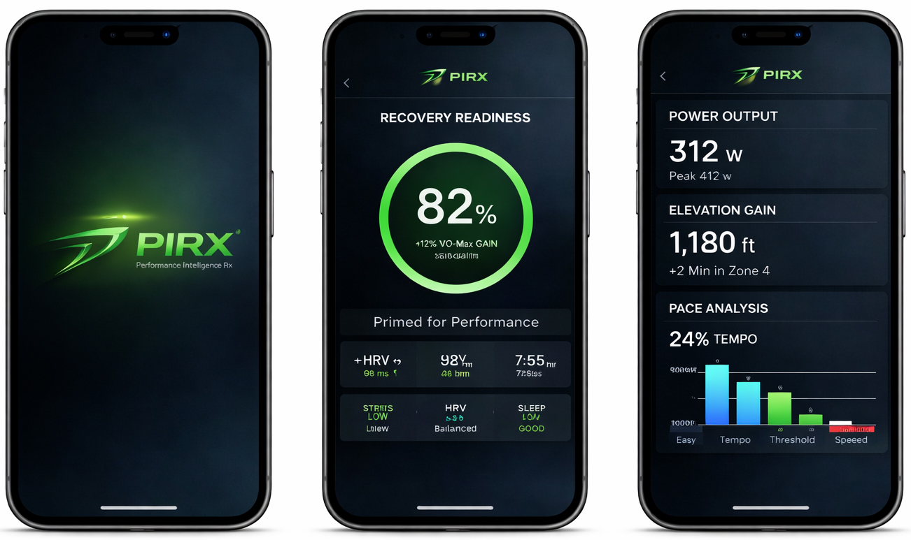
These mockups represent the PIRX blueprint as specified in Version 1.1. Visual design and UI are actively evolving. The data shown (9:53 · Danny G. · 3000m · March 2026) reflects the real validation race weekend projection.

