作业1 知识工程与知识图谱

学号：

1. Consider the following RDF document:

<rdf:RDF

xmlns:rdf="http://www.w3.org/1999/02/22-rdf-syntax-ns#"

xmlns:rdfs="http://www.w3.org/2000/01/rdf-schema#"

xmlns:iswww="http://sw.edu/#"

>

<rdf:Description rdf:about="http://sw.ed u/#germany">

<rdf:type rdf:resource="http://sw.edu/#country" />

</rdf:Description>

<rdf:Description rdf:about="http://sw.edu/#capital_of">

<rdf:type

rdf:resource="http://www.w3.org/1999/02/22-rdf-syntax-ns#Property"/>

<rdfs:domain rdf:resource="http://sw.edu/#city" />

<rdfs:range rdf:resource="http://sw.edu/#country" />

</rdf:Description>

<rdf:Description rdf:about="http://sw.edu/#country">

<rdf:type rdf:resource="http://www.w3.org/2000/01/rdf-schema#Class" />

<rdfs:label xml:lang="de">Land</rdfs:label>

</rdf:Description>

<rdf:Description rdf:about="http://sw.edu/#berlin">

<rdfs:label xml:lang="en">Berlin</rdfs:label>

<rdf:type rdf:resource="http://sw.edu/#city" />

<iswww:capital_of rdf:resource="http://sw.edu/#germany" />

</rdf:Description>

<rdf:Description rdf:about="http://sw.edu/#city">

<rdf:type rdf:resource="http://www.w3.org/2000/01/rdf-schema#Class" />

<rdfs:label xml:lang="de">Stadt</rdfs:label>

</rdf:Description>

</rdf:RDF>

Draw the graph representation of the above document.

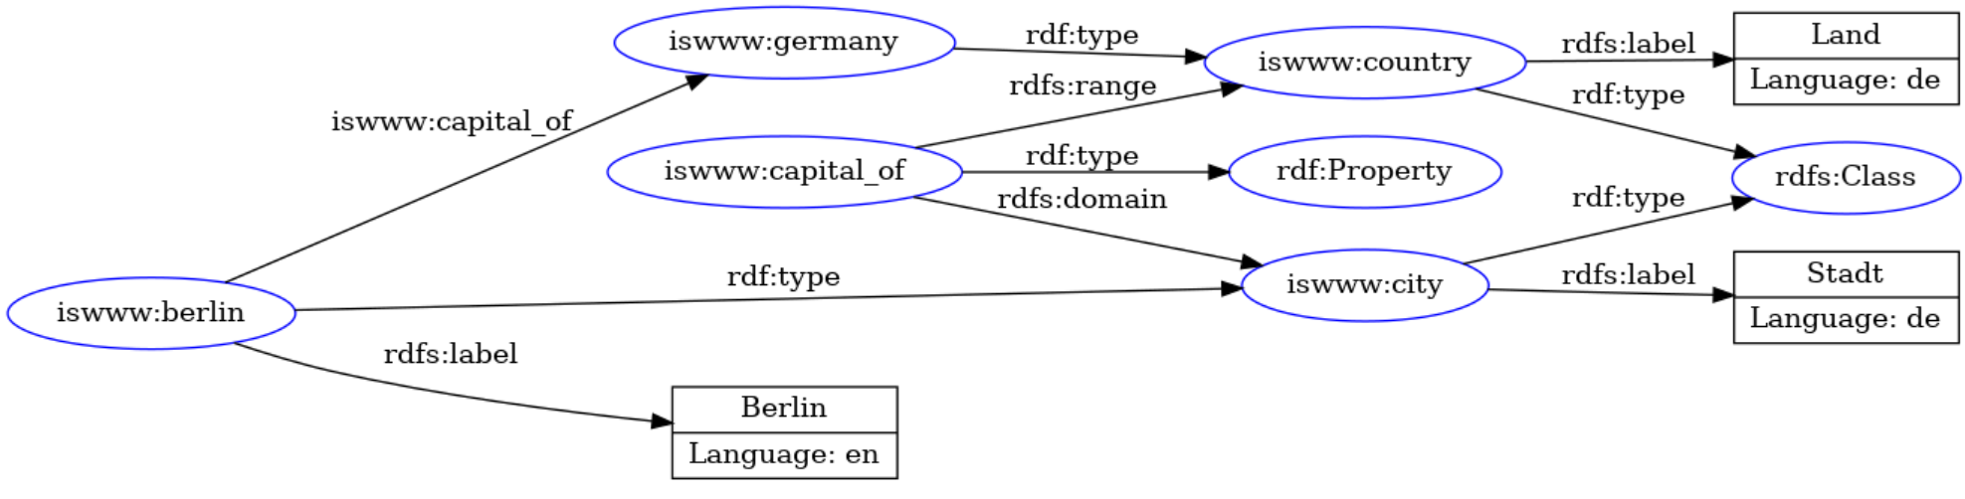

1. Translate the culinary-allergic example ontology as follows into RDF/XML syntax.

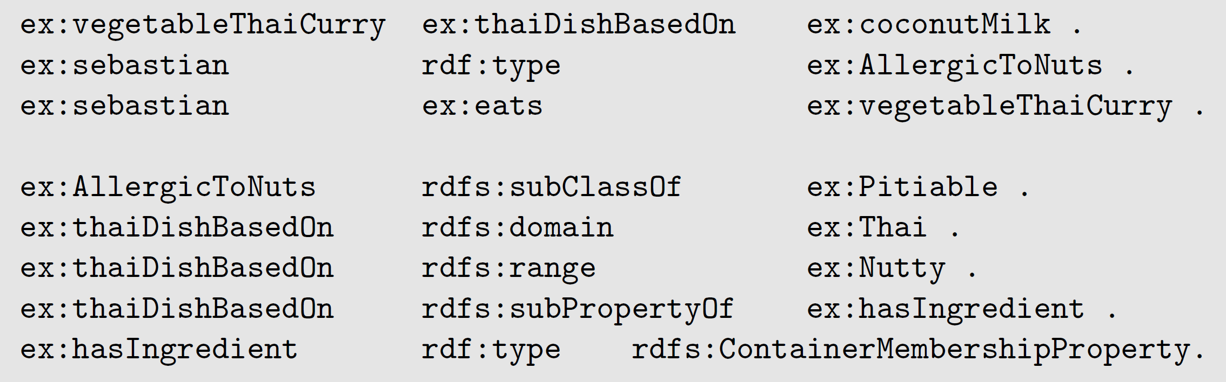

1. <?xml version="1.0"?>
2. <rdf:RDF
3. xmlns:rdf="http://www.w3.org/1999/02/22-rdf-syntax-ns#"
4. xmlns:rdfs="http://www.w3.org/2000/01/rdf-schema#"
5. xmlns:ex="http://example.com/schema#">
7. <!-- Declaration of individuals -->
8. <rdf:Description rdf:about="http://example.com/schema#vegetableThaiCurry">
9. <rdf:type rdf:resource="http://example.com/schema#ThaiDishBasedOn"/>
10. <ex:hasIngredient rdf:resource="http://example.com/schema#coconutMilk"/>
11. </rdf:Description>
13. <rdf:Description rdf:about="http://example.com/schema#sebastian">
14. <rdf:type rdf:resource="http://example.com/schema#eats"/>
15. <ex:allergicToNuts rdf:resource="http://example.com/schema#AllergicToNuts"/>
16. </rdf:Description>
18. <rdf:Description rdf:about="http://example.com/schema#coconutMilk">
19. <rdf:type rdf:resource="http://example.com/schema#AllergicToNuts"/>
20. </rdf:Description>
22. <!-- Declaration of classes -->
23. <rdf:Description rdf:about="http://example.com/schema#AllergicToNuts">
24. <rdfs:subClassOf rdf:resource="http://example.com/schema#Pitiable"/>
25. </rdf:Description>
27. <rdf:Description rdf:about="http://example.com/schema#ThaiDishBasedOn">
28. <rdfs:domain rdf:resource="http://example.com/schema#Thai"/>
29. <rdfs:range rdf:resource="http://example.com/schema#Nutty"/>
30. <rdfs:subPropertyOf rdf:resource="http://example.com/schema#hasIngredient"/>
31. </rdf:Description>
33. <rdf:Description rdf:about="http://example.com/schema#hasIngredient">
34. <rdf:type rdf:resource="http://www.w3.org/2000/01/rdf-schema#ContainerMembershipProperty"/>
35. </rdf:Description>
36. </rdf:RDF>
37. Decide whether the following propositions can be satisfactorily modeled in RDFS and, if so, give the corresponding RDF(S) specification:

• Every pizza is a meal.

• Pizzas always have at least two toppings.

• Every pizza from the class PizzaMargarita has a Tomato topping.

• Everything having a topping is a pizza.

• No pizza from the class PizzaMargarita has a topping from the class

Meat.

• “Having a topping” is a containedness relation.

1. :Pizza rdfs:subClassOf :Meal
2. 不行
3. 不行
4. ex:PizzaMargarita ex:hasTopping ex:Tomato
5. 不能表达
6. ex:hasTopping rdf :type rdfs:ContainerMembershipProperty.
7. As an example of an interpretation, this time with an infinite domain, consider the following vocabulary:

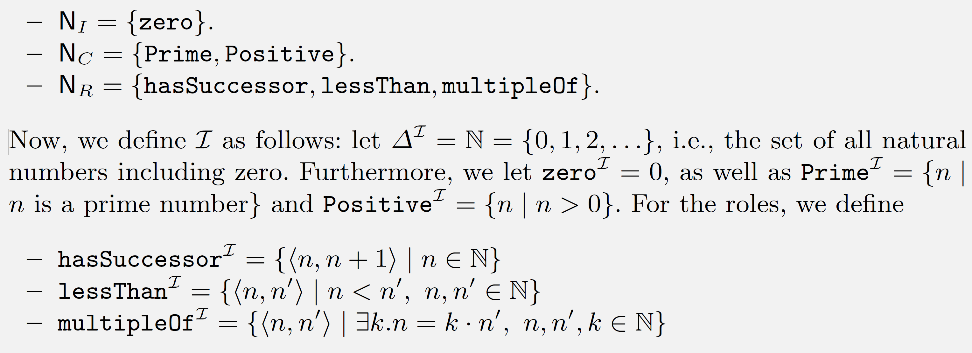

Describe (both verbally and formally) the extension of the following concepts with respect to the interpretation 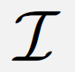 defined above

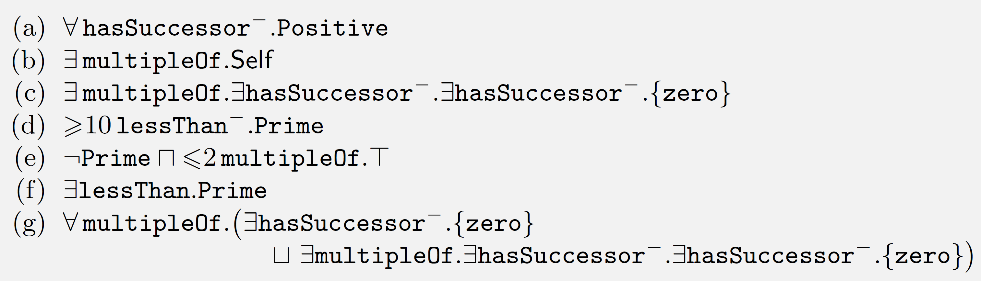

1. 所有有后继者的自然数都是正数。
2. 存在至少一个自然数是其自身的倍数。
3. 存在一个自然数是它的后继者的倍数，这个数不是0的后继者。
4. 至少有十个比某个素数小的自然数。
5. 不是素数且至多是两个数的倍数的自然数。
6. 存在比素数小的自然数。
7. 不是任何数的倍数，该数是0的后继者，或者是任何数的倍数，该数是0的后继者的后继者。
8. Decide whether the following axioms are satisfied by the interpretation  from Exercise 4.

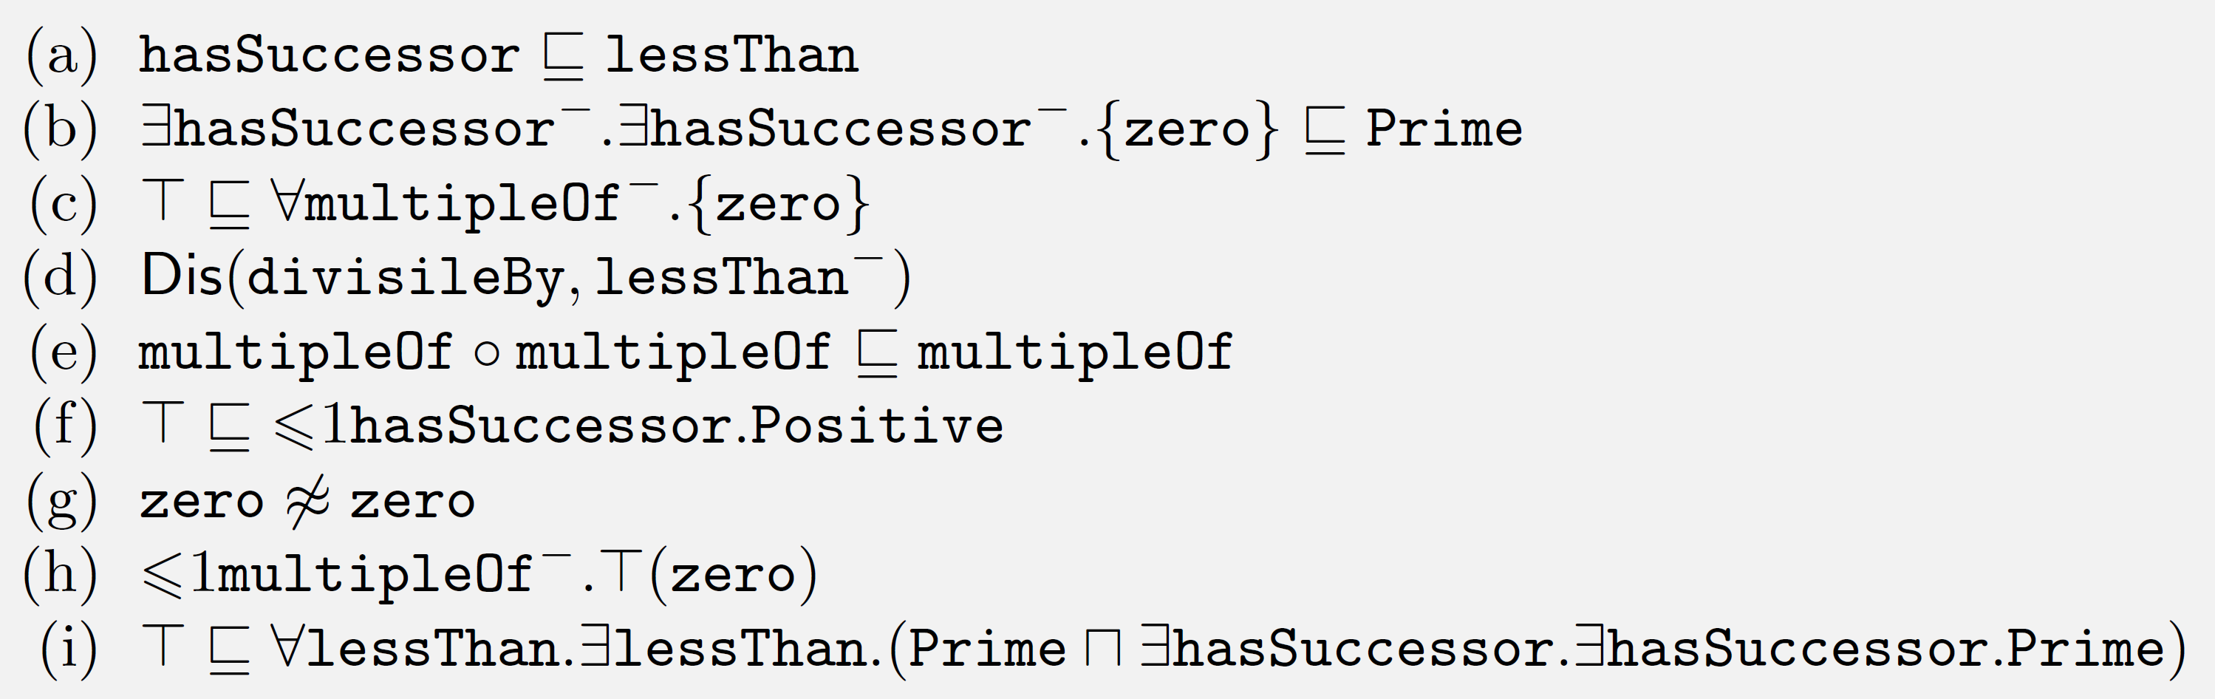

1. 满足。每个具有后继者的数都小于其后继者。
2. 0的后继者的后继者（2）是素数，满足
3. 所有的数都不是0的倍数，满足
4. 整除和大于等于不相交，满足，如果一个数 b 可以被 a 整除（即 a 是 b 的倍数），那么 a 不能小于 b
5. 数的倍数的倍数也是原来数的倍数，满足
6. 每个自然数有最多一个后继者，这个后继者总是正数，满足
7. 0不等于0？不满足
8. 0是0的倍数，满足
9. 对于每一个自然数，总能找到一个大于它的素数，且这个素数不是某个素数的后继者的后继者，满足
10. Show using the 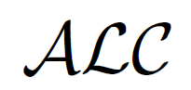 tableaux algorithm that the following knowledge base is unsatisfiable.

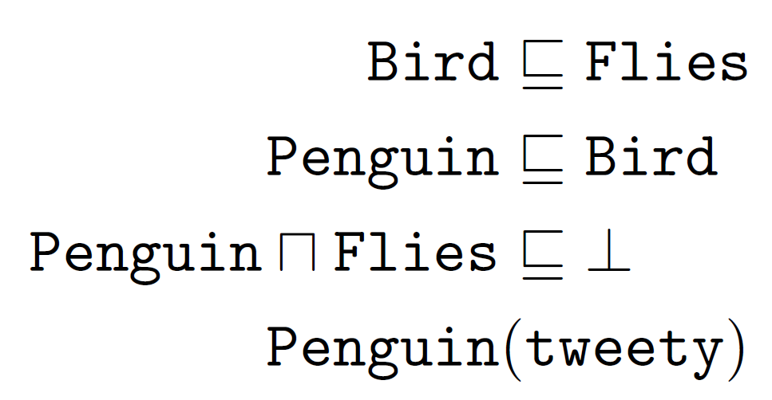

Penguin(tweety) 且Penguin⊑Bird，所以Bird(tweety)

Bird(tweety)且 Bird⊑Flies，所以Flies(tweety)

由于Penguin⊓Flies⊑⊥且Penguin(tweety)，所以¬Flies(tweety)，出现矛盾