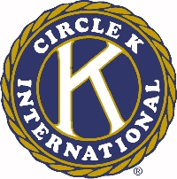
The 46th Annual Ohio District Circle K Convention

AWARD FORM SUBMISSION GUIDELINES

- All directions MUST be followed in order for your club to be considered for the awards that are submitted.

2. All award forms MUST be typed for submission.

3. District Policy Code 12, #9 will be enforced as stated. Circle K Clubs will not be eligible to participate in any award competitions at District Convention unless they have submitted at least nine (9) of the required twelve (12) club monthly reports.

*Reports must be submitted to the District Secretary postmarked by January 31, 2003.*

- Elected District Officers will be judging all awards, therefore they are to be excluded from the submission of all award forms. In order to keep the judging process impartial, Elected District Officers may not aid in the submission of these award forms.

5. The Official Signatures sheet MUST be included for consideration of all awards.

6. When submitting your awards, include the enclosed cover sheets with each award, so that there is no confusion on which form is being submitted.

7. Please send the COMPLETED and TYPED award forms postmarked no later than January 31, 2003 to:

Francine Smith
VWK 134D
P.O. Box 8803
Dayton, OH. 45401-8803

School Phone: 937-627-1250
Cell Phone: 440-227-6703

THE DISTRICT BOARD WILL NOT ACCEPT ANY AWARD FORMS THAT ARE POSTMARKED LATER THAN THE JANUARY 31st DEADLINE!!!

