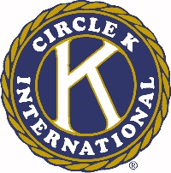
The 46th Annual Ohio District Circle K Convention

Oratorical Contest

Name __________________________________________________________________

Circle K Club of __________________________________________________________

Rules governing Ohio District Oratorical Contest:

1. The subject matter and presentation must be original and completely developed by the orator. These factors will be considered equally in the selection of the award recipient.

2. Each orator will be allowed a maximum of seven (7) minutes for their presentation.

3. Each orator will be allowed to use a maximum of two (2) minutes, of the seven (7) minutes allotted, for presenting quotations.

4. Each orator must be an official member in good standing with the Ohio District, Circle K International, and their Circle K Club.

5. Each orator can use notes on index cards only (no larger than 5 x 7).

6. Elimination trials will be held during the District Convention.

7. The outstanding orators will receive awards (first, second, and third place) during the Awards and Entertainment Session at the District Convention. The First place winner shall present their oration at this session.

8. Subject of all orations will be announced one month prior to District Convention.

The judging of this contest will be done by a committee composed of Kiwanians. They will use the following criteria in judging each presentation:

Clarity of message and projection of idea 20 points
Enthusiasm 10 points
Posture, Composure and Gestures 10 points
Voice-Tone and Effectiveness 10 points
Pronunciation and Word Choice 10 points
Originality 10 points
Organization 20 points
Reference to International Theme 10 points
Substance 5 points
Grammar 5 points
TOTAL 100 points

