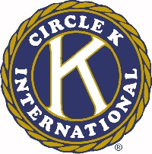
The 46th Annual Ohio District Circle K Convention

Single Service Award

Circle K Club of __________________________________________________________

Permanent Mailing Address _________________________________________________
________________________________________________________________________

Official Club Membership ______________________ (Number of Dues-Paid Members)

Rules:

1. The Single Service Award is given to that Circle K Club which through dedication and unselfish efforts has produced the best single project or service during the year.

2. Each club is urged to enter its most outstanding single service activity.

3. Only one service activity per club is allowed in this competition.

4. The activity to be entered must be written in a complete report covering all details of the project. If funds are raised, make no reference to the amount.

5. The activity described may cover any program of service performed between the period of the 2002 Ohio District Convention and the 2003 Ohio District Convention. The report must be typewritten (double-spaced). Newspaper clippings, substantiating photographs, and any other materials necessary may be included.

6. Each club in good standing with Circle K International and the Ohio District will have an opportunity to compete for this award.

7. A maximum of 2,000 words may be used in this report. The report will be judged in the following areas:
A. Need (describe briefly why this project was necessary)
B. Planning
C. Club Participation (include total service hours*)
D. Evaluation of project's merit to community or campus

*A service hour is defined as sixty (60) minutes of service enacted by one member of Circle K International. List time spent in each of the following areas and number of members involved in each area 1) planning, 2) travel, 3) actual project's time, & 4) follow-up.

