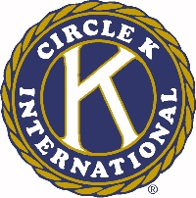
The 46th Annual Ohio District Circle K Convention

Talent Auditions

Circle K Club of __________________________________________________________

Talent for the talent competition is not limited in any way, shape, or form as to content. The only stipulation is that the performing members be members in good standing. Any and all talents are accepted. Please keep acts under 15 minutes.

Please notify the Convention Chairperson as soon as possible if there are any special needs in the form of equipment or staging. Please note that due to copyright laws, no copyrighted music can be used unless the proper arrangements are made by the performer. Please contact the Convention Chairperson if you have any questions.

The deadline for entry is midnight Friday of the Convention.

