List of things to bring to Sp.O.T.
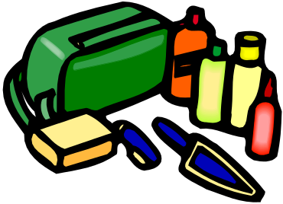
Sleeping Bag

Pillow
Toiletries
Weather-appropriate clothing
Tennis Shoes
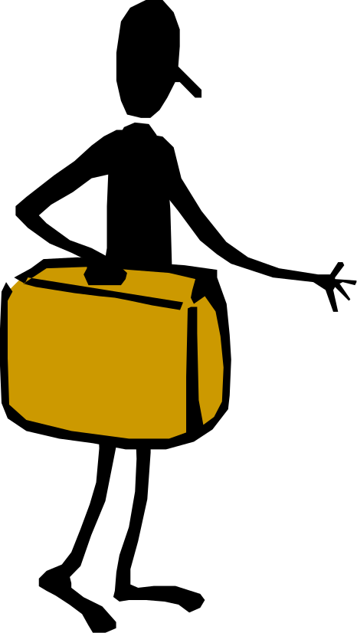
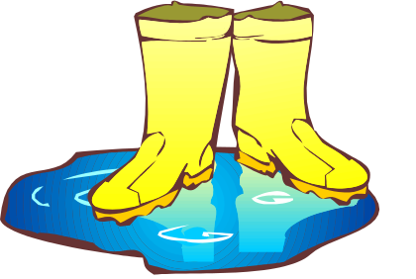
Rain Gear
Snacks
Flashlight
Bug Spray

and…
SMILES


