**JOANA (JOB OPENING AND APPLICANT NETWORK AUTOMATION): A WEB-BASED SYSTEM FOR DEPED APPLICANTS IN DIGOS CITY USING QUEUEING, RANKING AND LOCALIZTION ALGORITHM**

An Undergraduate Capstone Project  
Presented to the Department of Technical Programs  
UM Digos College  
Digos City

In Partial Fulfillment of the Requirements for the Degree of

Bachelor of Science in Information Technology

by

Venz Fredrick N. Olarte

Francis Lourd Emmanuel M. Bayos

Jhayvee E. Alcain

February 2025

**APPROVAL SHEET**

This study entitled **“JOANA (JOB OPENING AND APPLICANT NETWORK AUTOMATION): A WEB-BASED SYSTEM FOR DEPED APPLICANTS IN DIGOS CITY USING QUEUEING, RANKING AND LOCALIZATION ALGORITHM”** prepared and submitted by **Venz Fredrick N. Olarte, Francis Lourd Emmanuel M. Bayos** and **Jhayvee E. Alcain,** in partial fulfillment of the requirement for the degree of **Bachelor of Science in Information Technology** has been examined and is hereby recommended for approval and acceptance.

# **NESLE L. TAGALOG, MIT**

# Research Adviser

# PANEL OF EXAMINERS

**APPROVED** by the committee for Final Defense with the grade of **__________.**

|  |  |
| --- | --- |
| **CYVIL DAVE DASARGO, MIT** Chair | |
| **EDUARD L. PULVERA, MSIS** Member | **JOANE MAY B. DELIMA, MIT** Member |
|  | |

**ACCEPTED** in partial fulfillment for the degree of **Bachelor of Science in Information Technology**.

|  |  |  |
| --- | --- | --- |
| **JOANE MAY B. DELIMA, MIT** Research Coordinator |  | **CYVIL DAVE T. DASARGO, MIT** Program Chair, BSIT |
| **TOMAS JR. A. DIQUITO, Ph.D.** Dean of College |  | **TESSIE G. MIRALLES, Ph.D.** VP-Branch Operations |

**ACKNOWLEDGMENT**

Our accomplishments would not have been possible without the constant love and encouragement of our family, and for that, we are eternally thankful. Your unwavering support and faith in us have been our rock in times of both difficulty and success.

We are deeply grateful to all of our respected instructors and advisors, particularly **Miss Joane May B. Delima, MIT; Sir Eduard L. Pulvera, MSIS; Sir Cyvil Dave T. Dasargo, MIT;** the **Team Bangan;** and the entire IT faculty, for their unwavering commitment and priceless counsel. We would not be where we are without your dedication to our development and enthusiasm for teaching.

Our sincere appreciation also goes out to our friends and classmates, whose company and cooperation have made this experience truly remarkable and fulfilling. The friendship you've given us, as well as the experiences we've had together, have been invaluable to us.

We need to give ourselves credit for the self-confidence, strength, and maturity we've developed on this journey. Every challenge we conquer builds our determination and knowledge of our abilities.

All of our hard work and dreams have come to fruition in our capstone project. It is the culmination of our incessant pursuit of knowledge in this area, which has required countless hours of study, discussion, and improvement.

We would like to convey our profound appreciation to all individuals who have helped us along the way, whether it has been with encouraging words, helpful criticism, or insightful suggestions. To Joana Dianne Sarno, we thank you for the unwavering support and source of inspiration for this project. We couldn't have gotten here without your constant encouragement.

The friendships we made and the lessons we gained will stay by our side as we embark on a fresh phase in our lives. Our combined expertise has allowed us to not only learn more but also push our discipline forward. With an abundance of thankfulness and hope, we anticipate the possibilities that await us and the obstacles that we will overcome together. It means a lot to know you believe in us and have been there for us every step of the way.

Researchers

**DEDICATION**

We dedicate this to our family, whose unwavering support and encouragement have guided us through this milestone, and to our instructors, whose expertise and guidance assisted and encouraged us to succeed. We extend our deepest gratitude to our classmates and friends, whose companionship and collaboration made this experience truly unforgettable. We are very thankful to everyone for their constant support, insightful guidance, infinite inspiration, and involvement in this remarkable journey. We owe this moment to our commitment, effort, and growth. We succeeded because of our teamwork and passion.

Venz Fredrick N. Olarte

Francis Lourd Emmanuel M. Bayos

Jhayvee E. Alcain

**TABLE OF CONTENTS**

|  |  |
| --- | --- |
|  | **Page** |
| **TITLE PAGE** | i |
| **APPROVAL SHEET** | ii |
| **ACKNOWLEDGMENT** | iii |
| **DEDICATION** | iv |
| **TABLE OF CONTENTS** | v |
| **LIST OF TABLES** | vii |
| **LIST OF FIGURES** | viii |
| **ABSTRACT** | ix |
| **INTRODUCTION** | 1 |
| Project Context | 1 |
| Purpose and Description | 3 |
| Objectives of the Study | 3 |
| Scope and Limitation | 4 |
| **METHODOLOGY** | 4 |
| Data Gathering | 4 |
| Requirements Analysis | 4 |
| User Requirement Analysis | 4 |
| Hardware and Software Requirements | 5 |
| Design | 5 |
| Conceptual Framework | 5 |
| Data Flow Diagram | 6 |
| Architecture Design | 6 |
| Development | 6 |
| Software Methodology | 6 |
| Project Technology | 7 |
| Software Tools in Application Development | 8 |
| Testing | 8 |
| **RESULTS AND DISCUSSIONS** | 9 |
| Implementation Plan | 9 |
| Implementation Result | 9 |
| **CONCLUSION AND RECOMMENDATION** | 11 |
| **REFERENCES** | 12 |
| **APPENDICES** | # |
| 1. Test Cases | # |
| 1. Sample Source Code | # |
| 1. User Manual | # |
| 1. Letter of Permission | # |
| 1. Routing Form | # |
| 1. Assignment of Research Personnel | # |
| 1. Grammarly Report | # |
| 1. Plagiarism Result | # |

|  |  |  |
| --- | --- | --- |
| **LIST OF TABLES** | | |
| **Table** | **Description** | **Page** |
| 1 | Features comparison of different related system | 3 |
| 2 | Hardware Requirements | 5 |
| 3 | Software Requirements | 5 |
| 4 | Implementation Plan | 9 |
|  |  |  |
|  |  |  |

|  |  |  |
| --- | --- | --- |
| **LIST OF FIGURES** | | |
| **Figure** | **Description** | **Page** |
| 1 | Conceptual Framework | 5 |
| 2 | Data Flow Diagram | 6 |
| 3 | System Architecture | 7 |
| 4 | Use Case Diagram | 7 |
| 5 | Employee index Card | 9 |
| 6 | Add Implementation Plan | 10 |
| 7 | Add Transaction in Lactation Room | 10 |
| 8 | Add Transaction in Infirmary | 10 |
| 9 | Add Transaction in Consultation | 10 |
| 10 | Add Transaction in Dispensing Medicines | 10 |
| 11 | Distribution of Medicine and Supplies | 10 |
| 12 | Monthly Medicine and Supplies Received | 11 |
| 13  14  15  16  17 | Top 10 Dispensed Medicines  Landing Page  Login Page  Personal Data  Application Form | 11  11  11  11  11 |
|  |  |  |
|  |  |  |
|  |  |  |
|  |  |  |
|  |  |  |

# ABSTRACT

The Department of Education (DepEd) in Digos City uses a web-based system to simplified the hiring and selection of prospective teachers. Utilizing modern technologies such as Laravel, Bootstrap, Livewire, and Javascript, JOANA optimizes the recruiting process by integrating queueing, ranking, and localization algorithms. Current human recruiting procedures face several challenges, such as time inefficiencies, possible bias, and opaqueness. The system helps to overcome these obstacles by automating job advertising, Hiring assessments, and merit-based ranking.

The main features of JOANA are automated application queuing based on First-Come, First-Served rules, weighted sum model ranking to determine overall merit, and K-Nearest Neighbors localization for ground relationship. The DepEd's policies serve as the foundation for the system, guaranteeing a competency-based, equitable, and effective hiring process. The resource is reusable and applicable throughout the system, enabling compliance support and the advancement of their methods for managing human resources in public education. This demonstrates how technology can improve social behavior, governance, and civic engagement through intelligent HR systems.  
  
**Keywords:** *DepEd, Appointment, Employment, JOANA, Hiring, Policy, Recruitment, Selection*

**SDG*:***Decent Innovation and Infrastructure, Decent work and economic growth, Reduced Inequalities

**Executive Summary**

The "JOANA: Job Opening and Applicant Network Automation," a web-based system designed to address the problems in the hiring, selection, and appointment process for teaching positions within the Department of Education (DepEd) in Digos City, Davao Del Sur, is presented in this paper. The current manual recruiting system's high time commitment and propensity for errors, inefficiencies, and lack of transparency jeopardize the efficacy and fairness of the selection process.

To enhance and speed up the hiring process, JOANA has incorporated sophisticated rating, queuing, and localization algorithms. By automating the screening of applications, ranking candidates based on qualification, and geographic alignment, the system ensures a more efficient and transparent process. The approach prioritizes merit and expertise while reducing the burden of human resource personnel, all in strict adherence to DepEd's regulations and procedures.

The system, designed using Laravel, Livewire, and Bootstrap, has great functionality and user interface. It facilitates comparative analyses, enables the submission and tracking of applications by applicants, and offers data-driven insights that inform decisions. According to the research findings, JOANA improves recruitment processes while making the process more fair, transparent, and operationally efficient by addressing some of the deficits of the present manual approach. Suggestions include proper integration of algorithms to optimize the adoption of these systems and further development to meet DepEd's requirements.

**Categories and Subject Descriptors**

Information Systems → Information Systems Application → Enterprise Information System

**General Terms**

Documentation, Algorithm, Management

**Keywords**

DepEd, Appointment, Employment, JOANA, Hiring, Policy, Recruitment, Selection

1. **INTRODUCTION**

**Project Context**

The implementation of technology in the government sector has significantly impacted the operations of executive division in the Philippines, with a particular emphasis on the enhancement of service delivery, the improvement of transparency and accountability. The evolution of e-government from basic online services to more comprehensive platforms demonstrate the potential of technology for automating public administration process. Web-based information system in the Philippines offers numerous benefits, particularly in the enhancement of public administration’s efficiency an effectiveness. These technologies are necessary for the country’s developing governance requirements, as they enhance data administration, encourage public engagement,

and promote upgraded service delivery. One of the most important advantages of web-based information system is the enhancement of service delivery. By optimizing processes and offering online access to government services, these systems

decrease the time and effort required for citizens to access essential services. This automation improved the overall citizen experience by increasing the accessibility of services, in addition to strengthening operational efficiency[1].

The recruitment, selection, and placement(RSP) flow are an essential component of the Department of Education’s comprehensive strategic Human Resource Guidelines. It guarantees that the organization and its workforce are capable of addressing the challenges and opportunities of the 21st century, with a particular emphasis on the provision of quality, accessible, relevant and establishing basic education, In accordance with the 1987 Constitution, the Administrative Code of 1987, and Civil Service rules and regulations, this system encompasses policies and procedures for the applicants, evaluation, selection, and appointment of candidates for teaching positions, specifically the Teacher I [2]. Currently, New hiring guidelines have been implemented by the Department of Education (DepEd) in the Philippines as a result of DepEd Order No. 7, Series of 2023 [3]. This order is a significant change that is intended to enhance the recruitment, selection, and appointment processes within the department. It ensures that only the most qualified individuals are appointed to critical positions, thereby enhancing the overall quality of education, by prioritizing merit, competence, and fairness [4]. The new guideline is focused on the Teacher I position, also know as the First-Level based position in the Department of Education, which consists of Kindergarten, Primary and Secondary teaching personnel. There are several important phases form the recruitment process for Teacher I positions. It begins with the publication of employment openings, followed by the submission of applicant by individuals who are particularly interested. The HRMO (Human Resource Management Officer) conducts an initial evaluation of the applicant to ensure that they meet the minimum qualifications, The Human Resource Merit Promotion and Selection Board (HRMPSB) conducts a comparative evaluation of qualified applicant, which could include interviews, examinations, or skills demonstrations. The HRMPSB ranks the applicant the applicant and submits their recommendations to the Appointment Authority/Officer, who then makes the final decision on who should be hired. Afterwards, the selected candidate is appointed and undergoes induction.

The recruitment process for the Teacher I position, as outlined in DepEd Order No. 007, s. 2023, is subject to a variety of challenges that have the potential to significantly delay its efficiency, transparency, and overall effectiveness. These challenges include the manual operation. The process can be time-consuming and burdensome for both DepEd personnel and applicants due to the reliance on paper-based applicant and manual data entry. Human resources may be overburdened by the large volume of applicant, the complex evaluation and scoring procedures outlined in the order; resulting in potential delays, errors, and inconsistencies in the assessment. Communication and transparency may be obstruct prevent by the absence of a centralized digital platform, which can make it challenging for applicants to monitor the status of their applicant and for DepEd to guarantee a fair merit- based selection process. The manual process of organizing the applicants when potentially appointed have biases during the competency assessment phase. During the manual process, the Appointed Authority may choose academic performance rather than the accrual competency of applicants, which defeats the purpose of the policies given by other Human Resource personnel. According to an existing data within the Department of Education – Division of Butuan City, the Registry of Qualified Applicants (RQA) issued a total one thousand, four hundred eighty-five (1,485) applicants for the teaching profession from the year 2019 to 2021 [4]. It was determined that a general weighted average of their academic grades, which ranged from 1.6 to 2.0, was obtained by over half of the applicants, with a mean of 59.68% which explains that most applicants have good academic performance during their undergraduate years. However, the applicants possess either no teaching experience or less than two years of experience. This implies that the majority of them are recent graduates or have limited experience in the field of education. The utmost equivalent of 15 points on the scale of 100 points established in the Registry of Qualified Applicants (RQA) is applicable to this component of the secondary teacher hiring process [4]. To further summarize these results, the data showed that while the majority of the applicants provided excellent performance in their past academic performance, a considerable section of the applicants had no prior teaching experience. In particular, these results undervalue the need to pay substantially greater attention to both the recruitment of teachers and their assessment whereas the former, in most utter respect, are far more conditioned and complicated than a simple scrutiny of academic performance and past experience.

Understanding these cases, the researchers developed a web-system titled “JOANA: Job Opening and Applicant Network Automation: A Web-Based System for DepEd Applicants in Digos City Using Queueing, Ranking, and Localization Algorithm” to improve the recruitment process and guarantee the hiring of competent and qualified instructors. JOANA is driven by the urgent demand for a specialized web-based platform, based on the Division Office of Digos City, that can post job vacancies, simplify the applicant process and facilitate the coordination of a through evaluation of candidate’s suitability based on established standards. The most important element for achieving these objectives is automating the ranking process hierarchy with less dependence on Human Resource. The DepEd Division of Digos City, Davao del sur, Philippines, which is in charge of the coordination and/ management of public kindergarten, primary and secondary education in the local government-controlled jurisdiction, ensures the delivery of education services to all learners, manages resources, and entails the implementation of various educational policies and programs.

Open jobs posted will remain open until filled but not more than nine (9) months from date of posting. If open positions are not filled, they will be reprinted.

The qualifications and skills required for the open position will be included in the notification.

The advertising will state the closing dates.

The last day and hour mentioned in the advertisement is when applications should be submitted.

Applications submitted after this date will not be considered.[13]

LEGEND:

1. A web-based system with a focus on openness, effectiveness, and equity that would automate and trim the DepEd hiring, selection, and appointment process for applicants in Digos City.
2. Uses the First-Come, First-Served method of applicants considering factors such as competency, experience, and education
3. A Weighted algorithm to rank and grade applicants considering factors such as competency, experience, and education.

|  |  |  |  |  |
| --- | --- | --- | --- | --- |
| **Features** | **A** | **B** | **C** | **D** |
| Target Applicant | **✓** |  | **✓** | **✓** |
| Purpose | **✓** | **✓** | **✓** | **✓** |
| Algorithm Usage | **✓** |  |  | **✓** |
| User Roles | **✓** | **✓** | **✓** | **✓** |
| Transparency | **✓** |  |  | **✓** |
| Automation Level | **✓** | **✓** |  | **✓** |
| Technology Stack | **✓** | **✓** |  | **✓** |
| Geolocation  Feature | **✓** |  |  |  |
| Data Analytics and Reporting | **✓** | **✓** |  | **✓** |
| Scalability |  | **✓** |  | **✓** |
| Ease of Use | **✓** | **✓** |  | **✓** |
| Integration | **✓** | **✓** |  | **✓** |
| Cost | **✓** | **✓** |  | **✓** |
| Security and Data Privacy | **✓** | **✓** | **✓** | **✓** |

1. Positions the candidates according to their proximity in order to ensure an efficient and timely placement that follows local knowledge.

***Table 1. Features Comparison of Different Related System***

**Purpose and Description**

**Purpose**

JOANA is a web-based system to facilitate the recruitment and selection program and its subsequent appointment in the Department of Education. The process makes it easier for people who want to apply for a given post to find the vacancies, qualification standards, and means of applying as the criteria and parameters for evaluating applicants through rubrics are already set hence minimal workload for the employer, eliminating bias in the process and keep records of all processes providing results to applicants and a rigid format of addressing issues or concerns from applicants or candidates. The significance of JOANA lies in its ability to boost operational efficiency and optimize systematic methods of recruitment, selection, and appointment of personnel to positions. With the help of Laravel, Bootstrap, Livewire and JavaScript, JOANA is develop a user-friendly interface and powerful features. These include a ranking algorithm for the merit-system, queuing algorithm for the initial qualifications and localization algorithm with the integration of k-nearest and Google Localization API..

**Description**

The web system, referred as JOANA (Job Opening and Applicant Network Automation): A web-based System for DepEd Applicants in Digos City using Queueing, Ranking and Localization Algorithm, maintains the values of merit, fitness, competence, equal opportunity, transparency, and accountability in order to make sure that the right individuals are placed in the appropriate jobs at the right times through a methodical and competency-based process.

**Objectives of the Study**

The study “JOANA Job Opening and Applicant Network Automation: A Web-Based System for DepEd Applicants Digos City Using Queueing, Ranking, and Localization Algorithm” is set to attain the following objectives:

1. Develop a user-friendly platform that enables the automated initial screening of online web system based on their qualification standards, ensuring a more reliable and faster process of selecting applicants.
2. To verify the system’s compatibility with the Department of Education’s current recruitment policies and guarantee that it is adaptable for future updates.
3. Improve the recruitment process for teaching applicants and DepEd personnel in Digos City by enhancing the effectiveness and efficiency of essential stages in the recruitment workflow.

**Scope and Limitations**

**Scope**

This web-based system primarily targets individuals who use Web system process, allowing job seekers to submit applicant, track status, and receive alerts. It uses a queueing algorithm for organized reviews and an applicant ranking algorithm based on education, work history, and relevant variables. The localization features to help deploy applicants during the assessment based on their permanent address to ensure the familiarity with the way of life and the local community that makes the applicant ideal in that area. Overall, JOANA is designed to lighten the burden of manual labor, allowing the Human Resource to focus on more complex task.

**Limitations**

The system, designed for DepEd applicants in Digos City, may not be suitable for other areas. Data accuracy is crucial for the effectiveness of scoring algorithm. Technical limitations like hardware accessibility affect system development. User adoption and proficiency are key to its success, but resistance to new technology can impact user experience. Thus, the system needs to be integrated well with the overall requirements to ensure the effectiveness of the process and features.

1. **METHODOLOGY**

**Data Gathering**

Information on the DepEd Digos City Division Office was primarily sourced in the form of DepEd Order No. 007, Series of 2023. Said official document was provided directly by the Division Office and therefore acted as a critical reference in understanding specific guidelines and procedures enforced within the current policy. Due to the compliance of the Data Privacy Act, the researchers have concluded that the information will be based on test data to populate the required input fields of the database.

**Requirements Analysis**

***Queueing***

This algorithm automatically queues applicants upon their submission and process them in order. Specifically, the researchers come up with First-Come, First-Served (FCFS) by Andrew T. which fits the principle that the first applicant to fill up is the first to be served and process the applications in the order they were received, which can be beneficial in the application process [8].

***Ranking***

The most important factor during the selection processes is their scores based on the criteria and weights, which indicates their effectiveness, qualification and competency for

the positions being implemented. The best suitable algorithm for ranking applicants will be Weighted Sum Model (WSM) by R. L. Keeney which indicates that the model enables the decision-makers to assess the alternatives using a variety of criteria, each of which is assigned a specific weight that reflects its significance in the decision-making process. The WSM facilitates a systematic comparison of options by aggregating the products of the criteria values and their corresponding weights to calculate a score for each alternative [11].

***Localization***

Since the recruitment and selection process aims to ensure that the right people will be placed at the right job at the right time, this suggest that the decision would likely prioritize the specific needs of schools and divisions. One of the key factors is the geographic location of the applicants. In the context of recruitment, the researchers implemented the K-Nearest Neighbors (KNN) algorithm by Evelyn Fix, et al. to be the best fit for the geolocation feature. KNN can be implemented to analyze applicant data, including geographical information, in order to forecast the qualifications of candidates for particular positions. For example, the algorithm can optimize the recruitment process by identifying candidates who are not only qualified but also conveniently located by classifying them based on their proximity to job locations [9][10].

**Hardware and Software Requirements**

Tables 2 and 3 state the application's minimum hardware and software requirements. When the minimum requirements are met, users will be able to experience the optimal performance of the application.

|  |  |
| --- | --- |
| **Hardware** | **Requirements** |
| Processor | x64-based processor |
| RAM | 8gb |
| Wi-Fi | Yes |
| Cellular Network | 4G or 5G capable |

***Table 2: Hardware Requirements***

|  |  |
| --- | --- |
| **Software** | **Hardware** |
| Operating System | Windows |
| OS version | Windows 7 and Newer Versions |

***Table 3: Software Requirements***

**Requirement Documentation**

The Job Opening and Applicant Network Automation(JOANA) is an Web Based platform designed to manage and store their information for an applicant of Department of Education. This system enhances data accessibility, tracking, and monitoring through descriptive visualization and a well-organized database. The system’s design ensures efficient management of clinic operations, with a focus on improving working flows.

**Functional Requirements**

This program has one sort of end-user the Administrators: HRMO, HRMPSB, APPOINTING OFFICER will have an access to the system.

**Non-Functional Requirements**

The non-functional requirements are about usability, performance, security, and reliability, among other issues. These are the requirements for guaranteeing the overall quality of the software system. The requirements mean the standards or minimum criteria set for the system to meet.

**Design**

The researchers included the designing phase to ensure the visualization accuracy of the project. This includes the ERD and conceptual framework. To better understand the project, the researchers completed the necessary elements to guarantee the accuracy of the project

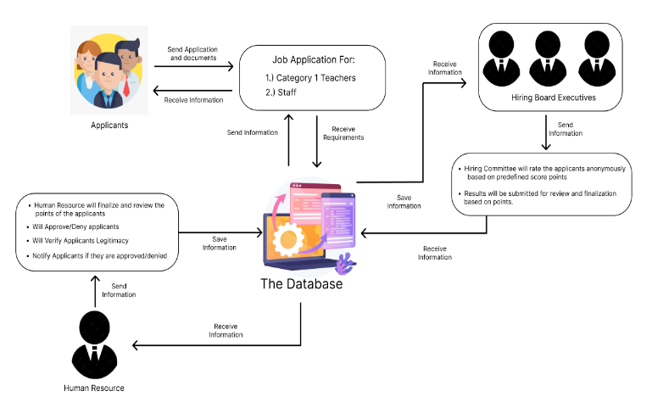**Conceptual framework**

***Figure 1: Conceptual Framework***

Figure 1 illustrates the workflow and interactions within the JOANA web based, designed to streamline the job applicant and hiring process for DepEd applicants. The framework is structured to ensure efficient data management, fair evaluation, and transparent communication between all parties involved.

**Input**

It starts with the registration Personal data (name, contact details, address, etc.) Educational background and work experience Uploaded documents (resume, credentials, certifications) Job title, job description, and prerequisites

Location, availability, posting date, and due date Education, experience, and certification Level Test and interview results

Additional qualifications (training, seminars attended) Preferred location of candidate Open positions by region Application date and time Priority handling according to deadlines and submission order.

**Process**

The DepEd admin produces, edits, and deletes job ads. After applicants register and verify their credentials, the admin checks in to keep an eye on candidates and job postings. The system saves and maintains access to employment information. Employees select positions and submit applications. The system verifies that the necessary documents are complete. Applications are arranged according to priority and submission time. Applications' processing delays are prevented by the system. Candidates are screened by the system based on predetermined parameters.

The applicants are ranked after receiving scores. The system suggests employment based on the applicant's selected location. Candidates can filter job openings based on proximity. The application status (pending, shortlisted, recruited, etc.) is tracked by the system. Candidates receive updates on the status of their applications. Candidates are identified and ranked by DepEd administrators. The system records final employment choices. The system offers application reports. hiring choices, rankings, and trends. Admins use system-generated reports to track the effectiveness of hiring.

**Output**

The account registration confirmation for the job application, List of applications and job suggestions ranked by location

Real-time information on the status of applications and invitations to interviews

automated through application rating and queuing for available positions

A filtered and ranked list of eligible applicants

Efficient monitoring of job advertisements and the status of applicants

Reports produced by data-driven decision-making systems

Openness and a more efficient hiring procedure

Processing of employment applications more quickly

Optimized candidate screening based on localization and ranking algorithms

**Data Flow Diagram**

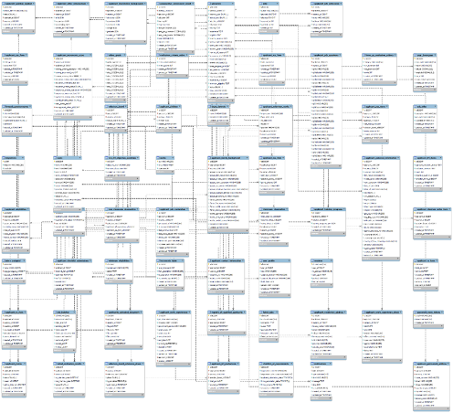

***Figure 2: Data Flow Diagram***

The figure 2 illustrates Data Flow Diagram for the web-based information system. The system that flows functions via queueing, ranking, and localization algorithms seamstress for DepEd applicants in Digos City will be made possible by JOANA (Job Opening and Applicant Network Automation). A system with structured data flow makes sure that all of the data moves through it without any problems. manages hiring choices, job postings, and candidate rankings. They also register, file, and track applications. Keep track of application data, job postings, rankings, and location-based information. Web based system set up accounts and input both personal and professional data. A government agency posts employment and registers candidates. DepEd administrators post job openings with particular qualifications. Candidates apply for open positions. After validation, the application is kept in the database. Applications are arranged by submission time using the queueing technique. Candidates are evaluated by the ranking algorithm based on predetermined metrics, including education and experience. For each post that is filled, the system generates a sorted list of applicants. Applicants are ranked by DepEd admin. Shortlisted candidates get notice of their interviews. The system is updated with the final hiring decisions. Applicants receive updates on the progress of their applications. The system notifies chosen candidates for further review or employment. Reports on hiring patterns, rankings, and job applications are generated by the system. Administrators examine data to improve the effectiveness of hiring.

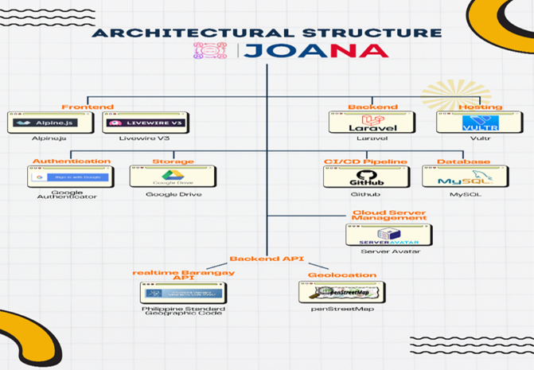**Architecture Design**

***Figure 3: System Architecture***

The diagram illustrates a Job Opening and Applicant Network Automation(JOANA) architecture. It shows how the job applicant information, inventory details and transactions data are collected and processed. The admin process acts as a super admin, processing and receiving data from various sources, including Patients registration, inventory management and transactions. Then, the processed data is stored in a central database. The system generates reports for analysis and sends notifications to patients. This integrated system supports efficient clinic management and clear communication.

**Development**

**Software Methodology**

In this chapter, the researchers discuss the approaches employed in the Web-based developing System.

**Agile Methodology**

The project's objective is to consistently deliver a high-quality result that precisely meets the end-user's requirements. It is a project management methodology that involves breaking down a project into several phases. By using this method, researchers can be flexible and alter their path to suit the needs of the user or job employ.

**Developmental Approach**

This development methodology is focused on making sure that all the typical phases of development process are employed in developing the system. These include planning and requirement gathering, solution analysis, system design, coding and unit testing or framework, integration and testing, or implementation, and operation and maintenance in a continuous way. The methodology is founded on iterative development and constant collaboration among developers and users with frequent feedback cycles. Adaptability and responsiveness should be the goals so that the system developed is responsive enough to satisfy its users at every stage of its development.

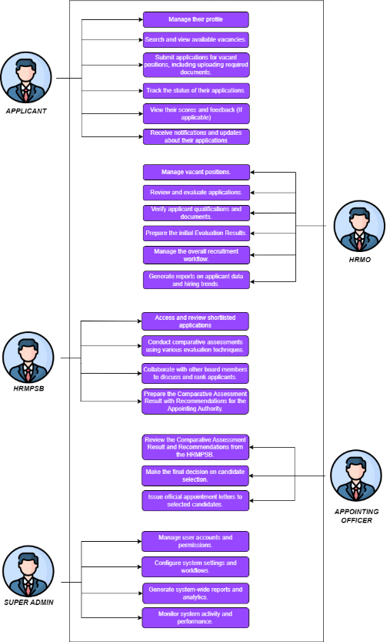

***Figure 4: Use Case Diagram***

Figure 4 shows the main features and interactions between the Department of Education- Digos City and the JOANA Web-based System illustrated in this use case diagram, which also gives an overview of the system's coverage.

*User Entity:* Create Account, Login/Logout, Edit Profile/Information, Upload Required Documents, View Feedback/Status, HRMO,HRMPSB, Appointing Officer, Applicant

**Planning**

The planning stage was the core of our system development cycle, and it started with collecting significant details from the stakeholders, particularly the Information Technology Officer, Sir Stephen R. Pascual, MIT. This stage entailed several meetings to learn about the existing problems and needs of the Job Hirings in DepEd. We seek advice/information from with who was extensively on recognizing the certain areas where the system might enhance the daily operations of the DepEd Office. In this stage, we defined the system's fundamental idea, which were to manage by although the following transactions, monitor their ranking, and maintain data privacy. We also established precise expectations of the functionalities and features that the system must have, such as report generation, rank monitoring, and alerting users of critical updates. We also thought about the user roles and the access types they would require. The planning stage was essential in setting the scope of the project and setting priorities on features depending on the urgent needs of the applicant. This enabled us to create a planning, defining the direction of the development process and also providing us with a structured process to deal with any changes or enhancements that would be made in the next Generation.

**Design**

The design process was aimed at converting the requirements obtained in the planning process into a technical solution. In this phase, we developed detailed system blueprints and user interface designs that illustrated how the system would work and how users would use it. The design phase enabled us to plan the overall system architecture in such a way that every module, including transaction management, stock tracking, and notifications, would interact with each other perfectly. We also focused on user experience (UX) design, making sure that the system would be easy and intuitive for the School Nurse and STAs to utilize. In this stage, we also chose the right technologies, like PHP for the back-end and Bootstrap for the front-end, so that the system would be efficient, scalable, and secure. The objective of the design phase was to develop a strong system structure that would fulfill all functional and non-functional requirements developed in the planning phase.

**Coding**

The next very important step in the system development is coding. The suggested system was created using the right web development tools By using queueing, ranking, and localization algorithms, the JOANA (Job Opening and Applicant Network Automation) system is an online platform designed to increase the number of job applications for DepEd applicants in Digos City. For efficiency and dependability, the project makes use of a modern, scalable, and secure technological stack. Tailwind CSS and React.js were used in its construction to create a responsive and intuitive user experience. Built with Node.js with Express.js, managing business logic, authentication, and API interactions. MySQL serves as a backup for dynamic data, whereas Server Avatar is used to store structured data.

**Project Technology**

Department of Education implementation of its Queueing, Ranking, and Localization Algorithm requires comprehensive data collection to develop an efficient and automated job application system. This process involves gathering user requirements, system functionalities, and essential applicant data to ensure the system meets the needs of both job seekers and hiring authorities in the Department of Education (DepEd).:

**Programming Language**

**PHP (Laravel Framework) & Node.js (Express.js)**

used to handle database interfaces, authentication, and business logic. Laravel is chosen because to its MVC architecture, security, and scalability simplicity. focuses on real-time data processing and API interfaces. used to efficiently handle asynchronous tasks.

**Software Tools in Development**

The following resources are utilized in the development of the suggested system to produce a productive and user-friendly web-based system:

**Laravel & Livewire**: In terms of Enterprise-Level Information System, Laravel & Livewire together provides a modern and efficient for handling multiple roles and permissions, quality approach of building full-stack web system and maintainability feature which makes this the best fit for this project.

**PhpStorm:** The researcher has a little time to develop, the best fit for Laravel IDE would be Phpstorm. Due to its faster development process with code assistance, debugging tools, and Laravel Specific features, Phpstorm is most recommended by Enterprise-Level developers to ensure the productivity boost and code quality of this project.

**Bootstrap:** By integrating a simple and clean interface at the same time as a faster development process, the researchers conclude to use Bootstrap as its front-end framework as it is visually appealing, responsive throughout all devices, and consistent in design.

**Bootstrap, Javascript, & CSS**

For the admin modules' websites, the development team utilizes Bootstrap, a framework that simplifies the creation of web applications with a consistent and user-friendly design. Bootstrap is especially effective for implementing innovative designs for administrative functionalities. The decision to use this framework was made because it seamlessly integrates HTML and CSS, improving the efficiency and streamlining the website design process.

**Testing**

Applicants were appropriately evaluated by the ranking algorithm based on predefined assessment factors. By efficiently sorting applications, the queue system reduced processing times and disputes. User satisfaction increased as a result of the system's significant reduction in processing times for job applications. By efficiently assigning candidates to nearby positions, the localization feature improved access. JOANA operated without any malfunctions or significant system outages. Stress testing demonstrated that the system was capable of handling multiple simultaneous users without a reduction in performance. Security tests against standard vulnerabilities like SQL injection and access to unauthorized data were successfully performed by the system. Because appropriate authentication and encryption procedures were in place, user information was protected. Over 90% of test users said the system was user-friendly and efficient for applying for jobs. Comments emphasized the system's

**Unit Testing**

Unit testing has been carried out on each part of the system to ensure that every feature functions as intended. This testing process involves evaluating individual components and functionalities to confirm that the system operates correctly and without flaws once developed. Early detection of any issues helps prevent disruptions and ensures a smooth, reliable experience for users.

**User Acceptance Testing**

The researcher completed this last testing, allowing the end user to conduct tests and operate the system in accordance with the agreed-upon criteria. Following Test, the navigation and usage of the system. Verify that the localizing, ranking, and queuing features live up to user expectations. Find out if there are any usability issues and ask for suggestions for changes. Participants completed activities such as searching for a job, submitting an application, and seeing their rank. Their suggestions were noted and used to improve the system.

**Alpha Testing**

Acceptance testing is performed before the release of a product to identify any potential errors or bugs. This process involves the system underwent alpha testing before entering the beta testing stage to evaluate its general performance, security, usability, and usefulness. To ensure that the system can fulfill both functional and non-functional objectives, the research In the Appendix A conducted testing using pre-defined test cases.

**Beta Testing**

During the testing phase, the system will be used by actual users or individuals selected for this purpose to evaluate the application's overall functionality. This survey follows the international software evaluation standard, ISO 25010, also known as the software quality model. End An automated, efficient, and equitable hiring procedure was guaranteed by the perfect operation of the ranking, localization, and queueing algorithms. the system is user-friendly and efficient. The system performed admirably under typical conditions; considerable slowness was seen. Applicant data confidentiality was maintained since no instances of data breaches or vulnerabilities were found. The results of the beta testing are documented in Appendix B.

**III. RESULTS AND DISCUSSION**

In this chapter, the findings from the research including the surveys, interviews, and testing are further addressed. The researchers discussed their study findings while the system was being created.

**Implementation Plan**

The following actions were taken throughout the system's implementation for the JOANA :

|  |  |  |  |
| --- | --- | --- | --- |
| **Strategy** | **Activities** | **Person’s Involved** | **Duration** |
| Information Distribution | Application Presentation | Proponent End-Users | 20 mins |
| Installation | Application Installation | End-Users | 20 mins |
| Training | Hands-on  Demonstration | End-Users | 20 mins |

***Table 4. Implementation Plan***

**Implementation Results**

The system was created to manage transactions, inventories, and notifications that are relevant to the Department of Education. It allows By utilizing queueing, ranking, and localization algorithms, JOANA (Job Opening and Applicant Network Automation) was implemented with the goal of automating the job application process for DepEd candidates in Digos City. This section presents the system's deployment results, evaluating its usability, performance, and efficacy.

**To develop a module that records and saves individual transactions directly into a digital index card system within the database.** This system has been implemented in such a way that it has proved the objectives were met. The project has successfully managed the development of the necessary system that will enable to record the transactions made by individual and saves it in their respective index card together with their personal information.



***Figure 5: Landing Page***

The JOANA landing page effectively presents the platform, guiding users through its features in an eye-catching and polished visual style. It successfully communicates the platform's function in automating DepEd Digos City employment applications through the use of compelling calls to action, clear navigation, and essential information.

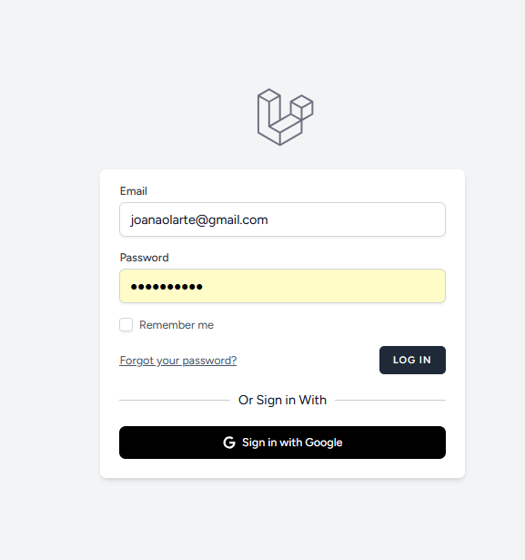

***Figure 6: Login Page***

Login Page is to provide a secure and user-friendly authentication procedure for both candidates and hiring managers. Below is a methodical explanation of the login page's features, capabilities, and importance. To make it simple for users to access their accounts, the login page features a basic user interface. The adaptable design makes it accessible on a variety of devices, and the contrast between the form fields, buttons, and backdrop enhances reading. An essential component of the JOANA system, the login page offers a safe, effective, and intuitive authentication procedure. The system is easy to use while maintaining robust security features by offering regular email-password login, a "Remember Me" function, password recovery, and Google authentication.

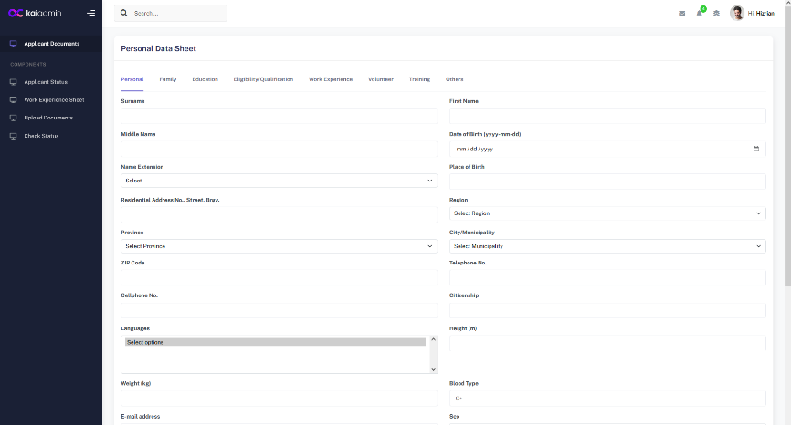

***Figure 7: Personal Data Page***

The JOANA (Job Opening and application Network Automation) Personal Data Sheet (PDS) Page is a crucial component that attempts to collect and handle crucial application data in an organized way. It is a data warehouse that helps DepEd Digos City efficiently automate the employment process. A key component of DepEd Digos City's endeavor to computerize the employment application process is the Personal Data Sheet Page in JOANA. This page's user-friendly and well-structured design improves data collecting speed, ensures secure record keeping, and provides applicants with a hassle-free platform to arrange their information.

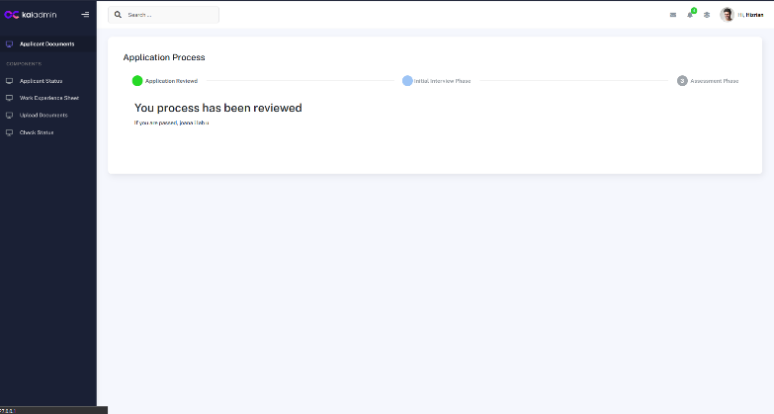

***Figure 7: Application Form***

The purpose of JOANA's (Job Opening and Applicant Network Automation) Application Process Page is to efficiently track and manage job applications in DepEd Digos City. This feature allows applicants the opportunity to track the status of their applications in real time and provides a structured procedure for processing them from receipt to review. One deciding element that streamlines DepEd Digos City employment applications is the Application Process Page in JOANA. The function enhances the application experience, reduces administrative strain, and offers a easily , transparent hiring process by providing an easy-to-use, automated, and transparent tracking system.

**IV. CONCLUSION AND RECOMMENDATION**

**Conclusion**

Based on the research outcomes, the researchers concluded that the web-based system functions and has achieved the stated objectives. The research also yielded additional results:

The system enables the admins tracked the personal information, and medical history made by students and employees.

The system allows the admin to manage transactions and track medical supplies, ensuring accurate and up-to-date records.

**Recommendation**

The researchers have compiled a list of suggestions that future researchers might enhance or add to the system. These suggestions will act as a guide for the researchers as they conduct their research.

1. To increase the number of applicants benefiting from these automated procedures, JOANA must be rolled out to other DepEd divisions in addition to Digos City..

1. Both appointing officer and HR staff need to be trained to fully leverage the system and ensure a smooth transition to help increase productivity.
2. To verify qualifications and expertise in real time, JOANA needs to be linked with other government databases, prioritizing the accuracy of application data. The system must be dynamically updated based on new DepEd recruiting practices and technological breakthroughs.

**V. REFERENCES**

1. M. Omar, et al, “Two-envelop system for consultant selection using weighted sum model”, International Journal of Engineering & Amp; Technology, vol. 7, no. 4.27, p. 121,2018
2. Teach Pinas. (2024). DepED Hiring Guidelines 2024: Teacher 1 Ranking Process. Retrieved from
3. Fuente, Jasper Klint de la. “Total Number of DepEd Teachers by Position Title and Level of Education” TeacherPH, 9 Aug. 2022, Accessed 02 Aug. 2024
4. Y.A Apilada, et al., “Cluster Analysis of the teacher – Applicants to be Enlisted in the Registry of Qualified Applicants for Public School Teachers: Basis for Policy Formu-lation”, *IJAMBER*, vol. 4, no2, pp. 421-428, Feb. 2023: <https://www.teacherph.com/deped-2023-guidelines-recruitment-selection-appointment-personnel/>
5. S. Niu., et al., “Employing checkpoint to improve job scheduling in large-scale system, Job Scheduling Strategies for parallel Processing,p.36-55,2013”

<https://doi.org/10.1007/978-3-642-35867-8_3>

1. S.Niu., et al “Enhancing recruitment efficiency: an advanced applicant tracking system (ats)”, Industrial Management Advances, vol. 2, no. 1, p. 6373,2024.

<https://doi.org/10.59429/ima.v2i1.6373>

1. M. Sahagun, “Machine learning based selection of incoming engineering freshmen in higher education institution”, International Journal of Computing and Digital System, vol. 11, no, p. 325-334,2022

<https://doi.org/10.12785/ijcds/110127>

1. S. Niu, J. Zhai, X. Ma, M. Liu, Y. Zhai, W. Chenet al., "Employing checkpoint to improve job scheduling in large-scale systems", Job Scheduling Strategies for Parallel Processing, p. 36-55, 2013. <https://doi.org/10.1007/978-3-642-35867-8_3>
2. P. Chavan, Y. Chandurkar, A. Tidake, G. Lavankar, S. Gaikwad, & R. Chavan, "Enhancing recruitment efficiency: an advanced applicant tracking system (ats)", Industrial Management Advances, vol. 2, no. 1, p. 6373, 2024.
3. M. Sahagun, "Machine learning based selection of incoming engineering freshmen in higher education institution", International Journal of Computing and Digital Systems, vol. 11, no. 1, p. 325-334, 2022. <https://doi.org/10.12785/ijcds/110127>
4. M. Omar, B. Trigunarsyah, & J. Wong, "Two-envelope system for consultant selection using weighted sum model", International Journal of Engineering &Amp; Technology, vol. 7, no. 4.27, p. 121, 2018.
5. Joseph Allen A. Cuevas, "Enhancing the barangay information system by integrating geolocation technology and tagalog chatbot using nlp algorithm for efficient community engagement and service", Journal of Electrical Systems, vol. 20, no. 5s, p. 1136-1149, 2024.
6. Cayanong, Aline A, Castillo, Ederlyn N, et. Al.

“Recruitment Selection and Process”

https://depedcaloocan.com/prime-hrm/rsp/

**APPENDICES**

**APPENDICES A**

Test Case

**APPENDICES B**

Sample Source Code

**APPENDICES C**

User Manual

**APPENDICES D**

Letter of Permission

**APPENDICES E**

Routing Form

**APPENDICES F**

Assignment of Research Personnel

**APPENDICES G**

Grammarly Report

**APPENDICES H**

Plagiarism Result