Table of Contents
1. Introduction
1.1 Background
1.2 Project Overview
1.3 Motivation
1.4 Key Features
2. Problem Statement
3. Aim and Objectives
3.1 Aim
3.2 Objectives
4. Scope of the Project
4.1 Scope of the Current Implementation
4.2 Future Production Scope
5. Existing Approach and Motivation
5.1 Existing Travel Analytics Approach
5.2 Need for an Integrated System
5.3 Engineering Motivation
6. Proposed System
6.1 System Overview
6.2 High-Level Workflow
6.3 Major Components
6.4 Functional Modules
7. System Architecture
7.1 Architectural Overview
7.2 Application Architecture
7.3 Data Flow
7.4 Repository Structure
8. Data and Dataset Processing
8.1 Dataset Description
8.2 Data Cleaning
8.3 Feature Engineering
8.4 Feature Encoding and Selection
8.5 Train-Test Split
9. Machine Learning Methodology
9.1 Flight Price Prediction
9.2 Hotel Recommendation
9.3 User Classification
9.4 Model Training
9.5 Model Evaluation
9.6 Model Serialization and Inference
10. Application and Inference Layer
10.1 Streamlit Application
10.2 Flight Price Prediction Module
10.3 Hotel Recommendation Module
10.4 User Classification Module
10.5 Inference Workflow
11. Deployment and Containerization
11.1 Deployment Architecture
11.2 Docker Configuration
11.3 Docker Image Creation
11.4 Container Execution
11.5 Health Check
11.6 Streamlit Deployment
12. Testing and Smoke Testing
12.1 Testing Strategy
12.2 Smoke Test Implementation
12.3 Flight Price Inference Test
12.4 Hotel Recommendation Test
12.5 User Classification Test
12.6 Test Execution and Results
12.7 Testing Limitations
13. Results and Discussion
13.1 Functional Results
13.2 Model Performance
13.3 Application Results
13.4 Deployment Results
13.5 Discussion
14. Security, Privacy, and Reliability Considerations
14.1 Data Privacy
14.2 Input Validation
14.3 Application Reliability
14.4 Deployment Security
14.5 Production Security Considerations
15. Advantages
16. Limitations
17. Future Enhancements
17.1 Model Improvements
17.2 MLOps and Monitoring
17.3 Testing and CI/CD
17.4 Security Enhancements
17.5 Scalability Improvements
18. Applications and Use Cases
18.1 Travel Planning
18.2 Hotel Discovery
18.3 Customer Analytics
18.4 Travel Industry Applications
18.5 Educational and Research Applications
19. Conclusion
20. References
Appendix A — Repository Structure

1. Introduction
The travel industry generates large volumes of structured and semi-structured information related to flights, hotels, users, routes, agencies, travel schedules, and booking behavior. Machine learning can transform these data sources into decision-support capabilities such as price estimation, recommendation, and customer analytics. However, practical machine-learning systems require more than a trained model: the models must be reproducible, serializable, callable through stable inference interfaces, integrated into an application, tested, and deployable.
Voyage Analytics addresses this productization problem by bringing three travel-oriented machine-learning tasks into a unified Streamlit application. According to the project repository, the platform serves a flight-price regression model, a KNN hotel recommendation model, and a Random Forest user-classification model through three application tabs. The repository also separates notebooks used for experimentation from inference modules used at runtime.
The project therefore represents an end-to-end ML application rather than a collection of disconnected notebooks. Its architecture covers model artifacts, runtime data, inference functions, application presentation, smoke testing, and Docker-based deployment. This makes the project relevant as a practical demonstration of applied machine learning and basic MLOps principles.

1.1 Project Overview
Component | Purpose | Model / Technique | Output
Flight Price Prediction | Estimate a flight's expected price | Regression | Predicted price
Hotel Recommendation | Recommend hotels similar to previous booking behavior | KNN similarity | Ranked hotel list
User Classification | Classify a user profile for analytics | Random Forest | Predicted class + probabilities
Streamlit Application | Provide a unified user interface | Python + Streamlit | Interactive predictions
Deployment | Package and run the application portably | Docker | Containerized service
Testing | Verify inference paths work | Pytest smoke tests | Pass/fail validation

2. Problem Statement
Travel decisions often require combining several types of information. A traveler may want to estimate the likely cost of a flight, identify suitable hotels based on prior preferences, and understand user segments from available customer data. In a conventional workflow, these tasks may be implemented as separate scripts or notebooks, making them difficult to use consistently and difficult to deploy.
The core problem addressed by Voyage Analytics is therefore the development of a unified, usable, and deployable analytics platform that converts trained machine-learning models into application-level functionality. The system should accept user inputs, perform the required preprocessing or lookup, invoke the corresponding trained model, and return an interpretable result through a single interface.
A secondary engineering problem is reproducibility. Model artifacts, runtime datasets, inference code, dependencies, and deployment configuration must be organized so that the application can be recreated and run in another environment. Voyage Analytics addresses this through a structured repository, serialized model artifacts, requirements management, Docker configuration, Git LFS for model files, and inference smoke tests.

3. Aim and Objectives

3.1 Aim
To design and implement an end-to-end travel intelligence platform that integrates multiple machine-learning models into a unified application capable of flight price prediction, hotel recommendation, and user classification, with reproducible inference, testing, containerization, and deployment.

3.2 Objectives
- Develop a regression-based flight price prediction capability.
- Develop a KNN-based hotel recommendation capability using booking-history information.
- Develop a Random Forest classification capability for user-profile analytics.
- Perform data cleaning, feature preparation, feature selection, and model training.
- Serialize trained models so they can be loaded independently during inference.
- Create dedicated inference modules that expose prediction functionality to the application.
- Integrate all three capabilities into a single Streamlit application.
- Implement smoke tests that confirm each model loads and produces a prediction.
- Containerize the application using Docker for portable deployment.
- Include a container health check to improve deployment readiness.
- Document the project structure, setup, local execution, testing, and deployment workflow.

4. Scope of the Project
The scope of Voyage Analytics includes the development and integration of three machine-learning functions and the engineering required to expose them through a web application. The current implementation covers model training artifacts, inference code, application integration, local execution, Docker packaging, deployment guidance, and inference smoke testing.

4.1 In Scope
- Travel-data preprocessing and exploratory analysis.
- Flight price regression.
- Hotel similarity recommendation.
- User-profile classification.
- Model serialization using joblib-compatible artifacts.
- Streamlit-based user interface.
- Docker containerization.
- Container health check.
- Pytest smoke testing.
- Git LFS management for model artifacts.

4.2 Out of Scope / Future Production Work
- Large-scale distributed model serving.
- Formal model registry and version governance.
- Continuous model retraining from live production data.
- Comprehensive load, stress, and security testing.
- Enterprise authentication and authorization.
- Real-time production monitoring and alerting.
- Automated model drift detection.
- External persistent object storage for large model artifacts.

5. Existing Approach and Motivation
The repository indicates that exploratory work is maintained separately in notebooks while runtime inference is implemented in dedicated Python modules. This separation is important because exploratory notebooks are useful for experimentation and visualization, whereas production or deployment environments benefit from deterministic inference functions with predictable inputs and outputs.
The motivation for the unified application is to convert multiple analytical capabilities into a single user-facing platform. Rather than requiring users to execute notebooks individually, the Streamlit application provides three model-specific tabs. This approach reduces the operational barrier between an ML model and an end user.

5.1 Engineering Motivation
- Centralize multiple travel analytics tasks in one interface.
- Separate model training from inference.
- Make model artifacts reusable after training.
- Provide a repeatable runtime environment through Docker.
- Validate inference paths before deployment through smoke tests.

6. Proposed System
The proposed system consists of a presentation layer, an inference layer, serialized model artifacts, runtime data, and deployment infrastructure. Users interact with the Streamlit interface. The selected application tab collects the relevant input and passes it to the corresponding inference module. The inference module loads the appropriate artifact and returns the prediction or recommendation.

6.1 High-Level Workflow
- User opens the Voyage Analytics Streamlit application.
- User selects one of the three analytics functions.
- The application collects the required input fields.
- The relevant inference module loads the serialized model and any required preprocessing/data artifacts.
- The model generates a prediction or ranked recommendation.
- The application formats the output for the user.
- The same inference functions can be exercised by the smoke-test suite independently of the UI.

6.2 Major Components
Layer | Repository Component | Responsibility
Presentation | app/streamlit_app.py | Unified interactive interface with three model tabs
Inference | app/inference/ | Runtime prediction/recommendation functions
Models | app/models/ | Serialized trained model artifacts
Runtime Data | app/data/ | Hotel lookup/booking-history data
Training | training/ | Standalone training and cleaning utilities
Experimentation | notebooks/ | EDA and model development notebooks
Testing | tests/test_inference.py | Smoke testing for all three inference paths
Deployment | Dockerfile | Container build and runtime configuration

7. System Architecture
Voyage Analytics follows a modular ML application architecture. The Streamlit application is the entry point and delegates prediction logic to dedicated inference modules. The model artifacts are stored separately from the inference code. The Dockerfile packages the application code, models, and runtime data into a single container image.

7.1 Logical Architecture
- User Interface Layer: Streamlit application and input widgets.
- Inference Layer: flight_price.py, hotel_recommendation.py, and classification.py.
- Model Layer: flight price model, preprocessor, recommendation model, and classification model.
- Data Layer: user data and cleaned hotel data used for training or runtime lookup.
- Testing Layer: pytest-based inference smoke tests.
- Deployment Layer: Docker image and container runtime.

7.2 Repository Organization
The repository contains dedicated directories for application code, data, notebooks, tests, and training. The main application entry point is app/streamlit_app.py. Model artifacts are stored under app/models, runtime hotel data is under app/data, and the inference modules reside under app/inference. The repository also includes Docker and dependency configuration files.
The project uses Git LFS to track serialized .pkl model artifacts. This is relevant because binary model files can become inconvenient to manage using ordinary Git object storage.

8. Data and Dataset Processing
The project uses separate data assets for its analytical components. The repository identifies data/users.csv as raw training data for the classification model and app/data/hotels_clean.csv as runtime lookup data for the hotel recommendation component. The flight and hotel model artifacts are exported from their respective notebooks.

8.1 Classification Data Preparation
The classification pipeline demonstrates a structured preprocessing workflow. String columns are stripped of whitespace, duplicate rows are removed, duplicate identifiers are consolidated, text casing is standardized, and numeric fields are converted to appropriate types. Invalid age values outside the accepted range are filtered, while records without valid gender or age are removed.
A first-name-derived feature is generated using a gender-detection library before the original identifier/name fields are removed. Categorical variables are transformed using one-hot encoding. VarianceThreshold is then applied to remove near-zero-variance features, followed by mutual-information feature scoring and SelectKBest to retain the most informative features.

8.2 Train/Test Split
The classification pipeline uses an 80/20 train-test split with random_state=42 and stratification by the target class. This preserves class proportions between the training and testing subsets and makes the experiment reproducible.

8.3 Data Quality Considerations
- Remove exact duplicate records.
- Remove duplicate identifiers while retaining the first occurrence.
- Normalize text fields.
- Coerce age values to numeric form.
- Filter implausible age values.
- Remove missing/unspecified target values.
- Encode categorical variables for machine-learning algorithms.
- Remove low-information features before final model training.

9. Machine Learning Methodology

9.1 Flight Price Prediction
The flight-price component is implemented as a regression problem. The repository describes inputs including route, flight type, agency, date/time information, and distance, with the output being an estimated price. The trained model and a corresponding preprocessor are serialized and loaded by the flight-price inference module.
A regression formulation can be expressed as: ŷ = f(X), where X represents the encoded travel attributes and ŷ represents the estimated flight price. The final model is used at inference time rather than retraining when a user submits a prediction request.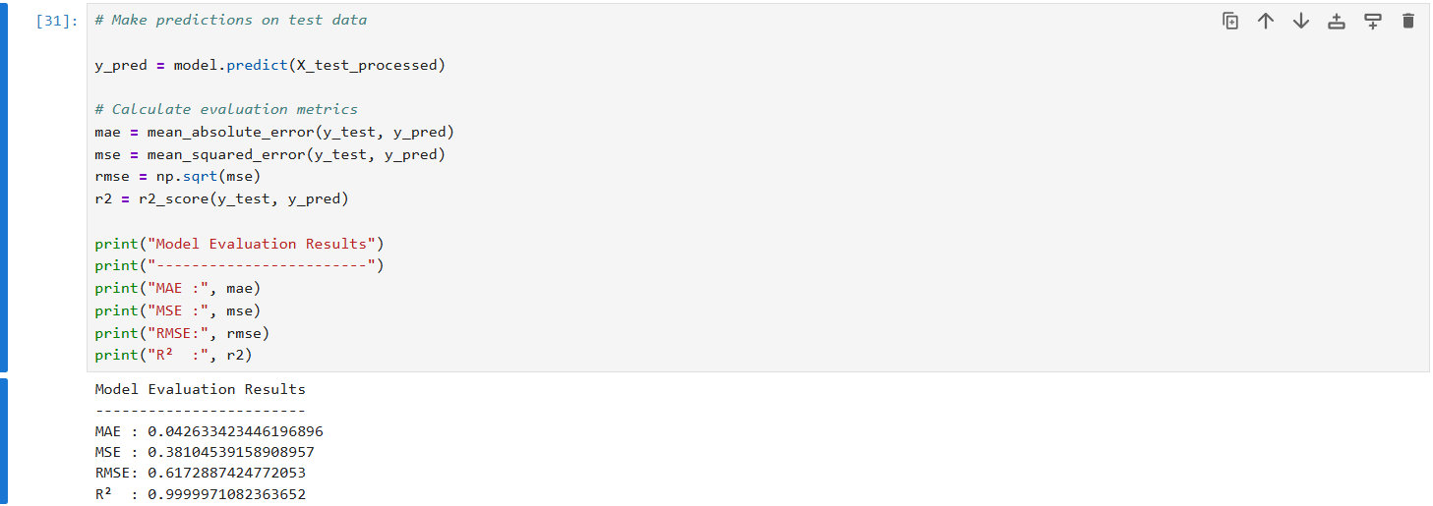

9.2 Hotel Recommendation
The hotel component is described as a K-nearest-neighbors similarity recommender. Instead of predicting a continuous target, the system identifies hotels that are similar to a user's booking history and returns a ranked list of recommendations.
Conceptually, KNN recommendation computes a similarity or distance between a query representation and candidate hotel representations. The nearest K candidates are selected and presented as recommendations. The runtime component uses the serialized recommendation model together with hotels_clean.csv.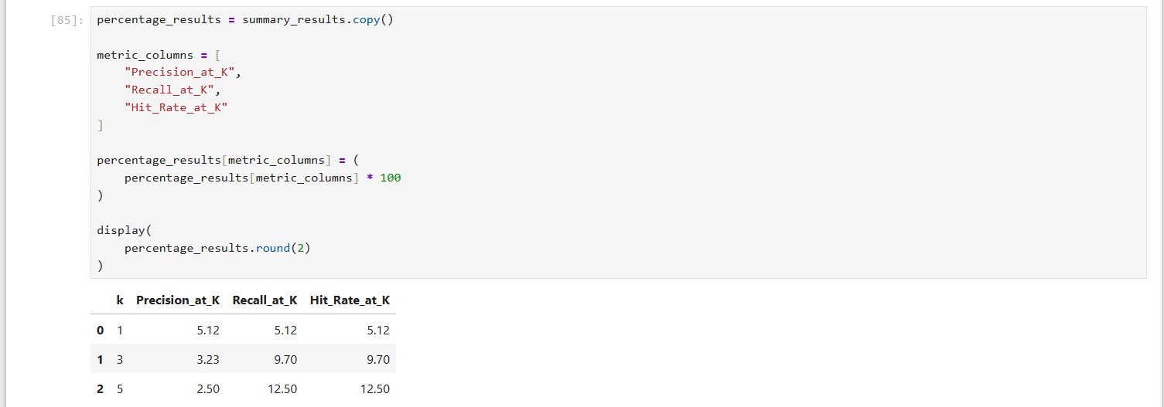

9.3 User Classification
The classification pipeline trains a Random Forest classifier with 200 trees and random_state=42. Feature selection is performed before the final train/test split, and the final classifier is evaluated using accuracy, a classification report, and a confusion matrix.
Random Forest is an ensemble method that combines multiple decision trees. For classification, each tree votes for a class and the aggregate result is used as the prediction. The approach is suitable for mixed and encoded tabular features and can provide feature-importance information.

9.4 Model Summary
Task | Problem Type | Technique | Primary Input | Primary Output
Flight price | Regression | Regression model | Travel/flight attributes | Estimated price
Hotel recommendation | Recommendation | KNN similarity | Booking history | Ranked similar hotels
User classification | Classification | Random Forest | Engineered user features | Class + probabilities

10. Application and Inference Layer
The project separates runtime inference from experimentation. Each of the three inference modules is responsible for loading the appropriate artifacts and exposing a prediction function. The Streamlit application calls these functions and presents their outputs to the user.

10.1 Streamlit Application
The main application entry point is app/streamlit_app.py. The README describes the interface as three tabs, one for each model. This structure provides a simple navigation mechanism while keeping the underlying inference components independent.

10.2 Inference Design
- Load model artifacts using serialized files.
- Apply the required preprocessing or feature transformation.
- Call the model's prediction/recommendation operation.
- Return a result in an application-friendly format.
- Keep runtime inference independent from notebook execution.

10.3 Reproducibility
The application can be reconstructed by installing requirements, generating the classification model when required, regenerating notebook-derived artifacts when needed, and launching Streamlit. The repository documents these steps and identifies the model/data artifacts required by the runtime.

11. Deployment and Containerization
Deployment is an explicit part of the Voyage Analytics implementation. The project includes a Dockerfile based on Python 3.11 slim. Dependencies are installed from requirements.txt, and the app directory containing the application code, model artifacts, and runtime data is copied into the container.

11.1 Docker Build
The documented Docker workflow builds an image using the repository root as the build context and tags it as voyage-analytics. The resulting image contains the trained .pkl files and hotels_clean.csv, allowing the application to run without external data dependencies for those artifacts.

11.2 Runtime Configuration
The container exposes port 8501 and starts Streamlit on 0.0.0.0 so that the service can receive external traffic when hosted in a container environment. The Dockerfile also sets PYTHONDONTWRITEBYTECODE and PYTHONUNBUFFERED to improve container behavior and logging.

11.3 Container Health Check
A Docker HEALTHCHECK invokes the Streamlit health endpoint at /_stcore/health using curl. This allows container-aware hosting platforms or orchestrators to determine whether the application is ready to serve requests.

11.4 Deployment Architecture
The repository describes the application as suitable for container-based hosts such as Hugging Face Spaces, Render, and Fly.io, and it also provides a Streamlit deployment URL. This demonstrates that the application is not limited to local execution.

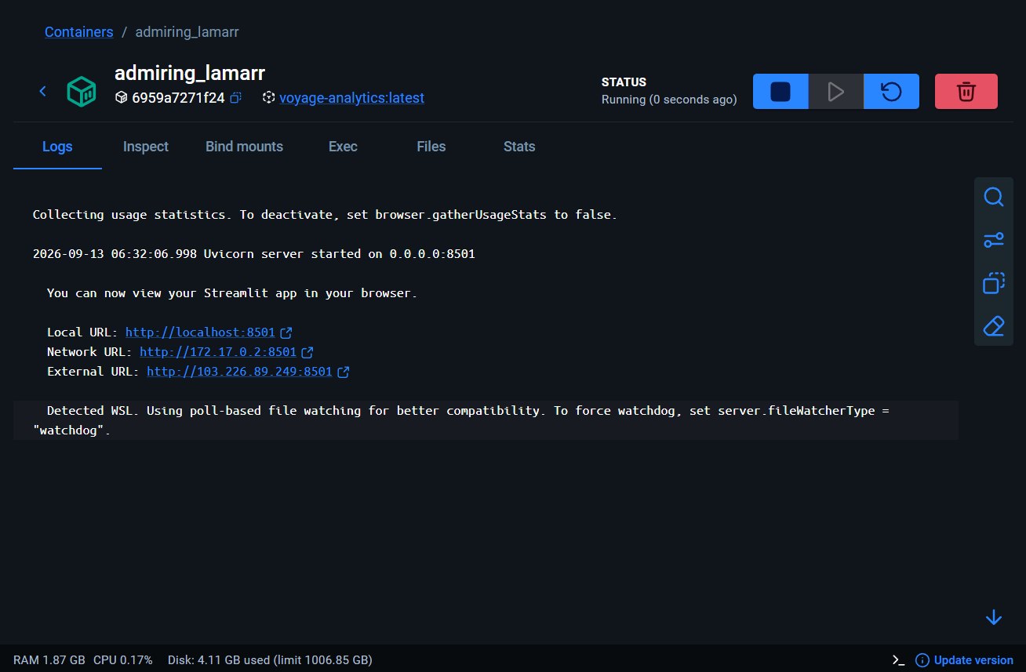 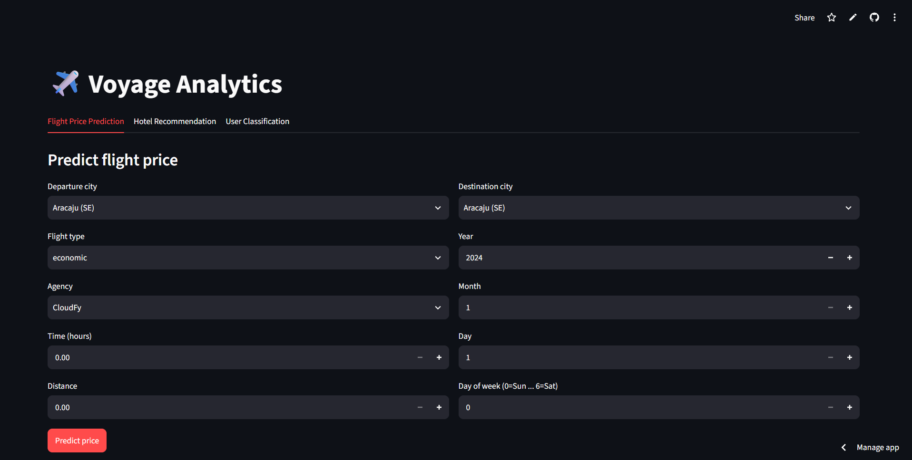11.5 Deployment Commands
git lfs install
git clone https://github.com/SuperSam9276/Voyage-Analytics.git
cd Voyage-Analytics
pip install -r requirements.txt
cd training
python train_classification.py
cd ..
cd app
streamlit run streamlit_app.py
# Docker
docker build -t voyage-analytics .
docker run -p 8501:8501 voyage-analytics

12. Testing and Smoke Testing
Testing is explicitly included in the repository through tests/test_inference.py. The purpose of this test suite is smoke testing: it verifies that the three model inference paths can load their required artifacts and produce predictions without crashing.

12.1 Smoke Test Scope
Test Area | Verification
Flight price inference | Model artifact loads and a prediction can be generated
Hotel recommendation | Recommendation model/data loads and recommendations can be generated
User classification | Classification artifact loads and a prediction can be generated
Runtime artifacts | Required model/data files exist before tests execute

12.2 Test Execution
pip install pytest
pytest tests/test_inference.py -v

12.3 Why Smoke Testing Matters
Smoke testing provides a fast deployment gate. A model may have been trained successfully but still fail at runtime because of missing artifacts, incorrect paths, incompatible serialization, or errors in inference code. By exercising the complete model-loading and prediction path, the smoke test provides a basic confidence check before deployment.

12.4 Testing Limitations
The current smoke tests should not be interpreted as comprehensive software testing. They do not replace unit tests for individual functions, integration tests for every UI path, load/stress testing, security testing, data validation testing, or formal model-performance evaluation. Those can be added as future improvements.

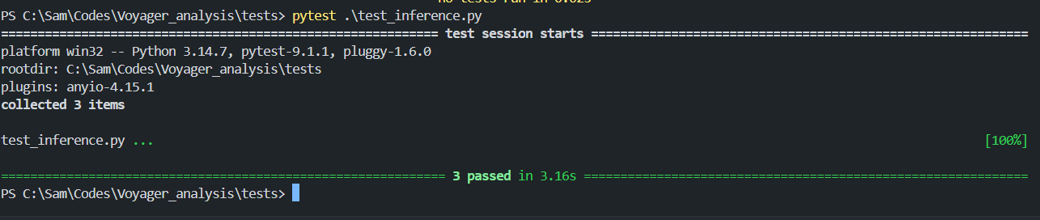13. Results and Discussion
The project successfully integrates three different machine-learning tasks into one application architecture: regression, recommendation, and classification. This is significant from an engineering perspective because the project demonstrates how heterogeneous models can share a common inference and presentation layer.

13.1 Functional Results
Functionality | Expected Result | Implementation Status
Flight price prediction | Estimated flight price for supplied travel inputs | Implemented
Hotel recommendation | Ranked list of similar hotels | Implemented
User classification | Predicted class and class probabilities | Implemented
Unified Streamlit UI | Three model-specific application tabs | Implemented
Docker deployment | Portable containerized application | Implemented
Smoke testing | Inference paths load and predict without crashing | Implemented
Health check | Container readiness endpoint check | Implemented

13.2 Quantitative Model Results
The repository's classification training pipeline prints accuracy, a classification report, and a confusion matrix. However, the repository overview does not expose fixed numerical values for these metrics in its README. Therefore, this report intentionally does not invent accuracy, precision, recall, F1-score, RMSE, MAE, or recommendation-quality values.
For a final academic submission, the exact metrics should be copied from the training notebook/script outputs. This keeps the report faithful to the experiment actually run. The same principle should be applied to the flight regression and hotel recommendation sections: report the actual evaluation metrics produced by the corresponding notebooks rather than estimated values.

13.3 Qualitative Discussion
- The project demonstrates end-to-end integration rather than model development alone.
- The inference layer improves separation between experimentation and application runtime.
- Docker packaging improves portability across compatible hosting environments.
- Smoke tests provide a lightweight runtime validation mechanism.
- The repository structure makes retraining and artifact regeneration explicit.

14. Security, Privacy, and Reliability Considerations
Although Voyage Analytics is primarily an analytics application, deployment introduces operational and data-management considerations. The repository itself notes that users should verify that the included datasets do not contain real personal booking or user data before treating the repository as fully public.

14.1 Data Privacy
- Avoid publishing personally identifiable or sensitive user/booking data.
- Anonymize datasets used in public repositories.
- Restrict access to private datasets where required.
- Document the provenance and permitted use of datasets.

14.2 Reliability
- Use smoke tests as a pre-deployment check.
- Use the Docker health check for basic service readiness.
- Pin or manage dependency versions for reproducibility.
- Track model artifacts carefully using Git LFS or external artifact storage as model size grows.

14.3 Production Security Improvements
- Add authentication and authorization if the application becomes multi-user.
- Validate and sanitize all user inputs.
- Use HTTPS in production.
- Avoid embedding secrets inside images or source code.
- Add structured logging and monitoring.

15. Advantages
- Combines multiple travel analytics functions in a single application.
- Demonstrates different machine-learning paradigms in one system.
- Separates model training and inference.
- Provides a simple interactive Streamlit interface.
- Supports Docker-based deployment.
- Includes a container health check.
- Includes inference smoke testing.
- Uses Git LFS for large serialized model artifacts.
- Provides documented local and container execution workflows.
- Creates a practical foundation for further MLOps development.

16. Limitations
- The current test suite is focused on smoke testing rather than comprehensive automated testing.
- Model-performance metrics are not centrally documented in the repository overview.
- The current deployment packages model/data artifacts directly into the Docker image, which may become less suitable as artifact sizes grow.
- There is no demonstrated enterprise authentication layer.
- There is no complete model registry, model versioning workflow, or automated drift detection.
- The recommendation system is based on similarity rather than a full personalized ranking/learning-to-rank pipeline.
- Classification quality depends strongly on the available dataset and the validity of engineered features.

17. Future Enhancements
- Introduce a formal model registry and model versioning strategy.
- Add CI/CD automation to run smoke tests and build Docker images on every relevant change.
- Add unit tests for preprocessing and inference functions.
- Add integration tests for Streamlit workflows.
- Add load and stress testing for deployment environments.
- Move large model artifacts to managed object storage such as S3/GCS when image baking becomes impractical.
- Add experiment tracking and metric logging.
- Implement model monitoring and drift detection.
- Add data validation at inference time.
- Improve hotel recommendation with richer user preference signals and ranking metrics.
- Add explainability features for flight price and classification predictions.
- Add authentication, authorization, audit logging, and rate limiting for public production use.
- Add observability through structured logs, metrics, and alerts.

18. Applications and Use Cases

18.1 Travel Planning
Travelers can use the flight-price component as a decision-support tool when comparing travel options and estimating expected costs.

18.2 Hotel Discovery
The hotel recommendation component can help users discover properties similar to those represented in their historical booking behavior.

18.3 Travel Customer Analytics
The classification component can be used as a demonstration of customer segmentation or profile analytics based on available attributes.

18.4 Educational and Prototyping Use
The platform is also valuable as an educational ML engineering project because it demonstrates the progression from exploratory notebooks to serialized models, inference code, application integration, testing, and deployment.

19. Conclusion
Voyage Analytics demonstrates how multiple machine-learning capabilities can be transformed into a unified travel analytics application. The system combines flight price prediction, hotel recommendation, and user classification within a single Streamlit interface. More importantly, the project includes engineering components that bridge the gap between experimentation and deployment: structured repository organization, reusable inference modules, serialized model artifacts, Git LFS tracking, smoke tests, Docker packaging, and a container health check.
The deployment and testing components are integral to the project rather than optional documentation. Docker provides a portable runtime environment, while smoke tests verify that the deployed inference paths can load their artifacts and generate outputs. This makes the project a useful demonstration of an end-to-end machine-learning product lifecycle.
For a production-grade system, the next stage would be to strengthen automated testing, model governance, monitoring, security, data validation, and artifact management. Nevertheless, the current implementation establishes a solid foundation for an integrated travel intelligence platform and demonstrates practical skills across machine learning, Python application development, testing, and deployment.

20. References
- SuperSam9276. Voyage Analytics. GitHub repository. https://github.com/SuperSam9276/Voyage-Analytics
- Voyage Analytics README.md — project overview, architecture, setup, testing, models, and deployment documentation.
- Voyage Analytics Dockerfile — container configuration, dependency installation, health check, and Streamlit runtime.
- Voyage Analytics Classification_pipeline.py — data preprocessing, feature selection, Random Forest training, and evaluation workflow.
- Scikit-learn documentation — Random Forest, train/test split, feature selection, and classification evaluation concepts.
- Streamlit documentation — application framework and runtime concepts.
- Docker documentation — container image and health-check concepts.
- Pytest documentation — Python testing framework and test execution.

Appendix A — Repository Structure
Voyage-Analytics/
├── .github/workflows/
├── app/
│ ├── streamlit_app.py
│ ├── models/
│ │ ├── flight_price_model.pkl
│ │ ├── flight_price_preprocessor.pkl
│ │ ├── recommendation_model.pkl
│ │ └── classification_model.pkl
│ ├── data/
│ │ └── hotels_clean.csv
│ └── inference/
│ ├── flight_price.py
│ ├── hotel_recommendation.py
│ └── classification.py
├── data/
│ └── users.csv
├── notebooks/
│ ├── flight_regression.ipynb
│ └── hotel_recommendation.ipynb
├── training/
│ ├── data_cleaning.py
│ ├── eda.py
│ └── train_classification.py
├── tests/
│ └── test_inference.py
├── Dockerfile
├── .dockerignore
├── requirements.txt
└── README.md

