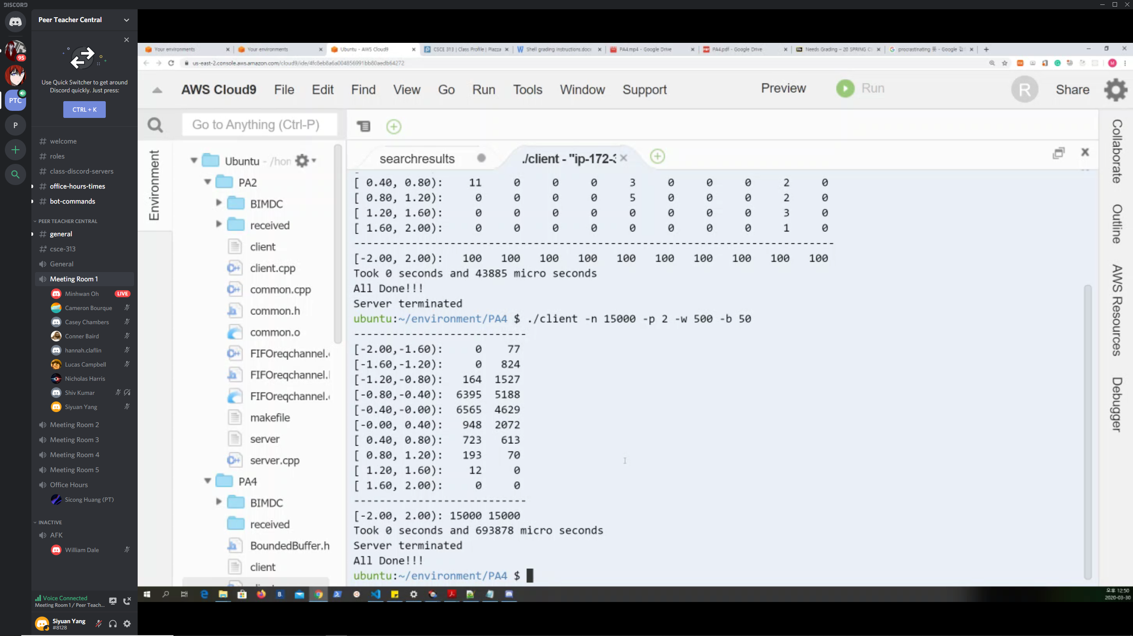

Change Histogram.cpp && BoundedBuffer.h