User case guide to Productivity Smart Office Sensor Data

Upon opening the webpage the user will be asked to select a date range for the data they would like to retrieve. This will send a RESTful data request to Netatmo for all available motes from the Insight building and store the data on a local DB. If the request fails an error will be displayed to the user along with a message reminding the user that internet access is required and to use the correct format for the date inputs. The user can then try again.

Once the data is retrieved successfully the user will be taken to the user interface page where he/she can build new charts by entering a mote id and start/end dates. This page will consist of three default charts holding five days of data and a hidden input section to the left. This can be opened by clicking on the top left ‘open’ link and minimized using the X button on top of the input section. Below the input fields are two tables. One table shows the user all the sensor types and there measurement units and another table list all the available motes and their respective locations. These tables are populated when the page loads by accessing the data on the local database.

Fig 1 shows what the use will see when the user interface page has loaded. A message will inform the user that an internet connection is needed for Google charts to display some default charts. If the error “Not enough columns given to draw the requested chart” is shown instead of a chart then the browser needs to be closed or the history cleared. This error can happen if the user refreshes the page.

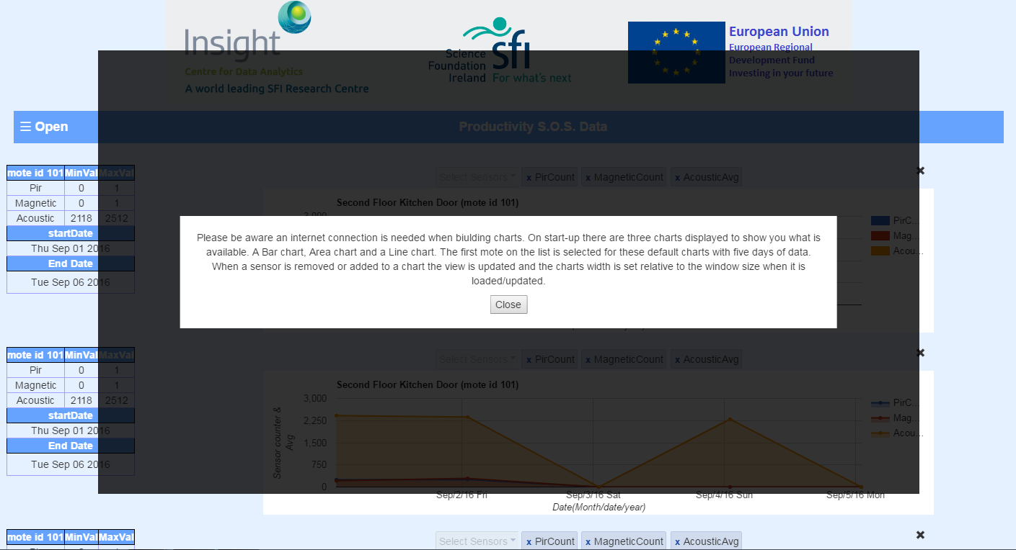

**Fig 1**

Once the user enters a mote id, start/end dates and selects from a list of three available options for a chart type, the user can then click on the button to fetch the data from the local DB. Two buttons, one to draw the graph and another to reset the options and start again, will appear on the page. Once the user hits the ‘Draw Graph’ button the chart will be displayed to the screen. To the left of the chart there will also be a table listing the details of the chart plotted. This will include a list of all the sensors for the given mote and there min/max values within the given dates.

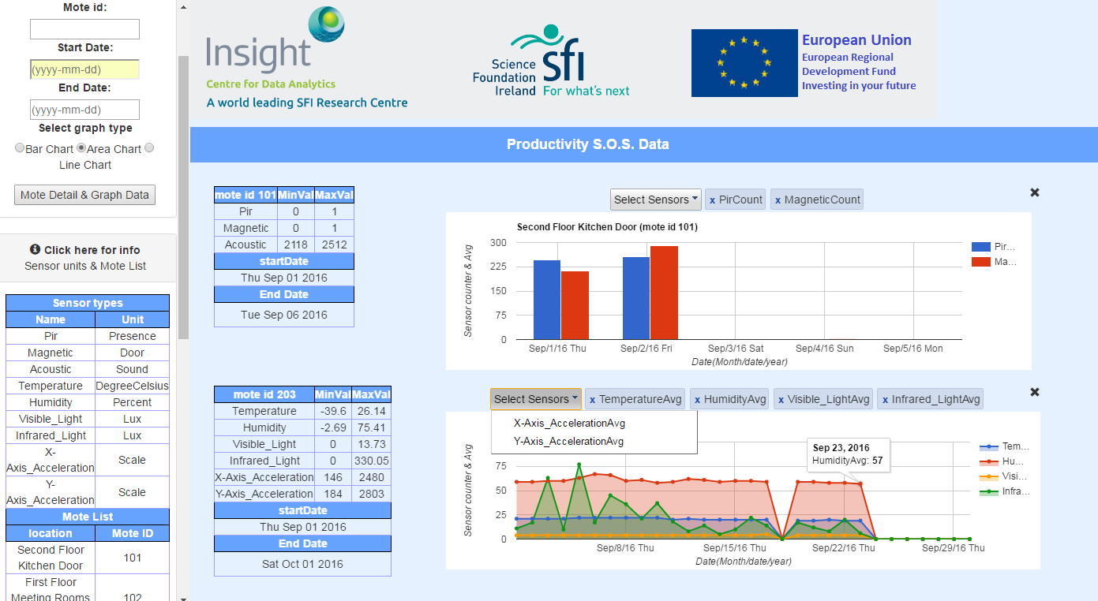

**Fig 2**

In fig 2 a bar chart and an Area chart are shown. Each graph has the option to remove/include different sensors to its display by clicking on the drop down list ‘Select Sensor’. Each time a sensor is removed or added the chart is redrawn. In fig 2 above the bar chart has Acoustic removed and the Area chart has the x and y axis sensors removed. If the mouse is hovered over a data point in the chart it will display its details as in the Area chart for Sep 23rd the Humidity Average was 57%.

A user can zoom in using their mouse wheel and scroll left or right to examine particular dates more closely as shown in fig 3. There is also the option to remove a chart from the dashboard by clicking on the X next to the desired chart. Any charts that are below the removed chart will be moved up in its place to keep a clean look to the page. In fig 3 the bar chart was removed.

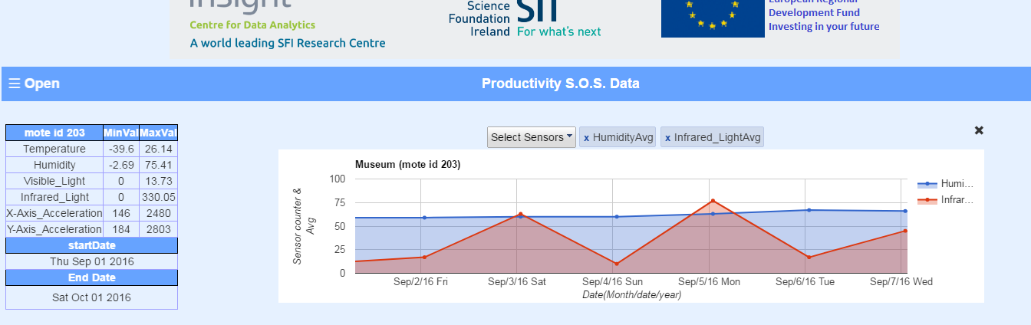

**Fig 3**