win10 安装tensorflow

工具集

[Anaconda3-5](https://repo.continuum.io/archive)

[pycharm](https://download.jetbrains.8686c.com/python)

[cuda](http://developer2.download.nvidia.com/compute/cuda)8.0

[cudnn6](https://developer.nvidia.com/rdp/cudnn-download)

确保你的 Python 版本是 **3.5** 64 位及以上

确保你的 pip 版本 >= 8.1。用 pip -V 查看当前 pip 版本；

升级pip：python -m pip install -U pip

安装anaconda3.5

到naconda3\Scripts目录下

运行命令，安装tensorflow

# GPU版本

pip install --upgrade tensorflow-gpu

# CPU版本

pip install --upgrade tensorflow

Win10，ANACONDA3(64-bit)，Python3.5.1。ANACONDA Prompt中不能用pip命令安装包，并且是在安装了TensorFlow后才发生的。报错如下：

D:\devlopSoftwareKit\anaconda3\Scripts>pip install --upgrade tensorflow-gpu

Collecting tensorflow-gpu

Exception:

Traceback (most recent call last):

File "D:\devlopSoftwareKit\anaconda3\lib\site-packages\pip\basecommand.py", line 215, in main

status = self.run(options, args)

File "D:\devlopSoftwareKit\anaconda3\lib\site-packages\pip\commands\install.py", line 335, in run

wb.build(autobuilding=True)

File "D:\devlopSoftwareKit\anaconda3\lib\site-packages\pip\wheel.py", line 749, in build

self.requirement_set.prepare_files(self.finder)

File "D:\devlopSoftwareKit\anaconda3\lib\site-packages\pip\req\req_set.py", line 380, in prepare_files

ignore_dependencies=self.ignore_dependencies))

File "D:\devlopSoftwareKit\anaconda3\lib\site-packages\pip\req\req_set.py", line 554, in _prepare_file

require_hashes

File "D:\devlopSoftwareKit\anaconda3\lib\site-packages\pip\req\req_install.py", line 278, in populate_link

self.link = finder.find_requirement(self, upgrade)

File "D:\devlopSoftwareKit\anaconda3\lib\site-packages\pip\index.py", line 465, in find_requirement

all_candidates = self.find_all_candidates(req.name)

File "D:\devlopSoftwareKit\anaconda3\lib\site-packages\pip\index.py", line 423, in find_all_candidates

for page in self._get_pages(url_locations, project_name):

File "D:\devlopSoftwareKit\anaconda3\lib\site-packages\pip\index.py", line 568, in _get_pages

page = self._get_page(location)

File "D:\devlopSoftwareKit\anaconda3\lib\site-packages\pip\index.py", line 683, in _get_page

return HTMLPage.get_page(link, session=self.session)

File "D:\devlopSoftwareKit\anaconda3\lib\site-packages\pip\index.py", line 811, in get_page

inst = cls(resp.content, resp.url, resp.headers)

File "D:\devlopSoftwareKit\anaconda3\lib\site-packages\pip\index.py", line 731, in __init__

namespaceHTMLElements=False,

TypeError: parse() got an unexpected keyword argument 'transport_encoding'

pip install Keras 报错：

parse() got an unexpected keyword argument 'transport_encoding'

解决：**conda install pip**

1. conda install -c anaconda html5lib
2. **conda install pip**

会看到一系列更新的结果，然后再次使用pip安装包，发现可以成功安装

下载cudnn6

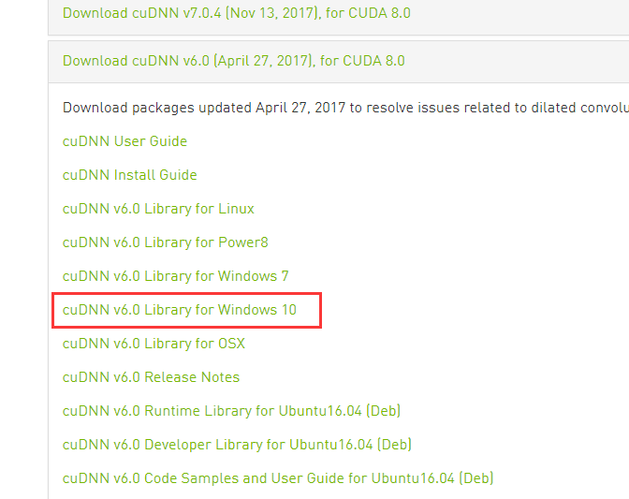

解压，配置环境变量