Project Plan

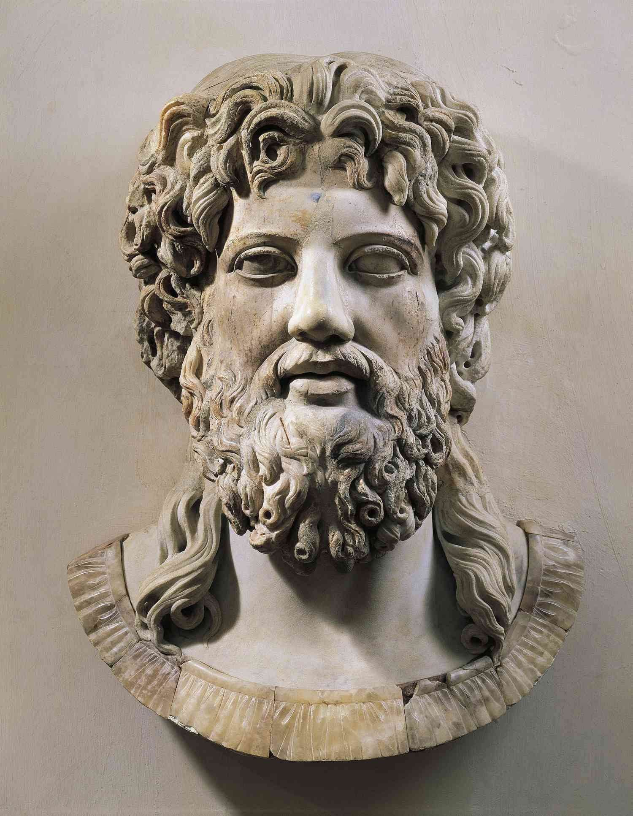

Erion’s art installation

Eindhoven, The Netherlands

Table of Contents

1 Project Definition 4

1.1 Project background 4

1.2 Problem definition 4

1.3 Project Goals 4

1.4 Expected outcome 5

1.5 Group structure 5

1.6 Project scope 5

1. Project plan 5

2. Team agreement 5

3. Interview 5

4. prototype 5

5. Individual pitch 5

6. End-of-sprint presentation 5

7. Final presentation 5

2.Project structure 6

2.1 Leadership 6

2.2 Team members 6

Research activities assigned 7

Sprint 1 7

Sprint 2 7

Sprint 3 7

Sprint 4 7

4.Risk Assessment 8

Late arrivals 8

Lack of leadership 8

Incomplete decisions 8

Communication failures 8

Assigned tasks not delivered on time. 9

5. Deliverables 9

Must have: Contact page, art showcase 9

Should have: clear UI, incorporation of Erion’s art style 9

Could have: 9

Won’t have: delivery service for bought art 9

6.Research methods 10

Main research question 10

Sub research questions 10

Empathise: 10

Define: 10

Ideate: 10

Prototype: 11

Test: 11

Assess: 11

CMD Research Methods 12

Benchmark creation: 12

Co-creation: 12

Competitive Analysis: 12

Design Specification: 12

Interview: 12

Mood Board: 13

Pitch: 13

Prototyping: 13

Requirement List: 13

Thinking Aloud: 13

USP (Unique Selling Points): 13

7. Planning 14

# 1 Project Definition

The following section will describe the project definition. It will contain an overview of the problems as well as the group’s goals and how the group plans to achieve the goals. The group will be referred to as Zeus from here on out.

## Project background

Through the initial project kick-off meeting with the client, the group was introduced to Erion Kapaj and what was required from Zeus. Erion would like to have a platform to showcase his portfolio. Therefore, the objective of this project is to create a fully functioning prototype where Erion can, as previously mentioned, showcase his portfolio. Erion stated that he wants to have his art seen by like-minded individuals and acquaintances.

## Problem definition

While some of Erion’s art can be found on different platforms, there is no centralised location where Erion showcases his portfolio. Erion expressed in the initial kick-off meeting he has lost out on opportunities due to a lack of an accessible, centralised location to showcase his paintings, sculptures, and more.

## Project Goals

The goal of this project is to provide Erion with an accessible platform, styled to his specifications, to showcase his portfolio.

Benefits solution:

* User friendly website
* A website to his specifications
* Showcase his artwork

## Expected outcome

An accessible, user-friendly prototype for Erion to showcase his artwork and extended portfolio to a wider known and unknown audience.

## Group structure

The group structure is linked to the project structure as each member will be responsible for the task, they are assigned to by the group member. If the member assignment has not been completed then the contract will be looked at, deciding on what the next course of action will happen.

## Project scope

We will be delivering multiple deliverables to create a final product in the end. The product will be considered a prototype for our client Erion. We broke down the final product into smaller steps to make sure that it will be done properly and in a correct order.

## Project plan

* Problem definition
* Project structure
* Risk assessments
* Deliverables
* Research methods

### Team agreement

* Group contract

### Interview

* Interview questions
* Interview transcript
* Summary

### prototype

* Low- med and high fidelity
* User testing results

### Individual pitch

### End-of-sprint presentation

* Each sprint presentation with what we have done so far

### Final presentation

* Our final product and what we did to accomplish it

When we deliver all of these, we should have a prototype that will showcase Erion’s art.

# 2.Project structure

The group consists of 7 members collectively referred to as Zeus.

## 2.1 Leadership

Currently there is no leader assigned to the group. Communication is a core value so open communication is a must. If it is believed that the lack of leadership is causing problems in the decision making the group may consider choosing a leader.

## 2.2 Team members

-Tim Lemmens

-Aadira Das

-Jean Luc Kronshorst

-Melany Lara Reyes

-Zhan Hrisotv

-Rob Verheijen

-Fleur Driessen

# 4.Risk Assessment

Likeliness that one risk will happen is determined in a scale of one to four, which can be seen below.

1 Highly unlikely

2 unlikely

3 likely

4 Highly likely

## Late arrivals

**(1-2)**

Late arrivals will be punished by having to do push ups at the earliest available convenience. There is no exemption for any group member. Per minute late, one push up must be done. If someone is more than 30 minutes late, they will have to do an additional 40 push ups, on top of each minute previously. If someone is unable to make it on time due to unforeseen circumstances (public transport issues, illness, etc) this does not apply.

## Lack of leadership

**(1)**

A lack of leadership is not expected in our current situation. Good communication is a core value of our group, which makes distinct leadership not as necessary.

## Incomplete decisions

**(2)**

If decisions are not made during our weekly stand-up meetings or when discussing specific assignments or tasks, a separate meeting will be held to come to a decision in a timely manner.

## Communication failures

**(1-2)**

Communication failures are not expected to be an issue due to our in-person communication at school. On top of constant communication, a discord group has been created where we share insights, work, plans and more.

If communication failures occur, a talk will be held with the individual(s) in question.

## Assigned tasks not delivered on time.

**(2)**

If tasks assigned to people are not delivered on time without proper reason provided, a talk will be held with the individual(s) in question. During the talk we as a group will come up with a suitable solution for the situation.

# 5. Deliverables

Here you can read the deliverables of our project.

What we will deliver outside of technical:

Paper prototype

Figma prototype

Project plan

Interview transcripts

Team charter

Problem statement

Individual pitch

End-of-sprint presentation

Final presentation

## MoSCoW

Using the MoSCoW method for the technical deliverables:

**Must Have:** Contact page, Art showcase

**Should Have:** Clear UI, Incorporation of Erion’s art style

**Could Have:** Shop function

**Won’t Have:** Delivery service for bought art

# 6.Research methods

## 

## Main research question

What would a showcase of Erion’s portfolio and personality look like, and how can that be incorporated into a website?

## Sub research questions

### Empathise:

What is Erion's personality like?

How does Erion interpret his own art?

How would he like to represent himself on the website?

How did he get interested in the art that he creates?

### Define:

What kind of art is in, and how big is Erion’s portfolio?

Does he want his art explained or left up to the viewer's interpretation?

### Ideate:

What feel does he want to give the users of his website?

What are some stylistic choices he wants to see on the website?

How did he get interested in the art that he creates?

How can other websites be used as a source of inspiration to create a quality portfolio for the client, Erion?

How can Erion’s portfolio be created in such a way to stand out from others in the market?

How will all the requirements be identified?

### Prototype:

How would he like to represent himself on the website?

How can Erion’s art best be used as a basis for a website?

How will we ensure that the final portfolio meets the requirements of the client?

### Test:

How often should Erion be contacted for progress updates?

How will we ensure that the final portfolio meets the requirements of the client?

How will all the requirements be identified?

### Assess:

How often would Erion like to give us feedback/ See the feedback that was implemented?

# CMD Research Methods

CMD research methods will be used to support the research planning needed to deliver a complete portfolio for Erion, the final client.

The following research methods will be used and the questions that will be answered:

## Benchmark creation:

Benchmark creation uses existing products in the niche market, which the group plans to use as a source of inspiration.

*How can other websites be used as a source of inspiration to create a quality portfolio for the client, Erion?*

## Co-creation:

The group plans to gain inspiration from Erion by involving him in the design process. This allows the group to know Erions expectations for the final product.

*How often would Erion like to give us feedback?*

*See the feedback that was implemented?*

*How often should Erion be contacted for progress updates?*

*How would he like to represent himself on the website?*

*How will we ensure that the final portfolio meets the requirements of the client?*

## Competitive Analysis:

Similar to the UPS method competitive analysis will be used to find in a niche or unique selling point competitors are not filling.

*How can Erion’s portfolio be created in such a way to stand out from others in the market?*

## Design Specification:

The characteristics of the portfolio will be identified so everyone involved is kept informed of all the design choices.

*What feel does he want to give the users of his website?*

*What are some stylistic choices he wants to see on the website?*

## Interview:

Interviews will be conducted to understand Erion better by gathering their opinions, and what is required of the group**.**

*What is Erion's personality like?*

*How does Erion interpret his own art?*

*How would he like to represent himself on the website?*

*How did he get interested in the art that he creates?*

## Mood Board:

Mood board will be used to describe the ‘mood’ or the ‘feel’ of the envisioned product and to see what is needed by Erion.

*What feel does he want to give the users of his website?*

*How would he like to represent himself on the website?*

## Pitch:

Use the unique selling points to communicate them and sell it to the client.

*How will we present our final project to Erion?*

## Prototyping:

This method will be used throughout the project, multiple prototypes will be created and evaluated as part of the as an iterative process.

*How will we ensure that the final portfolio meets the requirements of the client?*

## Requirement List:

A complete list of requirements will be used as a checklist to identify what is needed and keep track of what is done and what needs to be done.

*How will all the requirements be identified?*

## Thinking Aloud:

The group will use this method to understand the reasons behind user behaviour or uncover the mental models of the user in a usability test. Basically, asking users to think out loud their initial thoughts to get their first impressions on the product.

*How can we get the initial impressions of the portfolio?*

## USP (Unique Selling Points):

USP will be used to take into account similar existing products in the market. The group will identify how we plan to create a unique product for Erion that will stand out in the market.

*How can Erion’s portfolio be created in such a way to stand out from others in the market?*

# 7. Planning

