<http://www.scribd.com/doc/44223411/SQL-Assignments-4>

https://www.scribd.com/deleted/44223411

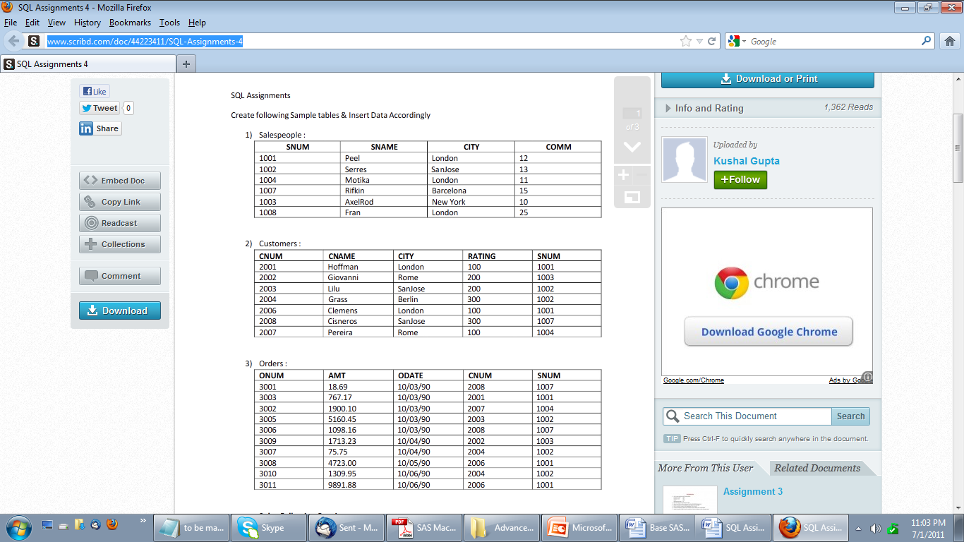

**Please create the above tables through Datalines in the SAS env.**

Solve Following Queries

**1.List all the column of the salespeople table.**

Select * from salespeople

**2. List all customers with a rating of 100.**

Select * from customers

Where rating = 100

**3. Find the largest order taken by each salesperson on each date.**

Select Odate, Snum, Max(Amt) as MaxSalePerSlaesPerson from Orders

Group by Odate, Snum

**4. Arrange the  order table by descending customer number**

Select * from Order

Order by descending CNUM

OR

Proc sort data = Order

Order by descending CNUM

**5. Find which salespeople currently have orders in the order table.**

Select distinct SNUM from Orders

**6.List names of all customers matched with the salespeople serving them.**

Select a.Cnum

          a.Snum

         b.Cname

         c.SName

From Orders a

Inner Join Customer b

      On (a.Cnum= b.Cnum)

Inner Join SalesPersons c

     On (a.Snum= c.Snum)

**7.Count the orders of each of the salespeople and output the results in descending order**

**8.Match salespeople to customers according to what city they live in.**

Select   a.Snum

         ,a.Sname

         ,a.city

       ,b.cnum

       ,b.cname

From salespeople a

Outer Join Customer b

      On Upcase(Trim(a. city)) = Upcase(Trim(b. city))

**9.Find all the customers in SanJose who have a rating above 200**

Select *

From customers

Where city = “SanJose” and Rating >200

**10. List the names and commissions of all salespeople in London**

**11. List all the orders of Salesperson Motika from the orders table**

Select * from Orders

Where Snum = (Select Snum from Salesperson where Sname= “Motika”)

**12.Find all customers who booked orders on October 3**

**13.Give the sums of the amounts from the Orders table, grouped by date, eliminating all those dates where the SUM was not at least 2000 above the maximum Amount**

Select Odate , Sum(Amt) as totalDailyAmount

From Orders

Group by Odate

Having calculated totalDailyAmount >  2000 + (select max(amt) as maxamt from orders)

**14.Select all orders that had amounts that were greater than at least one of the orders from**

**October 6.**

**15.List all the largest orders for October 3, for each salesperson**

Select Max(Amt) as largestOrderPerSalesPersn

     ,Odate, Snum

From Orders

Group By Odate, Snum

Where Odate = “10/03/90”

**16. Find all customers located in cities where Serres has customers.**

**17. Select all customers with a rating above 200.**

**18. Find salespeople with customers located in their own cities**

Select a.Snum,

From Orders a

Inner Join Customer b

      On (a.Cnum= b.Cnum)

Inner Join SalesPersons c

     On (a.Snum= c.Snum)

Where b.city = c.city

**19. Find salespeople whose name starts with P and fourth character is I**

Select * from salespeople

Where  sname = P??l%

/Not sure abt this query as the operator is version dependent */

**20. Write a query that uses a subquery to obtain all orders for the customer named Cisneros.Assume you do not know his customer number**

**21. Find the largest orders for Serres and Rifkin.**

Select Max (Amt) as largestOrder

         Onum

From Orders

Where Snum in (select Snum from salesperson where Sname = “Serres” OR Sname =  “Rifkin”)

**22.Sort the salespeople table in the following order : snum, sname, commission, city.**

**23. Select all customers whose names fall in between A and G alphabetical range**

**24. Write a query that totals the orders for each day and places the results in descending order**

**25. Write a select command that produces the rating followed by the name of each customer inSanJose.**

**26. Find all orders with above average amounts for their customers**

**27. Write a query that selects the highest rating in each city.**

**28. Find all salespeople that are located in either Barcelona or London**

**29.Write a query that joins the customer table to itself to find all pairs or customers served by asingle salesperson.**

**30.Write a query that will give you all orders for more than $1000.00**

**31. Write a query that lists each order number followed by the name of customer who madethat order.**

**32.Write two queries that will produce all orders taken on October 3 or October 4.**

**33. Find all rows from the customers table for which the sales person number is 1001.**

**34. Find all salespeople name and comminssion.**

**35. Find all sales people for whom there are customers that follow them in alphabetical order.**

**36. Write a query that produces the names and ratings of all customers who have averageorders**

**37.Find the sum of all Amounts from the orders table.**

**38. Write a query that gives the names of both the salesperson and the customer for each orderafter the order number.**

**39. List the commission of all salespeople services customers in London.**

**40. Find all orders attributed to sales people who live in London.**

**41. Find all salespeople who have customers with more than one current order.**

**42. Find the average commission for salespeople in London.**

**43. Find all orders credited to the same salesperson who services Hoffman. (cnum 2001).**

**44. Find all salespeople whose commission is in between 0.10 and 0.12 (both inclusive).**

**45. Write a query that will give you the names and cities of all salespeople in London with acommission above 0.10.**

**46. Write a query that selects each customers smallest order.**

**47.Write a query that selects the first customer in alphabetical order whose name begins withG.**

**48. Write a query that counts the number of different non NULL city values in the customerstable.**

**49. Find the average amount from the Orders Table.**

**50. Find all customers who are not located in SanJose and whose rating is above 200.**

**51. Give a simpler way to write this query.SELECT snum, sname, city, comm FROM salespeopleWHERE (comm.>+0.12 OR comm.<0.14);**

**52.Which salesperson has earned the maximum commission?**

**53.List all customers in descending order of customer rating**

**54.On which days has Hoffman placed orders?**

**55. Which salesmen have no orders between 10/03/1990 and 10/05/1990?**

**56.Who is the most successful salesperson?**