1. **Logistic Regression (code in *fisher_scoring.py*)**
   1. Find the Hession matrix for

where   
Hessian matrix: Show that H is ***semi positive definite***: Suppose ;  
Then

* 1. Fitted coefficients = [-2.6205116 0.76037154 1.17194674]
  2. The figure plotted in ps1q1c.png  
     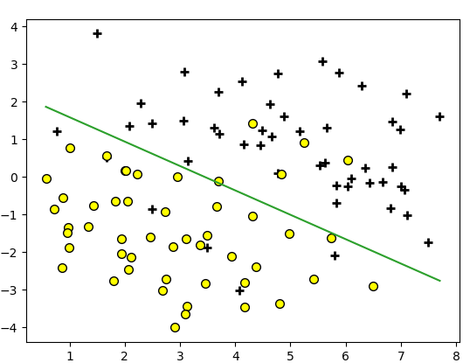

1. Poisson regression and the exponential family
   1. Show that Poisson distribution is in exponential family.
   2. According to the canonical parameter , the canonical response function (link function) is its inverse , plug in the final canonical response function is
   3. Plug in the canonical response function into and take the derivative of its log with respect to :

The stochastic gradient ascent rule is

* 1. Show that for any Exponential Family distribution the max log-likelihood stochastic gradient ascent will result in update rule

Prove:

Compare it with the update rule the question now is to prove:

Use the fact that

1. Gaussian discriminant analysis

Show that the posterior distribution of the label at x takes the form of a logistic function, and can be written:

Try some brute force math: