XL Re-EMT DevOps Knowledge Document

Document Details
Version | Date | Author | Description
1.0 | 01/08/2025 | Hemanth Kumar Ambati | Initial draft
1.1
1.2
1.3
1.4

Contact Details:
Roles and Responsibilities
Team Name | Team Member | Role | Mobile | Email
Risk Consulting Site Forward |  | Application Owner |  | ambuj.kumar@axaxl.com
DevOps Engineer | Hemanth Kumar Ambati | DevOps | - | hemanthkumar.ambati@contractor.axaxl.com
SDC/AMS |  | Support
Developer

Contents
XL Re-EMT DevOps Knowledge Document 1
Contact Details: 1
Getting Started 5
Introduction 5
XL Re EMT (XPO), a web-based application, will be migrated to Azure Cloud using a combination of Open PaaS and Azure PaaS services and following the XL Enterprise Guidelines. 5
Purpose 5
Overview: EMT CI/CD (Harness pipeline) 6
Source Code Repo : https://github.axa.com/xlc-portfolio-reinsurance-and-erm/xlc-app-xlre_emt 7
Code base Branch (Default): features/app_modernization 7
CPP Link : Cloud Platform Portal | XLC GT PANDA 7
Codebase branch for building CI Artifacts features/app_modernization 7
For Configs: EMT_ConfigurationVariables_Updated_V2.0.xlsx 7
Here for the build purpose, we do MS Build for 3 different Components: 7
1) WebApp API (.Net 4.8) [Mapping API] 8
Pipeline Name: xlc-app-cicd-mappingApi-azws 8
Branch: features/app_modernization Env: DEV, SIT, PPD, PROD, UAT 8
Reference: 8
8
CI Pipeline: 8
Name: xlc-app-build-mappingApi 8
CD Pipeline: 8
Name: xlc-app-deploy-mappingApi 8
2) Core API (.Net Core) [Open PAAS] 9
Pipeline Name: xlc-app-core-server-api 9
Branch: features/app_modernization Env: DEV, SIT, PPD, PROD, UAT 9
CI Pipeline: Name: xlc-app-build-docker 9
CD Pipeline: Name: xlc-app-deploy-openpaas 9
3) XPO UI (Angular) [Open PAAS] 10
Pipeline Name: xlc-app-xpo-ui 10
Branch: features/app_modernization Env: DEV, SIT, PPD, PROD, UAT 10
CI Pipeline: Name: xlc-app-build-docker 10
CD Pipeline: Name: xlc-app-deploy-openpaas 10
Refer: Build on windows container - AXA XL TAS DevOps Automation - Confluence by AXA GO 11
Codebase branch for deployment of All the 3 Pipelines: 15
CD Pipeline: Pipeline Name: xlc-app-cicd-mappingApi-azws 15
Branch: features/app_modernization Env: DEV, SIT, PPD, PROD, UAT 15
CD Pipeline: Name: xlc-app-deploy-openpaas 15
Delegate: Select the delegate(s) you want to use to execute this step. 23
The K8s Rollout Deploy step performs a rolling update strategy. 32
Delegate: Select the delegate(s) you want to use to execute this step. 32
Harness useful links: 33

Getting Started

Introduction

XL Re EMT (XPO), a web-based application, will be migrated to Azure Cloud using a combination of Open PaaS and Azure PaaS services and following the XL Enterprise Guidelines.

Purpose
This is a guide for all the application teams to get started XL Re-EMT application and understand how to deploy using the following tech stack:
Azure PAAS (.Net 4.8- Mapping API)
Environment | Resource Groups | Subscription | Region
PRD | z-xlc-0234-xlre-pr-ue2-rgp01-xlreemt | XLC_PRD_UE2_004 | East US 2
UAT | z-xlc-0234-xlre-pp-ue2-rgp02-xlreemt | XLC_PRD_UC1_001 | Central US
PPD | z-xlc-0234-xlre-pp-ue2-rgp01-xlreemt | XLC_PPD_UE2_001 | East US 2
SIT | z-xlc-0234-xlre-dv-ue2-rgp02-xlreemt | XLC_PPD_UE2_001 | East US 2
Dev | z-xlc-0234-xlre-dv-ue2-rgp01-xlreemt | XLC_NPD_UE2_003 | East US 2

Open Shift (PAAS)
Env | Name | Host Names | URL
DEV | XPO_UI (Angular) | 0234xlre-01-dev-axa-xl | https://xpo-dev.axaxl-cloud.com
DEV | CoreAPI (.Net Core) | 0234xlre-01-dev-axa-xl | https://xpo-coreapi-dev.axaxl-cloud.com
DEV | Mapping_API (.Net 4.8) | z-xlc-0234-xlre-dv-ue2-wap01-xlreemt | https://xpo-mappingapi-dev.axaxl-cloud.com
SIT | XPO_UI (Angular) | 0234xlre-04-dev-axa-xl | https://xpo-sit.axaxl-cloud.com
SIT | CoreAPI (.Net Core) | 0234xlre-04-dev-axa-xl | https://xpo-coreapi-sit.axaxl-cloud.com
SIT | Mapping_API (.Net 4.8) | z-xlc-0234-xlre-dv-ue2-wap02-xlreemt | https://xpo-mappingapi-sit.axaxl-cloud.com
PPD | XPO_UI (Angular) | 0234xlre-01-preprod-axa-xl | https://xpo-ppd.axaxl-cloud.com
PPD | CoreAPI (.Net Core) | 0234xlre-01-preprod-axa-xl | https://xpo-coreapi-ppd.axaxl-cloud.com
PPD | Mapping_API (.Net 4.8) | z-xlc-0234-xlre-pp-ue2-wap02-xlreemt | https://xpo-mappingapi-ppd.axaxl-cloud.com
UAT | XPO_UI (Angular) | 0234xlre-04-preprod-axa-xl | https://xpo-uat.axaxl-cloud.com
UAT | CoreAPI (.Net Core) | 0234xlre-04-preprod-axa-xl | https://xpo-coreapi-uat.axaxl-cloud.com
UAT | Mapping_API (.Net 4.8) | z-xlc-0234-xlre-pp-ue2-wap01-xlreemt | https://xpo-mappingapi-uat.axaxl-cloud.com
PROD | XPO_UI | 0234xlre-01-prod-axa-xl | https://xpo.axaxl-cloud.com
PROD | CoreAPI (.Net Core) | 0234xlre-01-prod-axa-xl | https://xpo-coreapi.axaxl-cloud.com
PROD | Mapping_API (.Net 4.8) | z-xlc-0234-xlre-pr-ue2-wap01-xlreemt | https://xpo-mappingapi.axaxl-cloud.com

Overview: EMT CI/CD (Harness pipeline)
Add.. Technical Design:
EMT application will be deployed as Azure WebApp in Azure App Service Plan.
EMT WCF Service will be deployed in Azure App Service Plan

Source Code Repo : https://github.axa.com/xlc-portfolio-reinsurance-and-erm/xlc-app-xlre_emt

Code base Branch (Default): main

CPP Link : Cloud Platform Portal | XLC GT PANDA

Harness pipelines:
URL: https://app.harness.io/ng/account/UVxMDMhNQxOCvroqqImWdQ/all/orgs/reinsuranceanderm/projects/xlcapp0234xlre/overview
Pipelines trigger branch: main
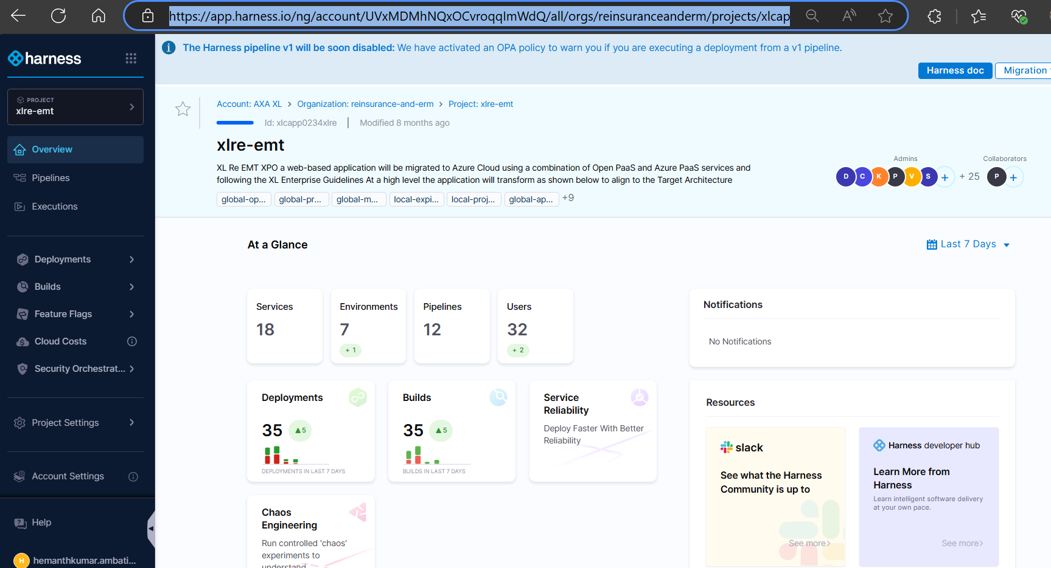

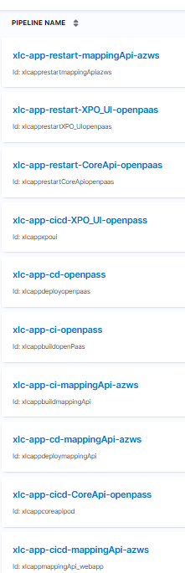

Code Build (CI Stage):

Codebase branch for building CI Artifacts main

For Configs: please review from harness variable and secrets

Here for the build purpose, we do MS Build for 3 different Components:

- WebApp API (.Net 4.8) [Mapping API]

Pipeline Name: xlc-app-cicd-mappingApi-azws

Branch: main
Env: DEV, SIT, PPD, PROD, UAT

Harness URL:

https://app.harness.io/ng/account/UVxMDMhNQxOCvroqqImWdQ/all/orgs/reinsuranceanderm/projects/xlcapp0234xlre/pipelines/xlcappmappingApi_webapp/pipeline-studio/?storeType=REMOTE&connectorRef=ghe0234xlre&repoName=xlc-app-xlre_emt&branch=main

Reference:

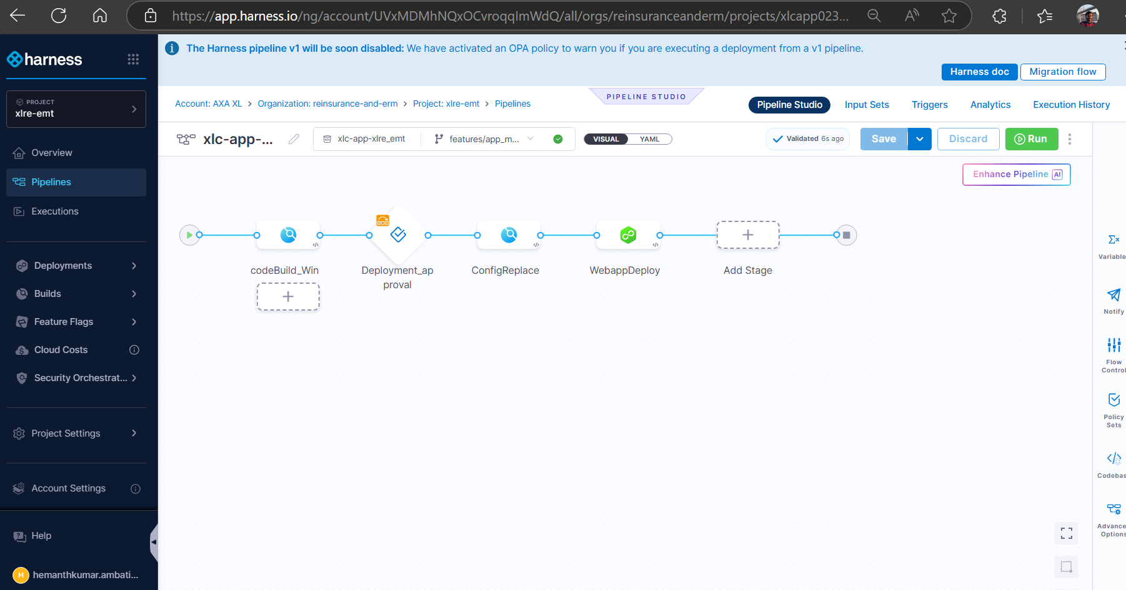

CI Pipeline:

Name: xlc-app-ci-mappingApi-azws

URL:

https://app.harness.io/ng/account/UVxMDMhNQxOCvroqqImWdQ/all/orgs/reinsuranceanderm/projects/xlcapp0234xlre/pipelines/xlcappbuildmappingApi/pipeline-studio/?storeType=REMOTE&connectorRef=ghe0234xlre&repoName=xlc-app-xlre_emt&branch=main

CD Pipeline:

Name: xlc-app-cd-mappingApi-azws

URL:

https://app.harness.io/ng/account/UVxMDMhNQxOCvroqqImWdQ/all/orgs/reinsuranceanderm/projects/xlcapp0234xlre/pipelines/xlcappdeploymappingApi/pipeline-studio/?storeType=REMOTE&connectorRef=ghe0234xlre&repoName=xlc-app-xlre_emt&branch=main

- Core API (.Net Core) [Open PAAS]

Pipeline Name: xlc-app-cicd-CoreApi-openpass

Branch: main
Env: DEV, SIT, PPD, PROD, UAT

Harness URL:

https://app.harness.io/ng/account/UVxMDMhNQxOCvroqqImWdQ/all/orgs/reinsuranceanderm/projects/xlcapp0234xlre/pipelines/xlcappcoreapipod/pipeline-studio/?storeType=REMOTE&connectorRef=ghe0234xlre&repoName=xlc-app-xlre_emt&branch=main

Reference:

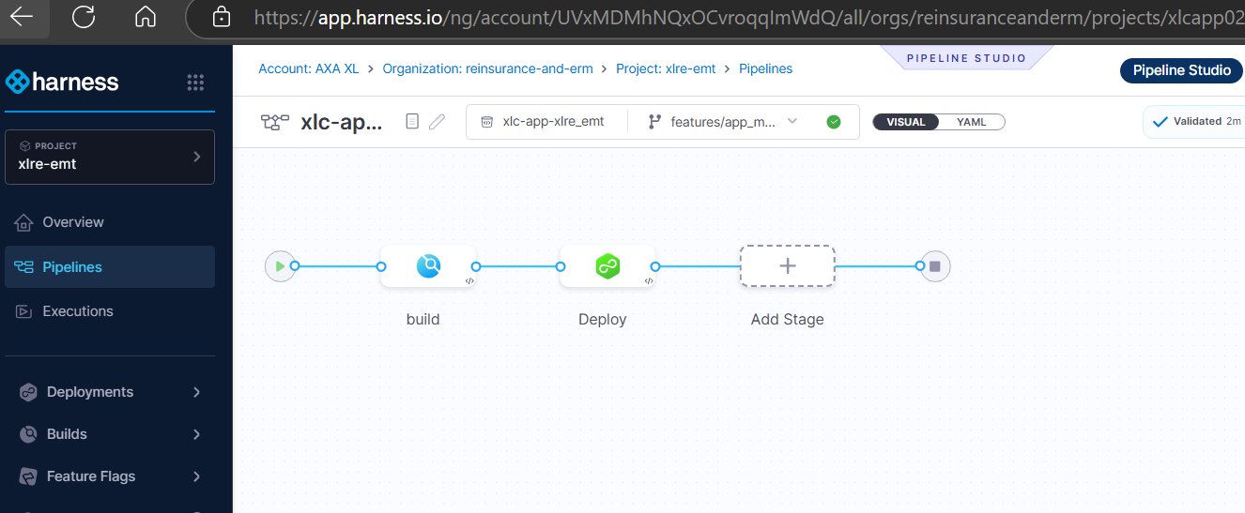

CI Pipeline:
Name: xlc-app-ci-openpass

URL:

https://app.harness.io/ng/account/UVxMDMhNQxOCvroqqImWdQ/all/orgs/reinsuranceanderm/projects/xlcapp0234xlre/pipelines/xlcappbuildopenPaas/pipeline-studio/?storeType=REMOTE&connectorRef=ghe0234xlre&repoName=xlc-app-xlre_emt&branch=main

CD Pipeline:
Name: xlc-app-cd-openpass

URL:

https://app.harness.io/ng/account/UVxMDMhNQxOCvroqqImWdQ/all/orgs/reinsuranceanderm/projects/xlcapp0234xlre/pipelines/xlcappdeployopenpaas/pipeline-studio/?storeType=REMOTE&connectorRef=ghe0234xlre&repoName=xlc-app-xlre_emt&branch=main

- XPO UI (Angular) [Open PAAS]

Pipeline Name: xlc-app-cicd-XPO_UI-openpass

Branch: main
Env: DEV, SIT, PPD, PROD, UAT

Harness URL:

https://app.harness.io/ng/account/UVxMDMhNQxOCvroqqImWdQ/all/orgs/reinsuranceanderm/projects/xlcapp0234xlre/pipelines/xlcappxpoui/pipeline-studio/?storeType=REMOTE&connectorRef=ghe0234xlre&repoName=xlc-app-xlre_emt&branch=main

CI Pipeline:
Name: xlc-app-ci-openpass

URL:

https://app.harness.io/ng/account/UVxMDMhNQxOCvroqqImWdQ/all/orgs/reinsuranceanderm/projects/xlcapp0234xlre/pipelines/xlcappbuildopenPaas/pipeline-studio/?storeType=REMOTE&connectorRef=ghe0234xlre&repoName=xlc-app-xlre_emt&branch=main

CD Pipeline:
Name: xlc-app-cd-openpass

URL:

https://app.harness.io/ng/account/UVxMDMhNQxOCvroqqImWdQ/all/orgs/reinsuranceanderm/projects/xlcapp0234xlre/pipelines/xlcappdeployopenpaas/pipeline-studio/?repoName=xlc-app-xlre_emt&connectorRef=ghe0234xlre&storeType=REMOTE

InputSet:
For all Pipelines we have created Input Sets to run the CICD
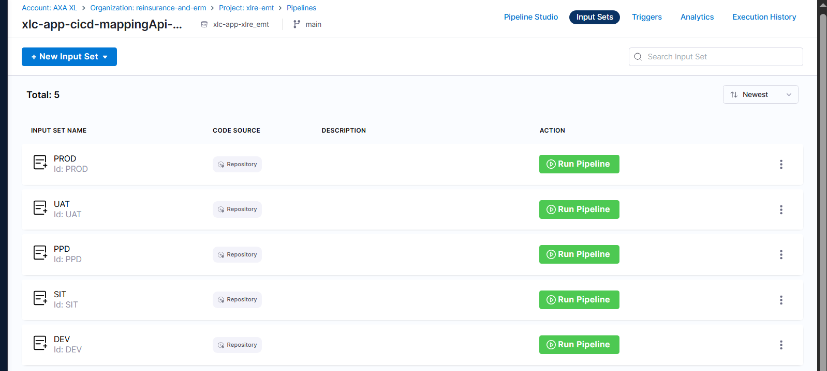

Infrastructure Section:
Note: For .Net 4.8 applications, we need to use Windows Build
Delegate: Select the delegate(s) you want to use to execute this step.
You can select one or more delegates for each pipeline step. You need to select only one of a delegate's tags to select it. All delegates with that tag are selected.

Warning: When the delegate selector is configured at a pipeline, stage, step level, it will override the delegate selector defined in the infrastructure definition's connector. This means that if a delegate has access to a different cluster, it can deploy to a different cluster than the one defined in the Infrastructure Definition.

Infrastructure: Kubernetes:
Operating System: Windows
Kubernetes Cluster: builder-shared-z-xlc-tool1-ue2
Namespace: builder-shared-ue2-prod-axa-xl
Reference: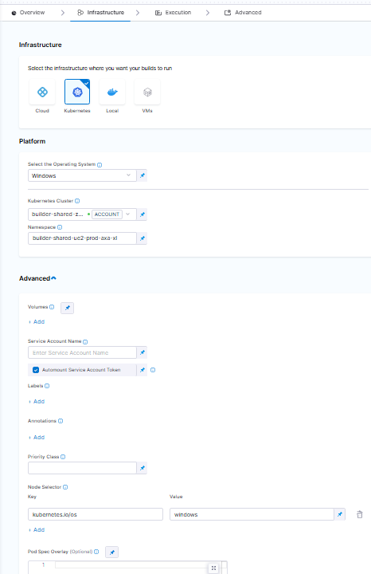

Refer: Build on windows container - AXA XL TAS DevOps Automation - Confluence by AXA GO

Execution:
$version =” <+pipeline.sequenceId>”
Image: artifactory.platform.axaxl-cloud.com/xlcpa-harness-continuous-integration-docker/axaxl/dotnet-framework-sdk:4.8-20240213-windowsservercore-ltsc2019
Reference:
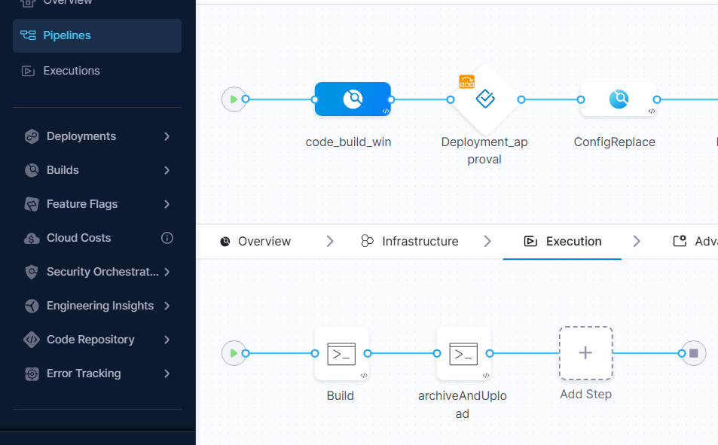

Artifacts (Push-Pull Artifacts Stage):
Here for each functionality respective artifacts are generated which can be found once the CI Pipeline is ran with a success. The artifact can be found in the pipeline itself and as well as the in the JFrog Artifactory.
Jfrog URL: https://artifactory.platform.axaxl-cloud.com/ui/repos/tree/General/docker
Repo: xlcreerm-xlre-emt-generic

Reference:
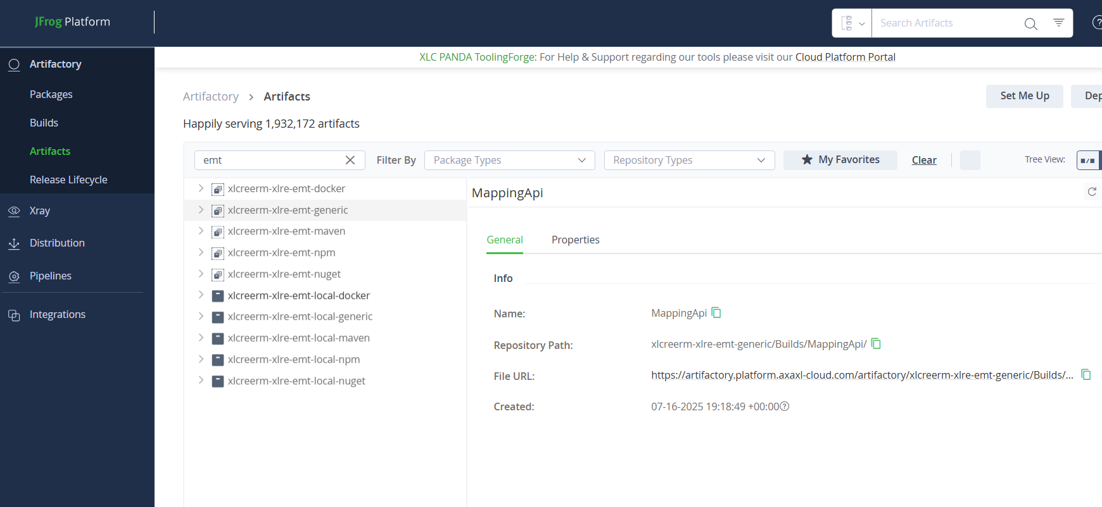
The Artifact is generated from CI Pipeline in the below format based on the Environment name:
Example: For xlc-app-cicd-mappingApi-azws:
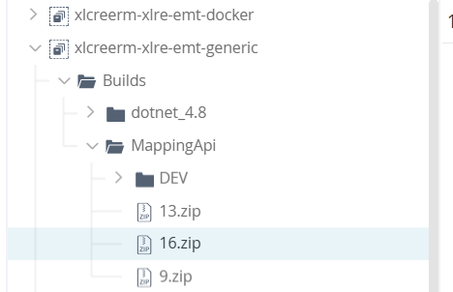
In the Pipeline:
Example: xlc-app-cicd-mappingApi-azws CI Pipeline for the DEV Environment.
The deployment structure and artifact flow for the xlc-app-cicd-mappingApi-azws CI pipeline targeting the DEV environment.
Repo: xlcreerm-xlre-emt-generic
Automatically pushes the latest deployed artifacts to the following path structure:
DEV: Represents the target environment (Development).
latest/: Holds the most recently deployed builds.
- versioned deployment packages (ZIP files) corresponding to the respective pipeline runs.
In such, includes PPD, UAT, or PROD environments as well.
In the JFrog Artifactory:
Artifact Mapping API URL: https://artifactory.platform.axaxl-cloud.com/artifactory/xlcreerm-xlre-emt-generic/Builds/MappingApi/
For XPO UI: https://artifactory.platform.axaxl-cloud.com/artifactory/xlcreerm-xlre-emt-docker/builds/dotnet/ui_xpo/
For Core API Server: https://artifactory.platform.axaxl-cloud.com/artifactory/xlcreerm-xlre-emt-docker/builds/dotnet/core_server/
Reference:
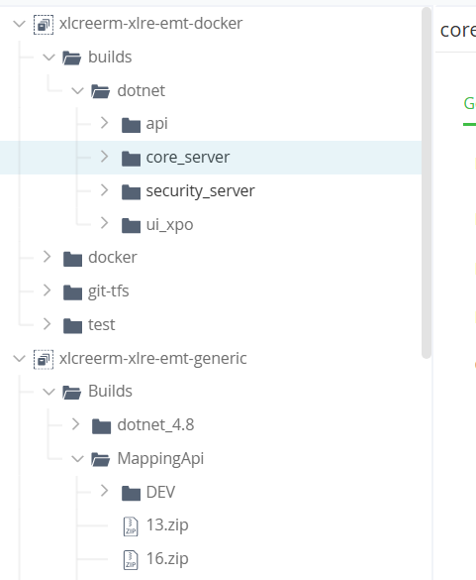

CD Stage (Deployment):

Codebase branch for deployment of All the 3 Pipelines:

CD Pipeline:
Pipeline Name: xlc-app-cicd-mappingApi-azws

Branch: main
Env: DEV, SIT, PPD, PROD, UAT

Harness URL:

https://app.harness.io/ng/account/UVxMDMhNQxOCvroqqImWdQ/all/orgs/reinsuranceanderm/projects/xlcapp0234xlre/pipelines/xlcappdeploymappingApi/pipeline-studio/?storeType=REMOTE&connectorRef=ghe0234xlre&repoName=xlc-app-xlre_emt&branch=main

CD Pipeline:
Name: xlc-app-cd-openpass

URL:

https://app.harness.io/ng/account/UVxMDMhNQxOCvroqqImWdQ/all/orgs/reinsuranceanderm/projects/xlcapp0234xlre/pipelines/xlcappdeployopenpaas/pipeline-studio/?storeType=REMOTE&connectorRef=ghe0234xlre&repoName=xlc-app-xlre_emt&branch=main

Deployment Approvals:
Approval: In this stage, approval is required to execute the pipeline in DEV, SIT, PPD, PROD UAT
Stage. For DEV approval is not required. So, if you execute the pipeline in DEV
Pipeline will start immediately i.e. approval stage will not be triggered but if you execute the pipeline in other stages, approval stage will be executed, and the stakeholders will receive a notification regarding the same and they must give their decision of approving or rejecting the pipeline. If they give approval the pipeline trigger will continue and run and gets executed, if they reject then the pipeline will not be running further and will stop there itself.

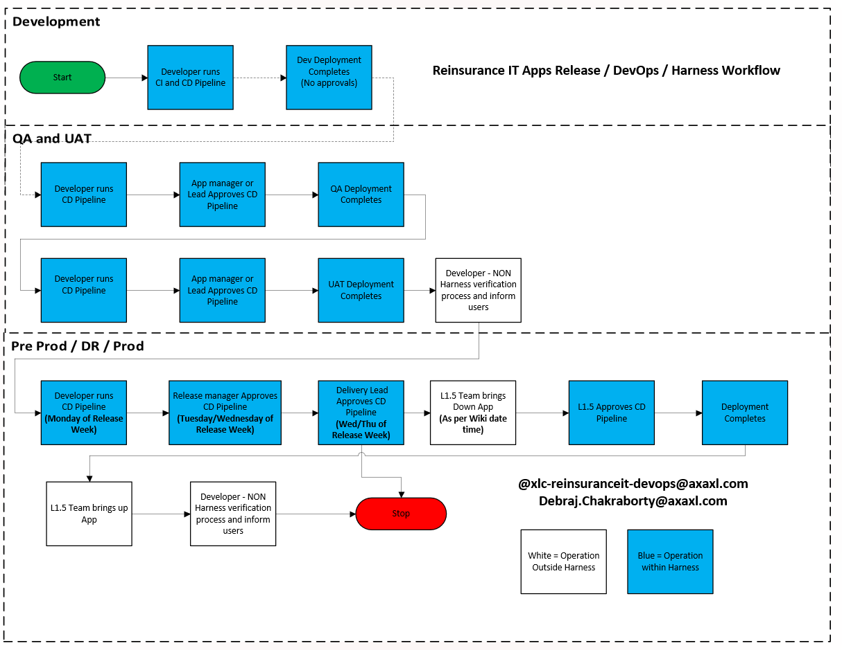
For SIT,PPD, PROD & UAT : Pipeline goes for approval to App Manager/
approval to Release Manager, Delivery Lead and L1.5 Team

Stage Overview: You can specify Harness User Group(s) to approve or reject a pipeline at any point in its execution. During deployment, the User Group members use the Harness Manager to approve or reject the pipeline deployment manually. Learn More
Approvals are added in between Stages to prevent the pipeline execution from proceeding without an approval.
Name: Approval
Advanced:
Stage Variables:
Name: Environment
Value: <+input>.allowedValues(DEV,SIT,PPD,PROD,UAT)
Execution section:
Name: Approval
Timeout: 1d
Approval Message: Please Approve/Reject the deployment for <+stage.variables.Environment> environment
Approvers: Name of the approver or approvers.
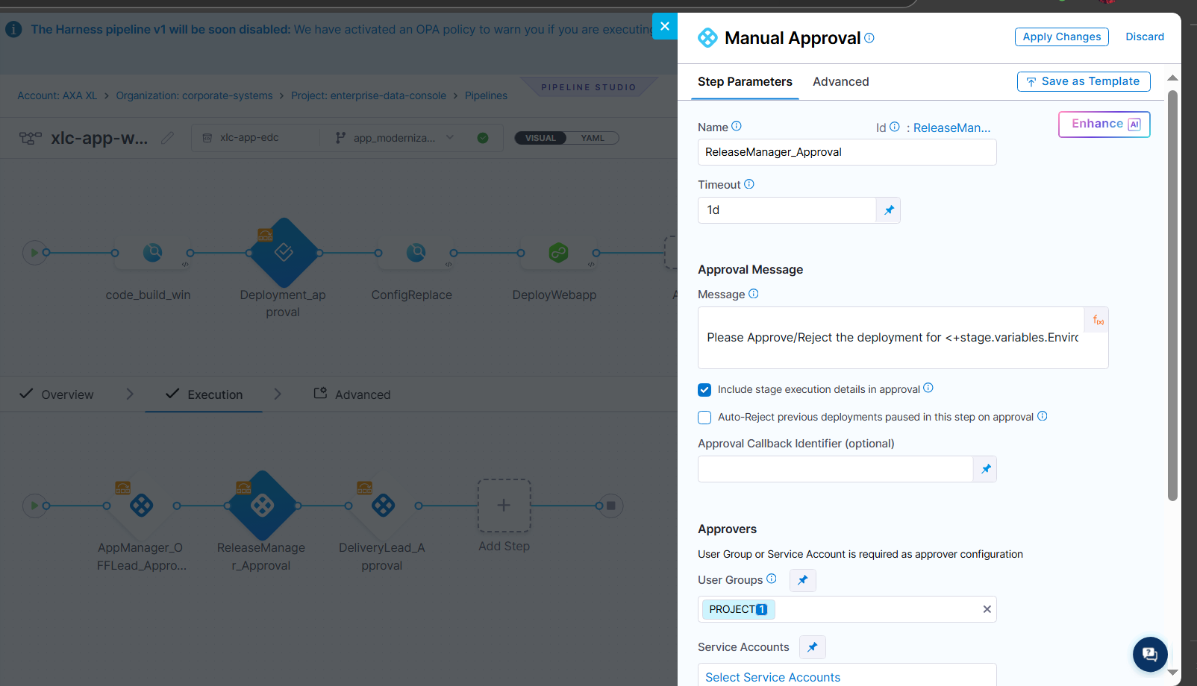

Approval Groups:
- App Management (App Manager + Tech leads)
- Release Management (Hafeeza, Sreeman, Sreeni)
- Delivery Lead
- L1.5 Team (Note: group e-mail does not work in Harness. So before running pipeline, Dev team has to add the name of the L1.5 team member doing the release)
- Notification to BAU DevOps Team for Pre Prod and Prod only (Debraj & Aravind)

Azure PAAS Deploy:
Stage Details:
Name: Service
Service Definition: Azure Web Apps
Deployment Type: The deployment type is how your service will be deployed. For example, using Kubernetes, Native Helm, Serverless, etc. Select the platform for your deployment. When you select a platform, its specific settings appear.
Note: If you change the deployment type (for example, from Kubernetes to Native Helm) there might be some conflicting resources in the target environment. As a result, Stage execution can fail. If this happens, delete all the conflicting resources and try again. You will also lose any deployment type-specific steps in this stage's Execution.
Note: If you switch your Service deployment from Azure DevOps to Harness, note that the actuator information may not immediately reflect the latest version deployed with Harness. This is due to the info being cached from the last Azure DevOps deployment. Verify the actuator info manually to ensure it reflects the correct version.
Artifacts
Add the same Docker image or non-containerized artifact you use in your Azure Web App.
Note: We need to create Environment Specific Jfrog connector for each
Specify Artifact Repository Type:
Artifactory
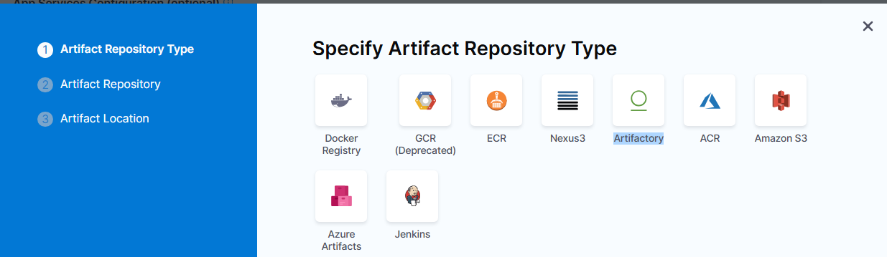

ARTIFACT REPOSITORY:
Here, we can Add multiple ways to pull the artifact from the Jfrog repo
Primary Artifact: <+input> (We can choose to select at the time of CI/CD pipeline trigger)
- Value_<ENV>_WebApp
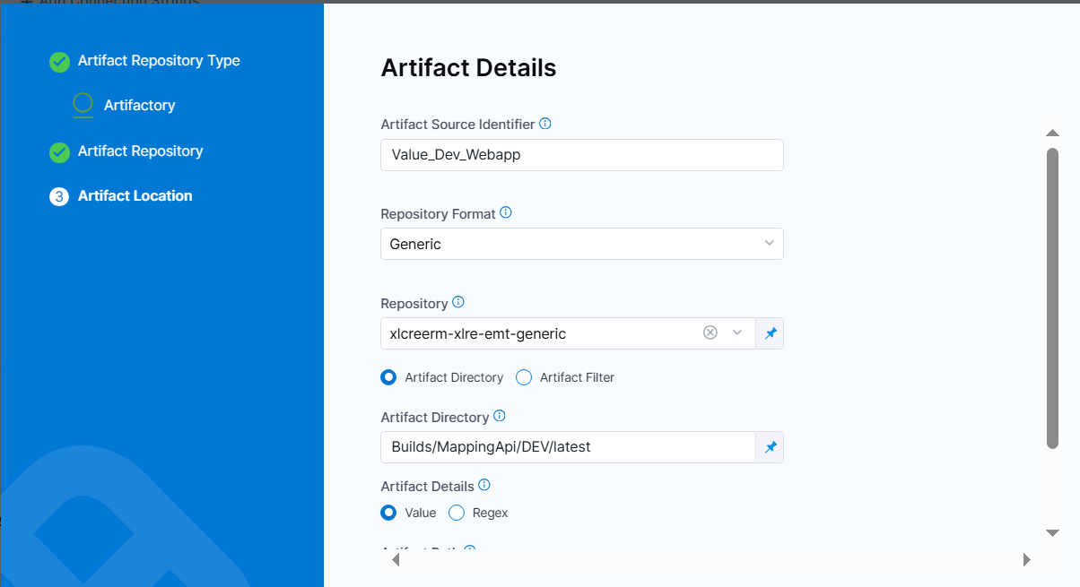
This is for to fetch the builds under respective environment post config changes.

- Seq_<ENV>_Webapp
This is for to fetch the build based on pipeline sequence ID (Build ID): <+pipeline.sequenceId>.zip
Reference:
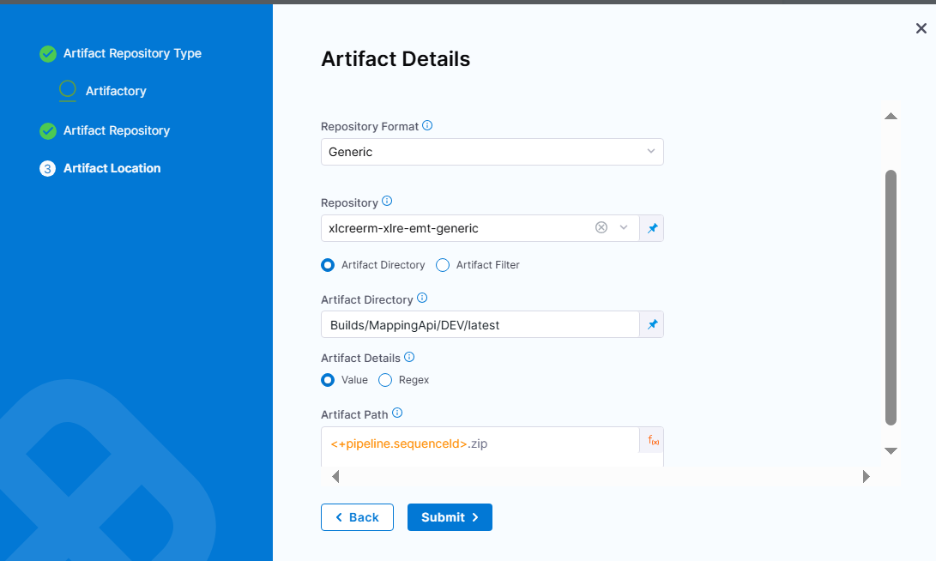

- regex_<ENV>_WebappUI

This is for to fetch latest artifact based on the timestamp of the artifact in the path. 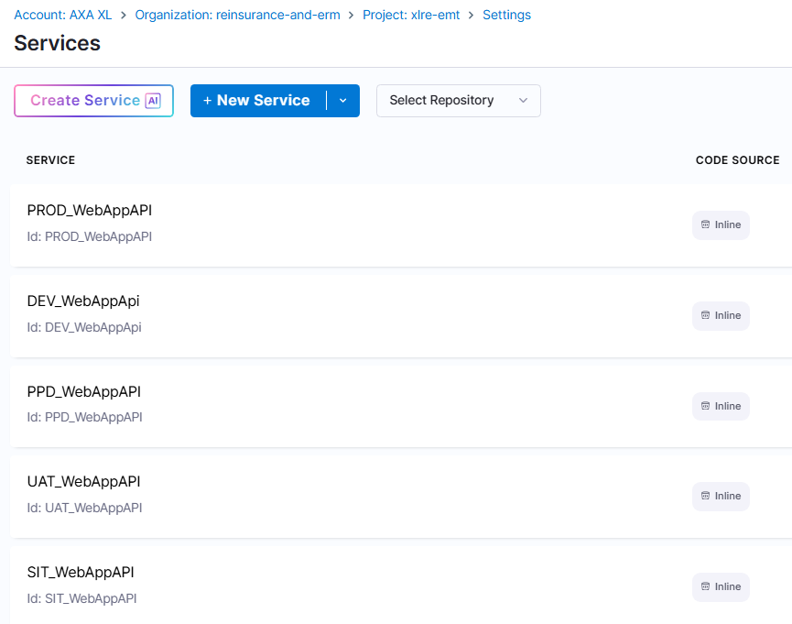
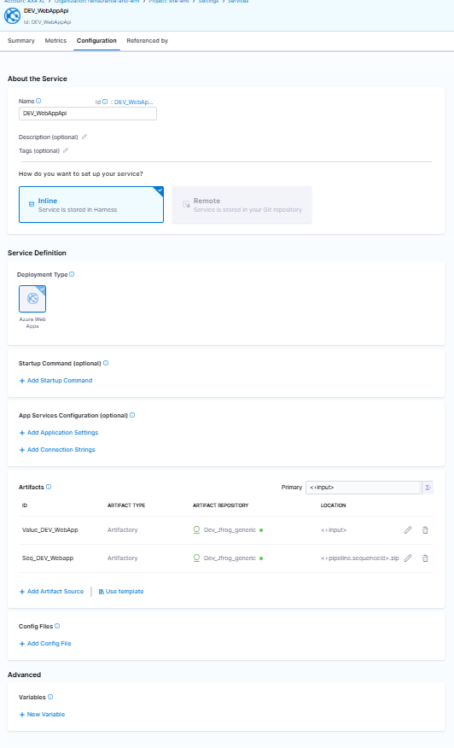
Environment: Harness Environments represent your deployment targets (QA, Prod, etc). You can add the same Environment to as many pipelines and stages as you need
Reference:
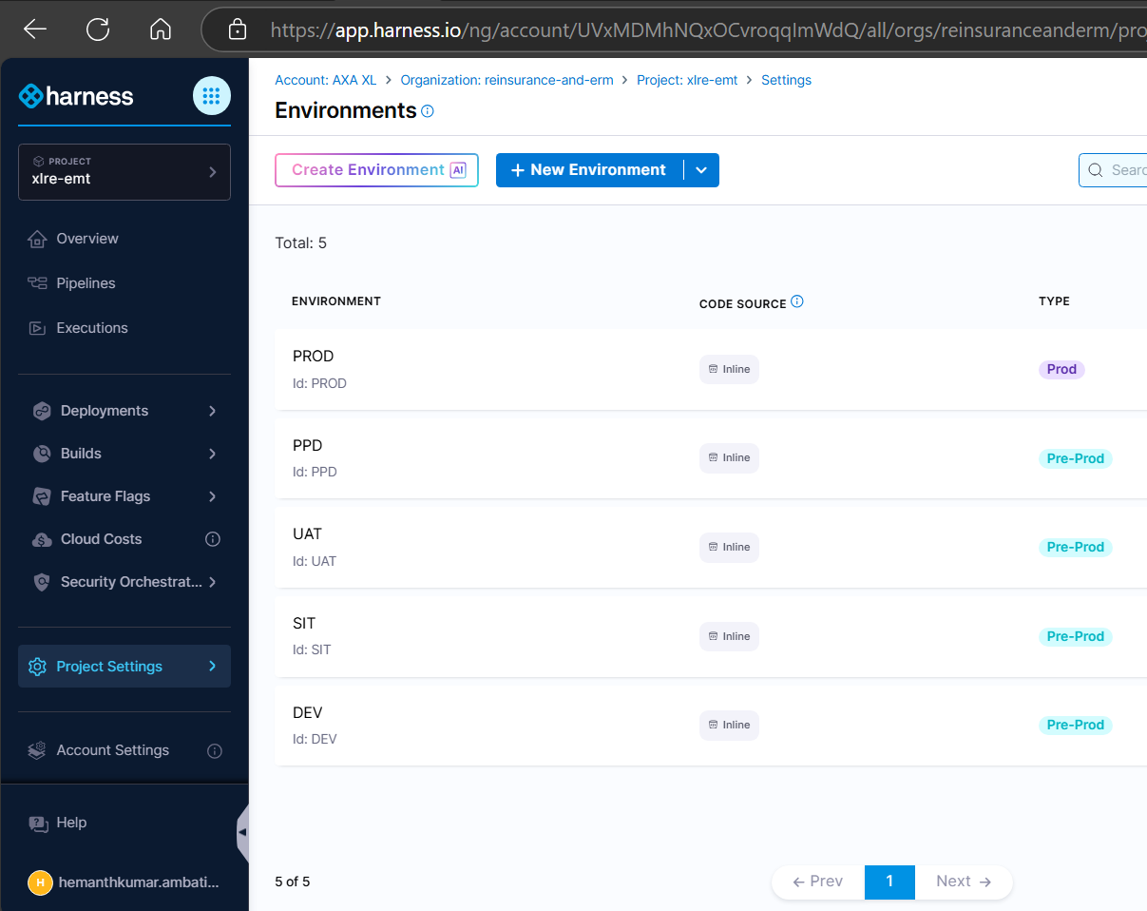

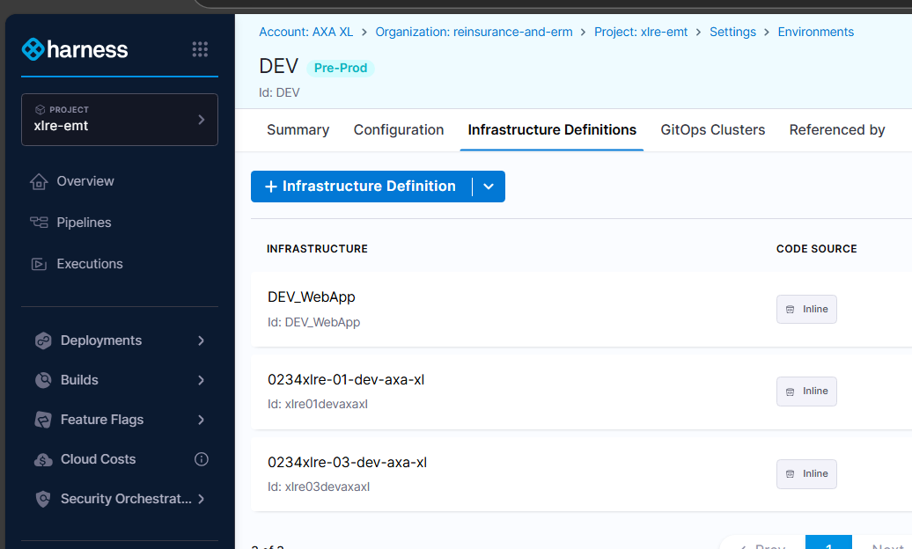
Infrastructure Definition:
Connector: Select or create an Azure Cloud Provider Connector to connect Harness with your Azure subscription. Harness requires certain Web App Roles and Permissions to perform the deployment.
Enter a name for this Connector. You can use the Microsoft Azure Cloud Connector to pull Azure artifacts and deploy your applications to Azure using Harness.

ENV_SERVICE CONNECTIONS:
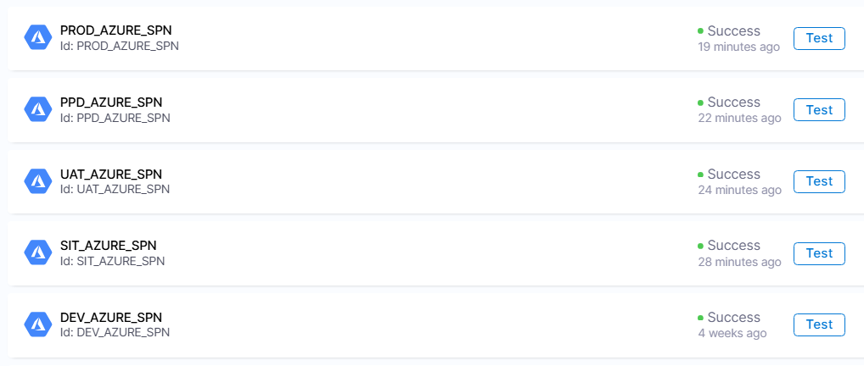

Subscription Id: Select the Azure subscription used by your Web App.
The subscription is in the Web App Overview section of the Azure portal.
Resource Group: Select the resource group used by your Web App.
The resource group is in the Web App Overview section of the Azure portal.
Infrastructure Execution Section: The Slot Deployment step is where you select the Web App and source deployment slot for the deployment.
Azure WebApp Slot Deployment: <+input>
Clean: Select if you want to clean the target directory prior to deployment. For more information, go to the documentation for the az webapp deploy command and see the description of the --clean option. Learn More
Deployment Slot: Enter the name of the Source slot for the deployment. This slot is where Harness deploys the new Web App version. Learn More

Delegate: Select the delegate(s) you want to use to execute this step.

You can select one or more delegates for each pipeline step. You need to select only one of a delegate's tags to select it. All delegates with that tag are selected.

Warning: When the delegate selector is configured at a pipeline, stage, step level, it will override the delegate selector defined in the infrastructure definition's connector. This means that if a delegate has access to a different cluster, it can deploy to a different cluster than the one defined in the Infrastructure Definition.

OpenShift PAAS Deploy:
Stage Details:
Name: Service
Service Definition: Kubernetes
Manifests
Manifest Identifier : <ENV><APP>
Example: DEV_COREAPI
Repository Name: xlc-app-xlre_emt
Git Account URL: https://github.axa.com/xlc-portfolio-reinsurance-and-erm
Git Fetch Type: Latest from Branch
Branch: main
File/Folder Path: Provide Deployment manifest file path
Example: EMT New Project/manifests/deployment_xpo_ui.yaml

Values.yaml: Provide Values manifest file path
EMT New Project/manifests/Values_SIT.yaml
Reference:
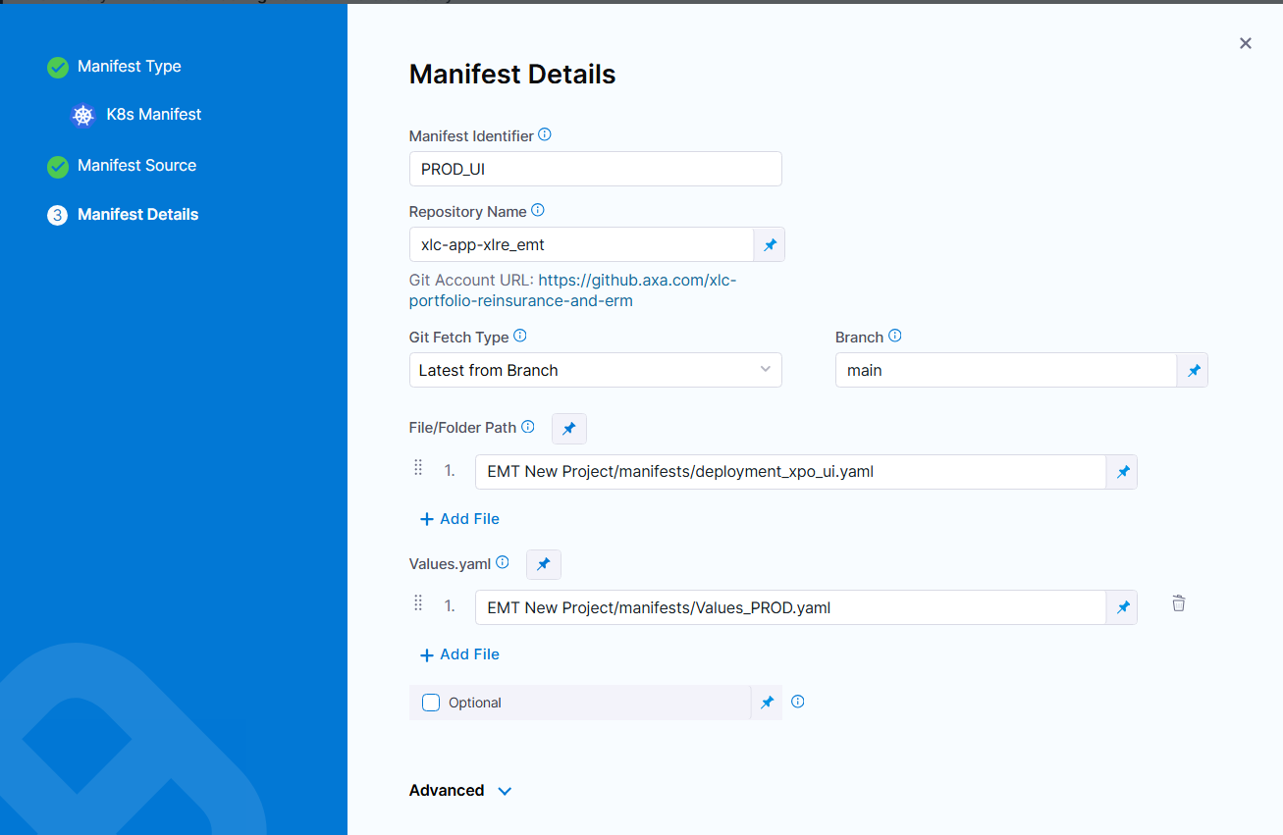
Artifacts
Add the same Docker image or non-containerized artifact you use in your Azure Web App.
Note: We need to create Environment Specific Jfrog connector for each
Specify Artifact Repository Type:
Artifactory
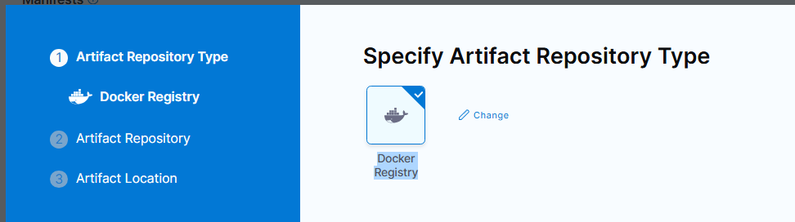

ARTIFACT REPOSITORY:
Here, we can Add multiple ways to pull the artifact from the Jfrog repo
Primary Artifact: <+input> (We can choose to select at the time of CI/CD pipeline trigger)
Repo: xlcreerm-xlre-emt-docker
- Value_ xlre<Seq.Number><ENV>axaxl 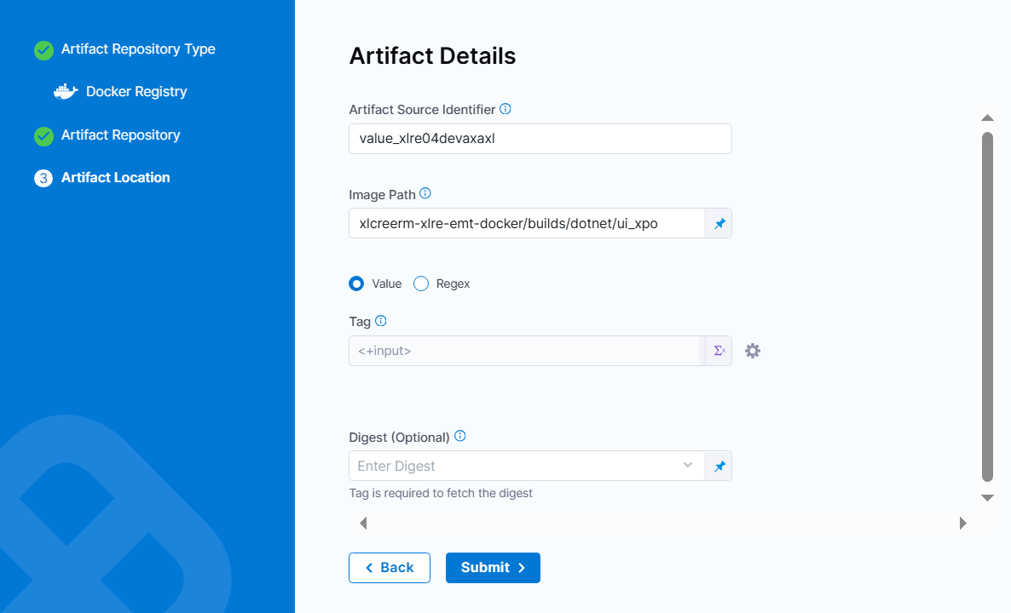
This is for to fetch the builds under respective environment post config changes.

- Seq_xlre<Seq.Number><ENV>axaxl
This is for to fetch the build based on pipeline sequence ID (Build ID): <+pipeline.sequenceId>.zip
Reference:
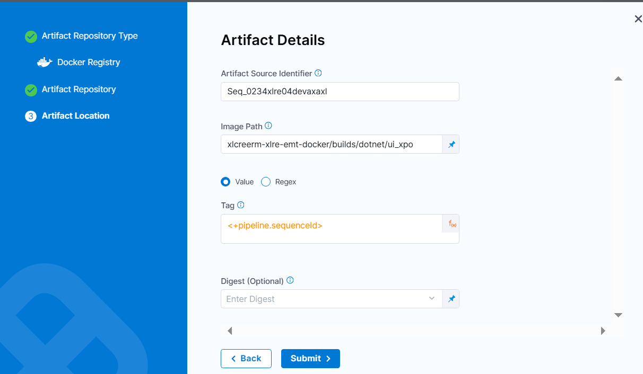

- regex_<ENV>_WebappUI
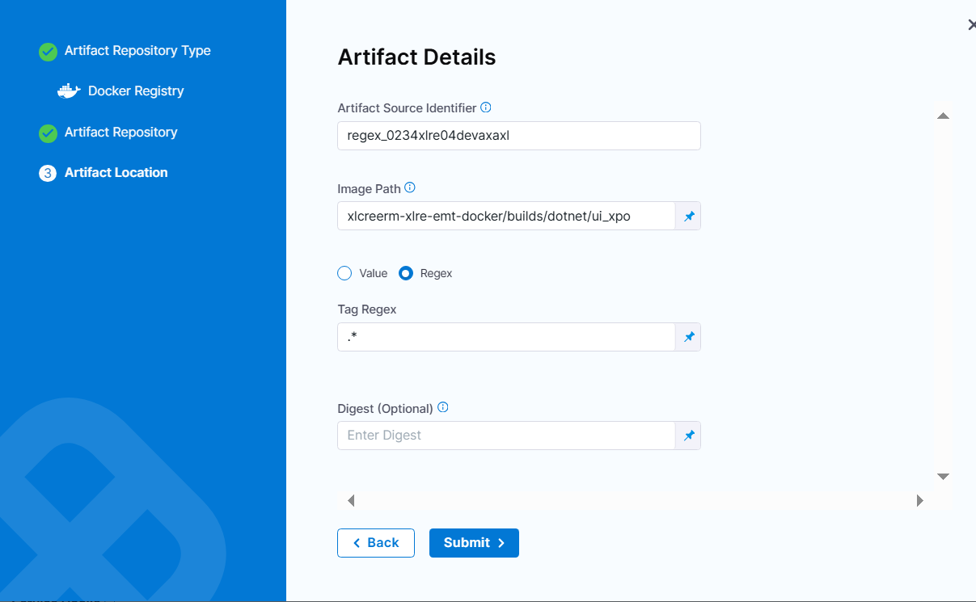
This is for to fetch latest artifact based on the timestamp of the artifact in the path.

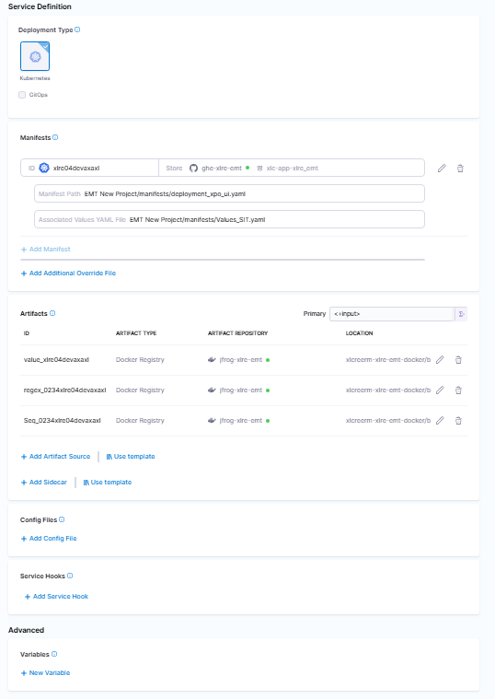

Core_API Services:
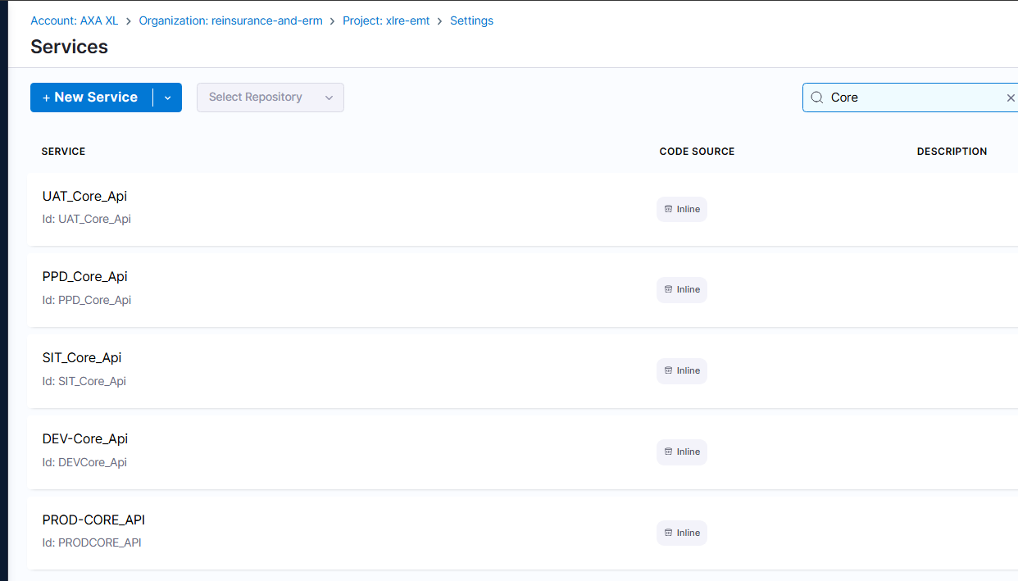
XPO_UI Services:
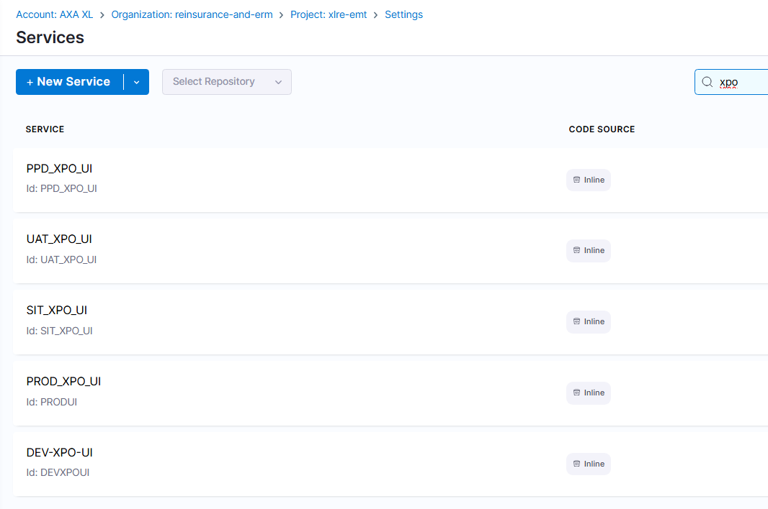
Environment: Harness Environments represent your deployment targets (QA, Prod, etc). You can add the same Environment to as many pipelines and stages as you need
Reference: 

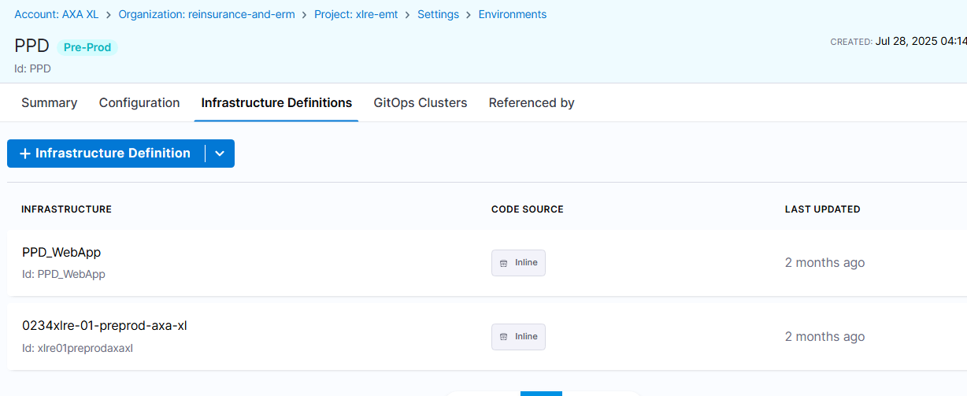
Infrastructure Definition:
Kubernetes
Connector Select or create the Connector that connects Harness to your target cluster.
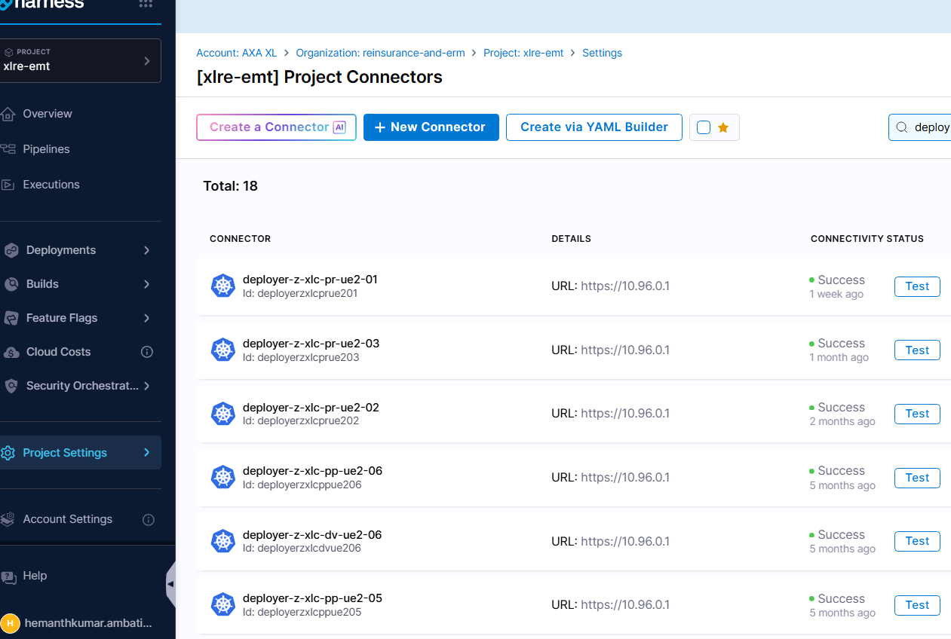
Select respective environment specified connector for each application
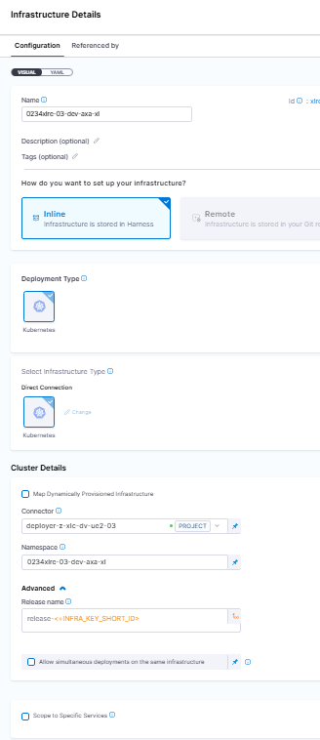

NameSpace: Select the Namespace used by your Openshift.
The Namespace is in the ENV section of the CPP portal.
Infrastructure Execution Section: K8s Rollout Deploy
Rollout Deployment: <+input>

The K8s Rollout Deploy step performs a rolling update strategy.

It updates Kubernetes deployments with zero downtime by incrementally updating pod instances with new ones. New pods are scheduled on nodes using the available resources.

Delegate: Select the delegate(s) you want to use to execute this step.

You can select one or more delegates for each pipeline step. You need to select only one of a delegate's tags to select it. All delegates with that tag are selected.

Warning: When the delegate selector is configured at a pipeline, stage, step level, it will override the delegate selector defined in the infrastructure definition's connector. This means that if a delegate has access to a different cluster, it can deploy to a different cluster than the one defined in the Infrastructure Definition.
Region wise -build Namespaces details
Resource location | eastus | centralus | northeurope | westeurope
npd/dev namespace | deployer-shared-ue2-dev-axa-xl  or  builds-shared-axa-xl
Preprod- build namespace | deployer-shared-ue2-preprod-axa-xl |  | deployer-shared-en1-preprod-axa-xl
Prod-build-namespace | deployer-shared-ue2-prod-axa-xl | deployer-shared-uc1-prod-axa-xl | deployer-shared-en1-prod-axa-xl | deployer-shared-ew1-prod-axa-xl

Restart pipeline (UI and API).
  - Cache load method should be called from Start Up method
  - Until cache is loaded, POD/ Web App will not accept requests
  - Applies Both POD and Web Apps
Name: xlc-app-restart-CoreApi-openpaas
Trigger / scheduled: Cron Expression
30 23 * * *
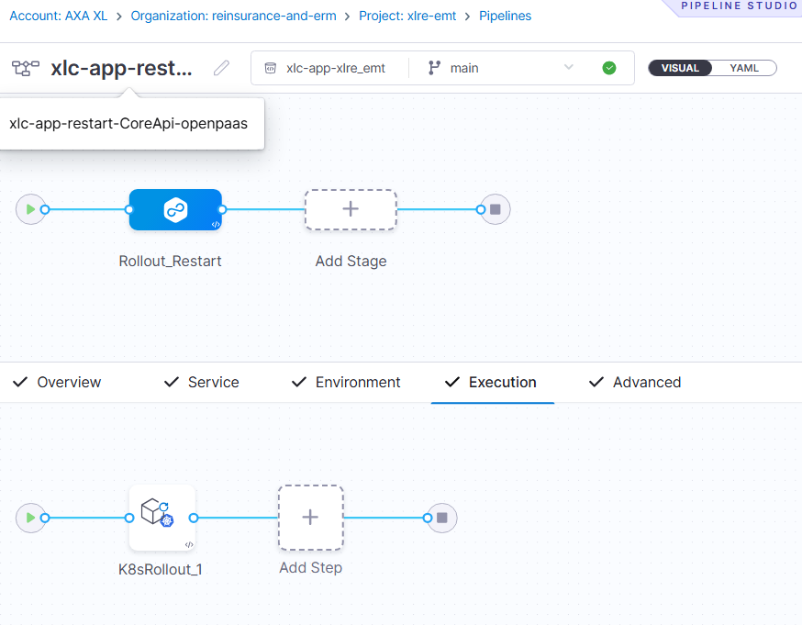
URL:
https://app.harness.io/ng/account/UVxMDMhNQxOCvroqqImWdQ/all/orgs/reinsuranceanderm/projects/xlcapp0234xlre/pipelines/xlcapprestartCoreApiopenpaas/pipeline-studio/?storeType=REMOTE&connectorRef=ghe0234xlre&repoName=xlc-app-xlre_emt&branch=main
Name xlc-app-restart-XPO_UI-openpaas
Trigger / scheduled: Cron Expression
30 23 * * *
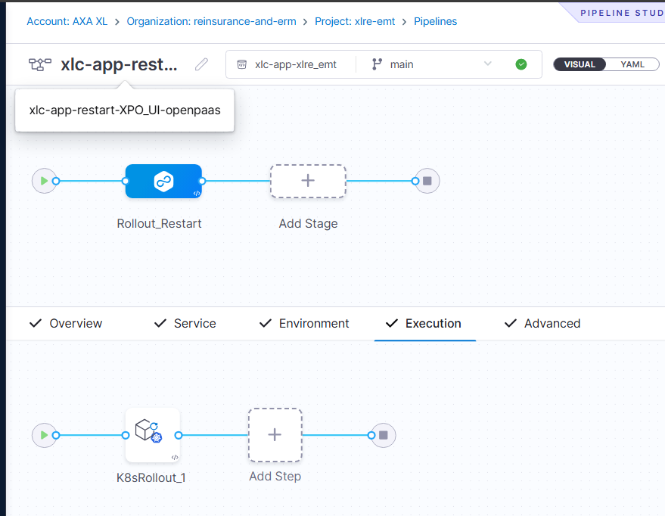
URL: https://app.harness.io/ng/account/UVxMDMhNQxOCvroqqImWdQ/all/orgs/reinsuranceanderm/projects/xlcapp0234xlre/pipelines/xlcapprestartXPO_UIopenpaas/pipeline-studio/?storeType=REMOTE&connectorRef=ghe0234xlre&repoName=xlc-app-xlre_emt&branch=main

Name xlc-app-restart-mappingApi-azws
Trigger / scheduled: Cron Expression
30 23 * * *

URL: https://app.harness.io/ng/account/UVxMDMhNQxOCvroqqImWdQ/all/orgs/reinsuranceanderm/projects/xlcapp0234xlre/pipelines/xlcapprestartmappingApiazws/pipeline-studio/?storeType=REMOTE&connectorRef=ghe0234xlre&repoName=xlc-app-xlre_emt&branch=main
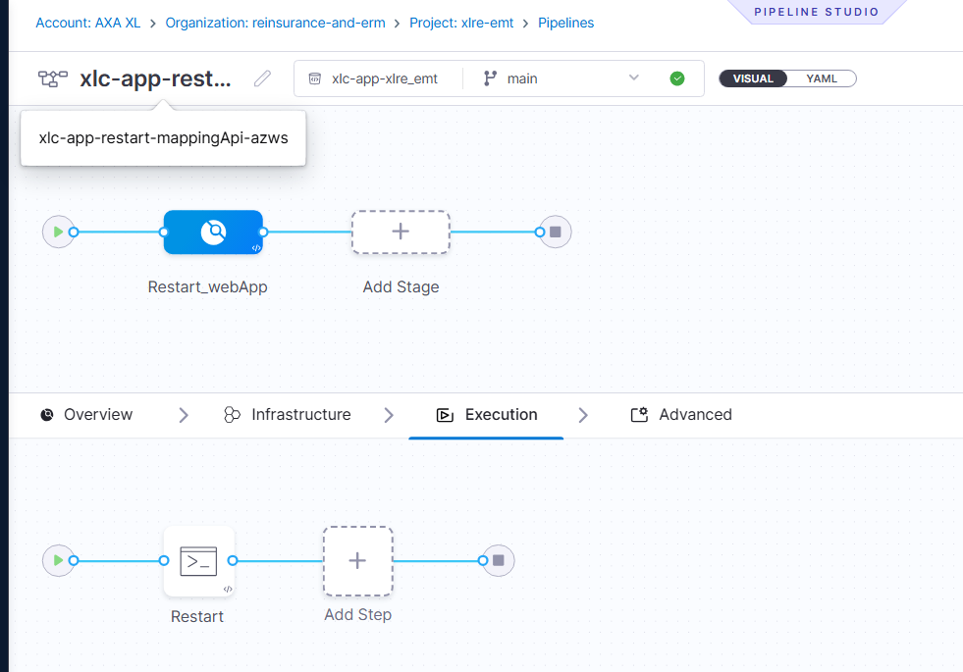

Certificate Renewal Process – Documentation:
As part of SSL-Certs process, there are 3 types of requests for Newly on-boarded application:

- DNS Management Request
Azure PAAS
Open PAAS
- Certificate Request
- Pfx Public Cloud - Custom Domain Management.
To raise RITM Request, please refer RITM Table below.
For Renewal of existing certs, only 2 types of requests should raise.
- If Open Paas based application, only Certificate Request is required.
- If it is for Azure Paas application, both Certificate Request & Pfx Public Cloud - Custom Domain Management is required.

SSL Certificates/PFX Requests:
Renewal Process
Stage1: Certificate Request
Step 1: RITM (Request Item) Creation
Login to Silva.
Navigate to: Unified Navigation App | ServiceNow → Catalog → Certificate Request.
Fill in mandatory details from the reference RITM (Ex: RITM8998775pick the respective Env> RITM for your reference)
Certificate Name
Application Name
Expiry Date
Environment (Dev/QA/Prod)
Technical Owner/Approver
Submit the request → An RITM ticket is generated.
Step 2: Certificate Renewal Implementation
Approval Stage
Application Owner / Security Team approves the request.
Change request (Auto created by Team) is linked to the RITM.
Certificate Generation
New certificate is generated via same RITM.
Stage2: Public Cloud - Custom Domain Management
Export certificate with PFX key. Fill in mandatory details from the reference RITM (Ex: RITM8998775pick the respective Env> RITM for your reference)
Submit the request → An RITM ticket is generated.

.pfx
.SAN
.csr

> To Generate .csr, we need to make sure Generate certificate.sh, SAN.cnf should place in path and run the updated Generate certificate.sh

To Generate .pfx, we need to make sure Generate pfx.sh, SAN.cnf, .csr and Certificate RITMzip should place in path and run the updated Generate certificate.sh

How to Update in Harness: (You need to covert .cer, .key, .pfx files to base64)
- Certificate file (.cer)
- Key file (.key)
- PFX File (.pfx)
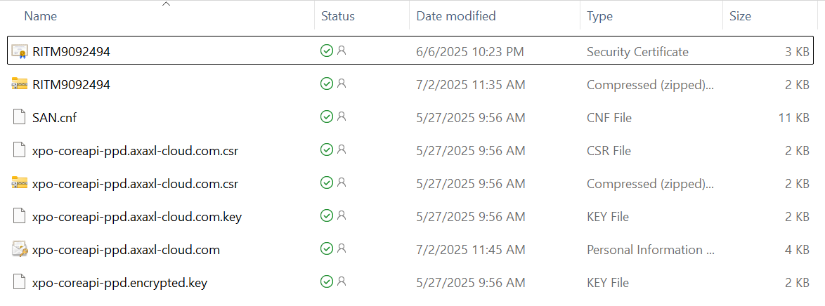
Certificate: Issued through RITM as above mentioned.
Key file (.key): Generated as part of csr process.
PFX File (.pfx): Created by running generate-pfx script
All three values you need to upload in each harness secrets based on the environment as mentioned in the yaml file
Go to GITHUB repo> Manifest > go to respective application values.yaml file:
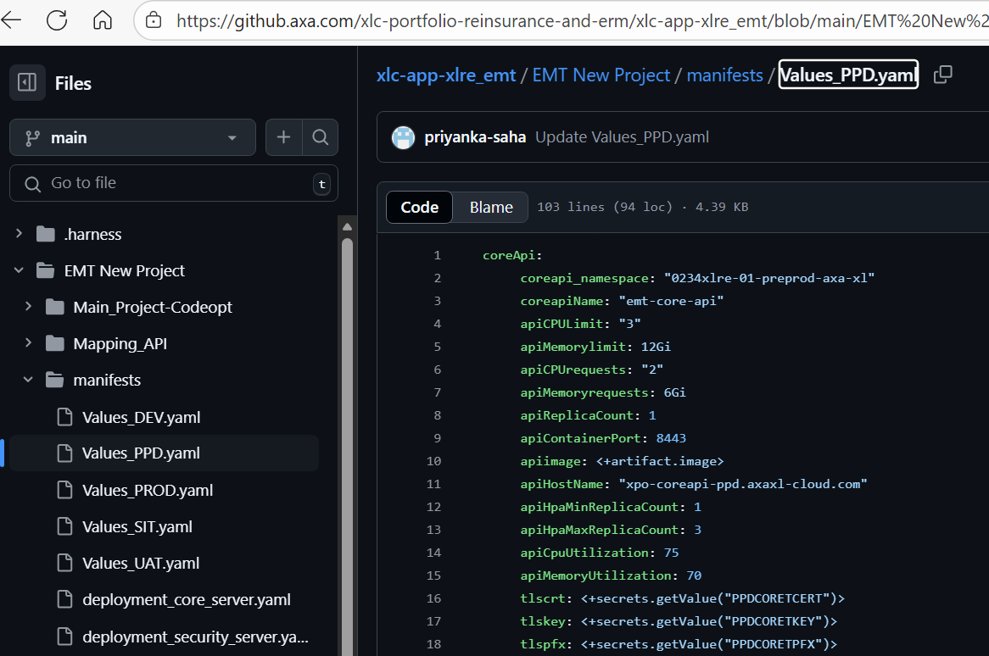
Certificate value should update in value of tlscrt
Key value should update in value of tlskey
PFX value should update in value of tlspfx:

Before updating the values, you need to encode base64 by running the command as follows:
base64 (RITM) > name.txt
Example:
base64 RITM9092494.cer > cert.txt
base64 xpo-coreapi-ppd.axaxl-cloud.com.key > key.txt
base64 xpo-coreapi-ppd.axaxl-cloud.com.pfx > pfx.txt

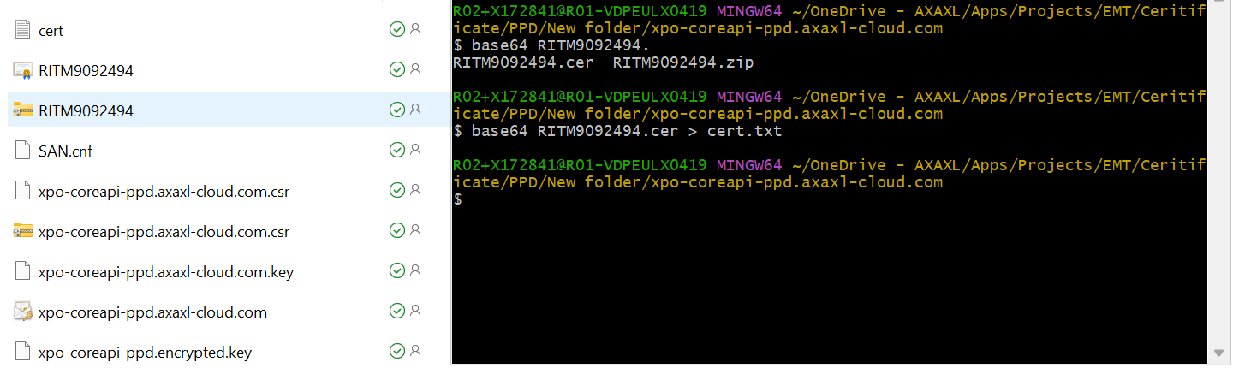
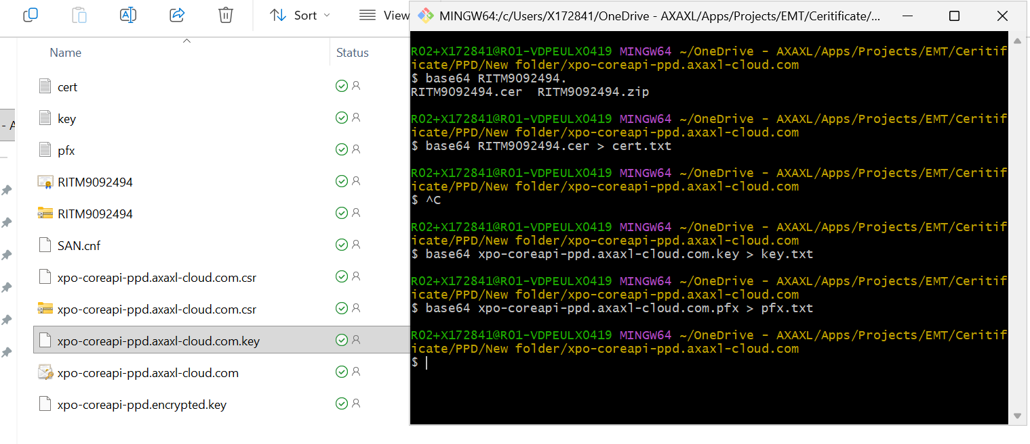
Let`s say I want to update the values:
PPDCORETCERT
PPDCORETKEY
PPDCORETPFX
Open each text file >> copy the content of the file>> Open harness secret value of PPDCORETCERT and update the value accordingly.
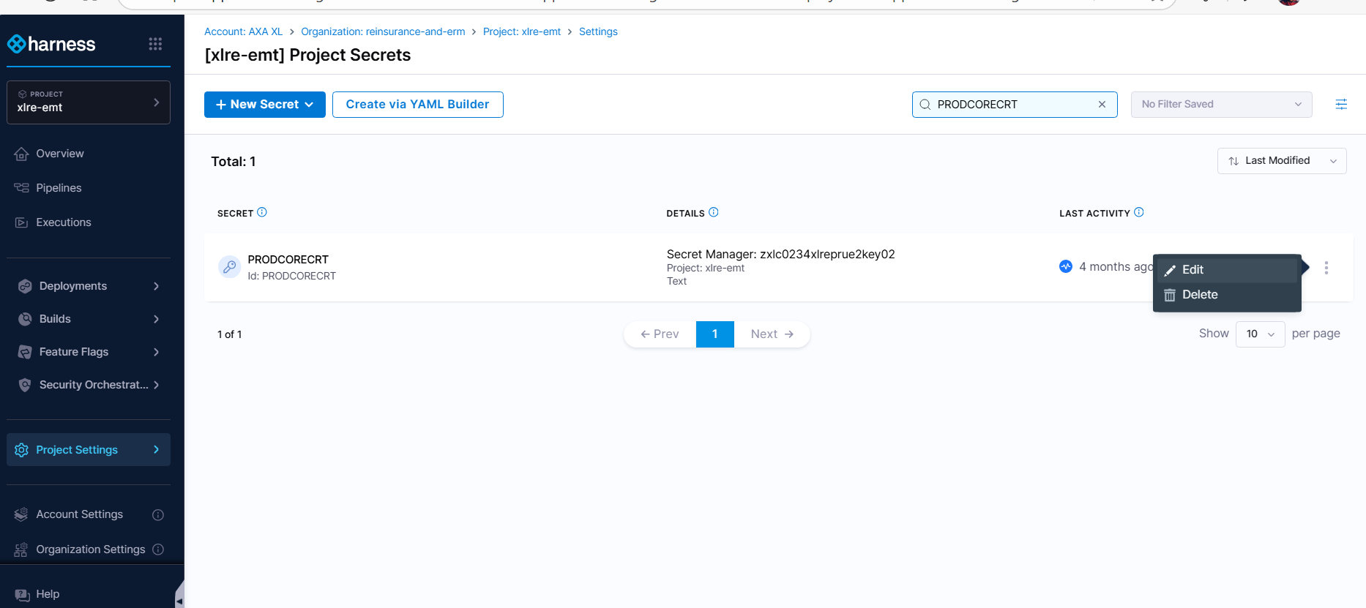
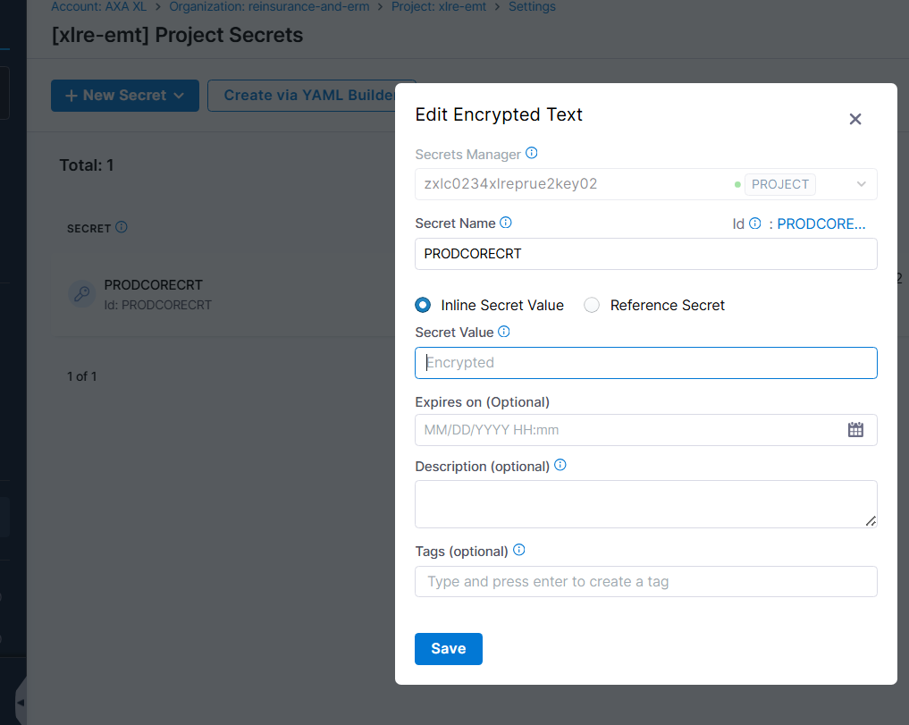

Update the values accordingly and save.
Validation
Validate by testing application endpoints.
Update reflects in the certificate URL with the new expiry date.
App Registration Renewals
No manual action is required from the Support Team.
Cloud Infra Team performs App Registration certificate/key renewal automatically.
After renewal, an auto-generated email notification is sent to the respective App Teams.
Support team’s responsibility:
Only acknowledge the mail if received.
No RITM creation or process steps needed.

RITM Table:
URL | DNS Management | Certificate Request | Pfx Public Cloud
https://xpo-dev.axaxl-cloud.com | RITM8995794 | RITM8998741 | Not required
https://xpo-securityapi-dev.axaxl-cloud.com | RITM8995839 | RITM8998775 | Not required
https://xpo-coreapi-dev.axaxl-cloud.com | RITM8995822 | RITM8998698 | Not required
https://xpo-mappingapi-dev.axaxl-cloud.com | RITM8995871 | RITM8998761 | RITM9026374
xpo-sit.axaxl-cloud.com | RITM9092383 | RITM9092474
xpo-securityapi-sit.axaxl-cloud.com | RITM9092379 | RITM9092437
xpo-coreapi-sit.axaxl-cloud.com | RITM9092373 | RITM9092431
xpo-mappingapi-sit.axaxl-cloud.com | RITM9092370 | RITM9055958 | RITM9092539
xpo-ppd.axaxl-cloud.com | RITM9092410 | RITM9092497
xpo-securityapi-ppd.axaxl-cloud.com | RITM9092402 | RITM9092496
xpo-coreapi-ppd.axaxl-cloud.com | RITM9092400 | RITM9092494
xpo-mappingapi-ppd.axaxl-cloud.com | RITM9092397 | RITM9055976 | RITM9092542
xpo-uat.axaxl-cloud.com | RITM9092393 | RITM9092490
xpo-securityapi-uat.axaxl-cloud.com | RITM9092390 | RITM9092484
xpo-coreapi-uat.axaxl-cloud.com | RITM9092387 | RITM9092480
xpo-mappingapi-uat.axaxl-cloud.com | RITM9092384 | RITM9055964 | RITM9092547
xpo.axaxl-cloud.com | RITM9092424 | RITM9092502
xpo-securityapi.axaxl-cloud.com | RITM9196724 | RITM9196747
xpo-coreapi.axaxl-cloud.com
xpo-mappingapi.axaxl-cloud.com | RITM9092421 | RITM9055981 | RITM9092552

Harness useful links:
- Technical design : XLRe EMT (XPO) - Technical Design - RADAR - Confluence by AXA GO
- Reusable Code for CI and CD through Harness: Reusable Code for CI and CD through Harness - XLC GT MttC - Confluence by AXA GO
- Reusable Solution - CI/CD pipelines for deployment in OpenShift: Reusable Solution - CI/CD pipelines for deployment in Openshift - XLC GT MttC - Confluence by AXA GO
- Automation Test Pipeline Setup in Harness: How To Setup Automation Test Pipeline - Cloud Transformation - XL Catlin Wiki
- Connect to Azure Storage account using Azure AD via Harness :Connect to Azure Storage Account via Harness using Azure AD - XLC GT MttC - Confluence by AXA GO
- Solution to generate CSR for Windows and Linux Server: How to Generate CSR using OpenSSL - Cloud Transformation - XL Catlin Wiki
- SSDT Database build and Database Deployment in ADO/harness :Database build and Deployment using CI/CD Pipeline - XLC GT MttC - Confluence by AXA GO
- Creating A Secure Route In OpenShift : How To Create A Secure Route In OpenShift - Cloud Transformation - XL Catlin Wiki
- Configuring Key Vault secrets in Harness Pipeline : Configuration Of Secrets In Harness - Cloud Transformation - XL Catlin Wiki
- Upload File to Artifactory using a shell script: Push File to Artifactory from a Linux VM - Cloud Transformation - XL Catlin Wiki
- Upload WAR to Artifactory from Harness Pipeline: Pull Executable File from Artifactory in Pipeline - Cloud Transformation - XL Catlin Wiki

-------------------------------.---------------------<<THE END>>-----------.------------------------.------------------------.------------

