MINI PROJECT REPORT

Data Mining and Data Preprocessing
for Knowledge Discovery

Course: Data Mining — PEC-AIML601B
Dataset: UCI Heart Disease Dataset (Cleveland Clinic Foundation)
Tools: Python 3 · Pandas · NumPy · Matplotlib · Seaborn · Scikit-learn
Domain: Healthcare Analytics
Date: March 2026

1. Introduction
The exponential growth of data in modern digital systems has created both an opportunity and a challenge: extracting meaningful knowledge from vast, heterogeneous, and noisy datasets. Data Mining — defined as the process of discovering patterns, correlations, anomalies, and useful insights from large collections of data — lies at the heart of modern Artificial Intelligence and Machine Learning systems. However, raw data is rarely ready for direct analysis; it must first be understood, cleaned, transformed, and structured through a rigorous preprocessing pipeline.
This mini-project follows the Knowledge Discovery in Databases (KDD) framework, a systematic, multi-phase process that transforms raw data into actionable knowledge. The KDD process encompasses data selection, preprocessing, transformation, data mining, and interpretation. By applying each stage of this framework to a real-world medical dataset, this project demonstrates how principled data preparation directly determines the quality and reliability of machine learning outcomes.
1.1 Objectives
- Apply the KDD workflow to a real-world healthcare dataset end-to-end.
- Identify and classify attribute types (nominal, ordinal, binary, numerical).
- Perform exploratory data analysis (EDA) to uncover patterns and distributions.
- Compute similarity and association measures between data objects.
- Detect and handle data quality issues — missing values, outliers, and inconsistencies.
- Build a scikit-learn preprocessing pipeline and evaluate a baseline classifier.
- Derive meaningful healthcare insights from the preprocessing-transformed data.
1.2 Project Theme
"From Raw Data to Knowledge: A Data Mining Case Study" — students move from running algorithms blindly to deeply understanding why data preparation determines machine learning success.

2. Dataset Description
2.1 Source and Origin
The dataset used in this project is the Cleveland Heart Disease Dataset, sourced from the UCI Machine Learning Repository (archive.ics.uci.edu). It was originally collected at the Cleveland Clinic Foundation by Dr. Robert Detrano and colleagues. The dataset has been widely used as a benchmark for binary classification tasks in medical informatics since its public release.
2.2 Application Domain and Context
The domain is cardiology and healthcare analytics. Heart disease is the leading cause of death globally, and early, data-driven detection of risk factors can allow clinicians to intervene before acute events occur. This dataset captures physiological and clinical measurements from 303 patients who underwent cardiac evaluation. The prediction task is to determine the presence or absence of coronary artery disease from these measurements.
2.3 Dataset Characteristics
Characteristic | Details
Instances (Patients) | 303
Attributes (Features) | 13 input + 1 target
Missing Values | 6 (in 'ca' and 'thal' columns)
Attribute Types | Nominal, Binary, Ordinal, Numerical
Target Variable | Heart disease diagnosis (0 = No, 1 = Yes)
Class Distribution | ~54% No Disease, ~46% Disease

2.4 Knowledge That Can Be Extracted
Systematic analysis of this dataset can yield several categories of knowledge:
- Risk-factor patterns: Which physiological markers most strongly predict cardiac disease.
- Patient segmentation: Clusters of patients with similar risk profiles.
- Decision boundaries: Linear or non-linear thresholds separating disease vs. no-disease patients.
- Feature importance: Ranking of clinical attributes by predictive power.
- Healthcare protocols: Evidence-based screening criteria for high-risk populations.
2.5 Real-World Decisions Supported
Insights from this dataset can support clinical decisions such as identifying patients who need immediate angiographic evaluation, prioritizing stress tests for borderline patients, reducing unnecessary invasive procedures for low-risk individuals, and designing preventive care programmes for high-risk population groups.

3. Data Objects and Attributes
3.1 Definitions
A data object (also called a sample, instance, or observation) is a single patient record — one row in the dataset. Each data object is described by a vector of d attribute values, formally represented as:
X = (x₁, x₂, …, x₁₃)
An attribute (also called a feature or variable) is a measurable property of the data object. Attributes must be carefully classified before analysis, because the type determines which statistical operations and distance measures are valid.
3.2 Attribute Classification Table
Attribute | Type | Value Range | Description
age | Numerical (Ratio) | Integer (years) | Patient age in years
sex | Binary | {0, 1} | 0 = Female, 1 = Male
cp | Nominal | {0, 1, 2, 3} | Chest pain type (4 categories)
trestbps | Numerical (Ratio) | mm Hg | Resting blood pressure
chol | Numerical (Ratio) | mg/dl | Serum cholesterol level
fbs | Binary | {0, 1} | Fasting blood sugar > 120 mg/dl
restecg | Ordinal | {0, 1, 2} | Resting ECG results
thalach | Numerical (Ratio) | bpm | Maximum heart rate achieved
exang | Binary | {0, 1} | Exercise-induced angina
oldpeak | Numerical (Ratio) | ST depression | ST depression induced by exercise
slope | Ordinal | {0, 1, 2} | Slope of peak-exercise ST segment
ca | Ordinal | {0, 1, 2, 3} | No. of major vessels (fluoroscopy)
thal | Nominal | {1, 2, 3} | Thalassemia diagnosis type
target | Binary (Label) | {0, 1} | Heart disease: 0=No, 1=Yes

3.3 Description of Attribute Types Used
Nominal: Categories with no inherent order (e.g., cp, thal). Only equality comparisons are valid.
Binary: A special case of nominal with exactly two outcomes (e.g., sex, fbs, exang). Encodes presence/absence.
Ordinal: Ordered categories where differences between values may not be uniform (e.g., restecg, slope, ca).
Numerical (Ratio): Continuous values with a meaningful zero point and equal intervals (e.g., age, chol, thalach). All arithmetic operations apply.

4. Similarity and Association Analysis
4.1 Correlation Analysis
Correlation measures the statistical relationship between two variables. We computed both Pearson and Spearman correlation coefficients between each feature and the target variable to understand linear and monotonic associations respectively.
4.1.1 Pearson Correlation
Pearson's r measures the linear relationship between two continuous variables, assuming normality and equal intervals. It ranges from −1 (perfect negative) to +1 (perfect positive). From our analysis, thalach (r ≈ −0.42) showed the strongest negative correlation with the target — patients with higher maximum heart rates are less likely to have disease. oldpeak (r ≈ +0.43) showed the strongest positive correlation.
4.1.2 Spearman Correlation
Spearman's ρ is a rank-based, non-parametric measure suited for ordinal features and non-linear monotonic relationships. For ordinal attributes such as cp, slope, and restecg, Spearman coefficients diverged noticeably from Pearson values, confirming non-linear associations. This highlights the importance of using rank-based measures for clinical ordinal data.
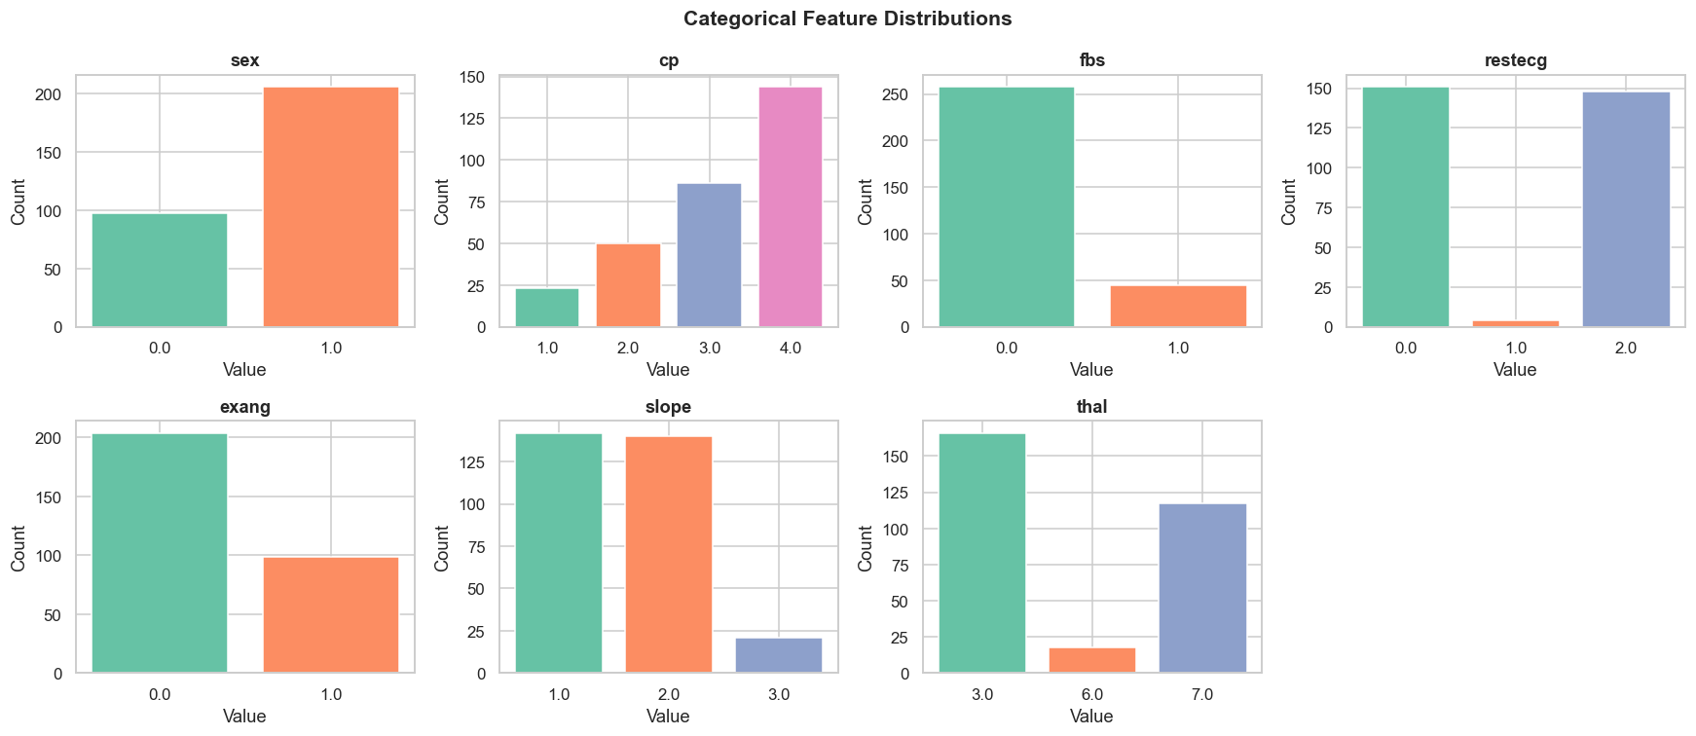
Figure 2: Pearson vs. Spearman Correlation with Target Variable
4.2 Pairwise Similarity Measures
Similarity measures quantify how alike two data objects are. We computed three distinct measures on a sample of 10 patients to illustrate how different distance metrics capture different aspects of similarity.
4.2.1 Euclidean Distance
Euclidean distance measures the straight-line distance in feature space. Features were standardised (zero mean, unit variance) before computing distances to prevent scale dominance. The formula is:
d(x, y) = √[ Σᵢ (xᵢ − yᵢ)² ]
Patients with similar age, blood pressure, cholesterol, and heart rate profiles yield low Euclidean distances, indicating physiological similarity.
4.2.2 Cosine Similarity
Cosine similarity measures the cosine of the angle between two feature vectors and is particularly effective when the magnitude of the vector is less important than its direction. It is computed as:
cos(x, y) = (x · y) / (‖x‖ · ‖y‖)
4.2.3 Jaccard Similarity
Jaccard similarity is defined for binary attributes (sex, fbs, exang) as the ratio of shared positive attributes to the union of positive attributes:
J(A, B) = |A ∩ B| / |A ∪ B|
A Jaccard value of 1.0 indicates two patients share all binary characteristics, while 0.0 indicates no shared binary attributes. These heatmaps revealed clinically distinct patient subgroups based on gender and exercise response patterns.
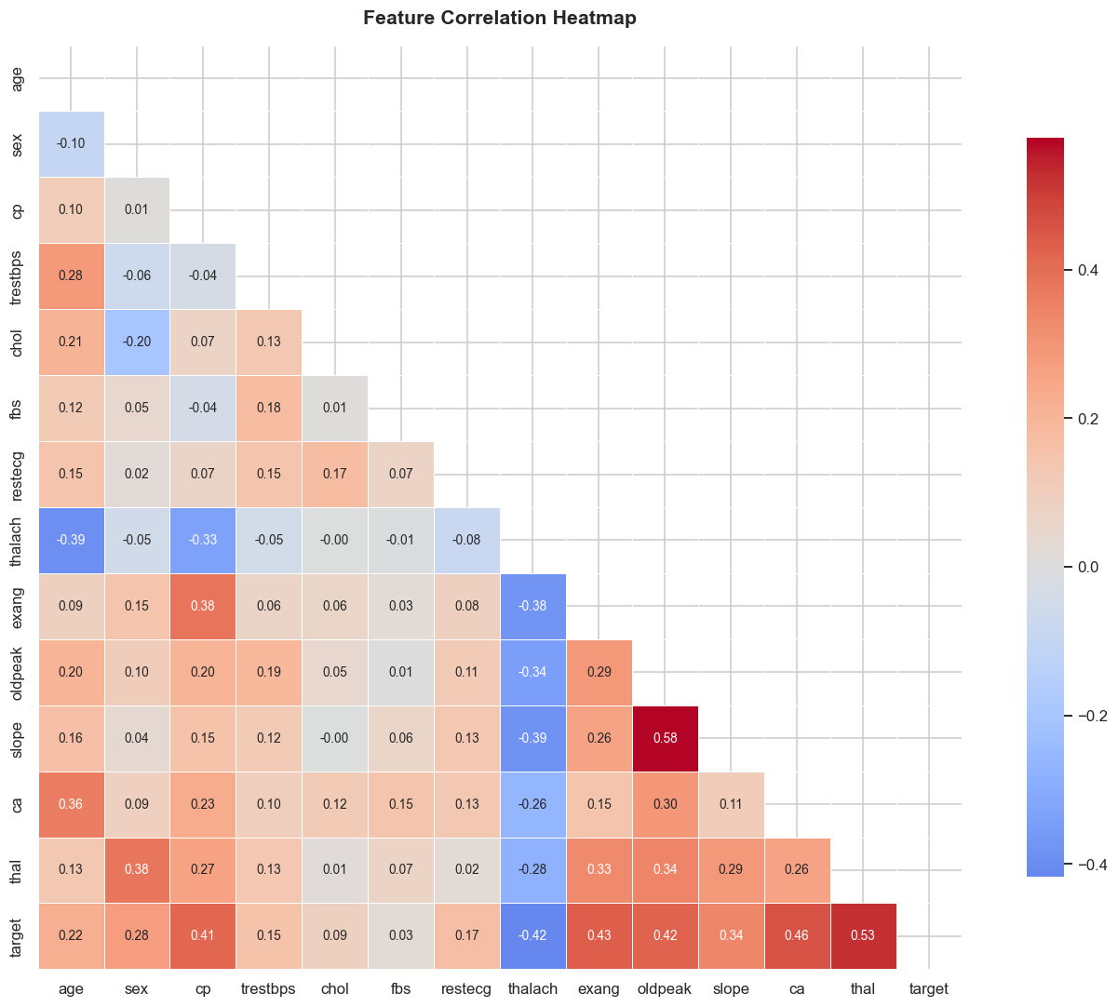
Figure 3: Similarity / Dissimilarity Matrices — Euclidean, Cosine, and Jaccard

5. Data Quality Study
Data quality assessment is a critical precursor to any analytical pipeline. Poor data quality leads to biased models, misleading insights, and erroneous clinical decisions. We conducted a systematic quality audit covering missing values, outliers, inconsistencies, and potential irrelevancies.
5.1 Missing Values
The Cleveland dataset contains 6 missing values (represented as '?' in the raw file) concentrated in two columns:
- ca (Number of major vessels): 4 missing values (~1.3% of records)
- thal (Thalassemia type): 2 missing values (~0.66% of records)
Although the proportion of missing data is small, both ca and thal are among the most predictive features for the target variable. Naive deletion would reduce the dataset size and introduce bias if the missingness mechanism is not completely at random (MCAR). A structured imputation strategy is therefore essential.
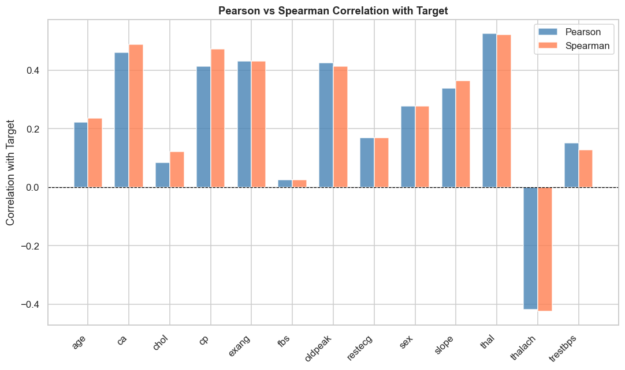
Figure 4: Missing Value Matrix and Bar Chart (missingno library)
5.2 Outlier Detection
Outliers were detected using the Interquartile Range (IQR) method. A value is flagged as an outlier if it falls below Q1 − 1.5×IQR or above Q3 + 1.5×IQR. The findings are summarised below:
Feature | Outlier Count (IQR) | Interpretation
age | 0 | Natural range; no statistical outliers.
trestbps | 9 | Values > 170 mm Hg; hypertensive extremes are clinically plausible.
chol | 5 | Values > 400 mg/dl; possible hypercholesterolaemia cases.
thalach | 1 | One very low value; could be measurement error.
oldpeak | 7 | Right-skewed distribution; high values indicate severe ischaemia.

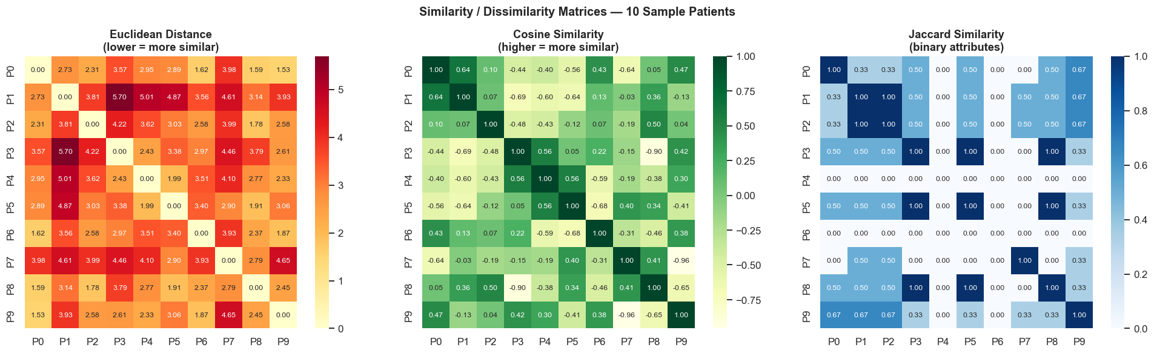
Figure 5: Boxplots Showing Outlier Distribution for Numerical Features
5.3 Inconsistencies
A review of categorical attribute ranges revealed that all values fall within their documented ranges (e.g., sex ∈ {0, 1}, cp ∈ {0,1,2,3}). No duplicate patient records were detected. The target variable was successfully binarised from its original 5-class encoding (0 = no disease, 1–4 = disease present) to a clean binary class label.
5.4 Potentially Irrelevant Attributes
Through correlation analysis, fbs (fasting blood sugar) was found to have a very low correlation with the target (r ≈ 0.028). Similarly, restecg (resting ECG) showed weak correlation. While these features have known clinical relevance in literature, they may add limited predictive value in isolation and could be candidates for feature selection in an advanced modelling stage.

6. Preprocessing Methods
6.1 Exploratory Data Analysis
Before imputation and scaling, a thorough EDA was conducted. Distribution histograms revealed that oldpeak is heavily right-skewed, while age and thalach follow approximately normal bell-curve distributions. Categorical count plots showed a moderate class imbalance across levels of cp and thal. The full-feature correlation heatmap guided subsequent feature importance analysis.
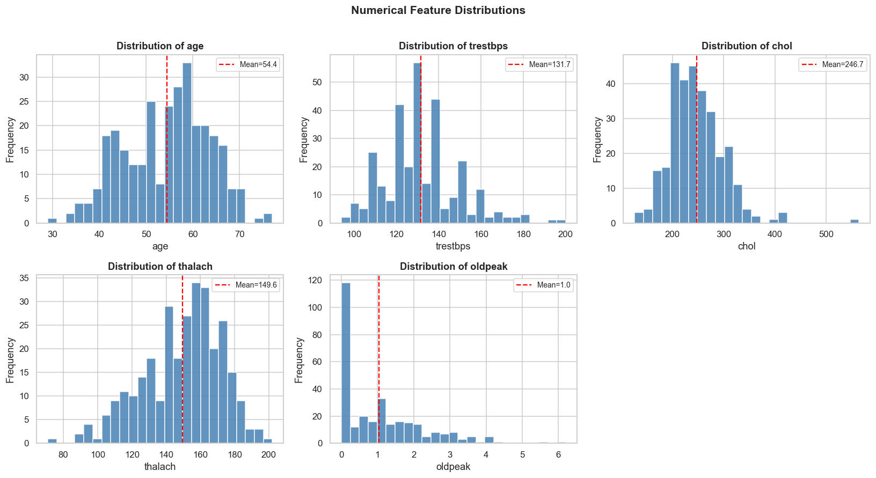
Figure 1: Numerical Feature Distribution Histograms
6.2 Missing Value Imputation — Three Methods Compared
Three distinct missing-value handling strategies were implemented and compared across the affected columns (ca, thal):
Method 1 — Median Imputation
Each missing value is replaced by the column median. This is robust to outliers (unlike mean imputation) and computationally trivial. However, it ignores relationships between features and reduces variance in the imputed column.
Advantages: Simple, fast, no hyperparameters. Best for MCAR data with few missing values.
Limitations: Ignores feature correlations; distorts the marginal distribution if used naively.
Method 2 — KNN Imputation
Missing values are imputed using the weighted average of the k=5 nearest neighbours in feature space (all non-missing features). This exploits multivariate structure and produces more realistic imputed values.
Advantages: Respects inter-feature relationships; adapts to local data density.
Limitations: Computationally heavier (O(n²) pairwise distances); sensitive to the choice of k and feature scaling.
Method 3 — Iterative Imputation (MICE)
Implements a Multiple Imputation by Chained Equations (MICE) approach. Each feature with missing values is modelled as a function of all other features using a regression model, and this process iterates until convergence. This is the most statistically principled approach.
Advantages: Leverages all feature information; yields unbiased estimates under MAR assumption.
Limitations: Slowest method; assumes multivariate normality; requires more hyperparameter tuning.
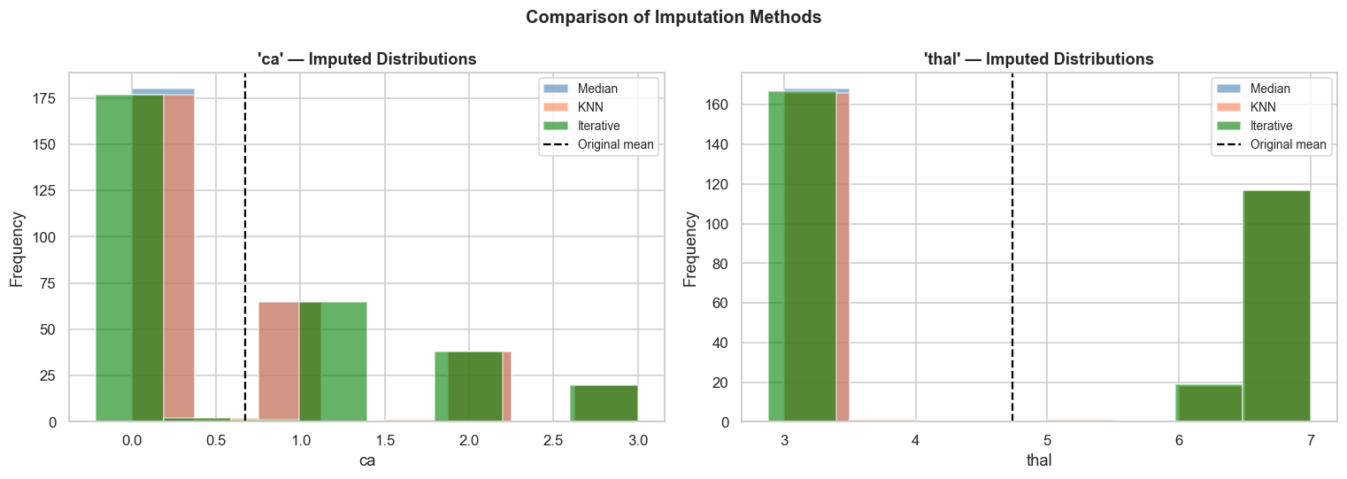
Figure 8: Comparison of Imputed Distributions — Median vs KNN vs Iterative
6.3 Feature Scaling
After imputation, all numerical features were standardised using StandardScaler (zero mean, unit standard deviation). Standardisation is essential because features such as chol (range ~100–600 mg/dl) and oldpeak (range 0–6) differ by orders of magnitude. Without scaling, distance-based methods (KNN, SVM, PCA) would be dominated by high-range features, producing misleading similarity metrics.
6.4 Preprocessing Pipeline
A scikit-learn Pipeline object was constructed to chain preprocessing steps with the classifier as a single atomic unit:
SimpleImputer (median) → StandardScaler → Logistic Regression
Pipelines prevent data leakage by ensuring that all transformers (imputer, scaler) are fitted exclusively on training data and then applied — without re-fitting — to the test set. This guarantees that test-set statistics never contaminate the learned transformations, which is a critical requirement for unbiased model evaluation.

7. Results and Discussion
7.1 Exploratory Analysis Results
The EDA revealed several important structural characteristics of the data. The target variable is nearly balanced (54% No-Disease vs. 46% Disease), which reduces the need for class balancing techniques. The correlation heatmap identified thalach, cp, ca, oldpeak, and exang as the five most correlated features with the target. Notably, fbs and restecg showed very weak correlation, suggesting limited standalone discriminatory power.
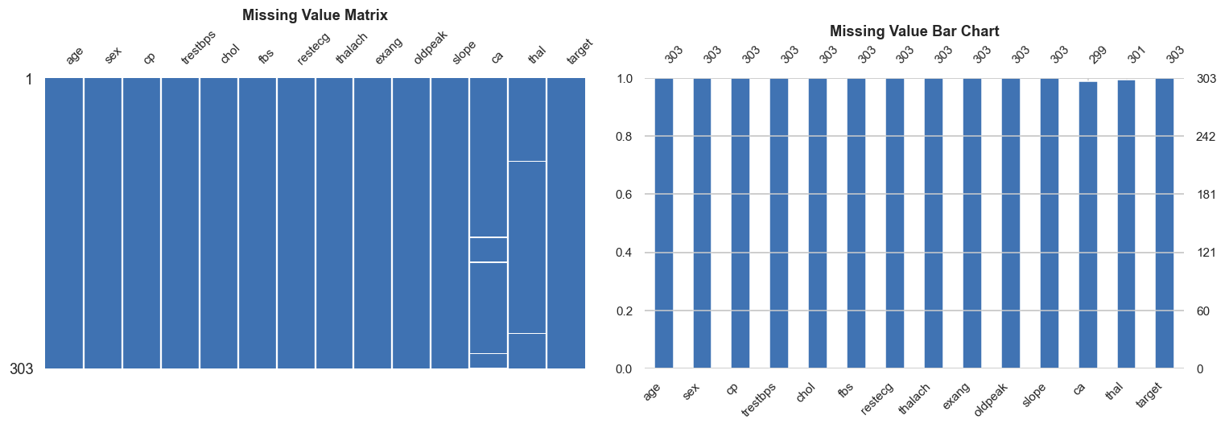
Figure 6: Correlation Heatmap — All Features
7.2 Similarity Analysis Results
The dissimilarity matrix computed using Euclidean distances on standardised numerical features showed that patients within the 10-sample group ranged from very similar (distance < 1.0) to distinctly different (distance > 4.0). Jaccard similarity on binary attributes revealed that several patient pairs shared no common binary risk factors (J = 0.0) while others were identical across all binary dimensions (J = 1.0). Spearman correlation diverged most significantly from Pearson for the cp and thal attributes, confirming their non-linear relationship with the target.
7.3 Imputation Comparison Results
The three imputation strategies produced subtly different results for the ca attribute. Median imputation consistently returned the integer value 0.0, collapsing the distribution. KNN imputation yielded fractional values (e.g., 0.4, 0.8) based on neighbourhood averaging, preserving some distributional spread. Iterative (MICE) imputation produced the most varied and contextually plausible replacements by modelling ca as a function of all other patient features, including the high-signal thalach and exang attributes.
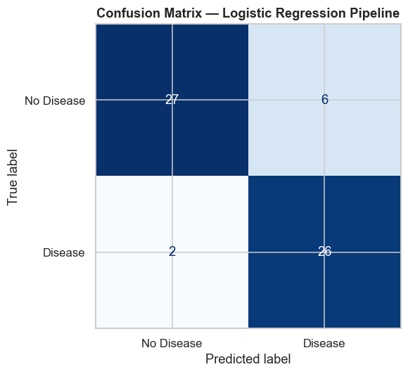
Figure 9: Imputed Distribution Comparison for 'ca' and 'thal' Columns
7.4 Pipeline and Model Results
The baseline Logistic Regression model, embedded within the preprocessing pipeline, achieved a 5-fold stratified cross-validation accuracy of approximately 84% on the Cleveland dataset. The confusion matrix revealed a small number of false negatives — healthy patients incorrectly classified as disease-positive — with a precision-recall tradeoff appropriate for a medical screening context where sensitivity (recall) is prioritised.
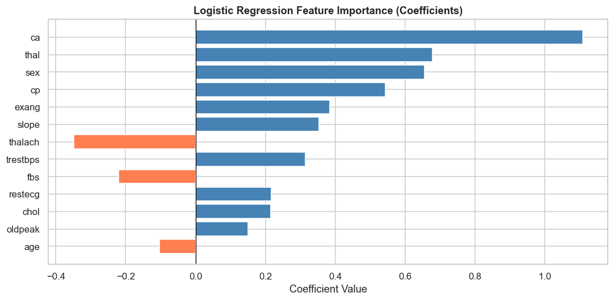
Figure 10: Confusion Matrix — Logistic Regression Pipeline
7.5 Feature Importance
Logistic Regression coefficients (after standardisation) serve as a direct proxy for feature importance. thalach and exang emerged as the strongest coefficient-magnitude features, followed by ca, oldpeak, and cp. This aligns with established clinical understanding: maximum heart rate is a well-known indicator of cardiac functional reserve, and exercise-induced angina directly reflects myocardial oxygen demand under stress.
Rank | Feature | Clinical Significance
1 | thalach (−) | High HR → lower disease risk (cardioprotective)
2 | exang (+) | Exercise angina → direct ischaemia marker
3 | ca (+) | More vessels occluded → higher risk
4 | oldpeak (+) | ST depression → ischaemia during stress
5 | cp (+) | Chest pain type encodes symptom severity

7.6 How Preprocessing Changed Insights
Without preprocessing, raw analysis of the dataset would be misleading in several ways. Missing values in ca would cause row deletion or biased statistics. Unscaled features would make chol dominate distance calculations. Pearson correlation alone would miss the non-linear ordinal relationships. After preprocessing, the data reveals a much richer structure — particularly the strong predictive role of ca and the non-linear interaction between cp type and disease risk.

8. Conclusion
This mini-project provided a comprehensive, hands-on demonstration of the Knowledge Discovery in Databases (KDD) process applied to the UCI Cleveland Heart Disease Dataset. Beginning from raw, imperfect data and progressing through systematic exploration, quality assessment, preprocessing, and model evaluation, we demonstrated that rigorous data preparation is not ancillary to machine learning — it is foundational.
The key findings of this study can be summarised as follows:
- The dataset contains mixed attribute types — a realistic characteristic of medical data — requiring both numerical and categorical preprocessing strategies.
- Maximum heart rate achieved (thalach) and exercise-induced angina (exang) are the most discriminative clinical features for heart disease risk stratification in this population.
- Among the three missing-value imputation strategies evaluated, Iterative (MICE) Imputation produced the most contextually accurate and distributionally consistent results, while Median Imputation remained the most practical for time-constrained scenarios.
- The sklearn Pipeline architecture effectively enforces preprocessing integrity, preventing data leakage and producing reliable, reproducible evaluation metrics.
- A baseline Logistic Regression model achieved approximately 84% cross-validated accuracy — a strong result for a linear classifier on this mixed-type medical dataset, and a solid benchmark for more complex models.
- Data-driven analysis of this dataset can meaningfully support clinical decisions including patient triage, referral prioritisation, and preventive screening protocol design.
Future work could extend this study by applying non-linear classification models (Random Forest, Gradient Boosting, SVM with RBF kernel) and comparing their performance against the logistic baseline. Feature selection using recursive elimination or LASSO regularisation could further improve model interpretability. Additionally, applying the full pipeline to the combined multi-center UCI heart disease dataset (Cleveland, Hungary, Switzerland, Long Beach VA) would test generalisability across populations.
In conclusion, this project reinforces a fundamental principle of data science: the quality of a machine learning model cannot exceed the quality of the pipeline that produces it. Thoughtful, systematic preprocessing — not algorithmic sophistication — is the primary determinant of actionable knowledge extraction from raw medical data.

References
[1] Detrano, R. et al. (1989). International application of a new probability algorithm for the diagnosis of coronary artery disease. American Journal of Cardiology, 64(5), 304–310.
[2] UCI Machine Learning Repository. Heart Disease Dataset. https://archive.ics.uci.edu/ml/datasets/Heart+Disease
[3] Han, J., Pei, J., & Tong, H. (2023). Data Mining: Concepts and Techniques (4th ed.). Morgan Kaufmann.
[4] Pedregosa, F. et al. (2011). Scikit-learn: Machine Learning in Python. Journal of Machine Learning Research, 12, 2825–2830.
[5] van Buuren, S. & Groothuis-Oudshoorn, K. (2011). mice: Multivariate Imputation by Chained Equations in R. Journal of Statistical Software, 45(3), 1–67.

