**To use Vi**

**Syntax** ->

vi <file_name>

**Examples :-**

1. Normal mode -> vi test.text
2. read only mode -> vi –R test.text
3. read only mode -> view test.text

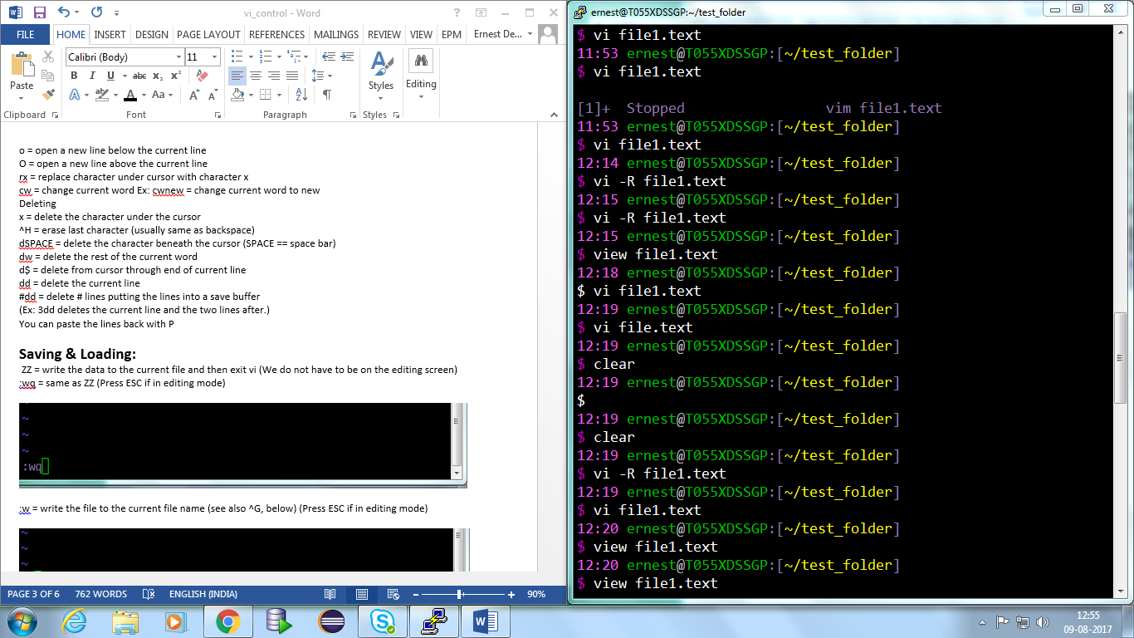

* **When in normal mode**

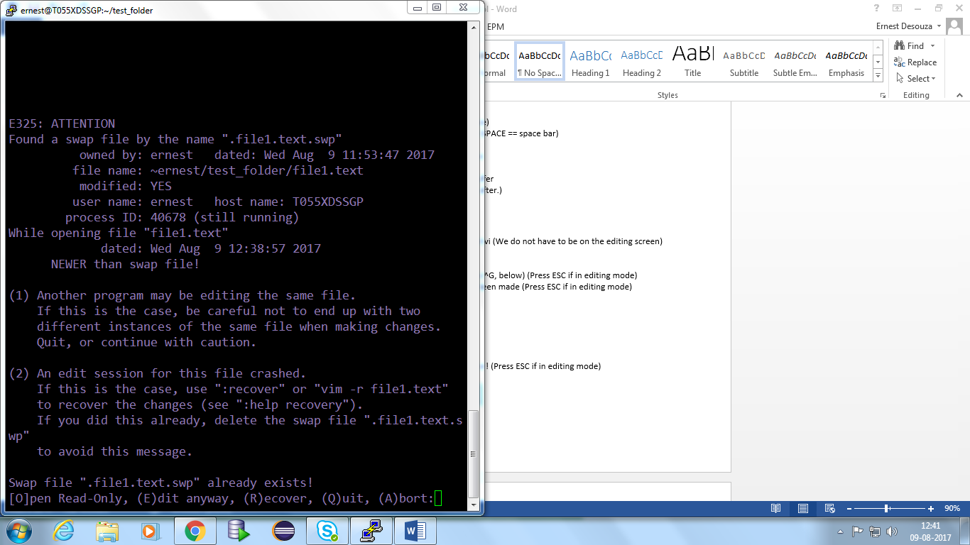

* **When edit in read-only mode**

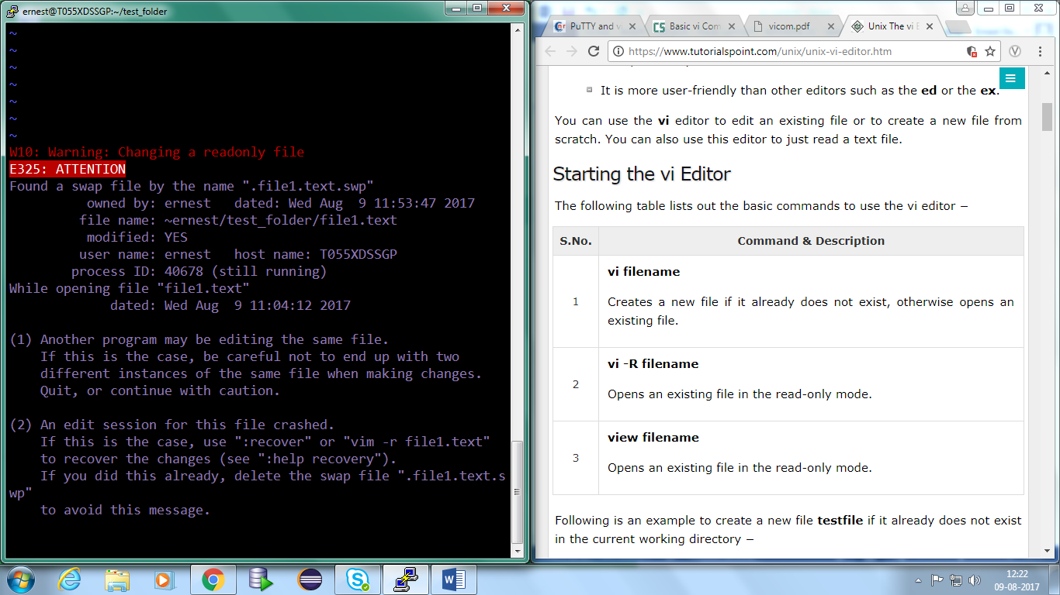

* **When in recover mode:-**

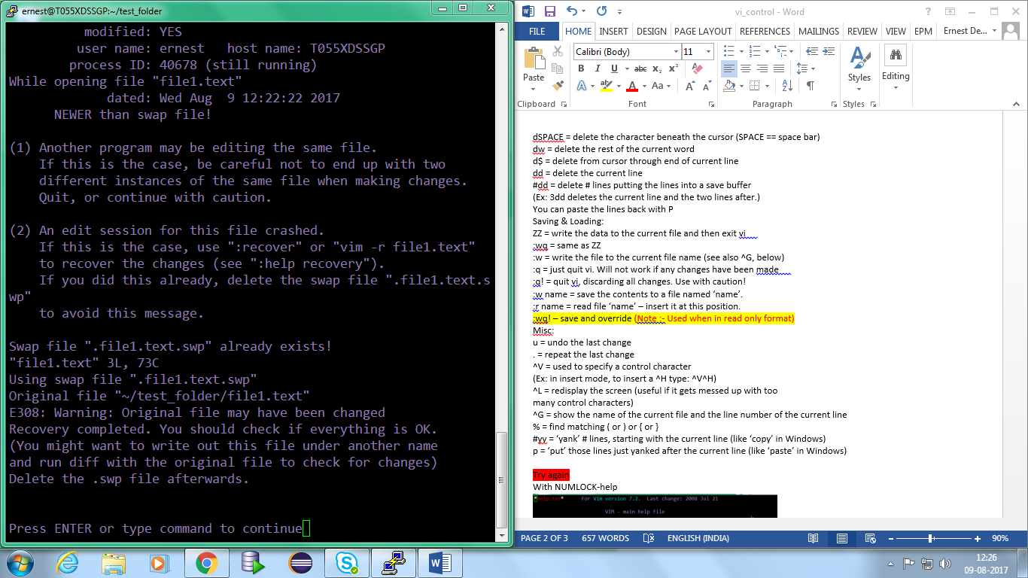

* **There are 2 modes:-**

1. **Command mode- When we press ESC.**
2. **Insert mode- when we press any of the editing commands like “ i , a “ .**

**Cursor Movement:**

1. h = move the cursor to the left
2. j = move the cursor down 1 line
3. k = move the cursor up 1 line
4. l = move the cursor right
5. Note:-(on some keyboards, the arrow keys have the same effect)
6. 0 = move to the front of the line
7. $ = move to the end of the line
8. w = move forward one word (goes to the start of next word) (ie word to word)
9. b = move backward one word (same as w but backword)
10. e = move forward to the end of the word (same as w but goes to the start of next word)
11. ^F = move forward a screen full (full scroll down- ie bring the cursor to the end of the screen and shows contents below that are not visible on the current screen)
12. ^D = move forward half a screen full (half scroll down-ie bring the cursor to the middle of the page)
13. ^B = move backward a screen full (full scroll up - ie bring the cursor to the start of the screen and shows contents above that are not visible on the current screen)
14. ^U = move backward half a screen full
15. G = move to the last line in the file. (Note it has to be caps)
16. #G = move to line numbered #. (Ex: 5G. Ex: Use 0G to move to the top of the file.)

**Searching**

1. n = repeat last search
2. N = reverse direction of last search
3. /pat = move cursor to next occurrence of pattern ‘pat’ (forward search)
4. ?pat = move cursor to previous occurrence of pattern pat backward search)   
   :1,$s/pattern/newpattern/g = replace all occurrences of pattern with new pattern.
5. shift+# = Search all the occurrences of the word under the cursor.(on command mode)

**Inserting**

1. i = insert before (new text will appear before the current cursor position) — leaves you in insert mode
2. a = append (new text appears after current cursor position) –leaves you in insert mode
3. o = open a new line below the current line
4. O = open a new line above the current line
5. rx = replace character under cursor with character x
6. cw = change current word Ex: cwnew = change current word to new   
   **Deleting**
7. x = delete the character under the cursor
8. ^H = erase last character (usually same as backspace)
9. dSPACE = delete the character beneath the cursor (SPACE == space bar)
10. dw = delete the rest of the current word. (ie Deletes from the current cursor location to the next word)(Note: Press d first then w)

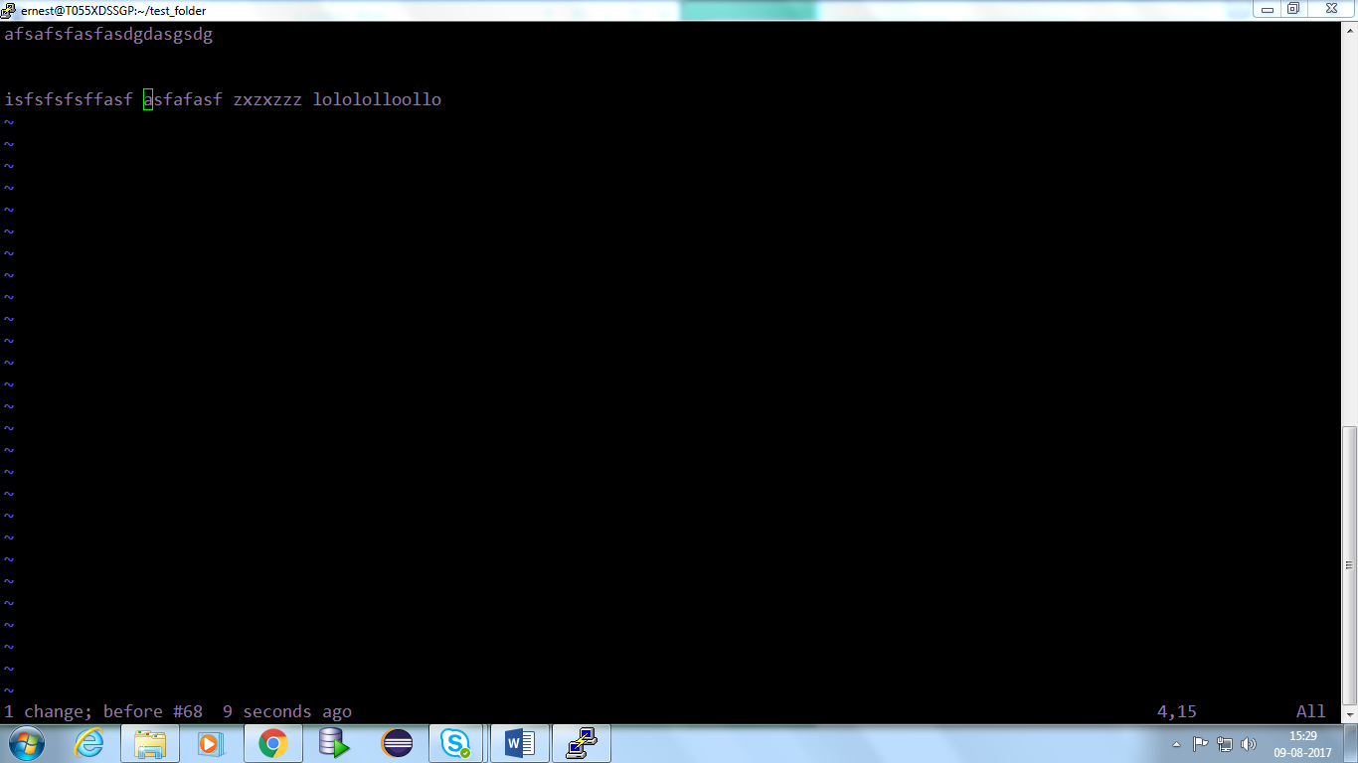

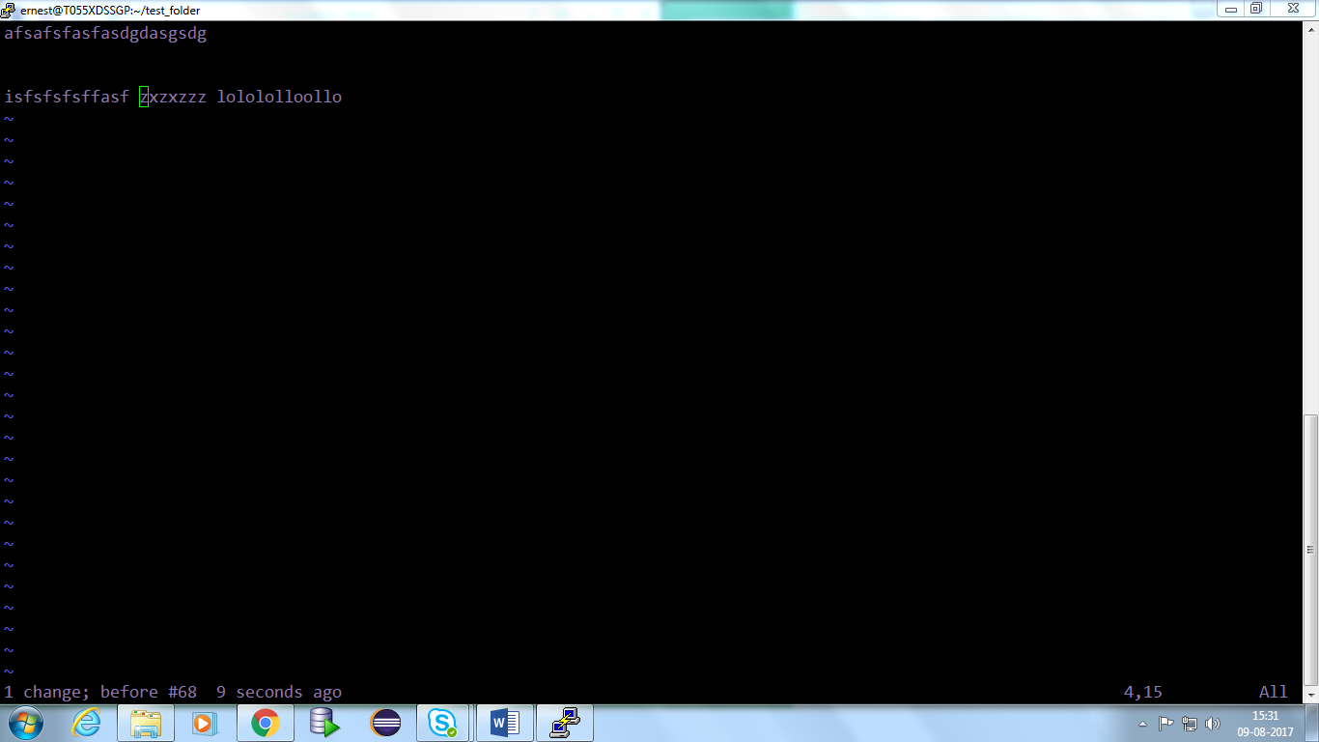

1. d$ = delete from cursor through end of current line
2. dd = delete the current line
3. #dd = delete # lines putting the lines into a save buffer   
   (Ex: 3dd deletes the current line and the two lines after.)   
   You can paste the lines back with shit+P.

**Saving & Loading**

1. ZZ = write the data to the current file and then exit vi (We do not have to be on the editing screen)
2. :wq = same as ZZ (Press ESC if in editing mode)

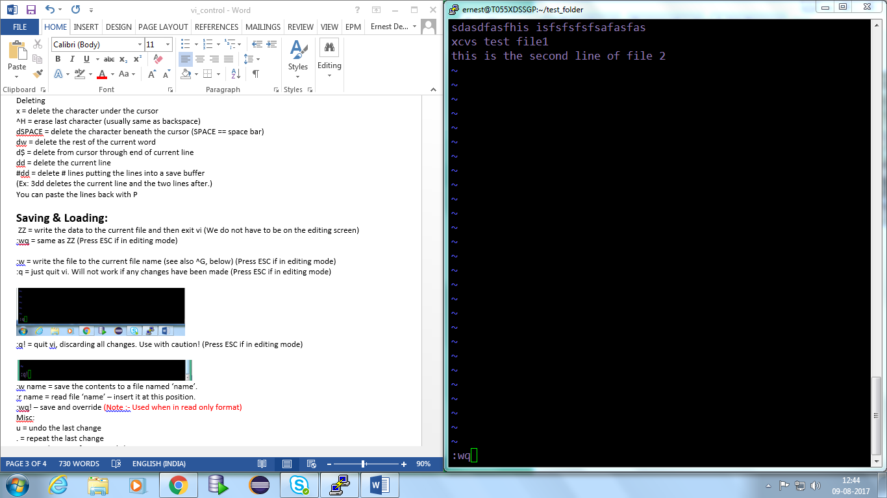

1. :w = write the file to the current file name (see also ^G, below) (Press ESC if in editing mode)

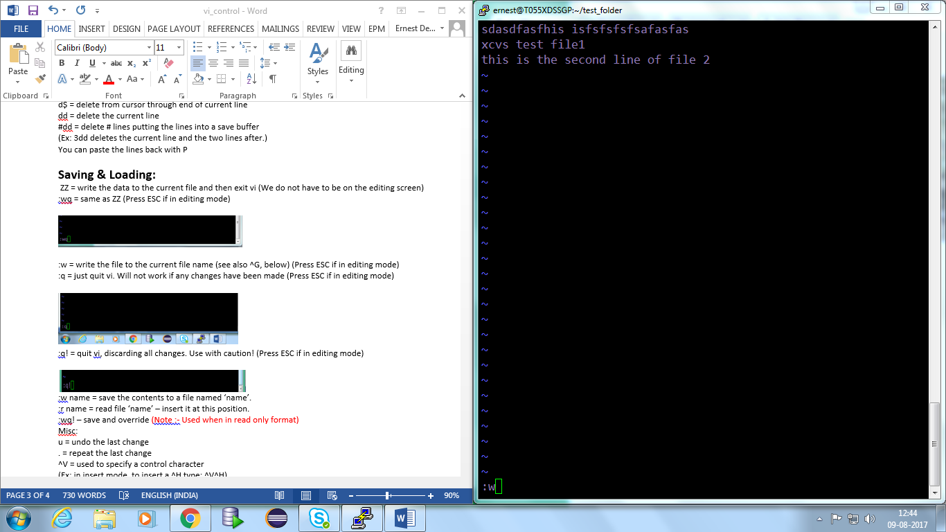

1. :q = just quit vi. Will not work if any changes have been made (Press ESC if in editing mode)

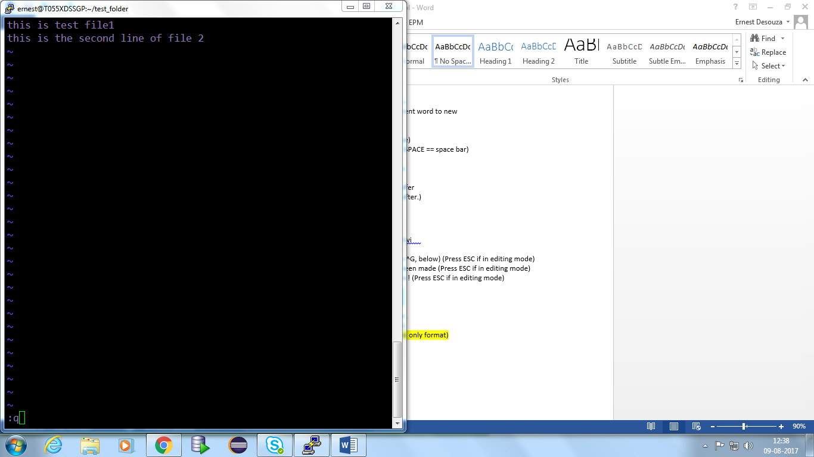

1. :q! = quit vi, discarding all changes. Use with caution! (Press ESC if in editing mode)

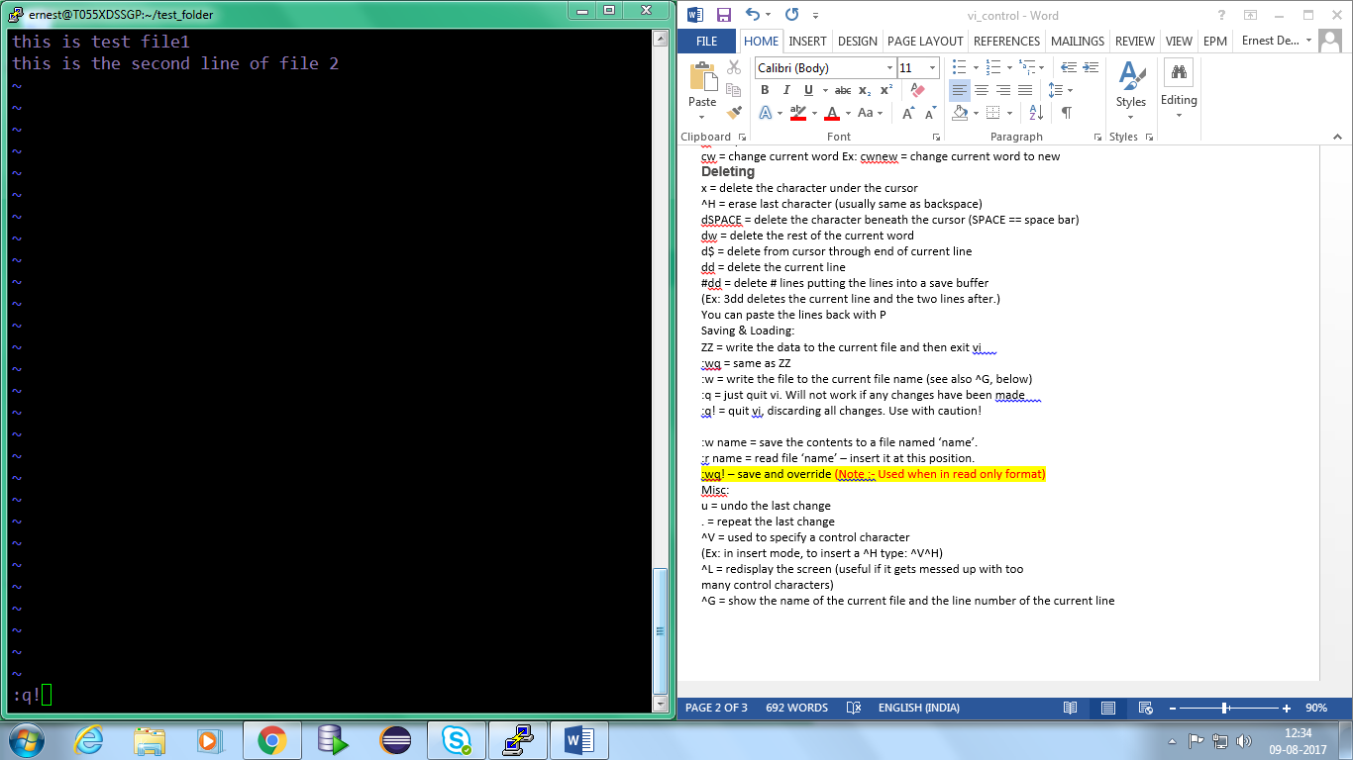

1. :w name = save the contents to a file named ‘name’.

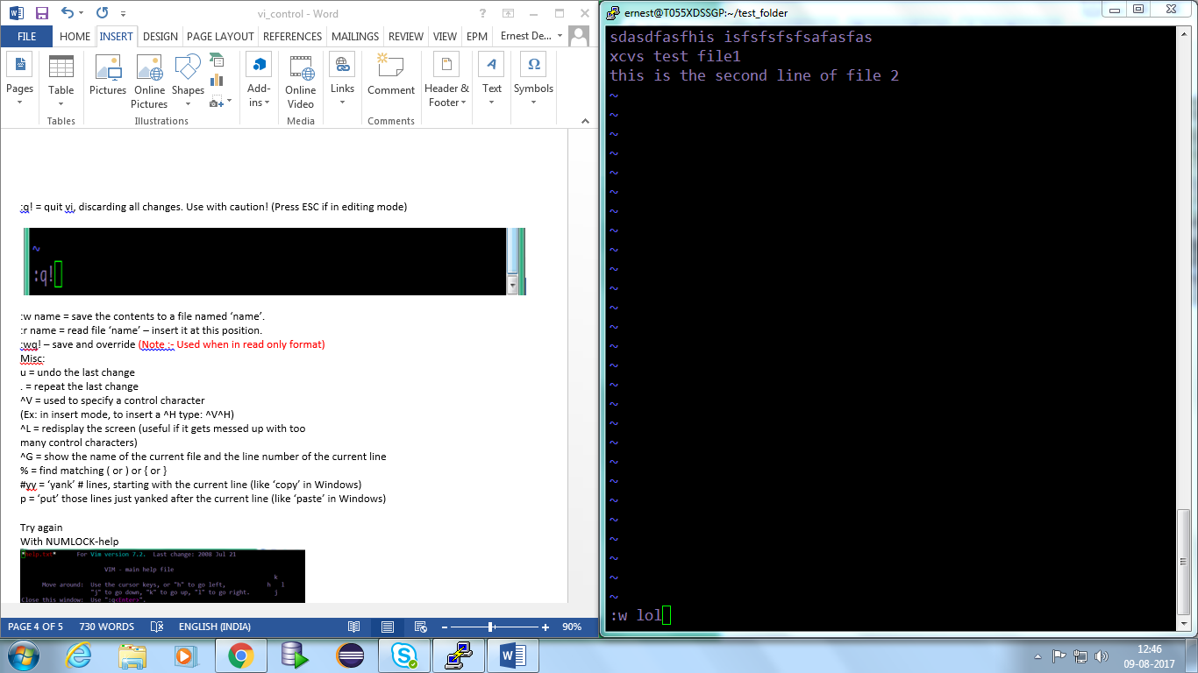

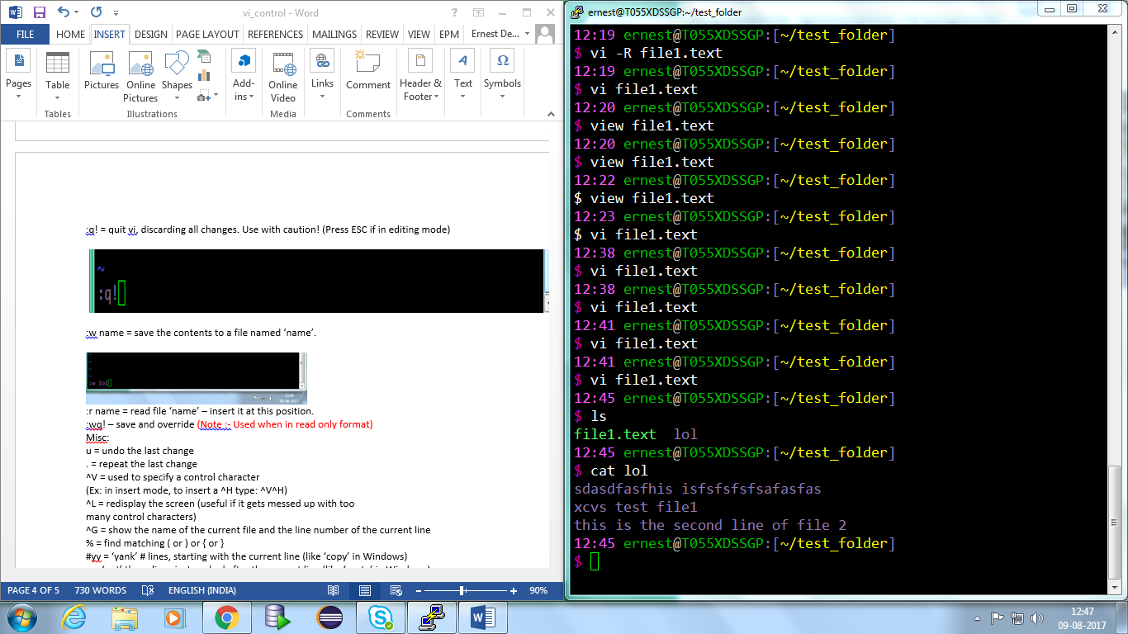

1. :r name = read file ‘name’ – insert it at this position.
   1. Step1:-Initial contents.

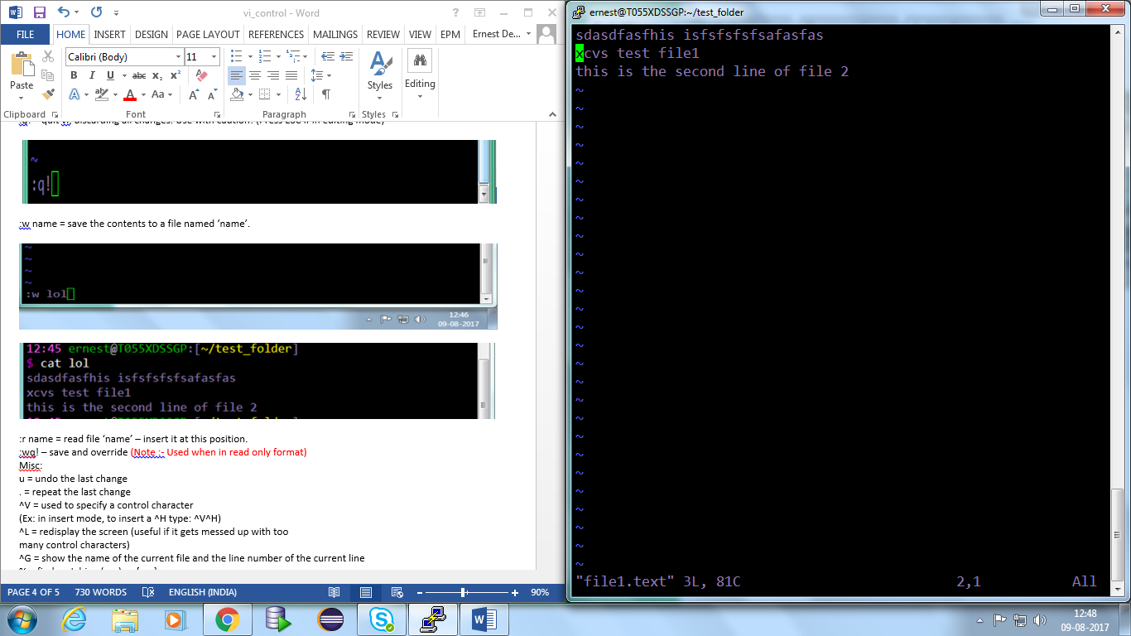

* 1. Step2 :- type “:r name_of_file”.

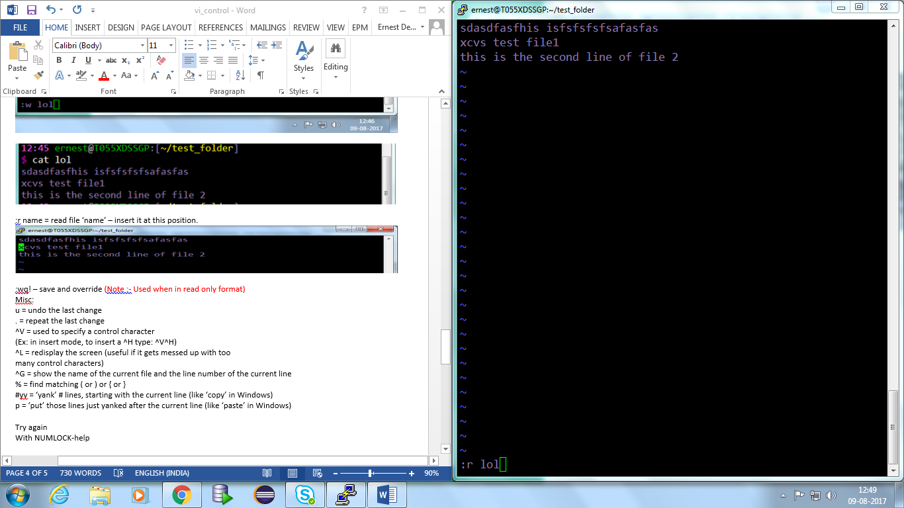

* 1. Step 3: After the command “:r name_of_file”

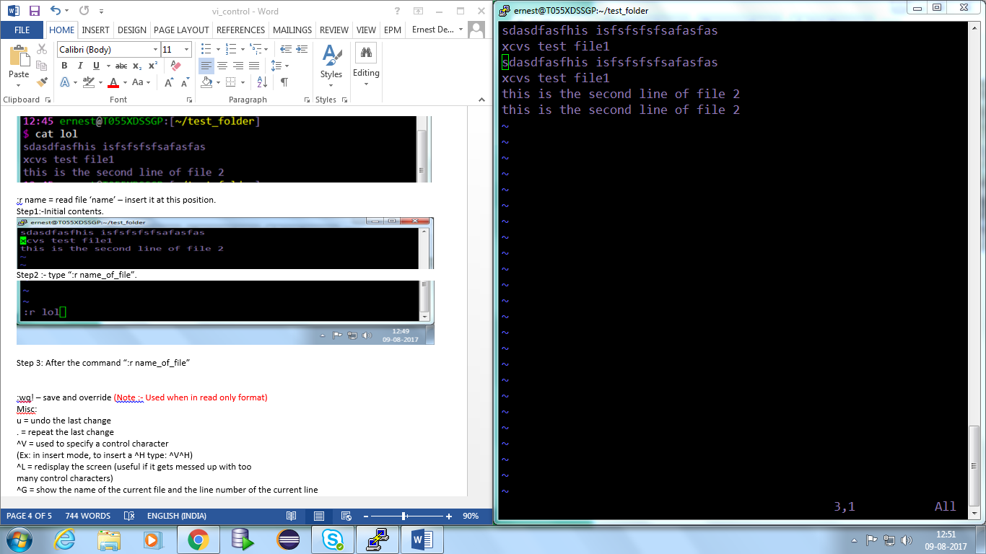

1. :wq! – save and override (Note :- Used when in read only format)
   1. Step 1:- Open the file as read only.
      1. using “vi –R <file_name>” OR “view <file_name>”



* 1. Step 2 : make some edit.

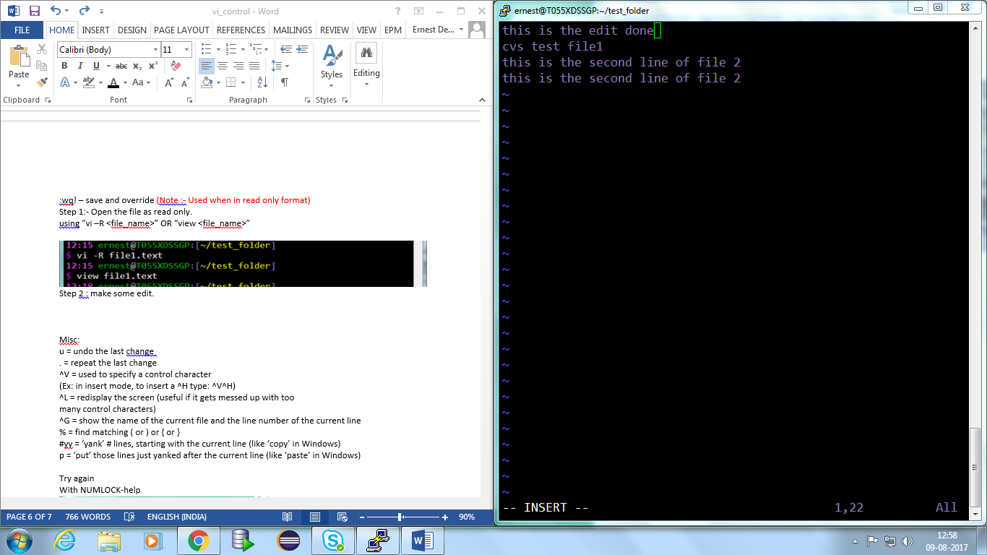

* 1. Step 3:- Press ESC then type “:wq!”

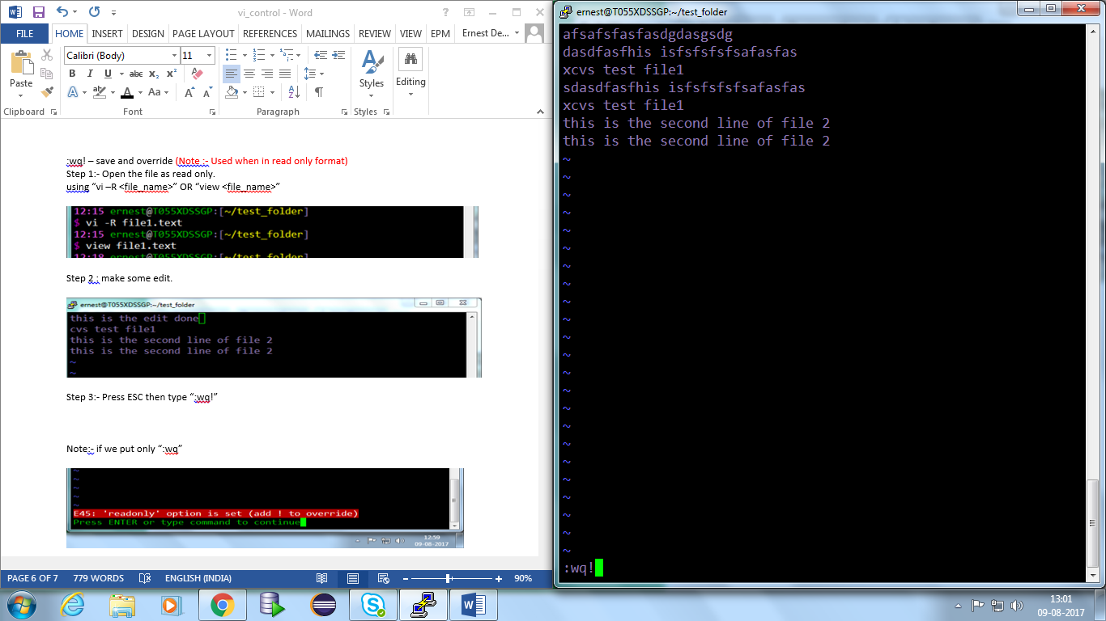

Note:- if we put only “:wq”

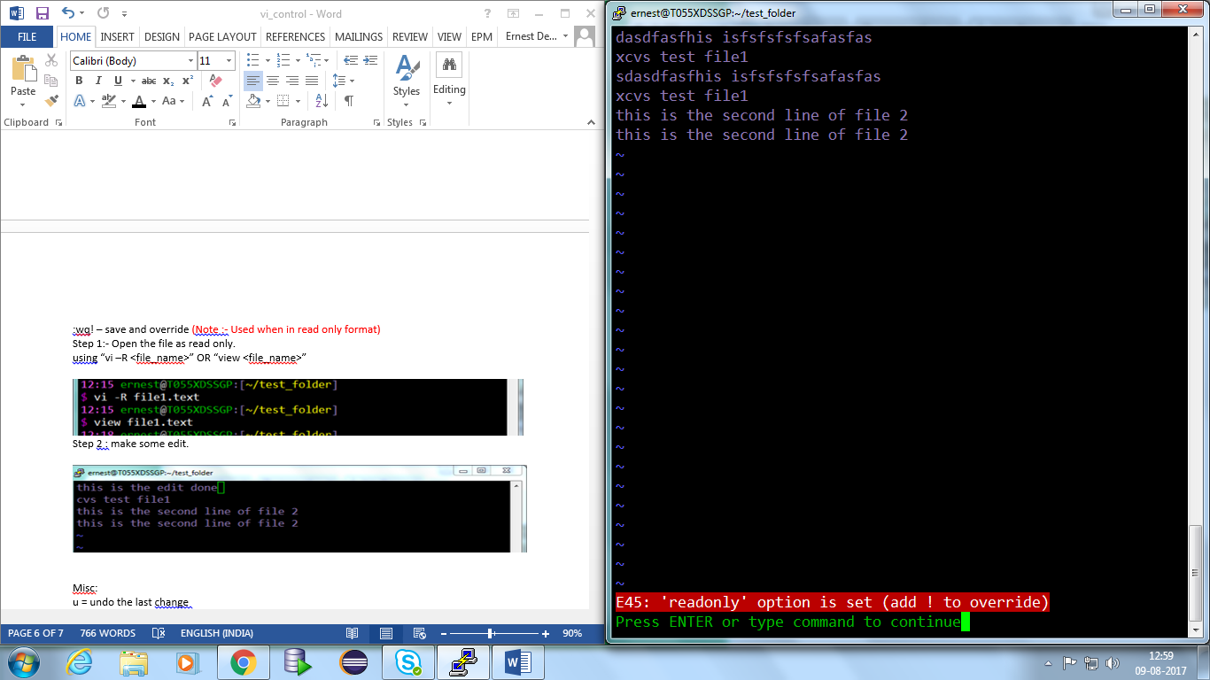

**Misc:**

1. u = undo the last change

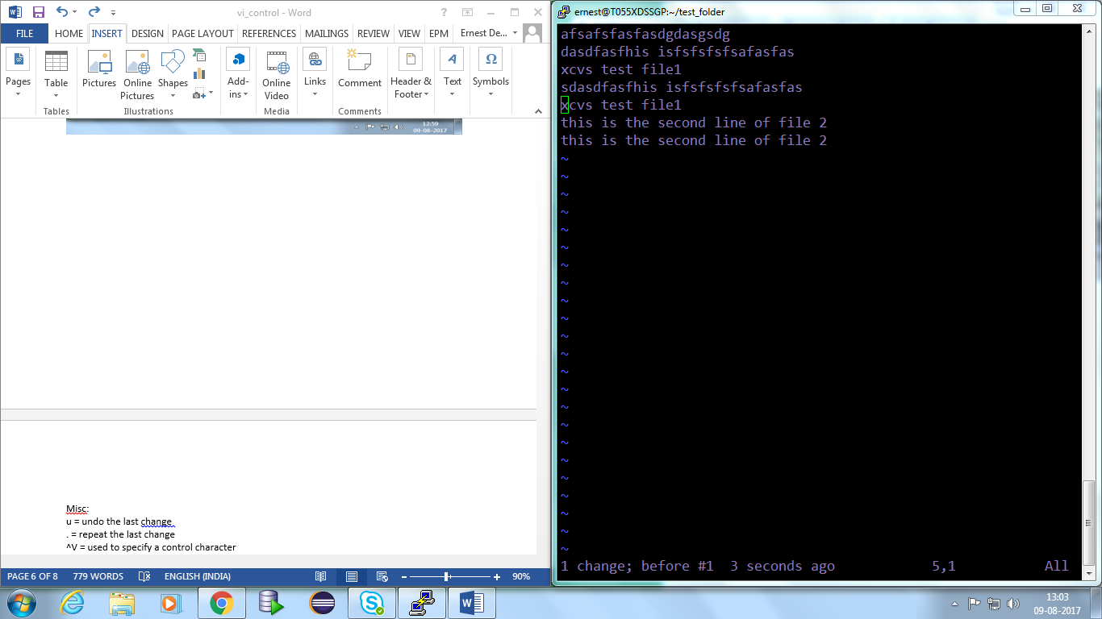

1. . = repeat the last change

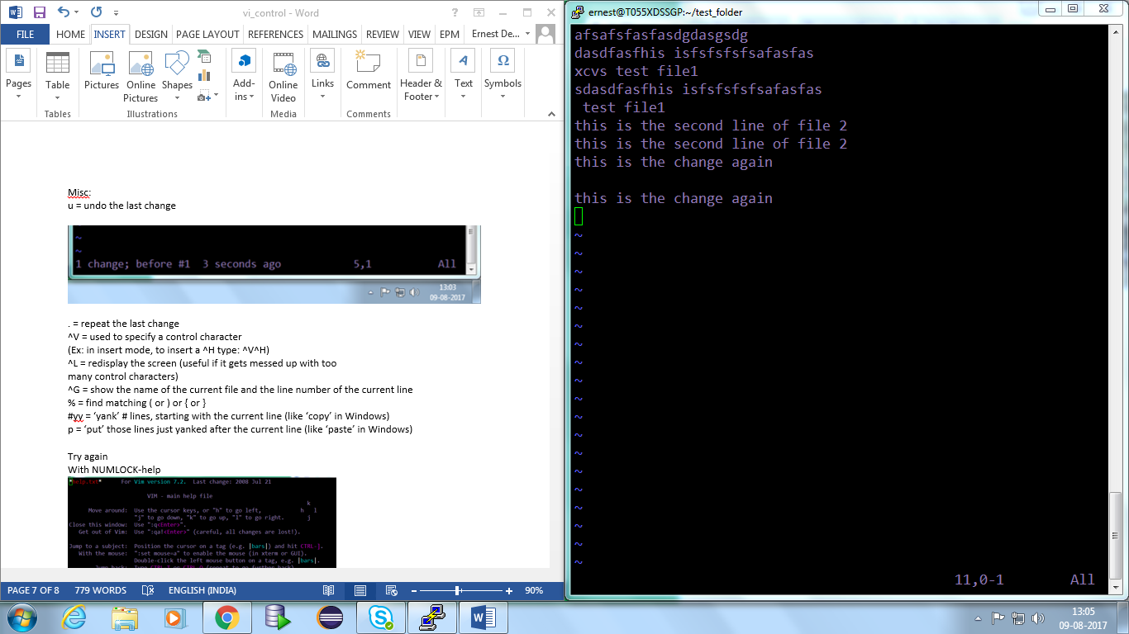

1. ^V = used to specify a control character
2. (we can select any word when in visual mode).
3. (Can be used with “v”,”^v”,”^V”)
4. ^C = To come out of visual mode.
5. (Ex: in insert mode, to insert a ^H type: ^V^H) (Note :- Otherwise if we press only ^H then it will delete the text like backspace)
6. ^L = redisplay the screen (useful if it gets messed up with too   
   many control characters)
7. ^G = show the name of the current file and the line number of the current line
8. % = find matching ( or ) or { or }
9. #yy = ‘yank’ # lines, starting with the current line (like ‘copy’ in Windows)
10. p = ‘put’ those lines just yanked after the current line (like ‘paste’ in Windows)

**To cut and paste a line at a desired location:- (Note:- for copy its #yy)**

1) First enter the number of lines to be cut.

2) Second press #dd –cuts the line/lines.

3) Third – press “shift+p“ to paste the line/lines

**References:-**

<http://computernewsreport.com/putty-and-vi-editor-commands/>

<http://vimdoc.sourceforge.net/htmldoc/visual.html>

<https://www.tutorialspoint.com/unix/unix-vi-editor.htm>

<http://cc.iiti.ac.in/vicom.pdf>

<https://www.cs.colostate.edu/helpdocs/vi.html>