Title of Game: Mini Game 1 Mini-Game: 1
(circle one or strike others)
Name of Developer: Adam Nutbrown

Design: (use sketches if required, hand-drawn will do)

Class Diagram:
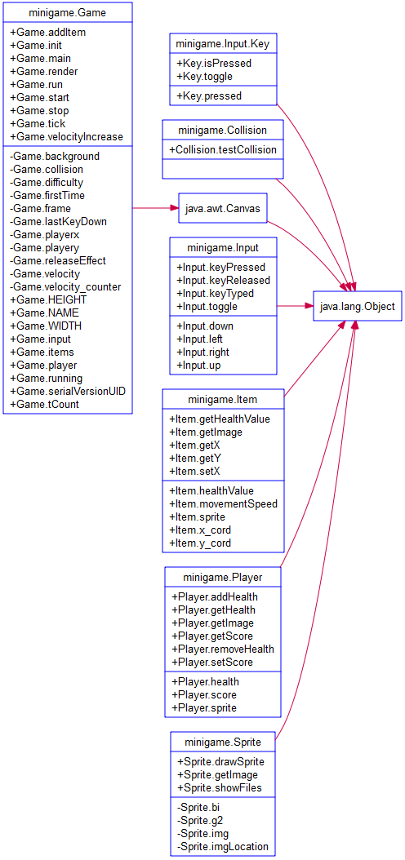

I decided to create a class for each element used within the game. I therefore have a class for input, sprite, player, item, collision and the main game itself.

Game:

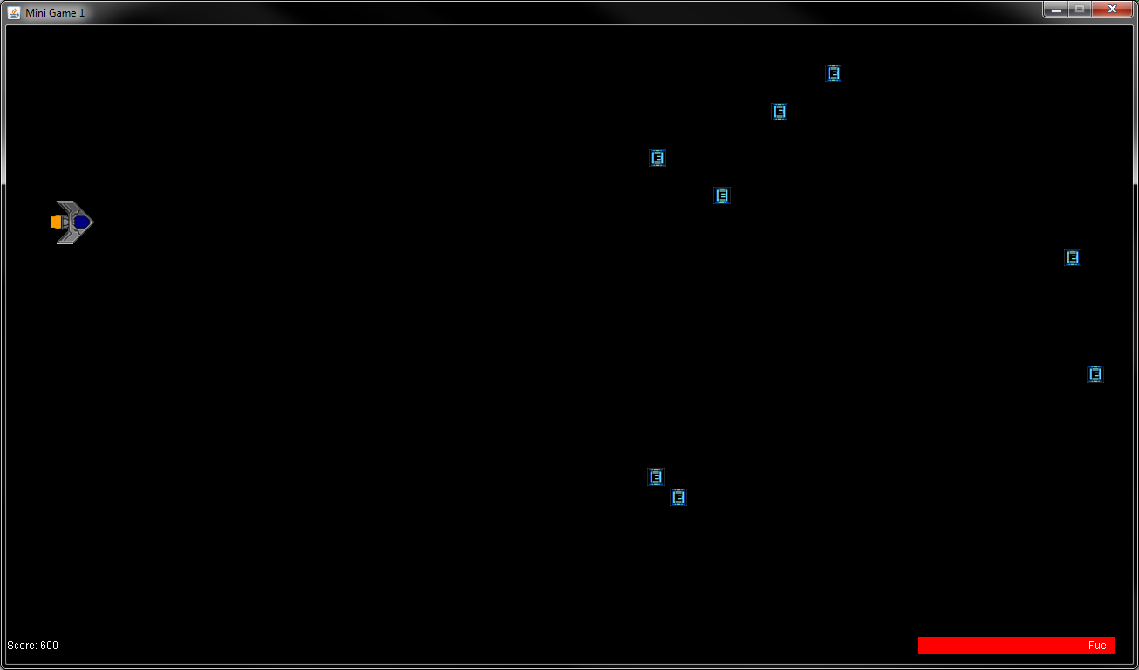

User Guide:

The objective of the game is to survive as your fuel gauge drops down to zero over time. You therefore have to refuel the ship to stay aflot. Score continues to go up over time and for each fuel can you hit, you gain additonal points.

The controls are:

W = UP
S = Down
A = Left
D = Right

References:

DesignsbyZephyr, 2012. Setting up the JFrame. YouTube, YouTube. Available from: https://www.youtube.com/watch?v=VE7ezYCTPe4 [Accessed 9 February 2015].

josh_demon, 2012. e23.gif. Image. YoYo Games: YoYo Games. Available from: http://gmjunk.webs.com/Tut/pixtut/mst/e23.gif [Accessed 9 February 2015].

Teerapat Mahasukhon, 2012. Energy Tank Square Sticker 3" x 3". Image. CafePress: CafePress. Available from: http://i3.cpcache.com/product/645401754/energy_tank_square_sticker_3_x_3.jpg?color=White&height=460&width=460&qv=90 [Accessed 9 February 2015].

