Draft Quarto document

Jonas Schaarup

# Advance learnig objectives

# 6. Descriptive results using targets

tar_read(df_stats_by_metabolite) %>%  
 mutate(MeanSD = glue::glue("{value_mean} ({value_sd})")) %>%  
 select(Metabolite = metabolite, "Mean SD" = MeanSD) %>%  
 knitr::kable(caption = "Descriptive statistics of the metabolites.")

Descriptive statistics of the metabolites.

| Metabolite | Mean SD |
| --- | --- |
| CDCl3 (solvent) | 180 (67) |
| Cholesterol | 18.6 (11.4) |
| FA -CH2CH2COO- | 33.6 (7.8) |
| Lipid -CH2- | 536.6 (61.9) |
| Lipid CH3- 1 | 98.3 (73.8) |
| Lipid CH3- 2 | 168.2 (29.2) |
| MUFA+PUFA | 32.9 (16.1) |
| PUFA | 30 (24.1) |
| Phosphatidycholine | 31.7 (20.5) |
| Phosphatidylethanolamine | 10 (7.6) |
| Phospholipids | 2.7 (2.6) |
| TMS (interntal standard) | 123 (130.4) |

tar_read(fig_metabolite_distribution)

`stat_bin()` using `bins = 30`. Pick better value with `binwidth`.

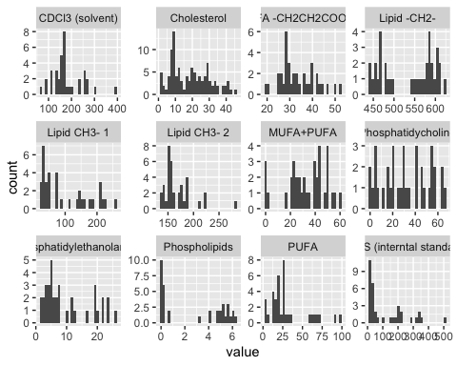

# 7. A general approach to do analysis

## Transforming into wideformat

lipidomics_wide <- lipidomics %>%  
 column_values_to_snake_case(metabolite) %>%  
 metabolites_to_wide()

Predictors, outcome, standardization…

Combine everything and the two parts in the input by pipeline, separately.

## Run analysis and get estimates!

create_model_workflow(  
 parsnip::logistic_reg() %>%  
 parsnip::set_engine("glm"),  
 lipidomics_wide %>%  
 create_recipe_spec(metabolite_cholesterol)  
) %>%  
 parsnip::fit(lipidomics_wide) %>%  
 tidy_model_output()

# A tibble: 4 × 5  
 term estimate std.error statistic p.value  
 <chr> <dbl> <dbl> <dbl> <dbl>  
1 (Intercept) 1.11 1.29 0.0817 0.935   
2 genderW 0.493 0.779 -0.907 0.365   
3 age 1.01 0.0377 0.183 0.855   
4 metabolite_cholesterol 2.97 0.458 2.38 0.0175

# 8. Now fun start: make multiple regresiion in one go

model_estimates <- targets::tar_read(models_estimate_loops)

targets::tar_read(fig_model_forrest_plot)

