LCD with Step Motor Control.

**Name**

**LaKeysha L. Green**

**Design Overview**

The device is a microcontroller that can control a stepper motor and 16x2 LCD display using the current specifications of a Tiva Launchpad. The components of this device include a TM4C123 Launchpad, LCD 16x2 display and 1 stepper motor and 2 potentiometers (one potentiometer controls the lighting of the LCD display, and the second potentiometer controls the lighting of the backlight).

**Hardware List**

Tiva Launchpad TM4C123- $11.45

Kuman Stepper Motor 28BYJ-48 5V -$12.99

SunFounder LCD1602 Module 3.3v backlight, 16x2 Character display white on blue background - $5.99

**Hardware Description**

The stepper motor and LCD display connect to a breadboard is powered through a USB cable on the Tiva Launchpad.

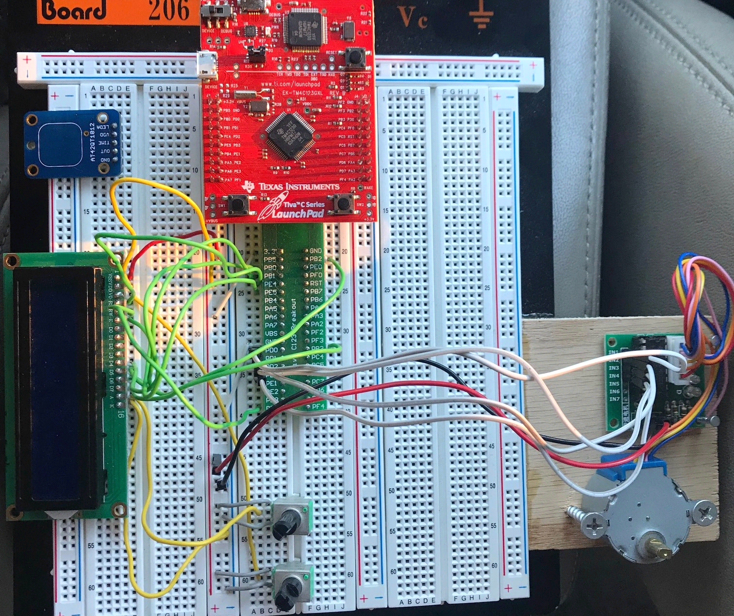

Using the code for varies sources, The LCD display along with the Stepper motor, activate when either switch one or switch 2 are pressed. When switch 1 is pressed, the stepper motor moves forward 15 times and then will run through the LEDs (Green, blue and Red) that were assigned to it. When switch 2 is pressed, the stepper motor moves backward 15 times and then run through the LEDs(Purple,Yellow,White & Cyan) that were assigned to it Each function programed to the on board switches will display the activity on the LCD display.

**Software Description**

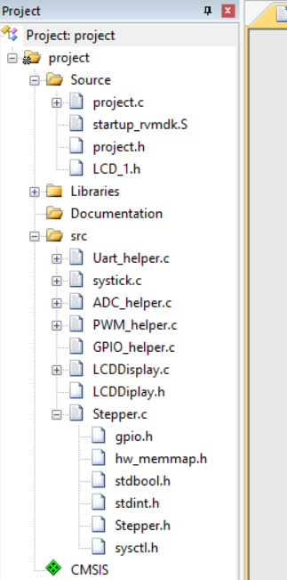Repo: https://github.com/Supergirlkish/LABNight

**Summary and Conclusion**

The microcontroller used here was a very interesting piece of equipment that is capable of many things. Once I was able to find different pinouts and code for the stepper motor and the LCD display, I was able to change the code to different pin outs to add multiple stepper motors.

Here is what was learn:

* The order of the position of the stepper motor has a certain order for it to step. Ex (0x01, 0x03, 0x02, 0x06....) typically a user who has never dealt with stepper motors would assume it was be in a numerical order. Ex (one, two, three, and four...)
* Stepper motors are popular for microcontroller-controlled machines because of the digital interface it has.
* It is easy for the microcontroller to control both position and velocity in an open-loop fashion.
* The cost of the stepper motor is reduce because they do not require feedback sensors.
* Stepper motors are currently placed in hard disk drives, scanners, and printers.
* Printing out characters on the LCD.

Here are things that will be continued:

* Scrolling characters
* Print timer/counters
* adjusting the speed of the stepper motor