Igor Retesz

Student ID: L38544245

Abstract

In this document ill will be explain features and tools that are used for back end developing. Some of the tools may include GitHub, Apache, php, vscode, phpMyAdmin and MySQL. Furthermore, I will be explained how I have been using them tools. Why is it used and explaining what I have created with them tools

BLOCK 2 – BACK END   
DEVELOMENT

BSc Computer Science

Contents

Introduction 2

The ER diagrams 2

The Website Functionality 3

Languages, hardware, software explanation 3

Validation 3

Processes of development 3

References 4

## Introduction

In this document I will be explain the uses of MySQL which is a database software. Next, I will be explaining about the uses of php and phpMyAdmin this will also include the explanation is xampp and Apache. The main objective of this project was to create a function database and php website to be able to add remove and view space companies’ data. the main tables used where Astronaut, targets, missions, and attends.

## The ER diagrams

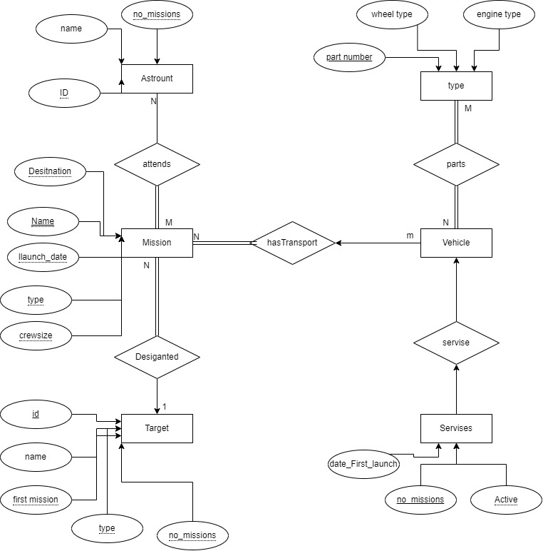

## The Website Functionality

The website is split in to multiple .php file all the php files have both php code CSS, java script and html. The function of the website is that it allows user to view tables data in the format of choosing and that they can be able to add data to the tables with out breaking it. To achieve this validation code and restrictions were added in both MySQL data base using php my admin and the php code. This also make it user friendly GUI to manipulate the data from the database.

## Languages, hardware, software explanation

The languages used for this project where PHP, JavaScript, html, MySQL, CSS, GitHub. The way they all work together is using php as using that file format allows to use the html CSS and java script. using the php code it allows the use of MySQL and the uses of the queries. this also allows pulling and pushing the data to the connected data base which is also possible from the php code. Some of the funcltiy to make it user friendly.

bootstrap has been added to the html code as from the source of Bootstrap [2021] It is a quickly designable and customizable responsive mobile first open-source tool kit used for front-end-development. Available at <https://getbootstrap.com/>. This open source allowed to make a user-friendly front-end part of the project.

Next is MySQL the open-source part of MySQL that has been use is MariaDB as MySQL is now no longer open source maria db. is a fork from the original open source of MySQL which makes it use the same syntax and same functions as MySQL. This means that the php will understand what code is instructing it to do.

Finally, it php language that is slowly being replaced by JavaScript. for this project it has been used it is it most efficient way to execute and manipulate MySQL queries. There fore its was the go-to use it for the project as it code use all over languages to create the final product

GitHub is a platform for developers used to backup the data and the main future of git hub is version control. Some the reason that git hub is used are do to the branches where multiple users can create different branches and then once confirm by everyone can m=be merged to the main product.

## Validation

The validation process that has been used is make up of 3 stages. The first stage of this was to validate the data enring the MySQL tables which using phpMyAdmin and MySQL queries this was set to what data was allowed in each of the entry points. Next in the php code a .php file was create that strips the data of any special characters that could break the tables or the database. Finally using the built in php code for MySQL quarriers the code for disabling queries in the input sections of the html code where disabled to disallow of MySQL queries to be imputed to gain data from the table do to the website being public.

## Processes of development

The process of development started from using azure to create the vm which then using the os of ubuntu (latest version). The software call Apache 2 has been installed with MariaDB and phpMyAdmin. These software’s allowed the progression of the public final version. As the testing and development have been done local xampp open source that allows the creation of local webserver with the funcuality of phpMyAdmin and Apache. (Undsgn ,2021) Xampp is cross platform abervision of php, Apache and MySQL that allows local webserver on windows machine. Source available at [https://undsgn.com/xampp-tutorial/ Have](https://undsgn.com/xampp-tutorial/%20Have%20) allowed to create a data base and to work on the code using visual studio code. using the software of phpMyAdmin the exporting of the testing and development of the database was made easier and less difficult then using MySQL queries. Transferring sing that data and backup creation of 2 methods was used to ensure no data lose and easy recover of version due to version control of git hub where the data was committed and push and pull on to the vm. The domain set and port forwarding were done by the dns of Cloudflare where the domain was forward to the Ip address of the machine. The statistics of what is the use of php in day-to-day life are as followed: from the source of (w3techs,2021) the use of php version 7 in 2021 is 69.6% worldwide. Source available at <https://w3techs.com/technologies/details/pl-php>. This shows that still in 2021 although php is being slowly less useful do to the simplest and the funcunality of JavaScript. It is still over majority of websites that use it day to day.

## References

* Igor Retesz GitHub, Available at <https://github.com/Superigi/UA92_data>
* Igor Retesz Finale Website, Available at <https://data.dashy3.co.uk>
* Bootstrap (2021)[ available at : <https://getbootstrap.com/>] accessed on 01/12/21
* Undsgn(2021) [available at: <https://undsgn.com/xampp-tutorial/>] accessed on 01/12/2021
* W3techs(2021) [available at <https://w3techs.com/technologies/details/pl-php>] accessed on 01/12/2021