<Date>

<AddressBlock>

Dear <Primary_Addressee>,

Many special opportunities and events will be taking place at UW-Superior, and we hope you will visit the campus frequently. Enclosed is your special parking permit.

The enclosed permit will allow you to park in any of the regular parking lots on campus, **except in metered or reserved spaces.** The permit should be hung from the rear-view mirror.

Your permit, <Permit>, is registered with our Campus Parking Services for your personal use. Please note that this permit is not transferable to another party.

Your special relationship with the University is important to us, and we hope to see you on campus often. If the University or I may be of any assistance to you, please feel free to contact me.

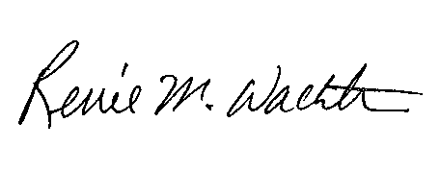Sincerely yours,

Renee Wachter, Ph.D.

Chancellor

RMW/djs

Enclosure