Chapter 2 - How Claude Works
By the end of this chapter, you will understand what Claude is, how it thinks, what it is good at, and — just as importantly — what its limits are. One of those limits will save you a significant amount of frustration if you know about it before you need it. This chapter covers that limit in full and shows you exactly how to work around it.

2.1 What Is Claude?
Claude is an AI assistant made by Anthropic. You type a question or describe a problem in plain language and Claude responds with a clear, thoughtful answer. It does not require technical vocabulary. It reads what you wrote, understands your specific situation, and gives you a direct answer rather than a list of links to sort through yourself.
Claude is different from a search engine in one important way. A search engine finds pages that might contain your answer and leaves you to figure out which one applies. Claude reads what you wrote, understands the context, and responds directly to your situation. If it needs more information, it asks. If the first answer does not solve the problem, you say so and the conversation continues.
This book was developed using AI tools as part of the writing process. The technical details were checked. The language was improved. Problems encountered during the writing — real problems on real hardware — were solved with AI assistance and then documented for you. The book you are reading is itself evidence of what Claude can do.
Claude is available free at claude.ai.
Open Firefox or Chrome, go to claude.ai, and type your question. No account is required for basic use. A free account gives you more daily conversations and saves your history. No payment details are needed for either.

2.2 How Claude Remembers — And How It Forgets
To use Claude well you need to understand one thing about how it works that is not obvious at first: Claude does not have memory between conversations. Every time you start a new conversation (A new chat session), Claude starts completely fresh. It does not remember the project you worked on yesterday, the files you uploaded last week, or the decisions you made together last month. Each conversation is its own clean slate.
Within a single conversation, however, Claude remembers everything. Every message you sent, every file you uploaded, every command that ran and its output, every decision that was made — all of it is present and available. Claude can refer back to something you said twenty messages ago as easily as something you said one message ago.
This within-conversation memory is called the context window. Think of it as a desk. Everything on the desk is visible and usable. Nothing that has been cleared off the desk is accessible. When you start a new conversation, the desk is cleared completely.

2.3 The Context Window — What It Is and Why It Matters
The context window has a size limit. Every message you send, every response Claude gives, every file that is read, every command that runs and its output — all of it accumulates. When the window fills up, Claude begins to slow down, make more mistakes, and lose track of earlier details. You may see a warning that says you have reached your tool limit, or that the conversation is being compacted.
This is not a subscription limit or a time limit. It is a memory limit. Claude is not being throttled to make you pay more. The context window is a fundamental property of how large language models work — there is a ceiling on how much text can be held in active memory at once.

What you will notice
In a long, complex session — one involving many file edits, long command outputs, and back-and-forth troubleshooting — you will eventually see one of these signals:
— A warning that you have reached your tool limit.
— A notice that the conversation is being compacted.
— Claude beginning to make mistakes it would not have made earlier.
— Claude losing track of a decision or file version that was established earlier in the session.
The last two are the most dangerous because they happen without warning. A context window that is nearly full degrades gradually. Claude's debugging ability — the careful, methodical tracing of a problem through multiple steps — is one of the first things to suffer. A fresh Claude at the start of a new conversation is significantly sharper than a Claude working in a nearly full context window.
Do not press Continue and hope for the best.
When you see a tool limit warning or compacting notice, pressing Continue lets Claude keep going — but it is adding more papers to an already overflowing desk. The quality of Claude's work drops. Debugging becomes unreliable. Mistakes increase.

The right response is to create a handoff file and start a fresh conversation. Section 2.4 shows you exactly how.

2.4 The Handoff File — How to Continue Without Losing Your Place
A handoff file is a short document you create at the end of a long session — or as soon as you see a context warning — that captures everything the next conversation needs to pick up where this one left off. It is the solution to the context window limit.
Think of it as a briefing note from one shift to the next. The outgoing shift writes down the current state, what was decided, what still needs doing, and where the relevant files are. The incoming shift reads the note and carries on without missing a beat.

What a handoff file contains
A good handoff file has five things:
- The project — one or two sentences describing what you are working on.
- The current state — what has been completed and what is working.
- The file versions — the exact names of the latest version of each file involved, so you upload the right ones to the new conversation.
- The decisions made — anything that was agreed or settled so Claude does not re-litigate it or contradict it.
- The next step — what you were about to do, or what still needs doing.

Ask Claude to write the handoff file for you.
Before you close a long session, simply ask: "Please write a handoff file for this conversation so I can continue in a fresh chat." Claude will summarise the project, the current state, the file versions, the key decisions, and the next steps — in a format you can paste directly into the next conversation.

Do this before you see the warning if possible. A Claude with a nearly full context window writing its own handoff is less reliable than one that is still sharp.

Starting the new conversation
Open a new conversation at claude.ai. Paste the handoff file at the top of your first message. Then upload the relevant files. Then describe what you want to do next. Claude reads the handoff, understands the context immediately, and continues as if the previous conversation never ended — but now with a full, fresh context window and all of its capability restored.
This is the professional way to work with Claude on long or complex projects. It is not a workaround — it is the correct approach. Experienced Claude users do this routinely. They treat each conversation as a focused work session with a clean start, rather than trying to maintain one endless thread that gradually degrades.
The fresh Claude is the sharp Claude.
A Claude at the start of a new conversation — with a handoff file and the right files uploaded — will outperform a Claude grinding through a context window that is nearly full. When the quality of the work matters, start fresh.

2.5 What Claude Cannot Do
Claude is not connected to your computer. It cannot see your screen, read your files, or run commands on your system unless you are in an environment that explicitly provides those tools. Everything it knows about your situation comes from what you type and what you upload. The more context you provide, the better the answer.
Claude's knowledge has a cutoff date. For very recent events or software releases, it may not have the latest information — and it will tell you so. When asked about something it is uncertain about, Claude says so rather than guessing. This is by design. A Claude that confidently makes things up would be far more dangerous than one that admits uncertainty.
Claude makes mistakes. Not often on straightforward tasks, but on long complex sessions — particularly toward the end of a full context window — errors increase. The right response when Claude makes a mistake is to tell it what went wrong. It will correct course. Never run a command or apply a change you do not understand — always ask Claude to explain it first.
Always read before you run a command.
Claude aims to give safe, correct advice — but no AI is infallible. Before running any command Claude suggests, read what it will do. If anything is unclear, ask Claude to explain it. If a command involves deleting files or changing system settings, confirm you understand the effect before pressing Enter. This is good practice regardless of where the command came from.

2.6 The Ways to Access Claude
Claude is not one thing. It is available in five different forms — each using the same intelligence but designed for different needs. Understanding which one suits you best will save you time from the very first session. The good news: every example, except chapter 4 and browser extensions, in this book works from the browser at claude.ai. Start with browser and add the others as your needs grow.

2.6.1 claude.ai — The Browser Interface
The simplest way to start. Open any browser — Chrome, Firefox, Safari, Edge — go to claude.ai, and type. No installation. No account required for basic use. A free account gives you more daily conversations and saves your history. Works on any device — Windows, Mac, Linux, phone, or tablet.
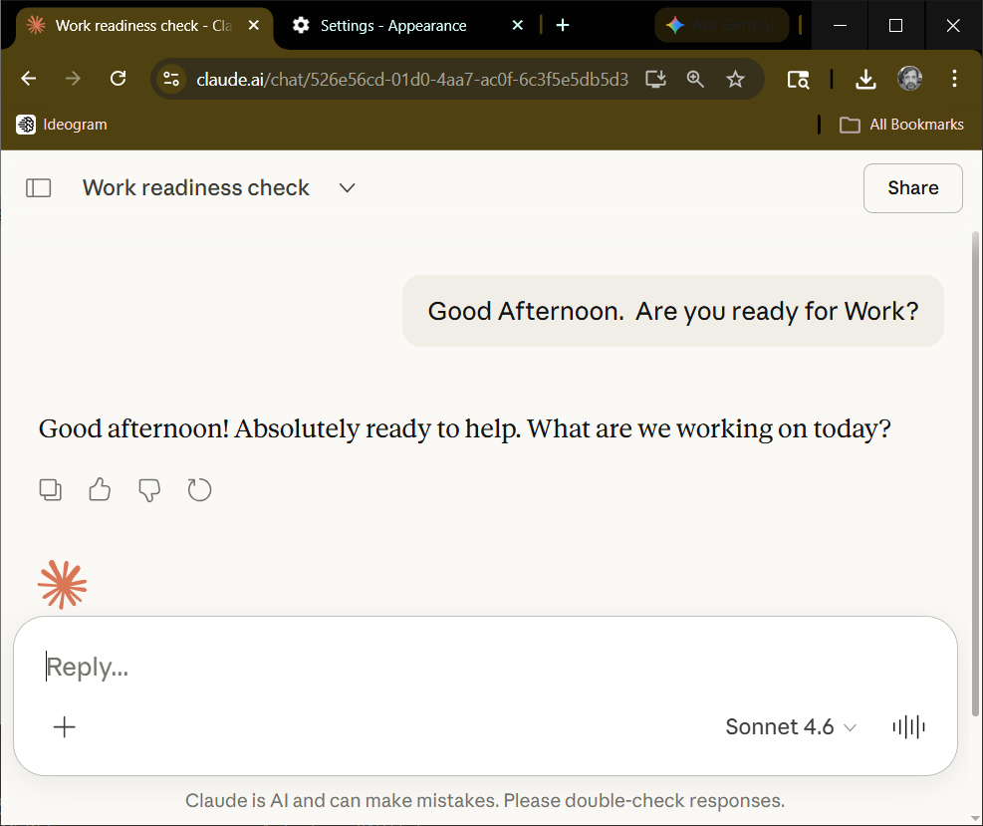
Best for: First conversations, writing, learning, research, uploading documents, quick questions. Almost everything in this book.
Limitation: No direct access to your computer files. No Cowork. Requires an open browser tab.

2.6.2 Claude Mobile — iPhone and Android
The official Claude app brings the full Claude experience to your phone. Free to download on both iPhone and Android. Sign in with the same Anthropic account you use on claude.ai and your conversation history carries across. The Read Aloud feature works beautifully here — tap the headphones icon and Claude speaks its responses while you commute, cook, or do anything else.
Best for: On the go, voice input, listening to Claude responses, continuing conversations from your computer. Perfect for readers with ADHD or who prefer listening over reading.
Limitation: Smaller screen. Best for conversation, not complex document work.

2.6.3 Claude Desktop — Windows and Mac
A native application that lives in your taskbar or dock — always one click away, even with fifty browser tabs open. Claude Desktop requires a paid subscription but adds capabilities the browser cannot match. Most importantly, it is where Cowork lives.
Cowork — the feature that changes everything — is only available in Claude Desktop. Cowork transforms Claude from a conversation partner into an autonomous worker. You describe an outcome, Claude plans and executes it, and delivers finished results while you step away. Organize your files. Research a topic and produce a report. Build a document from scratch. Chapter 4 covers Cowork in full.
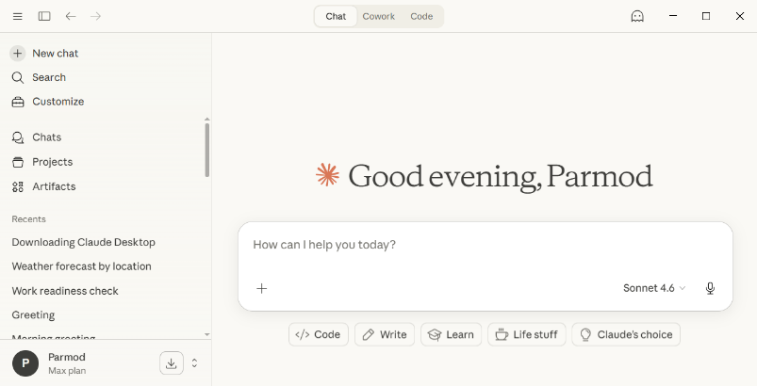
Best for: Cowork tasks, organizing files, creating documents, serious ongoing work, connecting to email and calendar, always-on desktop use.
Limitation: Requires a paid subscription. Windows and Mac only — not Linux yet. Download from claude.ai/download.

2.6.4 Claude Code — The Command Line
Claude Code runs in a terminal window — the command line interface that looks and works identically on Windows, Linux, and Mac. This is exactly why engineers and technical users love the command line: you learn it once and it works everywhere, on any platform, without different menus or layouts to navigate. If you set the path to your project folder, Claude Code gives Claude direct access to your files, your code, and your computer’s command line. Designed for developers and technically adventurous users who want Claude working directly inside their projects. Claude Code also reads your CLAUDE.md file automatically at the start of every session — your personal instructions are always in place without typing them. In other platforms, you have to remember to upload this file for the same effects at the start of each new session.
If the words terminal and command line are unfamiliar, skip this option for now. The browser interface gives you full access to everything in this book without it.
Section 2.7 walks you through installing step by step.
Best for: Programming, coding projects, automation scripts, working directly with project files. Reads CLAUDE.md automatically.
Limitation: Requires comfort with the terminal and command line. Not for beginners.

2.6.5 Claude in Chrome — The Browser Extension
Claude in Chrome is a browser extension that brings Claude into any webpage you are reading — without switching tabs or opening a new window. A panel slides open on the right side of your screen. Claude can see what you see and you can ask it about any page, highlight text for a quick explanation, get help filling in a form, or ask it to research a topic as you browse. It works in the background while you navigate, even across multiple pages at once. This is Claude in action, not just in conversation. Claude in Chrome is available in beta on all paid plans and works only in Google Chrome. If you want to listen to Claude’s responses out loud, there is a free add-on called NaturalReader that does exactly that. Section 2.8 walks you through installing both, step by step.
At a glance — which Claude is right for you?
Option | Cost | Cowork? | Best For
claude.ai | Free / Paid | No | Everyone — start here. Everything in this book.
Mobile App | Free / Paid | No | On the go, listening, voice input
Claude Desktop | Paid | Yes — only here | Files, Cowork, serious ongoing work, document creation
Claude Code | Paid | No | Developers, coding, terminal, automation scripts
Claude in Chrome | Paid | No | Research while browsing, help on any webpage

Start with claude.ai. Add the others when you are ready.
Every example in this book works from the browser. You do not need to install anything to get full value from every chapter. Claude Desktop, Claude Code, the mobile app, and the Chrome extension are all worth exploring — but they are upgrades, not requirements.
If you want Cowork — the feature that does your work while you step away — Claude Desktop is where you need to go. Chapter 4 will show you everything.

2.7 Installing Claude Code
You need to install Node.js before installing Claude Code. Navigate to nodejs.org in your browser.
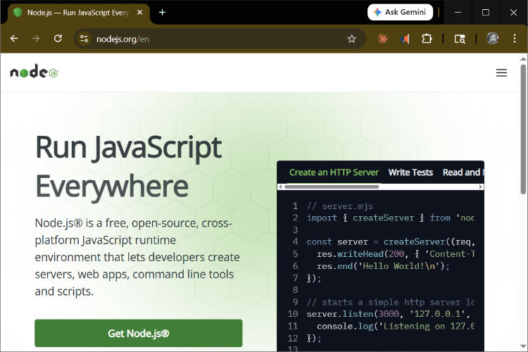
Click the green Download Node.js button. Once it downloads, double-click the file to run it. The installer will complete quietly in the background.
After installing Node.js, proceed to claude.com/download to get Claude Desktop. Use this link exactly — there are unofficial lookalike pages online. The installer detects your platform automatically — usually Windows. Download the appropriate file for your platform.
To launch Claude, press the Windows key + R on your keyboard. A small Run box appears. Type Claude and press Enter. The first thing Claude asks is: Do you trust this computer? Press Enter to say Yes and continue.
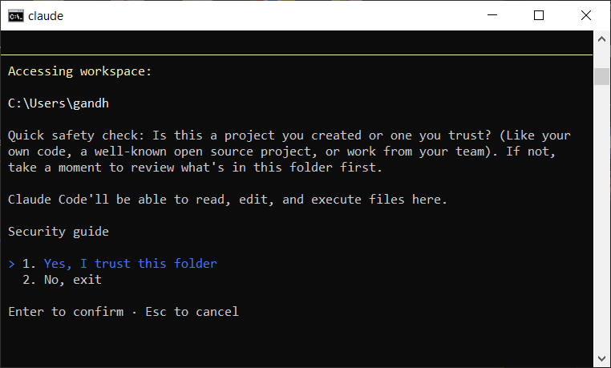
If there are updates available, Claude will show a command like: winget upgrade Anthropic.ClaudeCode. Copy that command — select it with your mouse and press Ctrl+C. Open a new command window, right-click to paste the command, and press Enter. Note: updates cannot be run from inside Claude itself. Open another command window and without starting Claude, type the link you copied. Just right click to drop the link. Press the enter key to install the updates.
Restart Claude by typing Claude at the command prompt.
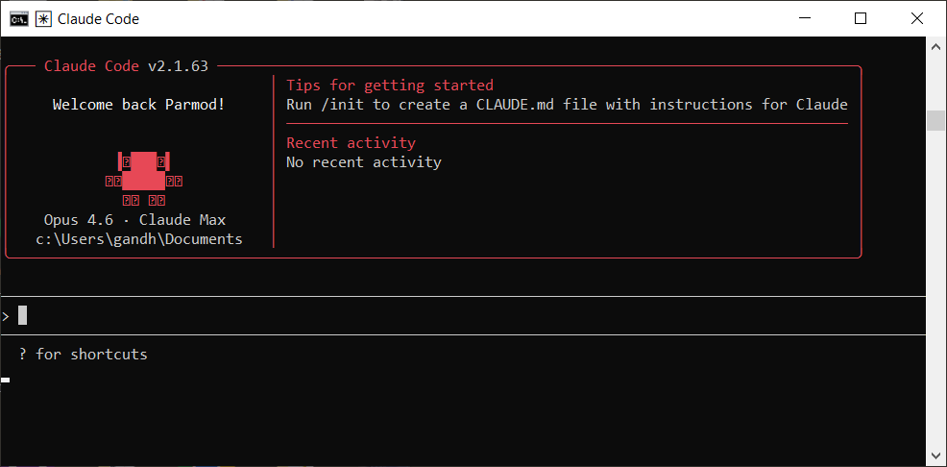
Claude is ready. Type any question you like, or follow along with the examples in this book.

2.8 Installing Claude in Chrome and Read Aloud
This section walks you through two installations: Claude in Chrome, which brings Claude into your browser as a side panel, and NaturalReader, which lets you listen to Claude’s responses out loud. Take your time. Each step has an image to show you exactly what to look for. If anything looks different on your screen, that is normal — both tools are updated frequently.
Before you begin
You need a paid Claude plan (Pro, Max, Team, or Enterprise) to use Claude in Chrome. The free plan does not include this feature. If you are not sure which plan you have, sign in at claude.ai and check Settings.

Part A — Installing Claude in Chrome
Claude in Chrome is a browser extension. An extension is a small add-on that gives your browser new abilities. Installing one takes about two minutes and does not affect anything else on your computer.
There are bad ratings for this product, which in my view is very wrong. The main reason is that users find it hard to follow the installation sequence and other mundane tasks like starting and starting tasks. It is length explanation but necessary to make your journey smooth.
- Make sure you are using Google Chrome
Claude in Chrome only works in Google Chrome. As of this writing, it does not work in Firefox, Safari, Edge, Brave, or Arc. If you are not sure which browser you are using, look at the colourful circle icon in your taskbar or dock — that is Chrome. If you do not have Chrome, download it free at google.com/chrome and install it first.
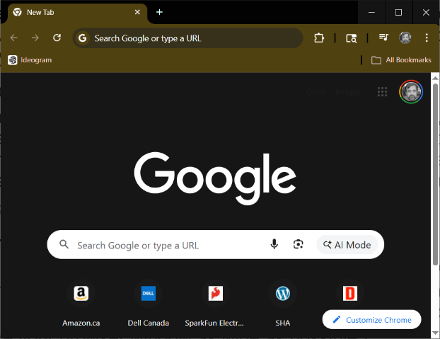
- Find Chrome settings
Locate 3 vertical dots on top right corner. Click on those to drop down a menu. At the bottom of the menu you will see Settings, select it.
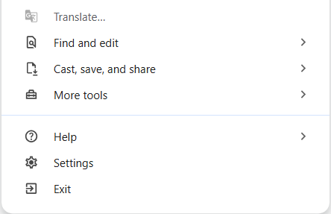
- Find Chrome Store
After you click on Settings, you should see a screen like this one.
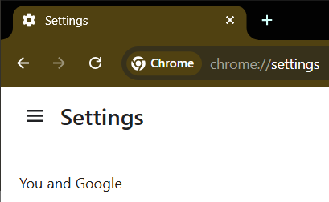
this is top left corner of the window. Click on 3 horizontal lines, which will bring up a menu shown below.
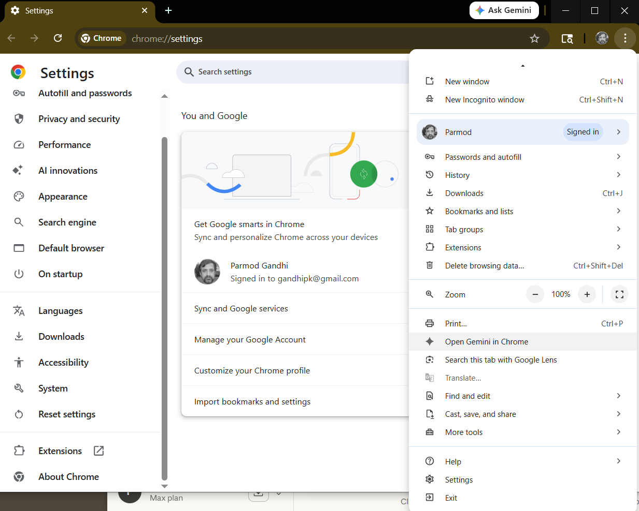
Way down at the bottom you see Extensions, click on that to bring up following screen.
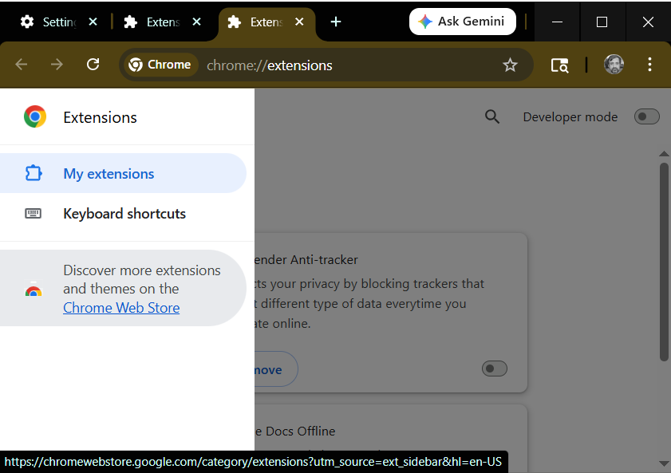
Now you see the Chrome Web Store at the bottom of the screen. Click on that.
- Choose Extension for Claude
type Claude in the search box to find our extension.
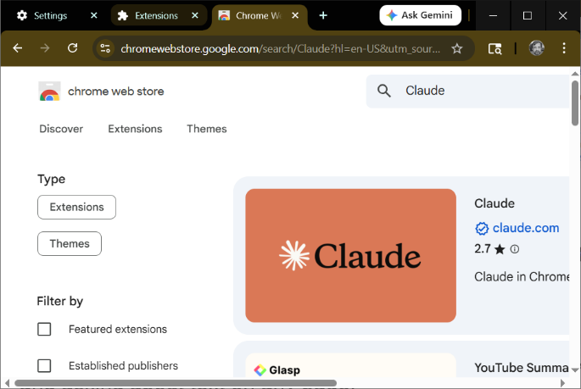
- Make your browser window as wide as possible
Drag your browser window to fill the full width of your screen. The Add to Chrome button sits on the far right side of the page. If your window is too narrow, the button may be hard to see or cut off.
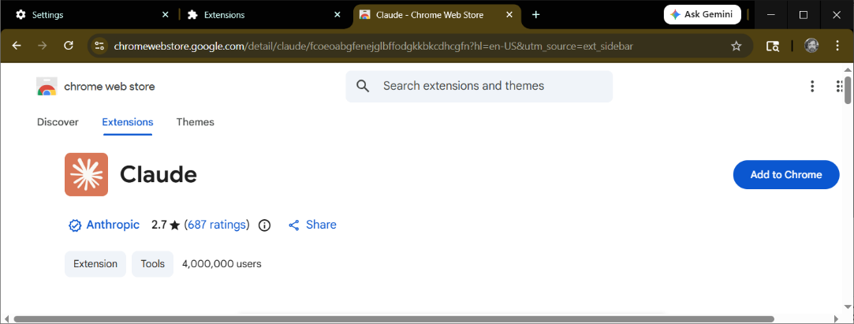
- Click Add extension in the confirmation box
Click the blue Add to Chrome button on the right side of the page. If you do not see it, your window may still be too narrow — try making it wider. A small box will pop up on your screen asking you to confirm.
- Find the puzzle piece icon and pin Claude
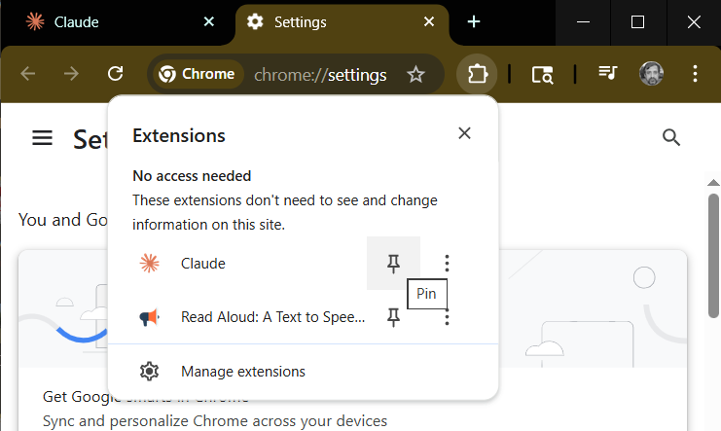
Look at the top, just to the right of the address bar. You will see a small puzzle piece icon. Click it. A menu drops down showing all your installed extensions. Find Claude in the list. Click the thumbtack icon beside it. The Claude icon will now appear permanently in your toolbar so you can always find it.
- Click the Claude icon to open the side panel
You will now see a small Claude icon in your toolbar, just to the left of puzzle icon. Click it. A panel slides open on the right side of your browser. This is the Claude side panel. The major difference is that now Claude sees what you see. It stays open while you browse, so you can ask Claude about any page you are reading without leaving it.
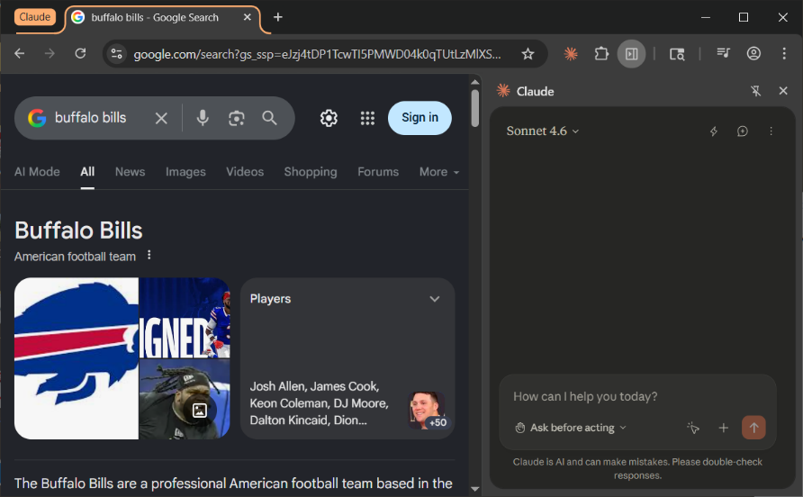
- Sign in with your Anthropic account
The side panel will ask you to sign in. Use the same email and password you use at claude.ai. Once signed in, Claude will ask for a few browser permissions. These allow Claude to see the pages you are visiting so it can help you with them. Click Allow or Accept when asked. You are now ready to use Claude in Chrome.
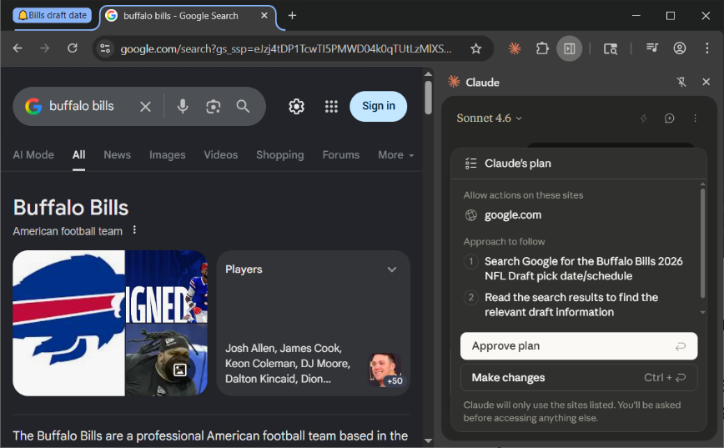
Notice what happened to my question about Bills NFL draft schedule. It presented a plan and asked for my approval. You can set it just below to either perform the action or ask before action. If you are rearranging your mail folder on the web, you certainly want to see the plan before you let is go. So safety is built in.

A note about this beta
Claude in Chrome is still in beta, which means it is good but not quite finished. Occasionally something may not work as expected — a button might not respond, or the side panel might go quiet. This is normal. If it happens, simply refresh the page by pressing F5 on Windows or Command+R on Mac, then try again. Most issues resolve themselves.

Part B — Adding Read Aloud with NaturalReader
Chrome does not have a built-in Read Aloud feature the way the Kindle app or Apple Books does. NaturalReader is a free extension that adds this ability. Once installed, it can read any webpage out loud — including Claude’s responses in the side panel. It works on webpages, Google Docs, PDFs, and emails.
One thing to know before you start
When NaturalReader first installs, it defaults to a premium voice that runs out after 20 minutes per day. This confuses many people. Step 4 below shows you how to switch to a free voice right away. The free voices sound perfectly natural and have no daily limit.

- Go back to the Chrome Web Store
Click in the address bar, type chromewebstore.google.com, and press Enter. You are back at the same place where you found Claude. Here is new shortcut.
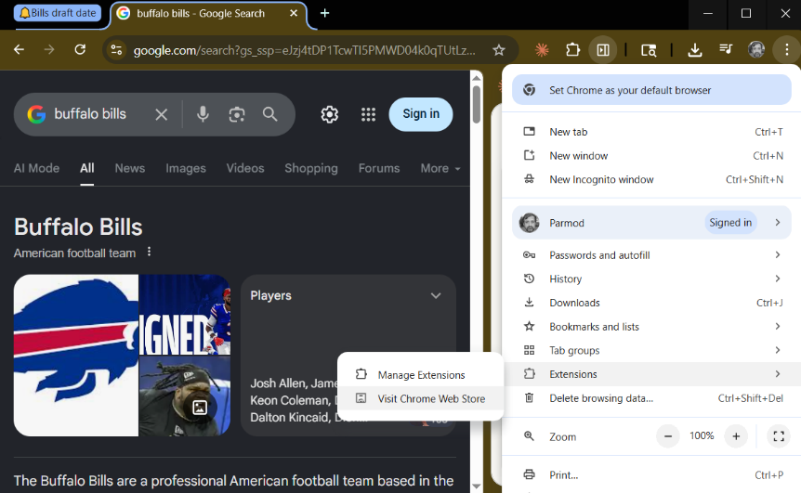
- Search for NaturalReader
In the search box on the left, type NaturalReader and press Enter. Look for the result that says NaturalReader — AI Text to Speech, published by NaturalSoft Ltd. It has over one million installs and a 4.2 star rating.
- Click Add to Chrome, then Add extension
Click the blue Add to Chrome button on the right. When the confirmation box appears, click Add extension. Chrome installs NaturalReader in about ten seconds.
- Pin NaturalReader to your toolbar
Click the puzzle piece icon in the top right corner of Chrome. Find NaturalReader in the list and click the thumbtack beside it. The NaturalReader icon — a small green headphone symbol — will now appear in your toolbar next to the Claude icon.
- Switch to a free voice right away
Click the NaturalReader icon in your toolbar. The NaturalReader reading bar appears across the top of the page. Look for the voice name displayed in the bar — it likely shows a premium voice. Click on the voice name to open the voice panel. Click the Free tab at the top. Choose any voice from the free list and click it to select it. You will hear a short sample. This voice is now your default and has no daily time limit.
- Start reading
On any webpage, click the NaturalReader icon to open the reading bar. Click the play button — the triangle pointing right — and NaturalReader begins reading the page from the top. As it reads, each sentence is highlighted in the text so you can follow along. To read only a specific section, highlight that text with your mouse first, then click the small play icon that appears beside your selection.
- Pause, resume, and stop
To pause: click the pause button in the reading bar, or press the spacebar on your keyboard. The same button — or spacebar — resumes reading from where it stopped. To stop completely and close the reading bar, hover over the bar and click the small X that appears at the top right corner of it. You can adjust reading speed using the speed control in the bar. Most people find 1.2 to 1.5 times normal speed comfortable for listening to Claude’s responses.

If something does not work as expected
NaturalReader occasionally skips a paragraph or stops mid-sentence on certain websites. If this happens, try highlighting just the section you want and using the play icon on the selection rather than playing the whole page. On most pages it works smoothly.
To sign out of NaturalReader, click the NaturalReader icon in your toolbar, look for the small person icon or menu in the top corner of the reading bar, and select Sign Out. To sign back in, click the same icon and choose Sign In.

Chapter 2 Summary
Here is what you now know about Claude and how it works:
- Claude is an AI assistant that responds to plain language — no technical vocabulary required.
- Claude remembers everything within a conversation but nothing between conversations. Each new chat starts completely fresh.
- The context window is a memory limit, not a subscription limit. As it fills, Claude's quality degrades — especially its debugging ability.
- When you see a tool limit warning or compacting notice, do not press Continue. Create a handoff file and start a fresh conversation instead.
- Ask Claude to write the handoff file for you before the context gets full. Paste it at the top of the new conversation along with your files.
- Claude cannot see your screen or access your files unless you provide them. It makes mistakes — always read before you run.
- Sections 2.7 and 2.8 cover installing Claude Code and Claude in Chrome step by step — with an image at every step.

Ready for Chapter 3?
Chapter 3 covers how to ask Claude well — the habits that consistently produce better, faster answers. The difference between a vague question and a well-framed one is the difference between a generic answer and one that solves your actual problem.

