Chapter 6 - 3D Design Describing Objects into Existence
Not long ago, designing a three-dimensional object and printing it in your home was the exclusive territory of engineers with years of CAD (Computer Aided Design) training, expensive software, and a tolerance for steep learning curves. The tools existed. The barrier was the expertise required to use them.
That barrier is gone.
Today you can describe an object in plain language — a box for your recipe cards, a set of decorative glasses for your table, a precision enclosure for a custom circuit board — and Claude will write the code that builds it inside a professional 3D design tool. You run the code, the object appears on screen, you slice it, and you print it. No CAD training. No drawing. No guesswork.
This chapter shows you how. It starts with a simple box, moves to something beautiful, and then shows what happens when you push the workflow as far as it can go. By the end you will understand the process well enough to design almost anything you can describe.

The Mythical Man-Month
“Plan to throw one away; you will anyhow.”
Fred Brooks, project manager for the IBM System/360 operating system
I read this book 50 years ago and still remember every chapter. It was full of insights for software engineering — and it turns out, for 3D printing too.

6.1 Three Things You Can Build
Before we talk about tools or process, let me show you three real things this workflow produces. They range from simple to complex. All three were designed by describing them to Claude, running the generated code in Autodesk Fusion, and printing them on a Bambu Lab P1S.
Each example below shows the kind of description you give Claude and the parameter block that comes back. The parameter block is not code you need to understand — it is a plain-English record of every decision in the design. When something needs to change, you change a number in that block and the entire object updates automatically.

A Box
A recipe card box. 102mm wide, 157mm long, 80mm tall inside, with a slip-in lid and a finger notch at the front. Designed from a hand-drawn sketch. First print in about 90 minutes. Total filament cost: about four dollars.
It is the simplest object in this chapter and the best place to start. Every concept in this workflow — parametric design, running a script, iterating from a print — is illustrated by this one object.
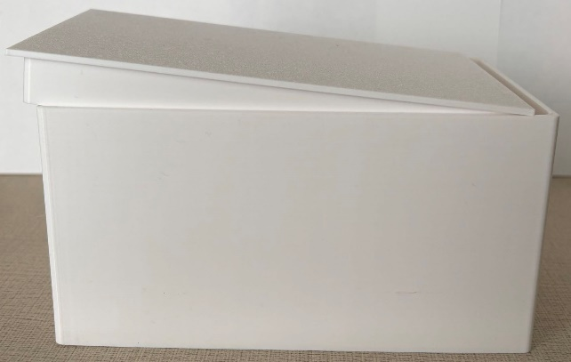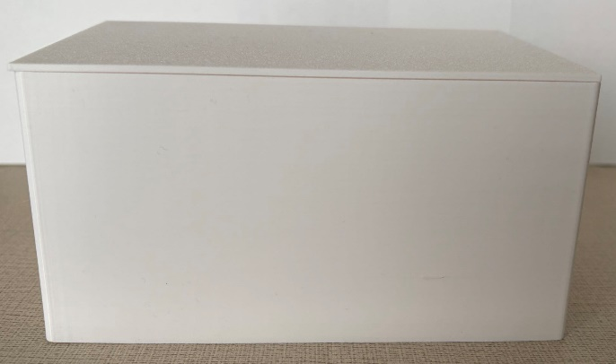
Here is the kind of description that gets you a good first script from Claude:
I need a storage box for standard 4x6 inch recipe cards. I have about 100 cards so the inside needs to be at least 102mm wide, 157mm long, and 80mm tall. Wall thickness 2.5mm. I want a slip-on lid that is 22mm tall with a 0.3mm clearance fit so it slides on and off smoothly without being loose. Add a finger notch in the front wall of the lid — 25mm wide and 10mm deep — so I can lift it off with one hand. Round all outside corners with a 3mm radius. Print in white PLA on a Bambu Lab P1S.

Notice what that description includes: the purpose, the inside dimensions so the cards actually fit, the wall thickness, how the lid works, the clearance number, the finger notch size, and the corner style. The more of those details you provide up front, the fewer back-and-forth questions before Claude writes the script. By changing the thickness from 2.5 to 2 mm will save you some material and reduce your cost.
Claude translates that description into a parameter block that looks like this:
# Recipe Card Box — parameter block

BOX_W = 102.0 # inside width in mm (4 inch card = 101.6mm + 0.4mm clearance)
BOX_L = 157.0 # inside length in mm (6 inch card = 152.4mm + 4.6mm margin)
BOX_H = 80.0 # inside height in mm (stack of ~100 cards)
T = 2.5 # wall thickness in mm
LID_H = 22.0 # lid outer height in mm
FILLET = 3.0 # outer corner radius in mm
GAP = 0.3 # lid-to-tray clearance per side in mm
NOTCH_W = 25.0 # finger notch width in mm
NOTCH_D = 10.0 # finger notch depth in mm

def cm(v): return v / 10.0 # Fusion API uses centimetres

Every number in that block came directly from your description. BOX_W is 102mm rather than 101.6mm because Claude added 0.4mm of clearance, so the cards slide in and out smoothly. GAP is 0.3mm per side — the right amount for a lid that fits snugly on an FDM printer without requiring force to open. Each of those small decisions is visible, named, and easy to change.
First print too tight? Change GAP from 0.3 to 0.5. Box too short for your cards? Change BOX_H from 80 to 90. Rerun the script. The whole object rebuilds in Fusion 360 in thirty seconds.

A Glass Collection
This is where the workflow becomes something unexpected. The same approach that builds a practical box can produce decorative objects — things that have no circuit board to fit around, no functional requirement beyond looking right and feeling good in your hand.
Each glass in this collection shares the same physical shape: 70mm base diameter, 81mm at the lip, 100mm tall, 3mm wall. What makes each one different is the surface pattern — vertical flutes, a five-arm spiral, a rope twist, a diamond crisscross. Claude generates a different Python script for each pattern. The printer produces them one at a time.
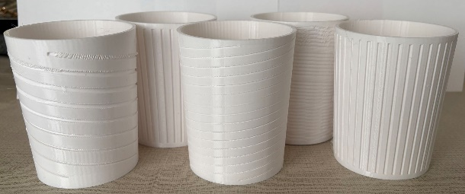
Here is how you describe a decorative pattern to Claude. The geometry is the key — you are telling Claude not just what the glass looks like but exactly how the grooves are defined:
I want a drinking glass with a spiral groove pattern on the outside. The glass body is a cylinder: 70mm base diameter, 81mm at the lip, 100mm tall, 3mm wall thickness. Leave a plain band 4mm tall at the bottom and 4mm at the top — no grooves in those areas. The spiral pattern has 5 arms; each arm makes 3 full turns clockwise from bottom to top. The groove profile is a round channel, 2mm wide and 1mm deep, cut into the outside surface. Keep all arms evenly spaced around the circumference.

That description gives Claude everything it needs: the body geometry, where the plain bands are, how many spiral arms, how many turns, the direction, and the groove profile. The parameter block Claude returns makes every one of those decisions visible and changeable:
# Spiral Glass — parameter block

BASE_D = 70.0 # base diameter in mm
LIP_D = 81.0 # lip diameter in mm
HEIGHT = 100.0 # glass height in mm
WALL = 3.0 # wall thickness in mm

GROOVE_BOTTOM = 4.0 # plain band at bottom in mm
GROOVE_TOP = 96.0 # groove stops here (100mm - 4mm plain band)

N_ARMS = 5 # number of spiral arms
N_TURNS = 3.0 # full turns from bottom to top
CHANNEL_W = 2.0 # groove width in mm
CHANNEL_R = 1.0 # groove depth in mm (radius of round profile)

def cm(v): return v / 10.0

Want to try a different pattern? Describe it the same way: the groove geometry, how many repeat around the glass, where they start and stop. Each pattern becomes its own script. The glass shape parameters stay the same across all of them — every glass in the collection matches in size even as the patterns change.
Vertical flutes, rope twist, crisscross, fish scale — one conversation each.
You can apply these designs to decorative platters as well. After this book is published, I will research that further and post the results on the companion website, GetToKnowClaude.com.

The TmpMonitor Enclosure
The TmpMonitor is a real IoT temperature sensor — a custom circuit board designed and built by the author. It needed a precision two-piece enclosure: standoffs to mount the board at the right height, a USB-C cutout through the wall, a battery compartment underneath, and a rebate joint so the lid closes firmly but opens cleanly with two fingers.
This is the most complex example in the chapter because it must fit real hardware precisely. The description you give Claude is longer and more specific. Here is an excerpt of the kind of detail required:
I need a Fusion 360 Python script to generate a two-piece PCB enclosure with an outside rebate joint. The PCB is 40.1mm wide and 52.3mm long, 1.6mm thick. Wall thickness 2.5mm, outer corner fillet 3mm. The lower tray is 50mm tall outside.

USB-C connector is on the front wall, centred at X = 20.05mm from the left edge. The slot bottom is 11.16mm from the inside floor, the slot top is 14.48mm, the slot width is 10mm.

Four standoffs at PCB corners: (3.5, 3.5), (36.6, 3.5), (3.5, 48.8), (36.6, 48.8) — all in mm from PCB corner. Each standoff is 8mm tall, 5mm outer diameter, with a blind M2 screw hole 3mm deep.

Battery space of 12mm below the PCB floor. All Z measurements are from the inside floor of the lower tray.

That level of detail — every connector position, every standoff coordinate, every height measured from the same reference point — is what allows Claude to write a script that fits the real hardware on the first or second version rather than the fifth or sixth.
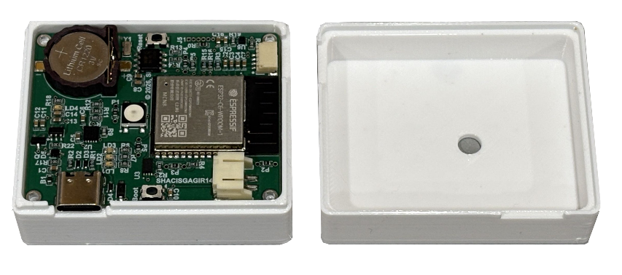
The parameter block that comes back from a description like that is longer, but it follows the same principle: every measurement has a name, every name is a number you can change:
# TmpMonitor Enclosure — parameter block (excerpt)

PCB_W = 40.1 # PCB width in mm
PCB_L = 52.3 # PCB length in mm
PCB_T = 1.6 # PCB thickness in mm
PCB_GAP = 0.4 # clearance each side around PCB
T = 2.5 # wall thickness in mm
FILLET = 3.0 # outer corner fillet radius

STANDOFF_H = 8.0 # standoff height in mm (PCB sits on top)
STANDOFF_OD = 5.0 # standoff outer diameter in mm
BATTERY_H = 12.0 # battery space below PCB floor in mm

USBC_CX = 20.05 # USB-C slot centre X from PCB left edge
USBC_Z_BOT = 11.16 # USB-C slot bottom, from inside floor
USBC_Z_TOP = 14.48 # USB-C slot top, from inside floor
USBC_W = 10.0 # USB-C slot width in mm

def cm(v): return v / 10.0

When version 7 revealed the USB-C slot was 1.6mm too high, the fix was one line: change USBC_Z_TOP from 14.48 to 12.88. Rerun the script. Reprint only the lid. Done.
About the TmpMonitor
The TmpMonitor is described in full in the companion book Let’s Make a Gadget, coming from Superior Home Automation Corp. approximately one month after this book. In this chapter it serves as a real-world example of what Claude and a 3D printer can accomplish together.

6.2 The Printer — What I Use and Why
The printer used for every example in this chapter is the Bambu Lab P1S. It costs around $400 USD. It prints reliably out of the box without any tuning or expertise. It is enclosed, which means it handles PETG, and tougher materials without temperature problems. And it is fast — what used to take three or four hours on an older printer takes ninety minutes on the P1S.
I chose it because I wanted a printer that would just work. I did not want to spend my time calibrating. I wanted to send a file and come back to a finished part. The P1S does that.

How It Compares to Other Printers
The honest answer is that 3D printing has improved dramatically in the last few years. Printers that cost $300 to $400 today produce results that would have required a $2,000 machine five years ago. The P1S is at the better end of this range, but it is not the only good option.
Printer | Price (2026) | Best For | Notes
Bambu Lab P1S | $399–449 | Reference printer | Enclosed, fast, reliable out of box. Best overall for enclosure work.
Bambu Lab A1 | $299–350 | Budget option | Slightly slower. No enclosure chamber — use PLA only.
Prusa MK4S | $799 | Open ecosystem | Excellent quality. Open source. Slower speed.
Creality K1C | $299–349 | Budget fast | Enclosed chamber. Good value. Community-tuned profiles available.
Creality Ender 3 | $150–200 | Lowest entry cost | PLA only. May need first-layer calibration each session.

If you do not own a printer yet, the Bambu Lab A1 at around $300 is a strong starting point. If you already own a printer — a Prusa, a Creality, almost anything made in the last three years — it will work. The scripts Claude generates are Python files that Fusion 360 uses to build your object and export standard STL files that every modern printer handles.
If you do not want to buy a printer at all, services like JLC3DP, Craft cloud, and local makerspaces will print your STL files and ship the parts. The workflow is identical. The wait is three to seven days instead of ninety minutes.

6.3 Filament — Materials and Costs
The material a 3D printer uses is called filament — a thin plastic strand wound onto a spool, fed through a heated nozzle, and deposited layer by layer. A standard spool holds one kilogram of filament and costs between $15 and $30 depending on the material.
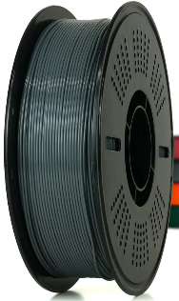
For the objects in this chapter, you need one material: PLA.

PLA — Start Here
PLA (polylactic acid) is the most common 3D printing material. It is easy to print, does not warp, smells mild when printing, and comes in every colour imaginable. It is made from corn starch, which makes it compostable under the right conditions. A one-kilogram spool costs about $20. Depending on quantity, color, packaging, shipping and supplier cost goes up or down the listed average number.
The recipe card box uses about 200 grams of filament — roughly $3. Each glass in the collection uses about 60 to 80 grams — about $1 per glass. The TmpMonitor enclosure — both pieces together — uses about 45 grams, under a dollar. These are not estimates. These are the actual numbers reported by Bambu Studio before each print.

One Important Thing to Know About Filament
FDM printing builds objects layer by layer, and those layers never fuse into a perfectly solid mass. The printed object is porous — there are microscopic gaps between layers. This matters for one specific use case: liquids.
The glasses in this chapter are decorative. They are not suitable for drinking from. Water will seep through the walls over time, and the surface is difficult to clean properly. Use them as display pieces, pencil holders, or planters.
There is a way to make a printed object liquid-safe: sealing the surfaces after printing. Several options are available and each has its strengths.
Food-grade epoxy resin is the most thorough solution. Products like ArtResin and Stone Coat Countertops — available on Amazon — brush over the surface, fill the microscopic gaps between layers, and cure into a smooth, non-porous, washable finish. One caution: epoxy is toxic in liquid form, so wear gloves when applying it. Once fully cured it is safe. Treat sealed prints as hand-wash only — most epoxy coatings are not dishwasher safe.
Food-grade silicone coating is a gentler option — easier and safer to apply than epoxy, no toxic fumes, and it seals well. Look for silicone sealants marked food-safe or FDA-compliant.
Mineral oil — the same food-safe oil available at any pharmacy, widely used on wood cutting boards and counters — can be rubbed onto the surface. It has no smell, no toxicity, and costs almost nothing. On wood it soaks in deeply. On plastic it coats the surface rather than penetrating it, so it needs reapplying occasionally. It is a good starting point if you want to try something simple before committing to epoxy.
Try them and see which works best for your use. For a decorative glass you fill occasionally, mineral oil may be all you need. For something used daily, epoxy gives the most durable finish.
Speaking of planters — a printed planter works beautifully. Just add drainage holes in the base so water does not pool at the roots. The porosity that makes a glass unsuitable for drinking actually helps a planter breathe.
There is a lot more to say about filament types, colours, specialty materials, and what each is good for — more than fits comfortably in a chapter that is really about designing with Claude. A free ePub covering filament in depth will be available at GetToKnowClaude.com.

Other Materials Worth Knowing
PETG is tougher and more heat-resistant than PLA — useful for anything that might sit in a hot car or take mechanical stress. It costs about the same as PLA and prints almost as easily on an enclosed printer like the P1S.
ASA and ABS are for outdoor use and higher temperatures. They require an enclosed printer and a bit more patience. For the objects in this chapter, you will not need them.
TPU is flexible rubber-like filament — useful for phone cases, gaskets, and anything that needs to bend. Interesting to work with, and a different set of design rules applies.
What filament should you buy first?
One spool of white PLA and one spool of black PLA will handle almost everything in this chapter. White shows surface detail well in photos. Black looks professional on enclosures. Both cost about $20 each. Start there.

6.4 Installing Autodesk Fusion
Fusion is the 3D design tool where your objects come to life. It is free for personal use and for small businesses with annual revenue under one thousand dollars. It runs on Windows and Mac. The installation takes about ten minutes.
You do not need to learn how to use Fusion manually. The Python scripts Claude generates do the building for you. What you need to know is how to run a script — which takes about thirty seconds to learn and is covered right below.

Step-by-Step: Installing Fusion
- Go to autodesk.com/fusion in your browser.
- Click the Free Download button. Autodesk will ask you to create a free account if you do not have one. Use your email address and choose a password.
- Once your account is created and you are signed in, the download begins automatically. The installer file is about 1.5 GB.
- Run the installer. On Windows, double-click the downloaded .exe file. On Mac, open the .dmg file and drag Fusion to your Applications folder.
- Fusion will launch and sign you in automatically. The first launch downloads additional components and takes three to five minutes.
- When Fusion opens, you will see the Design workspace with an empty canvas. You are ready.
Personal use is free — no tricks.
Autodesk offers Fusion free for personal, non-commercial use and for small businesses under $1,000 annual revenue. No credit card required to start. The free version includes everything you need for this chapter.

Step-by-Step: Running a Script Claude Gives You
This process is the same for every script in this chapter. Once you have done it once, it takes about thirty seconds.

Where to save your script files
Keep each Python script in its own folder and give the folder the same name as the file. For example, put recipebox.py inside a folder called recipebox. Fusion requires this match. You can store these folders anywhere — your Documents folder works well.

- Save the script Claude gave you as a .py file. Name the file and its containing folder the same thing — for example, a folder called recipebox containing recipebox.py.
- Open Fusion. Wait for it to fully load into the Design workspace.
- In the menu bar, go to Utilities → Add-Ins → Scripts and Add-Ins. (On some versions of Fusion, Shift + S also opens this dialog, but the menu path works reliably on all versions). You will see a window this. There are many scripts there
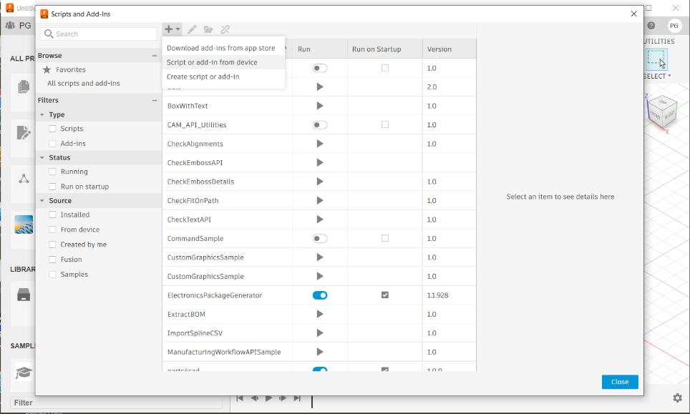
- Click the small + button next to the search box near the top. Navigate to your script folder and select the .py file. Fusion adds it to the list.
- Select your script in the My Scripts list and click Run or double click. A new design document opens and the script executes. Watch the browser panel on the left populate as the object builds. When it finishes, a message confirms success.|
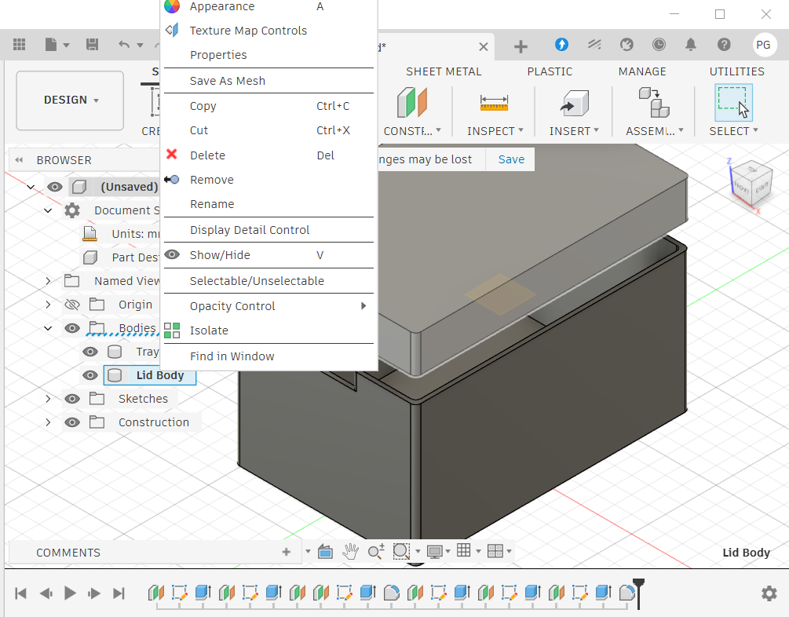
- On the left drop down menu you see Tray & Lid Body. Those are 2 objects that this script contains. Click on Lid Body to select it. Right Click on the selected menu item to bring up the drop-down menu shown above. From the menu choose Save As Mesh.
- This will bring up the following window. Accept all defaults and Press the OK Button to continue.
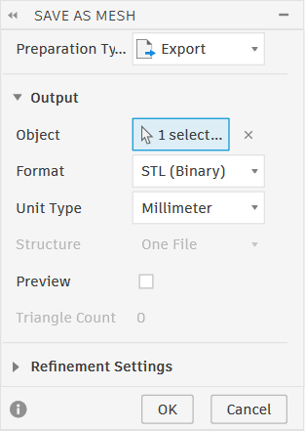
- Next you will see a save file dialog.
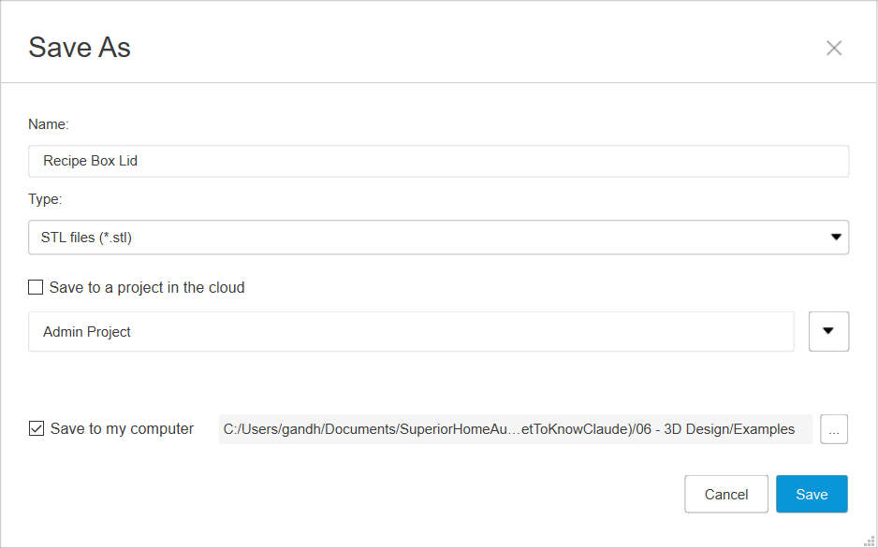
There will be an arbitrary name in the Name box. Change it to something that matches your .py file. At the Save to my computer list chose the target folder. I chose the same folder where .py file is located. This will save the .stl file. This is the target file you take over to the Bambu Lab Slicer or another slicer you prefer.

All Fusion API coordinates are in centimetres, not millimetres.
A box that is 100mm wide is 10.0 cm in Fusion. Every measurement in Claude’s scripts passes through a cm() helper function that divides by 10. Claude handles this automatically. But if you ever edit a script manually and add a measurement, remember to divide by 10. Forgetting produces an object ten times the wrong size.

6.5 Installing and Using Bambu Studio
Bambu Studio is the software that takes your finished 3D model and prepares it for printing. This step is called slicing — the software cuts your object into thousands of thin horizontal layers and generates the exact instructions your printer will follow.
Bambu Studio is free and works with every printer, not just Bambu Lab. Prusa users have PrusaSlicer. Creality users have Creality Print. They all work the same way. This section covers Bambu Studio because that is what the P1S uses.

Step-by-Step: Installing Bambu Studio
- Go to bambulab.com and click Software in the top menu. Select Bambu Studio.
- Download the installer for your operating system — Windows or Mac.
- Run the installer. On Windows, double-click the .exe. On Mac, open the .dmg and drag to Applications.
- Launch Bambu Studio. On first launch it will ask you to select your printer. Choose your printer from the list. If you are just exploring, you can select any printer for now.
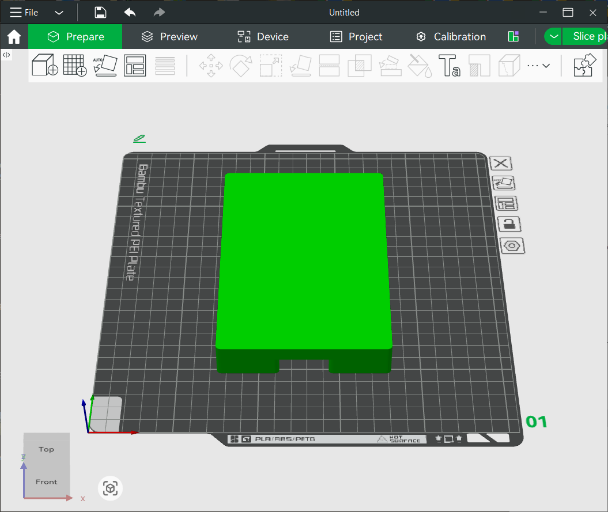
- You can double click on .stl file you stored from Fusion software or browse and open the .stl file. You will see an image like the one above. Normally we would proceed to slicing and print. But notice that lid is loaded right side up. This will be a problem for printing as there is a hollow space underneath the lid. There is nothing under the top to support the flat top. We can add support but that is messy. Let’s flip it over so it prints perfectly without wasting any material for support and cleaning the extra material after print.
- To flip the lid, we need to rotate it 180 degrees in Y direction. Select the object by clicking on it. You will see that some of the toolbar icons are not grayed anymore. Select the Rotate tool, enter 180 under Y symbol and press the Enter key.
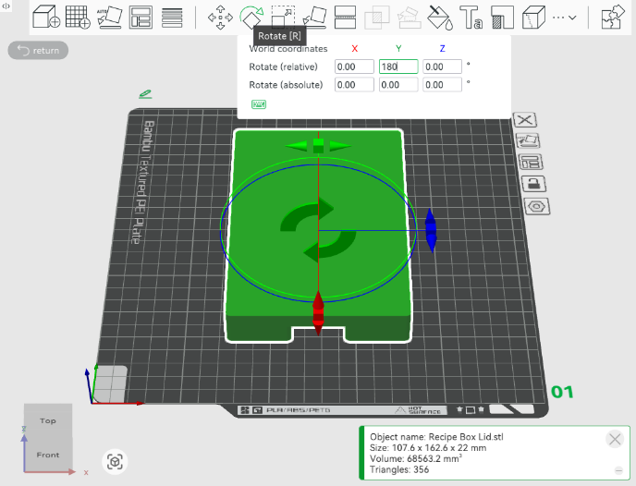
- You can also add the other object to print both in one shot. For that go to File > Import and select the Recipe Box Tray.stl file. Select each object to move them with the mouse. Keep the as close to each other as possible without overlapping or touching each other. Now you are ready to slice the object. For this just press the Slice Plate button on the top right corner.
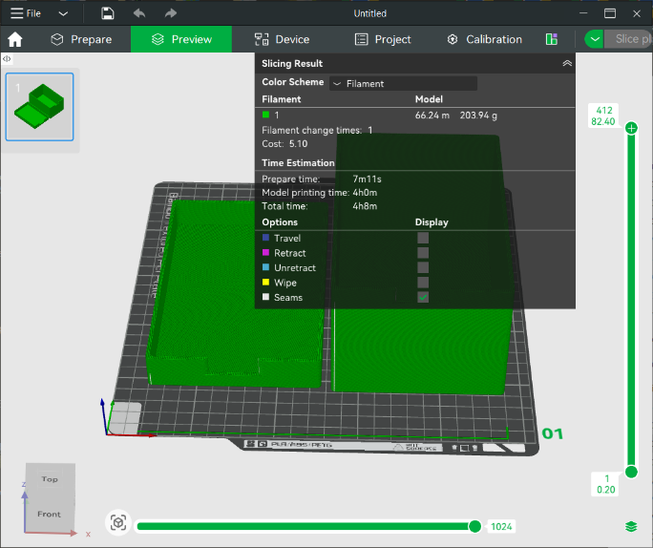
- Notice that slicer now shows exactly how much material will be used and how long it will take to print the object.

Exporting Your Model from Fusion
Before you can slice in Bambu Studio, you need to export your object from Fusion as an STL file. STL is the standard format that all slicers understand.
- In Fusion, right-click the body you want to export in the browser panel on the left. Select Save As Mesh.
- Set the format to STL. Set Refinement to High. Click OK and save the file.
- If your design has two pieces (like a box and a lid), export each one separately.

Visualizing and Slicing Your Model
Now open Bambu Studio and import your STL file.
- Click the + button or drag your STL file onto the build plate. Your object appears as a 3D model you can rotate, zoom, and inspect from every angle.
- If you have two parts, import the second STL file as well. Arrange both pieces on the build plate so they are not overlapping.
- Set your print settings. For most objects in this chapter: 0.2mm layer height, 3 wall loops, 15% gyroid infill.
- Click Slice. Bambu Studio processes your model and shows you two important numbers before you print anything.
- When you are happy with what you see, click Print. If your printer is on the same Wi-Fi network, Bambu Studio sends the job wirelessly and the printer starts automatically

Two numbers to check before every print:
Print time — how long the printer will run. The recipe card box takes about 90 minutes. A single glass takes about 45 minutes. The TmpMonitor enclosure takes about 75 minutes. These numbers are accurate to within a few minutes.

Filament used (grams) — how much material will be consumed. Multiply the grams by your filament cost per gram to get the exact cost of that print. A $20 spool holds 1,000 grams — so 80 grams costs $1.50.

Temperature Settings — The Most Important Setting
Before you send your first print, there is one setting you must get right: temperature. Get it wrong and your print will fail. Get it right and your printer will produce clean, solid results every time.
Temperature has two parts: the build plate temperature, which determines whether the first layer sticks, and the nozzle temperature, which determines whether the filament flows correctly. Each material has its own requirements. Using the wrong temperature for your material is the most common cause of a failed print.

PETG Temperature Settings

Build plate — first layer: 70°C
Build plate — subsequent layers: 70°C
Nozzle — first layer: 270°C
Nozzle — subsequent layers: 268°C

PETG is the material used for most of the prints in this chapter. It is tougher and more heat-resistant than PLA, and it produces beautiful results — but it demands high temperatures. The plate must be hot enough for the first layer to grip firmly. The nozzle must be hot enough for the filament to flow smoothly and bond between layers.
What happens if PETG temperatures are wrong
If the plate is too cold, the first layer will not stick. The material peels up, gets dragged by the print head, and accumulates on the nozzle. Enough material stuck to the head can damage it. Always verify your temperature settings before starting a PETG print.

PLA Temperature Settings

Build plate — first layer: 60°C
Build plate — subsequent layers: 60°C
Nozzle — first layer: 230°C
Nozzle — subsequent layers: 220°C

PLA is more forgiving. It prints at lower temperatures, sticks reliably to a warm plate, and is the easier material to start with. It is also biodegradable — made from corn starch — which makes it the more environmentally friendly choice.
Both PETG and PLA are made from food-safe materials. That makes them a natural choice for planters, seed trays, and garden containers. One important note: the food safety refers to the filament material itself. Because FDM printing is porous, the printed surface is not suitable for direct food contact — bacteria can harbour in the microscopic gaps between layers. For planters, that is not a concern. For anything that will hold food or drink, it is.
Bambu Studio sets these temperatures automatically when you select your material profile. Choose PETG or PLA from the filament dropdown and the correct values are applied for you. The first time you use a new material, you must check the settings manually to confirm they match the numbers above or whatever your supplier suggests.

Bambu Studio Can Do Much More
What you have learned so far is enough to print everything in this chapter. But Bambu Studio has many more capabilities — support generation, multi-colour printing, variable layer heights, paint-on supports, and more.
That depth deserves proper attention, not a paragraph in a chapter about something else. A free ePub covering Bambu Studio in full will be published at GetToKnowClaude.com. It is focused, practical, and written for people who do not want to wade through technical documentation.
Free ePub: Bambu Studio from Start to Finish
A complete guide to Bambu Studio — slicing, supports, multi-colour, optimization, and more — will be available as a free download at GetToKnowClaude.com.

6.6 The Parametric Principle — One Number, Everything Updates
The most important concept in this chapter is parametric design. It is simple and it changes everything about how iteration works.
In a traditional 3D design tool, you draw shapes manually. When you want to change something, you go back into the drawing and redraw it. Change the wall thickness and you might need to redraw every wall. Change the box height and you might need to adjust the lid, the standoffs, and the joint. Every change is work.
In a parametric script, every dimension is a named variable defined once at the top. The rest of the script uses those variables everywhere. Change the variable, rerun the script, and every feature that depends on that measurement updates automatically.
# The parameter block — every dimension defined once
BOX_W = 100.0 # outer width in mm
BOX_L = 150.0 # outer length in mm
BOX_H = 80.0 # outer height in mm
T = 2.5 # wall thickness in mm
LID_H = 20.0 # lid height in mm
FILLET = 3.0 # corner radius in mm
GAP = 0.3 # lid-to-tray clearance in mm

def cm(v): return v / 10.0 # Fusion API uses centimetres

That block is the entire design specification. Change BOX_W from 100 to 120, rerun the script, and you have a wider box with every wall, lid, and joint correctly updated. Change GAP from 0.3 to 0.5 and the lid fits more loosely. Change T from 2.5 to 3.0 and all four walls get thicker simultaneously.
This is why the TmpMonitor enclosure could go through ten versions in one afternoon. Each version changed one or two parameters. Each version took two minutes to specify, thirty seconds to run, and forty-five to ninety minutes to print — unattended — while other work continued.

6.7 Three Ways to Start a Design
You can start a 3D design conversation with Claude in three ways. All three work. Choose based on what you have in front of you.

Sketch It
Draw your object on paper with dimensions, photograph it, and upload the photo. Claude reads the sketch, identifies what is clear, asks about what is ambiguous, and writes the script from your answers. You do not need to be an artist. A rough sketch with numbers written on it is enough.
Tips for a sketch Claude can read well: draw two views (top and side), label every dimension with arrows, note what the lid should do, use a ruler, photograph flat on a table from directly above in good light.

Describe It
Tell Claude what you need in plain language — what it is for, what needs to fit inside it, how the lid should work. Claude will ask the dimensions it needs and build from your answers. This works especially well when you are clear about purpose but have not thought through every measurement yet.

Photograph It
Take a photo of an existing object you want to design around — a circuit board, a set of tools, something you want to store safely — and upload it. Claude reads the shape and proportions, asks you to confirm key measurements with a ruler, and designs around the real object.

6.8 Giving Corrections That Work
When a print reveals a problem, how you describe it determines how quickly it gets fixed. Vague descriptions produce guesses. Specific descriptions produce solutions.
The correction technique that works every time has three parts: what is wrong, where it is measured from, and what should not change.

Be Specific About What Is Wrong
# GOOD — specific, measurable, fixable
The USB-C slot top is 1.6mm too high.
Change USBC_Z_TOP from 14.48 to 12.88mm.

# VAGUE — Claude has to guess
The USB connector doesn't fit.

Say What to Keep as Well as What to Change
# GOOD — preserves what works
Do not change the lower tray — it is perfect.
Only fix the upper lid tongue relief.

# RISKY — Claude may improve things you did not ask about
Fix the lip problem.

One problem at a time.
When multiple things are wrong after a print, fix one, reprint, verify the fix worked, then move to the next. The TmpMonitor went through ten versions precisely because each version addressed one specific issue. When you change two things at once and something new breaks, you do not know which change caused it.

One more thing: you do not always need to print to check your work. Both Fusion and Bambu Studio show you a full 3D visual of the object before a single gram of filament is used. Get in the habit of examining that visual carefully — rotate it, zoom in on every feature, look at the joints and cutouts. If something looks wrong, take a screenshot and send it to Claude with a note about what you are seeing. Claude can often spot a geometry problem in a screenshot and suggest the fix before you print anything.

6.9 The TmpMonitor — Ten Versions, One Afternoon
Here is what the full workflow produces when you push it. A precision two-piece enclosure for a custom circuit board, designed from scratch, iterated through ten versions in one afternoon, printed for under fifteen dollars total.
The TmpMonitor enclosure needed: standoffs to mount the board at the right height, a USB-C cutout in the wall, a battery compartment underneath, a rebate joint so the lid closes firmly but opens cleanly, and the product name embossed on the lid in a second colour.

Version | Problem Found | Fix Applied
v1 | Wall cut helper used wrong construction plane — slot cuts not finding target body | Rewrote slot cuts using horizontal planes at correct Z height
v2 | PCB too tight, standoffs too tall, through-holes in floor | Increased clearance gap, standoffs made solid with blind holes
v3 | USB-C slot position wrong — measured from wrong reference point | All Z measurements now from inside floor, added wall thickness offset
v4 | Lower tray rim clashing with USB-C connector body | Added relief cut on tray top rim in USB-C zone
v5 | Upper lid tongue clashing with USB-C — relief cut placed too high | Added tongue relief cut but positioned incorrectly
v6 | Tongue relief still too high — lid would not close | Moved relief cut start to Z=0, bottom of lid plate
v7 | USB-C slot top still 1.6mm too high | Changed USBC_Z_TOP from 14.48mm to 12.88mm — one parameter, one line
v8 | Qwiic connector clashing with tray rim and lid tongue | Added relief cuts on both pieces in Qwiic zone
v9 | Old Qwiic wall slot no longer needed after relief cuts | Removed redundant slot cut, kept lip and tongue relief only
v10 | Corner notches appearing where tongue meets box corners | Separated fillet passes — box corners first, then tongue corners

Read that table as a realistic picture of what building something physical actually looks like — not as a list of failures. Every version fixed exactly one thing. Every fix was a small, precise change. Ten versions. One afternoon. Fifteen dollars. A finished enclosure that fits the real hardware, snaps together cleanly, and looks like a commercial product.

6.10 Verify Before You Print
Claude can design anything you can describe. But Claude has never held your object in its hands. It does not know that your specific USB-C connector is 0.5mm taller than the datasheet says because of the solder fillet underneath. The physical world requires physical verification.
Every dimension that matters for fit — connector positions, standoff locations, wall cutout sizes — needs to be measured with calipers, not estimated from memory or a datasheet. A measurement that is 1mm wrong in a script produces an enclosure that does not fit.
Print a test piece before a long print.
For any enclosure that needs to fit real hardware, print a small test piece before running the full print. A 10-minute print of just the USB-C slot area, or just the lid joint, will tell you whether the dimensions are right before you spend 90 minutes on the complete enclosure.
Measure the test piece with calipers. Compare against what you expected. Adjust the parameters. Then print the full piece. Ten minutes of testing saves ninety minutes of reprinting.

Also inspect the Fusion model before you export. Rotate it, zoom into every feature, verify that what you asked for is what appeared. Claude can make geometric mistakes — a slot cut from the wrong face, a standoff at the wrong coordinates. These are visible in Fusion before you commit a single gram of filament.

Chapter 6 Summary
- This chapter showed three real things you can build: a simple box, a collection of decorative glasses, and a precision circuit board enclosure. The same workflow produces all three.
- The tools are free: Autodesk Fusion for personal use, the Fusion Python scripting API, and Claude. A capable FDM printer completes the setup.
- Filament costs are low. A one-kilogram spool of PLA costs about $20. Most objects in this chapter use less than 100 grams — under two dollars per print.
- PLA is porous. Decorative glasses, planters with drainage, and enclosures are all great uses. Anything that holds liquid is not.
- Sealing options can make a printed surface liquid-safe: food-grade epoxy resin (ArtResin, Stone Coat Countertops) gives the most durable finish; food-grade silicone is easier to apply; mineral oil from the pharmacy is the simplest starting point. Try them and see what works best for your use.
- Installing Fusion takes about ten minutes. Running a script takes thirty seconds. Slicing in Bambu Studio adds another two minutes. Then you press print and walk away.
- Bambu Studio shows you the exact print time and grams of filament before every print. You always know what you are committing before the printer starts.
- The parametric principle is what makes iteration fast. Every dimension is a named variable. Change one number, rerun the script, the entire object rebuilds.
- You do not always need to print to check your work. Examine the 3D visual in Fusion or Bambu Studio first. Send a screenshot to Claude if something looks wrong.
- Corrections work best when they are specific: name the parameter, give the current value, give the target value, and protect what should not change.
- One problem at a time. Fix one thing, verify it, then move to the next.
- Measure with calipers. Print a test piece before a long print. Inspect the Fusion model before you export. The responsibility for physical accuracy is yours.

Ready for Chapter 7?
Chapter 7 is about building your own website and online presence — with Claude doing the heavy lifting. No web design background required. If you have something to share with the world, Chapter 7 shows you how to put it there.

