Facebook Post
Social Media Post — Ready to Copy and Paste

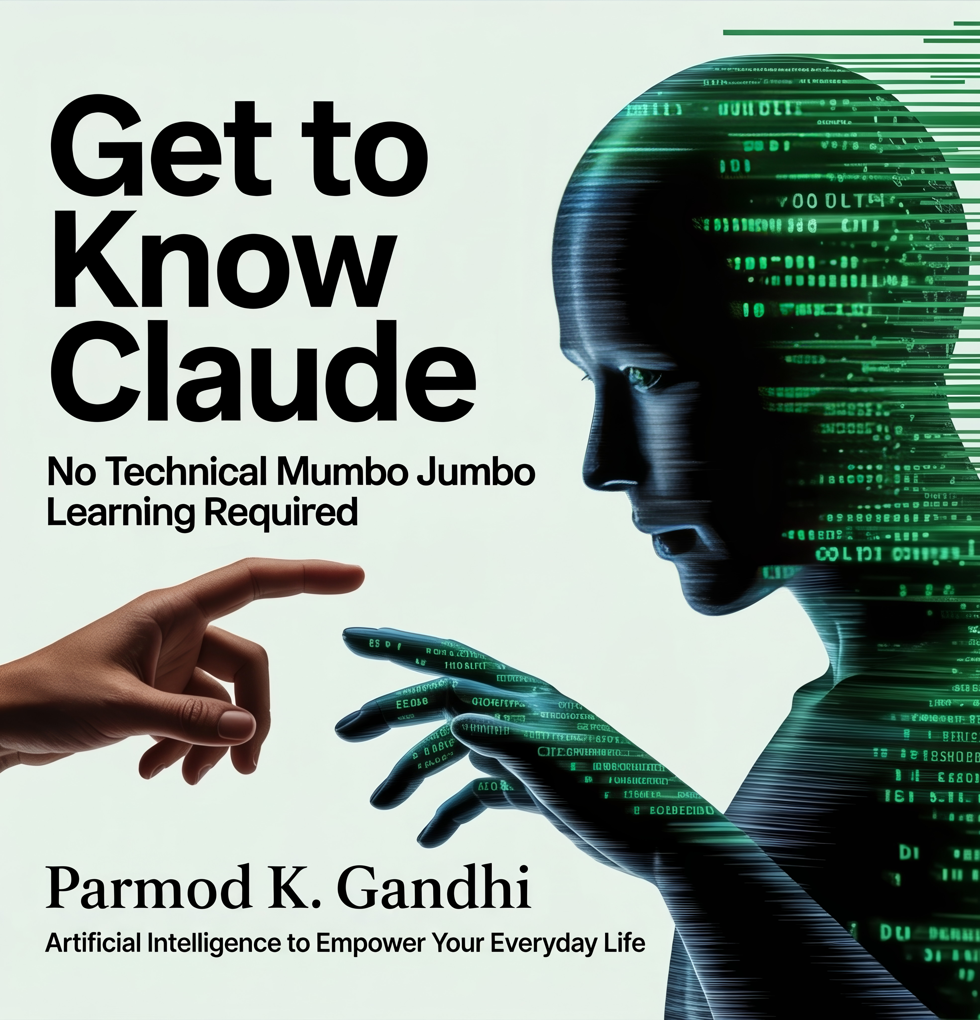

Copy the text below and paste into your post. Attach the cover image above separately.

After fifty years in hardware and software, I thought I had seen every wave of technology come and go. Then I met Claude.
Not a search engine. Not a chatbot that gives you ten blue links. A tool that actually thinks with you.
I spent months learning what it could really do — writing, building websites, 3D design, health research, business proposals, financial planning — and I wrote it all down in plain English so you would not have to figure it out alone.
Get to Know Claude is now available for pre-order on Kindle. No technical mumbo jumbo. No learning required. Just open your browser and start.
Whether you are running a small business, writing something you have been putting off, or just curious about what AI can actually do for ordinary people — this book meets you exactly where you are.
The orchestra is ready. What would you like to play?
Pre-order now — delivered to your Kindle on April 18.
[PASTE YOUR AMAZON LINK HERE]
GetToKnowClaude.com
#GetToKnowClaude #ClaudeAI #AI #ArtificialIntelligence #Kindle #NewBook #NoTechnicalMumboJumbo

