LinkedIn Post
Social Media Post — Ready to Copy and Paste

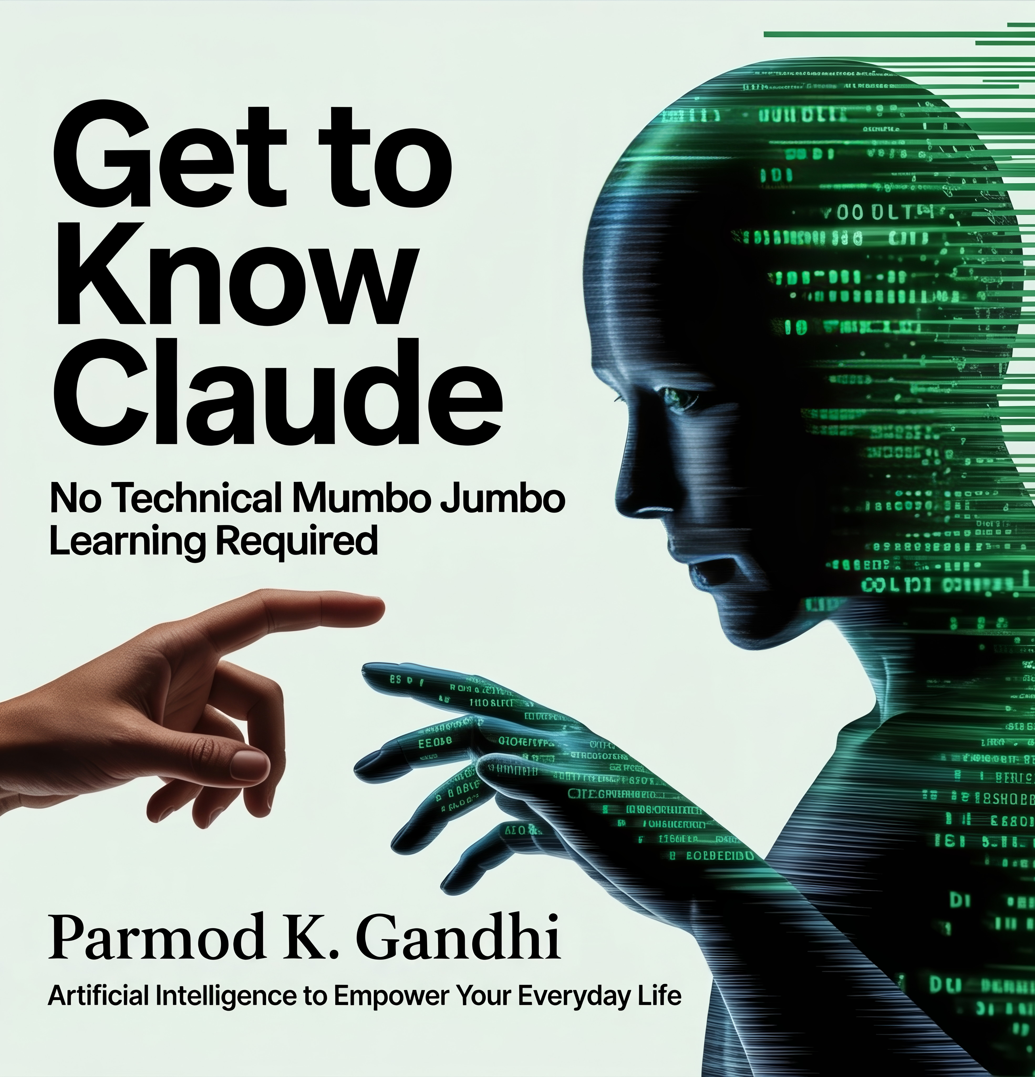

Copy the text below and paste into your post. Attach the cover image above separately.

I just published my latest book: Get to Know Claude — Artificial Intelligence to Empower Your Everyday Life.
After fifty years in hardware and software — from punch cards at Ryerson to eight years at Ontario Hydro to building microphone systems during the pandemic — I have watched every wave of technology arrive and change the rules.
This one is different.
Claude is not a search engine. It is a tool that thinks alongside you. And most people who try it walk away using a fraction of what it can do — not because they lack ability, but because nobody showed them how.
This book fixes that. Twelve practical chapters covering writing, business, health, finance, 3D design, websites, learning, and more. Written for ordinary people. No technical background required.
If you run a small business, manage a team, or simply want to understand what AI can actually do in your daily work — this is the starting point I wish I had.
Pre-order now — delivered to your Kindle on April 18.
[PASTE YOUR AMAZON LINK HERE]
GetToKnowClaude.com
#GetToKnowClaude #ClaudeAI #ArtificialIntelligence #AI #Productivity #SmallBusiness #BookLaunch #Kindle #TechForEveryone

