Procedures for testing the program

We take Fig. 6(b) in the manuscript as an example to illustrate how to test and use the program. To reproduce Fig. 6(b), please follow the input introduced below and run the main function file “ASCIB3D.m”. We divided the inputs into different groups so that it will be easier for the users to remember. The procedures of input are

1) Input the radius and inclination and azimuth of the borehole defined referred to the NED (North(x)-East(y)- Downward(z)) coordinate system.

rbh=0.1;% radius of borehole (unit, m)

boreholeIdeg = 45 %-inclination of the borehole in degrees

boreholeAdeg =45 %azimuth of the borehole in degrees

2) Input the far-field stress state applied to the borehole.

% Magitude of the stress components

stress1=[20 0 0;% The far-field stress tensor in units of MPa (Eqn.8)

0 10 0;

0 0 30];

% Orientation of far-field stress frame defined referred to the NED (North(x)-East(y)-Downward(z)) coordinate system

orientS=[90,0,90];%orientS=[strikeS,dipS,rakeS]=(*φs*,*δs*,*γs*):a 1 X 3 vector containing the strike, dip, and rake of the stress tensor in degrees

% strikeS- strike of *σ*xx-*σyy* plane; dipS- dip angle of *σxx*-*σyy* plane;

% rakeS- the angle of line rake indicating the direction of σxx within *σxx*-*σyy* plane

3) The borehole fluid pressure.

pw=5.0; % magnitude of wellbore pressure in units of MPa

4) The elastic property of the media.

%C1 is the elastic stiffness matrix in the material coordinate frame in GPa

C1=[45.2,16.4,19.67,0,0,0;

16.4,45.2,19.67,0,0,0;

19.67,19.67,28,0,0,0;

0,0,0,7.05,0,0;

0,0,0,0,7.05,0;

0,0,0,0,0,14.4];

% Orientation of medium symmetry frame defined referred to the NED (North(x)-East(y)-Downward(z)) coordinate system

orientM=[120,30,90];%orientM=[strikeM,dipM,rakeM]=( *φm*, *δm*, *γm*): a 1 X 3 vector containing the strike, dip, and rake of the stiffness matrix in degrees.

%strikeM -strike of the foliation; dipM -dip angle of the foliation; rakeM -the angle of line rake indicating the direction of lineation

5) The size and mesh of the medium.

rmedia=4 % rmedia -the maximu radial distance into the medium that the calculations are to extend;

n1n2=1000 % n1n2 – size of matrix

After inputting the data shown above, please run the main function “ASCIB3D.m”. The outputs are the matrices showing the values of the stress components near the borehole including

1) radial_sigmarr- n1 X n2 (equaling 181 X 361 in the example case) matrix containing the calculated values for *σrr* in MPa;

2) hoop_sigmass- n1 X n2 matrix containing the calculated values for *σθθ* in MPa;

3) axial_sigmazz- n1 X n2 matrix containing the calculated values for *σzz* in MPa;

4) taursz_sigmasz- n1 X n2 matrix containing the calculated values for *σθz* in MPa;

5) taurz_sigmarz- n1 X n2 matrix containing the calculated values for *σrz* in MPa;

6) taurs_sigmars- n1 X n2 matrix containing the calculated values for *σrθ* in MPa.

It should be noted that the output matrices are in cylindrical co-ordinate frame with the rows indicating the radius and the columns indicating the azimuth.

The program outputs seven figures. The stress components on the contour of the borehole is plotted in Fig. 1. In the test of the program, this figure should be same to Fig. 6(b) made by the matlab program in the manuscript. Fig. 2 to 7 are polar colormap images showing the distribution of stress near the borehole. All output matrices of the stress components referred to the testing case are collected in the six text files in the folder “outputs”. The images produces by the PYTHON code are shown here.

Figure 1

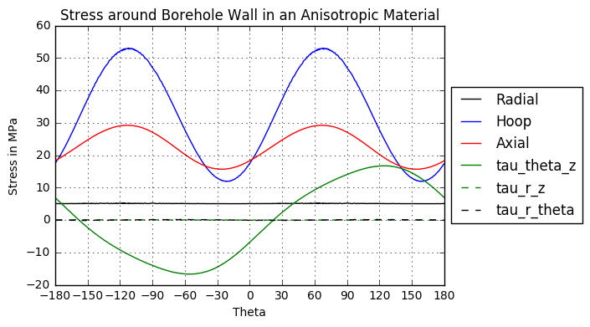

Figures 2-7

