# Test Document

This is the first paragraph.

## Section 1

This is the first paragraph. This is in section 1.

This is the 2nd paragraph. This is in section 2.

## Section 2

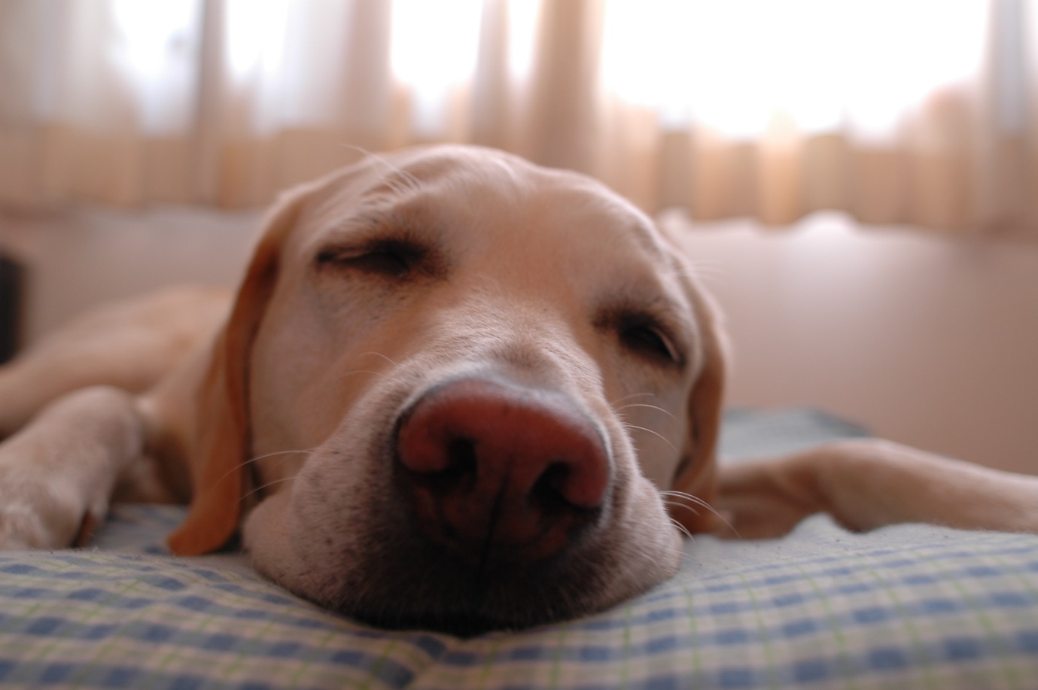

Sample Image

## Section 3

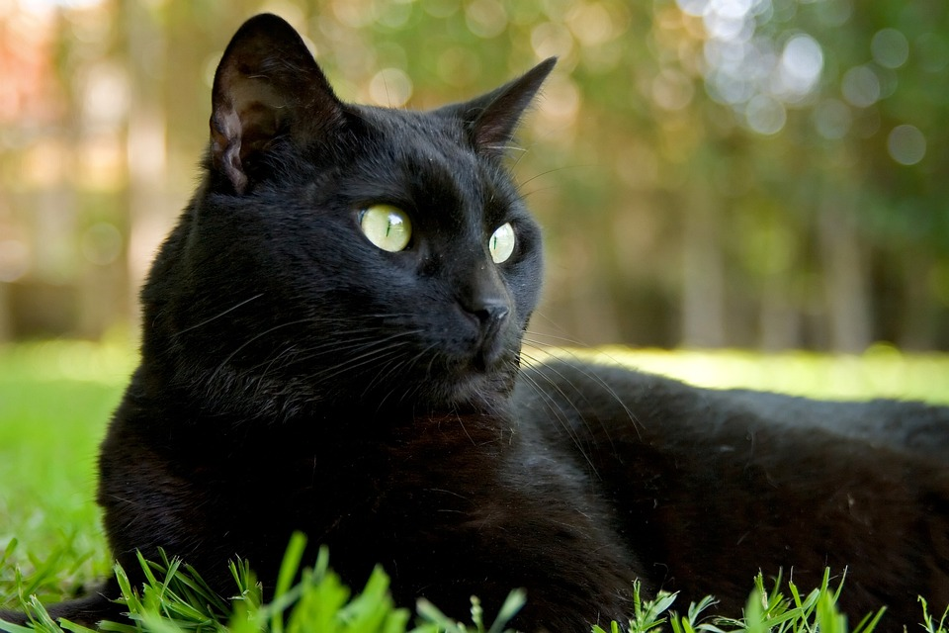

1. Cat is black
2. Has green eyes