

Soil Data Management Toolbox for ArcGIS™ (including gSSURGO Database Toolset for ArcGIS™)

User Guide

Version 3.0

February 2016

National Soil Survey Center

National Geospatial Center of Excellence

**Nondiscrimination Statement**

The U.S. Department of Agriculture (USDA) prohibits discrimination against its customers, employees, and applicants for employment on the basis of race, color, national origin, age, disability, sex, gender identity, religion, reprisal, and where applicable, political beliefs, marital status, familial or parental status, sexual orientation, whether all or part of an individual’s income is derived from any public assistance program, or protected genetic information. The Department prohibits discrimination in employment or in any program or activity conducted or funded by the Department. (Not all prohibited bases will apply to all programs and/or employment activities.)

If you wish to file an employment complaint, you must contact your agency’s EEO Counselor (<http://directives.sc.egov.usda.gov/33081.wba>) within 45 days of the date of the alleged discriminatory act, event, or personnel action. Additional information can be found online at <http://www.ascr.usda.gov/complaint_filing_file.html>.

If you wish to file a Civil Rights program complaint of discrimination, complete the USDA Program Discrimination Complaint Form, found online at <http://www.ascr.usda.gov/complaint_filing_cust.html> or at any USDA office, or call (866) 632-9992 to request the form. You may also write a letter containing all of the information requested in the form. Send your completed complaint form or letter by email to [program.intake@usda.gov](mailto:program.intake@usda.gov) or by mail to:

USDA

Office of the Assistant Secretary for Civil Rights

1400 Independence Avenue, S.W.

Washington, D.C. 20250-9410

If you are deaf, are hard of hearing, or have speech disabilities and you wish to file either an EEO or program complaint, please contact USDA through the Federal Relay Service at (800) 877-8339 or (800) 845-6136 (in Spanish).

If you have other disabilities and wish to file a program complaint, please see the contact information above. If you require alternative means of communication for program information (e.g., Braille, large print, audiotape, etc.), please contact USDA’s TARGET Center at (202) 720-2600 (voice and TDD).

Any use of trade, product, or firm names is for descriptive purposes only and does not imply endorsement by the U.S. Government.

Table of Contents

Introduction 5

Individual Tool – Short Descriptions 8

SSURGO Download Toolset 8

SSURGO Data Management Toolset 9

gSSURGO Database Toolset 11

Create gSSURGO DB Tools 11

Create gSSURGO Raster Tools 12

gSSURGO Mapping Toolset 14

Selecting the Proper Tools for the Job 15

I want to obtain SSURGO datasets for use with Soil Data Viewer. 16

I want to create a multi-county SSURGO dataset for use with Soil Data Viewer. 16

I want to create a gSSURGO database. Soil Data Viewer compatibility is not required. 16

I want to create a series of very large soils databases (gSSURGO) 17

Examples of How to Use the Tools 18

Example: Creating gSSURGO for Delaware 18

Create New Folder for the SSURGO Downloads 18

Download current SSURGO Status Map shapefile (one time only) 18

Add the SSURGO Download Toolbox 18

Download SSURGO by Areasymbol (only required once) 19

Example: Create gSSURGO - State-Tiled 19

Example: Create gSSURGO Raster 20

Example: Creating gSSURGO CONUS 21

Examples of Tool Menus 22

When downloading SSURGO isn’t an option 28

Installation – Soil Data Management Toolbox 29

Processing Strategies 29

Processing Errors 31

Citing gSSURGO Data 31

The Citation for gSSURGO 31

State Tile 31

Conterminous US Tile 32

National Collection of Tiles 32

The Citation for the National Value Added Look Up (valu) Table Database 32

Citation Examples 33

State Tile 33

Conterminous US Tile 33

National Collection of Tiles 33

National Value Added Look Up (valu) Table Database 33

Acronyms 34

References 34

# Introduction

The Soil Data Management Toolbox consists of four toolsets contained in a single toolbox. Each toolset contains several ArcTools used to acquire, assemble and manage individual SSURGO datasets and to create gSSURGO databases. It is recommended that the tools be run in foreground mode (not background) because a lot of useful status information is printed to the geoprocessing window. The Toolbox requires:

* ArcGIS™ 10.1 or greater
* Internet connection

SSURGO datasets for an entire state or region can require a large amount of storage space and computer resources to process. These tools are designed to make the process of acquiring, managing and using SSURGO datasets for large land areas much easier and faster.

**Each tool contains detailed built-in help which can be displayed on the right side of the tool dialog box.** Much of this information in the help is not available in this document, so it would be a good idea to read the help for each parameter before using the tool. If the Help window is not visible, click on the ‘Show Help>>’ button. It is recommended that these tools be executed in their default foreground mode. Important status information is displayed in the tool window. Red error messages may be displayed either if a problem is encountered with the data or if there is a problem with the Python script. **Script errors will normally display a line number indicating where the error occurred.**

The Soil Data Management Toolbox is divided into four toolsets:

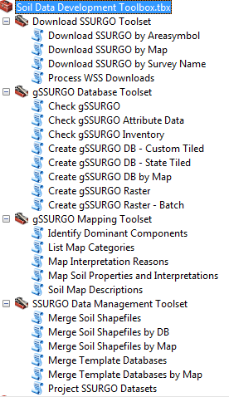

1. **Download SSURGO** – automated batch downloads of SSURGO datasets from Web Soil Survey or processing SSURGO cache files (wss*.zip). These are used for creating Soil Data Viewer-compatible datasets and for creating gSSURGO file geodatabases.
2. **gSSURGO Database** – creation of gSSURGO databases and raster layers. Checks output databases for completeness.
3. **gSSURGO Mapping** – creation of Soil Data Viewer type maps using gSSURGO databases.
4. **SSURGO Data Management** – automated tabular imports and merging of SSURGO datasets (shapefile and .mdb).

gSSURGO Specifications

* The entire download process is driven by the AREASYMBOL attribute (soil survey id). All SSURGO datasets, including the shapefiles and the Microsoft Access databases, incorporate the AREASYMBOL value of the data they contain. Any deviation from the standard naming convention such as renaming folders or shapefiles will break the gSSURGO process.
* The SSURGO download process will **not** need to be repeated unless new data become available on Web Soil Survey or old data is updated.
* No clipping to state (or other) boundaries is performed.
* All gSSURGO products have the same database structure with differences arising due to geographic extent and soil survey area data content.
* gSSURGO databases can be created for any desired area by manually selecting the boundary polygons in the survey status map layer and using the appropriate Create gSSURGO tool.
* Currently the tools are limited to creating databases in the Albers Equal Area projection and datum appropriate to the geographic region.
  + Lower 48 states – USA Contiguous Albers Equal Area Conic USGS, NAD 1983, using the WGS_1984_(ITRF00)_To_NAD_1983 transformation.
  + Hawaii and American Samoa – Hawaii Albers Equal Area Conic, WGS 1984.
  + Alaska – Alaska Albers Equal Area Conic, WGS 1984.
  + Puerto Rico and U.S. Virgin Islands - USA Contiguous Albers Equal Area Conic USGS, NAD 1983, using the WGS_1984_(ITRF00)_To_NAD_1983 transformation. This is the same as the Lower 48 states.
  + Pacific Islands – Western Pacific Albers Equal Area Conic, WGS 1984.

# Individual Tool – Short Descriptions

## SSURGO Download Toolset

This toolbox contains three **‘Download SSURGO’** tools that allow the user to download the surveys by Areasymbol, by Map or by Survey Name. Using these tools, the user can easily download and process large numbers of SSURGO datasets from Web Soil Survey.

The fourth tool (**Process WSS Downloads**) is designed to be used with a copy of the entire Web Soil Survey SSURGO cache of zip files which can be ordered from the Gateway for a fee.

The SSURGO Download tools are designed to download SSURGO without an included Template database. This saves significant time by reducing the size of the download by 2 megabytes less per survey area.

If however, compatibility with Soil Data Viewer is a requirement, the SSURGO Template databases **must be populated**. It is recommended that the user download a single copy of a Template database and the tools will make automatically make additional copies as needed. The state and U.S. Template databases are available from Web Soil Survey on the ‘Download Soils Data’ tab. For multi-state work, the U.S. Template database (soildb_US_2003.mdb) is recommended.

Some of the tools require the user to download the Soil Survey Status Map shapefile, which is available from Web Soil Survey at the following URL: <http://websoilsurvey.sc.egov.usda.gov/DataAvailability/SoilDataAvailabilityShapefile.zip>.

The Web Soil Survey archives each zipped SSURGO dataset with a URL similar to the following: [http://websoilsurvey.sc.egov.usda.gov/DSD/Download/Cache/SSA/wss_SSA_AL001_[2011-07-25].zip](http://websoilsurvey.sc.egov.usda.gov/DSD/Download/Cache/SSA/wss_SSA_AL001_%5b2011-07-25%5d.zip). Each individual SSURGO download will be saved in a local folder named ‘soil_<areasymbol> (e.g., ‘soil_al001’). Every complete dataset will consist of spatial and tabular folders. The spatial folder will contain the original shapefiles (GCS WGS 1984 coordinate system). The tabular folder will contain the raw data in text file format.

## SSURGO Data Management Toolset

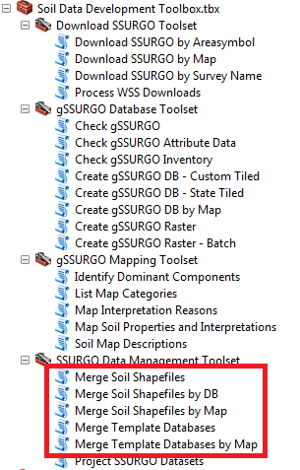The SSURGO Data Management Toolset contains five **‘Merge’** tools simplify the task of merging the data from multiple spatial surveys into a single shapefile and Template attribute database that are compatible with Soil Data Viewer, allowing users to create soil maps across multiple counties.

Please note that **none** of the SSURGO Management tools are used in the process for creating gSSURGO. These are only used to create multi-county datasets (shapefiles and Access databases) that are compatible with **Soil Data Viewer**.

The ‘Merge Soil Shapefiles’ tools are designed to work with the standard SSURGO data structure and shapefile naming convention created by any of the three Download tools. Each SSURGO dataset exists within its own subfolder whose name begins with ‘soil_’ and ends with the 5 character Areasymbol value (e.g. ‘soil_wv001’). The tools will search within the specified ‘Input Folder’ for datasets containing the appropriate soil map unit polygon shapefiles (‘soilmu_a’) and add them to the ‘Soil Survey’ choice list. Select the desired soil surveys to be merged by checking the boxes. A similar pair of tools (Merge Template Databases and Merge Template Databases) are used to populate a SSURGO Access database that is compatible with Soil Data Viewer.

**Warning: There is a 2 gigabyte (GB) limit for both the ESRI shapefile and Microsoft Access database format**. A warning is displayed if merging the selected survey shapefiles will create a new shapefile that approaches the 2 GB file size limit. If the estimated output size exceeds the 2 GB limit, the tool will display a red warning and refuse to execute. Also, the user should be aware that slow database performance becomes a problem well before the size limit is reached.

**Warning: The ‘Merge Soil Shapefiles’ tool does not validate the input coordinate system of the shapefiles to ensure that they all match**. The Web Soil Survey provides SSURGO downloads with a Geographic WGS 1984 coordinate system only. The tools assume that input shapefiles are in the original coordinate system.

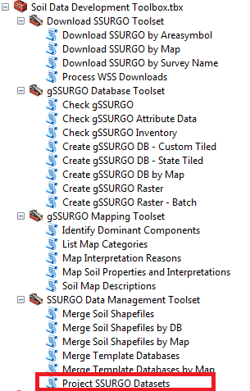The **‘Project SSURGO Datasets’** tool allows the user to batch-project an entire selection of SSURGO downloads to a new projected coordinate system.

The Web Soil Survey only supplies SSURGO data in a geographic coordinate system (GCS WGS 1984). Web Soil Survey DOES NOT provide any option for downloading the data in a projected coordinate system.

With this tool, the user can manually select soil survey area polygons in a map layer and then each of the associated SSURGO datasets will be automatically projected to the specified coordinate system in another folder.

The appropriate datum transformation for the specified geographic region is automatically set, based on the selected ‘Geographic Region’. The island survey areas (‘Hawaii’, ‘American Samoa’, ‘Pacific Islands Area’) are assumed to be WGS 1984. CONUS, Alaska, Puerto Rico and the U.S. Virgin Islands are assumed to be NAD 1983.

## gSSURGO Database Toolset

### Create gSSURGO DB Tools

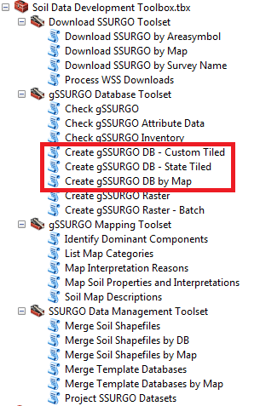The three ‘**Create gSSURGO DB Tools**’ allow the user to convert the downloaded SSURGO dataset (shapefiles and Microsoft Access Template database) to the new gSSURGO ArcGIS file geodatabase format.

Each tool works in a very similar manner, they just offer different methods for identifying the target survey areas. The user can choose which method is most convenient and the output will very much the same.

It is important for the user to maintain the original naming convention for SSURGO download folders and filenames (e.g. ‘soil_wv001’) for the gSSURGO tools to operate properly. The ‘**Create gSSURGO DB**’ tools create new file geodatabases from the individual feature classes and merges into a new soil feature class. The attribute tables will be merged also. The output coordinate system of the datasets will be an appropriate Albers Equal Area projection and datum that adhere to the gSSURGO standard. The output coordinate system of the gSSURGO dataset is defined by the XML workspace document and the datum transformation set by the ArcTools:

* Lower 48 states – USA Contiguous Albers Equal Area Conic USGS, NAD 1983, using the WGS_1984_(ITRF00)_To_NAD_1983 transformation.
* Hawaii and American Samoa – Hawaii Albers Equal Area Conic, WGS 1984.
* Alaska – Alaska Albers Equal Area Conic, WGS 1984.
* Puerto Rico and U.S. Virgin Islands - USA Contiguous Albers Equal Area Conic USGS, NAD 1983, using the WGS_1984_(ITRF00)_To_NAD_1983 transformation.
* Pacific Islands – Western Pacific Albers Equal Area Conic, WGS 1984.

### Create gSSURGO Raster Tools

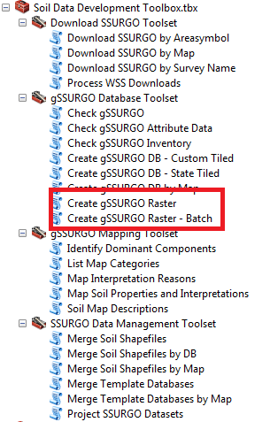The two ‘**Create gSSURGO Raster**’ tools are designed to create a raster version of the soil map unit polygon feature class in a selected gSSURGO file geodatabase. Both tools work exactly the same except one will create rasters in a batch-mode process. The tools look for the standard gSSURGO ‘MUPOLYGON’ feature class within the specified geodatabase and use the PolygonToRaster geoprocessing tool to perform the conversion. The method used to assign the MUKEY cell value is “MAXIMUM_COMBINED_AREA”. Output coordinate system will be the same as “MUPOLYGON”.

The only required setting is the ‘Input Geodatabase’. Creating a raster layer for a very large area of extent may require checking the option ‘Use tiles’. This option will take longer to execute, but will have greater chance of success if the user’s computer is short of resources.

Usually the snap raster option is only required when the output soils raster must be aligned with raster data other than the default USGS NLCD or NASS Cropland data. The tool will automatically align the output grid to the USGS NLCD if a snap raster is not specified. The output raster can be set to 5, 10, 30, or 90 meter resolution and still maintain alignment with NLCD or NASS Cropland rasters.

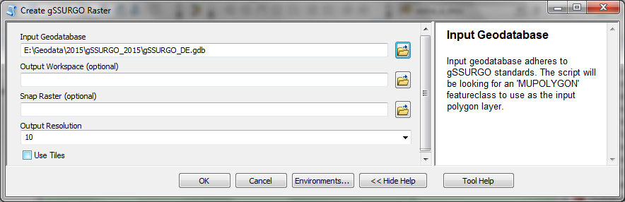

**Check gSSURGO Tools**

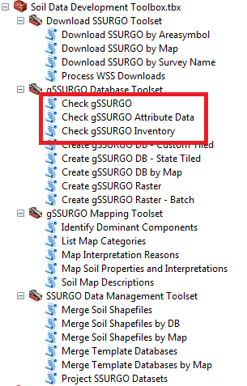The ‘**Check gSSURGO**’ tools are designed to make sure that the final gSSURGO products are complete and that the tables are correctly populated. These tools may be especially important if large numbers of databases have been created in a batch-mode process. Currently there are three tools in this toolset, but in the future the plan is to merge them into a single tool.

**Check gSSURGO** – inventories each geodatabase. Checks to make sure that each featureclass, table and raster is present. Runs a record count and compares with the Enterprise database to make sure there are no missing records.

**Check gSSURGO Attribute Data** – looks for possible inconsistencies in the population of the component and horizon level tables. Examples would include map units which have greater than 100 percent sum of components, components which have no horizon data or components whose horizon records have gaps or overlaps. Output is written to a text file named after the input gSSURGO database and stored in the same folder as the database.

**Check gSSURGO Inventory** – simply lists the file size, and the number of featureclasses, tables and rasters found in each file geodatabase within the specified folder. This is another test for completeness and is also useful for estimating disk space requirements.

## gSSURGO Mapping Toolset

The ‘**gSSURGO Mapping’** Tools allow the user to create soil maps from gSSURGO similar to those created by Soil Data Viewer, but without the limitations in geographic extent.

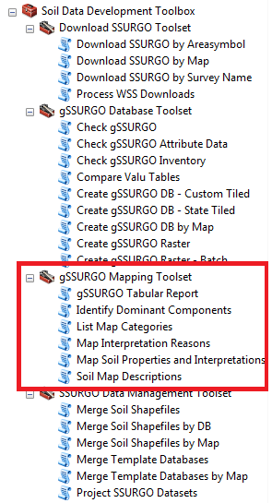**gSSURGO Tabular Report** – creates simple reports containing more detailed information about the ratings or properties of the soil map, often at the component or horizon level (when appropriate). No summary information is produced in this first generation of reports.

**Identify Dominant Component** – creates a table containing mukey, cokey and comppct_r values for the dominant component of each map unit. This table can be used to join component-level attributes to the MUPOLYGON or MapunitRaster layers.

**List Map Categories** – Creates a report listing the different map layers that can be generated from the selected database.

**Map Interpretation Reasons** – this ArcMap tool creates a series of map layers for a selected soil interpretation. Each map layer represents the geographic extent and component percent for each limitation or rating reason used in generating the overall rating. This tool is CPU intensive and can take time to run.

**Map Soil Properties and Interpretations** – this ArcMap tool produces soil maps in a similar fashion as Soil Data Viewer. Over 160 soil maps can be created for various soil properties and interpretations.

**Soil Map Descriptions** – gives the description of any selected soil property or interpretation that can be generated by the ‘Map Soil Properties and Interpretation’ tool.

# Selecting the Proper Tools for the Job

This section outlines which tools are used to generate specific SSURGO or gSSURGO products. Most of the tools are designed to work in a batch mode which significantly reduces the amount of work for the user and ensures that output is consistent. There are five important questions that the user should answer before they use the tools:

1. ***Is compatibility with Soil Data Viewer required?*** If there is the slightest possibility that Soil Data Viewer will ever be used with any of this data, the user should always set the option for ‘Template Database’ when executing any of the ‘Download’ tools. Soil Data Viewer only works with soil polygon shapefiles (spatial) and the Template Access database (tabular). Remember that gSSURGO databases (ESRI file geodatabase format) are NOT compatible with Soil Data Viewer.
2. ***How good are internet download speeds and bandwidth?*** If internet speed or bandwidth is poor, the user may want to consider ordering multiple SSURGO datasets on an external hard drive. This option would normally only be used when the amount of data makes downloading impractical.
3. ***How many SSURGO datasets will be required?*** There are over 3, 260 individual SSURGO datasets in the entire collection (approximately 60 GB zipped). For very large areas of interest (AOI), several hours may be required to download the data from Web Soil Survey, but at least this method is free! Fortunately the ‘Download’ tools can run unattended overnight. Using the ‘Download’ tools it is the same amount of work to download a single SSURGO dataset as it is a hundred. Remember, once a survey has been downloaded and saved, it will not need to be downloaded again unless there is an update.
4. ***What output coordinate system should be used?*** SSURGO data is only available with a Geographic WGS 1984 coordinate system. Once the data has been downloaded, ‘SSURGO Management’ tools can be used to re-project the spatial data to other coordinate systems such as UTM (WGS 1984 or NAD 1983 datum only). When creating gSSURGO databases, the output is automatically set to an Albers Equal Area coordinate system and datum appropriate for the AOI.
5. ***How large is the Area of Interest?*** If the intent is to create a single, merged dataset for the AOI, the user should be aware that there is an operating system file size limit and a performance limit to for a shapefile and an Access database. The number of SSURGO datasets that can be merged will vary, but a rough estimate is fifty surveys. If the amount of data exceeds those limits then the only options are to reduce the AOI or to use the gSSURGO format which has no size limits.

## I want to obtain SSURGO datasets for use with Soil Data Viewer.

1. Create a single folder (e.g. WSS_Downloads2015) where a current copy of the SSURGO downloads can be kept. Make sure to always set the ‘Template Database’ option on the tool menu. Select from one of the three similar tools that can be used to automatically download and unzip SSURGO data from Web Soil Survey.
2. Download a copy of a SSURGO Template database from Web Soil Survey. They can be found on the ‘Download Soils Data\Download SSURGO Template Databases’ webpage. This is a one-time operation. Unzip and store this database (.mdb) in a secure location that is easy to find later. Browse and set the ‘Template Database’ to this file.
3. Select from one of the three Download tools.
4. The ‘*Download SSURGO by Areasymbol’* tool works well when the user wants to download all SSURGO data (3,260+) or all SSURGO data that matches a wildcard such as ‘DE’ for all three Delaware survey areas.
5. The ‘*Download SSURGO by Map*’ tool works well when the user can select their AOI on a survey boundary map layer. See Download current SSURGO Status Map shapefile (one time only). Selecting and highlighting the AOI on a map will help ensure that all of the necessary survey areas are being downloaded.
6. The ‘*Download SSURGO by Survey Name*’ is normally only used to download a single survey area where the name is known but not the areasymbol.
7. If these SSURGO datasets are destined for USDA Service Center Geodata, use the ‘Project SSURGO Datasets’ tool found in the ‘*SSURGO Management Toolset’* to create new SSURGO shapefiles with a UTM NAD 1983 coordinate system.

## I want to create a multi-county SSURGO dataset for use with Soil Data Viewer.

1. Download all of the required SSURGO data for the AOI using one of the three ‘SSURGO Download’ tools discussed in the previous section.
2. Create a merged Access Template database using the most appropriate tool: ‘*Merge Template Databases by Map’* or ‘*Merge Template Databases’*.
3. Create a merged soil polygon shapefile using the most appropriate ‘*Merge Soil Shapefile’* tools: ‘*Merge Soil Shapefiles by Map’* , ‘*Merge Soil Shapefiles by DB’* or ‘*Merge Soil Shapefiles’*. Set the appropriate output coordinate system for the new shapefile.

## I want to create a gSSURGO database. Soil Data Viewer compatibility is not required.

1. If internet speed and bandwidth are good, any of the following three tools will work.
2. The ‘*Download SSURGO by Areasymbol’* tool works well when the user wants to download all SSURGO data (3,260+) or all SSURGO data that matches a wildcard such as ‘DE’ for all three Delaware survey areas.
3. The ‘*Download SSURGO by Map’* tool works well when it is easiest for the user to select their AOI on a survey boundary map layer. See Download current SSURGO Status Map shapefile (one time only). Selecting and displaying the AOI on a map will often help insure that all of the necessary survey areas are being downloaded.
4. The ‘*Download SSURGO by Survey Name’* is normally only used to download a single survey area where the name is known but not the areasymbol.
5. If SSURGO data cannot be downloaded from Web Soil Survey, the ‘*Process WSS Downloads’* tool provides an off-line option.
6. Obtain a copy of the Web Soil Survey cache.
7. Use the ‘*Process WSS Downloads’* tool to unzip the SSURGO data and set up the proper folder structure required by the ‘*Create gSSURGO’* tools.

## I want to create a series of very large soils databases (gSSURGO)

1. Trying to merge SSURGO datasets into state-wide or regional databases can easily exceed the limits of the original SSURGO shapefile-Access database format. The gSSURGO format (ESRI file geodatabase) can overcome the size limitations although compatibility with Soil Data Viewer is lost. The process for creating gSSURGO still begins with downloading SSURGO data.
2. If internet speed and bandwidth are good, any of the following three tools can be used to download the required SSURGO data.
3. The ‘*Download SSURGO by Areasymbol’* tool works well when the user wants to download all SSURGO data (3,260+) or all SSURGO data that matches a wildcard (e.g ‘DE’ for all three Delaware survey areas).
4. The ‘*Download SSURGO by Map’* tool works well when the user selects their AOI on a survey boundary map layer. See Download current SSURGO Status Map shapefile (one time only). Selecting and displaying the AOI on a map will often help insure that all of the necessary survey areas are being downloaded.
5. The ‘*Download SSURGO by Survey Name’* is normally only used to download a single survey area where the name is known but not the areasymbol.
6. If SSURGO data cannot be downloaded from Web Soil Survey, the ‘*Process WSS Downloads’* tool provides an off-line option.
   1. Obtain a copy of the Web Soil Survey cache.
   2. Use the ‘*Process WSS Downloads’* tool to unzip the SSURGO data and set up the proper folder structure required by the ‘*Create gSSURGO’* tools.
7. Two tools offer a batch mode process for creating multiple gSSURGO databases.
   1. To create one or more ‘state-tiled’ gSSURGO databases, use the ‘*Create gSSURGO – State Tiled’* tool. Please note that the output from this tool is not clipped to state boundaries. Even if a survey area crosses a state boundary, the entire survey area is included.
   2. To create one or more ‘custom-tiled’ gSSURGO databases, use the ‘*Create gSSURGO – Custom Tiled’* tool. An example of the type of output from this tool would be a series of gSSURGO databases based upon HUC-8 boundaries.

# Examples of How to Use the Tools

## Example: Creating gSSURGO for Delaware

The following instructions are designed to assist the user in creating a state-tiled gSSURGO database, using the state of Delaware as an example.

### Create New Folder for the SSURGO Downloads

Identify or create a single, local folder to store the SSURGO downloads from Web Soil Survey. This step usually is required only once, unless the user decides to create a new archive for each fiscal year.If possible, save the WSS downloads (SSURGO) on one local drive and create the gSSURGO databases on another. This will result in significant performance increases if a large number of surveys are to be processed. Placing them on network drives or external USB drives may slow down performance.

* Create a folder for the downloaded data (e.g. ‘WSS_Downloads_FY15’)
* Create a second folder for the new gSSURGO databases (e.g. ‘gSSURGO_FY15’)

### Download current SSURGO Status Map shapefile (one time only)

* Open Internet Explorer and access Web Soil Survey at:
  + <http://websoilsurvey.sc.egov.usda.gov>.
* Click the green **Start WSS** button.
* Select **Soil Survey Status.**
* Select **Shapefile (zipped).**
* At the bottom of the window click the **Save** down arrow and click on **Save as.**
* Download to the gSSURGO_FY15 folder location
* Use Winzip to extract the contents (soilsa_a_nrcs.shp) to the same location.

### Add the SSURGO Download Toolbox

* Start ArcMap with a new untitled map
* Select Add Data…
* Add the SSURGO status map layer (soilsa_a_nrcs.shp) file to the table of contents
* Open ArcToolbox 
* Right click in the ArcToolbox dialog box and select Add Toolbox…
* Navigate to Toolboxes\My Tooboxes and add the SSURGO Download Toolbox

### Download SSURGO by Areasymbol (only required once)

* Open the **Download SSURGO by Areasymbol** tool.
* Set **Search by Areasymbol** to the two letter state abbreviation (e.g. **DE)**\*
* Note that entering the asterisk (*) wildcard list **ALL** available SSURGO data
* Set the **Output Folder** to the desired location where the downloads will be saved
* Check the soil survey areas listed under **Soil Surveys** using the **Select All** button
* If the output SSURGO needs to be ‘Soil Data Viewer’ compatible, set **Master Database** to the location of ‘soil_us_2003.mdb’ or any state Template database
* If the output SSURGO data will only be used to create gSSURGO databases, leave the **Master Database** setting blank
* Click **OK** to begin processing
* The same downloaded SSURGO data can be used to create other gSSURGO databases that incorporate Delaware soils data. The download for any survey does not need to be repeated unless there is an update or new survey area becomes available.

Messages will be displayed at each step of the download process.

**NOTE:** If a local copy of a survey already exists in the output folder, the survey dates will be compared. If the Web Soil Survey version is more recent, the older copy will be overwritten. Users may want to consider maintaining their SSURGO downloads as a type of an annual SSURGO archive.

* Click **Close** in the Geoprocessing dialog box once the download tool has completed.

**NOTE:** Create or select a folder to contain the new gSSURGO databases. Performance may be enhanced if the input folder containing the download SSURGO is on a different drive than the location where the output gSSURGO will be created.

## Example: Create gSSURGO - State-Tiled

Each of the three ‘*Create gSSURGO DB’*  tools works in a similar fashion. The only difference is how the selection of survey areas for the database is made. To create a gSSURGO database for Delaware, use the ‘*Create gSSURGO DB – State Tiled’* tool. Please note that clipping to state or other boundaries is NOT performed by any of these tools.

The state-tiling method uses a Soil Data Access query against the legend area overlap table to determine which survey areas are part of each state. The areasymbol values for those survey areas is then used to select datasets from the ‘SSSURGO Downloads’ folder and create the new geodatabase.

Select the **Create gSSURGO DB – State Tiled** tool.

* Set the **SSURGO Downloads** parameter to the folder where the SSURGO downloads have already been stored
* Set the **Output Folder** to where the new gSSURGO is to be stored
* Check the box next to ‘**Delaware**’
* Check the boxes for **Overwrite output** and **Require All Data**
* ‘**Use text files**’ option
  + If the text files (tabular folder) for each survey area dataset are available, check the box next to ‘**Use text files**’.
  + If the text files (tabular folder) for each survey area dataset have been deleted, the tabular data must be imported from the Template databases located in the tabular folders. Uncheck the ‘**Use text files**’ option.
* Select **OK**

**NOTE:**  Some state tiles will include survey areas that cross state boundaries. The ‘*Create gSSURGO DB -State Tiled’*‘ tool uses the LAOVERLAP table to identify and include those overlapping surveys. An example of this occurs for survey TN640 which will be present in both the TN and NC gSSURGO geodatabases.

Upon completion, all successfully imported surveys will be listed. Any errors that incur will be shown in red type.

* Select the **Close** button in the Geoprocessing tool dialog box.

## Example: Create gSSURGO Raster

* Select the **Create gSSURGO Raster** tool.
* Set the **Input Geodatabase** field to the location of the gSSURGO_DE.gdb geodatabase.
* The **Output Workspace** option is only used when the output needs to be a TIFF or JPEG rather than a file geodatabase raster
* The **SnapRaster** setting is only used when the output raster will not be aligned to the National Landcover Dataset (USGS-NLCD).
* If problems are encountered during the PolygonToRaster conversion (e.g. 9999 error), run the tool again but check the ‘Use tiles’ option. This is a useful option when data is too big or the computer is too small.
* Select **OK.**
* After the gSSURGO raster generation process has completed, select **Close**.

## Example: Creating gSSURGO CONUS

Both CONUS and PAC Basin gSSURGO can be created using the ‘Create gSSURGO DB by Map’ tool. The user will manually select which survey areas to include in the output geodatabase. Some of the menu choices may be very slow to populate for the CONUS database, so be patient.

* If not already available, download all available surveys using ‘*Download by Areasymbol’* tool. Use an asterisk for the wildcard and select all surveys listed.
* Open ArcMap
* Add the SSURGO status map shapefile (soilsa_a_nrcs.shp) to the table of contents
* Using the ‘*Select Feature’* tool, highlight all of the soil survey boundary polygons in the lower forty-eight states. Make sure that the single survey for Mexico is not selected (use shift-click to unselect it)
* Set the ‘*SSURGO Downloads’* parameter to the folder containing all of the unzipped SSURGO datasets
* Set the ‘Geographic Region’ option to ‘Lower 48 States’
* Enter ‘CONUS’ in the Featureclass Identifierfield
* Run the ‘*Create gSSURGO by Map’*tool. This will take several hours at least.
* Run the ‘*Create gSSURGO Raster’*  tool. Make sure the ‘Use tiles’ option is checked. The CONUS raster may be created in three different resolutions: 10, 30 and 90 meters.

# Examples of Tool Menus

This section gives examples of some of the tool menus and how the parameters might be filled out. Notice that detailed Help is given for each parameter.

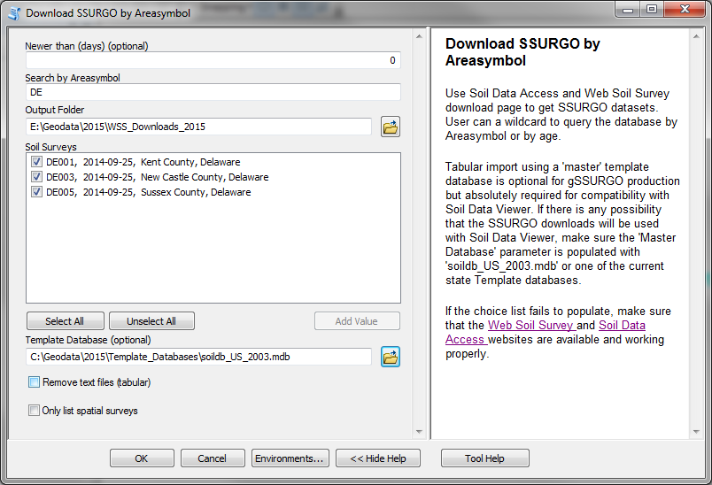

Figure . Download SSURGO by Areasymbol.

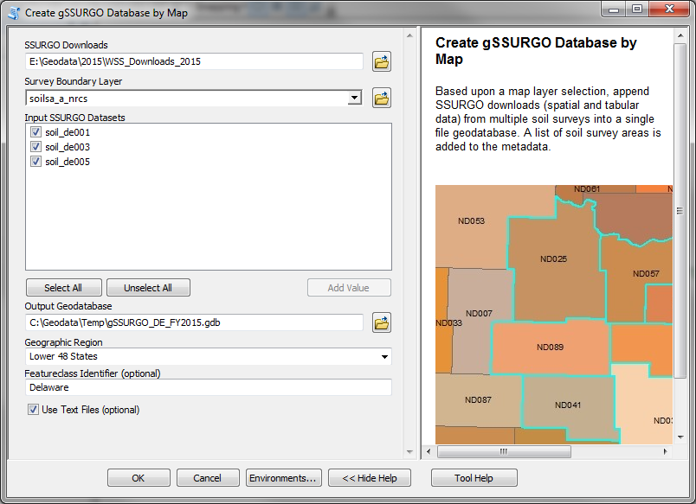

Figure . Create gSSURGO Database by Map.

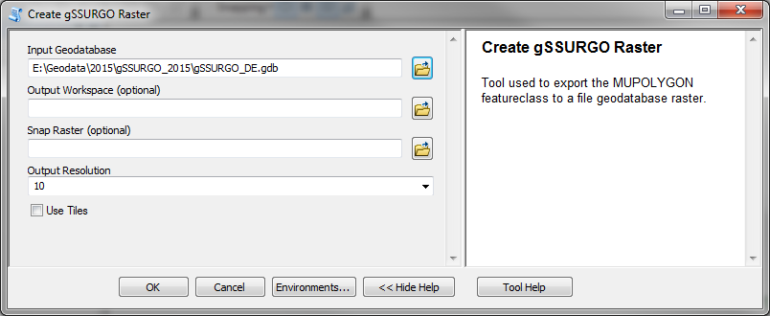

Figure . Create gSSURGO Raster.

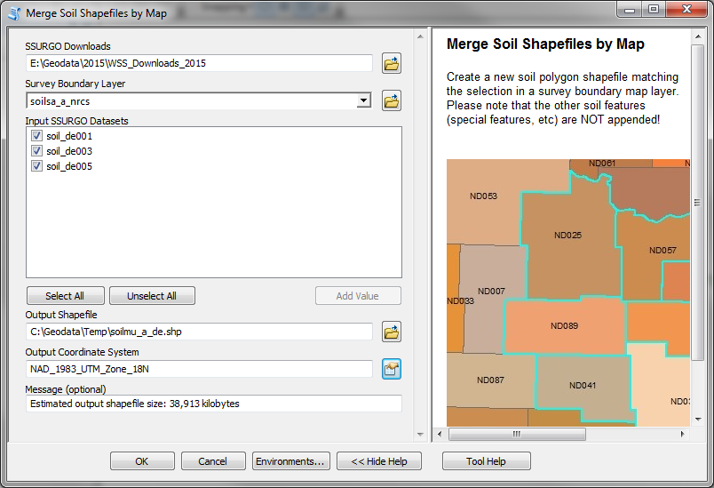

Figure . Merge Soil Shapefiles by Map.

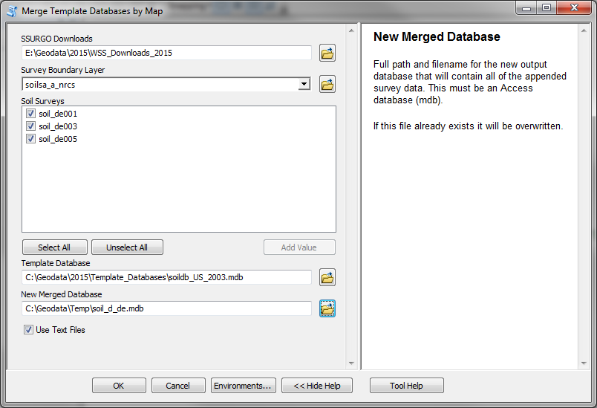

Figure . Merge Template Databases by Map.

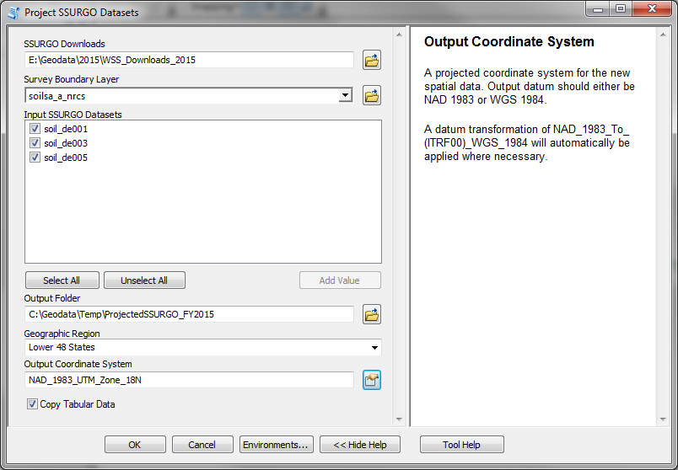

Figure . Project SSURGO Datasets.

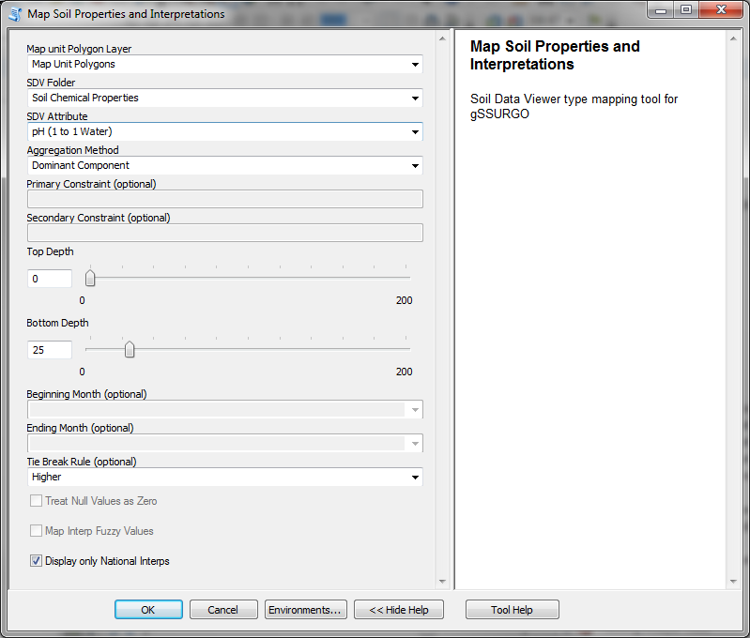

Figure . Map Soil Properties and Interpretations Tool.

# When downloading SSURGO isn’t an option

The national collection of SSURGO downloads (AKA Web Soil Survey Cache) can be obtained by contacting the USDA-NRCS National Geospatial Center of Excellence (NGCE) representative Rosemary Rivera (rosemary.rivera@ftw.usda.gov) or by phoning (817) 509-3371. The cost for this service is $250. The customer provides the external storage device and also pays shipping costs.

# Installation – Soil Data Management Toolbox

The Soil Data Management Toolbox is provided as a zipped collection of:

* Python scripts (.py)
* ArcGIS 10.1 Toolbox file (.tbx)
* XML Workspace Documents (.xml)

Installation steps:

* Copy the zip file to the ArcGIS 10.X custom tools folder. This is normally a folder named MyToolboxes’ e.g., *C:\Users\<your login>\AppData\Roaming\ESRI\Desktop10.X\ArcToolbox\My Toolboxes*.
* Unzip the file to the current folder: ‘My Toolboxes’.
* Optional. Download from Web Soil Survey a copy of the **soildb_US_2003.mdb** file to a new folder where it can be easily found in the future. The download tools may need this SSURGO Template database if the SSURGO downloads are required to be compatible with Soil Data Viewer.
* Download the SSURGO Status Map shapefile from: <http://websoilsurvey.sc.egov.usda.gov/DataAvailability/SoilDataAvailabilityShapefile.zip>.

## Processing Strategies

Downloading SSURGO data and using these tools to create gSSURGO or other new datasets can consume a lot of time and computer resources. The following are steps that will help increase the odds for a successful creation of the gSSURGO dataset:

1. A properly configured computer
   1. Windows 7 64-bit operating system
   2. ArcGIS 10.1 or 10.2 with all updates
   3. At least 12 GB of RAM, 16 or even 24 would be better
   4. Plenty of fast, local disk space. Raid 5 or 10 using 10k or 15k SAS drives works well
   5. External, USB drives aren’t usually recommended for geoprocessing
   6. Maintain plenty of free disk space for data and temp files
   7. For ArcGIS, get the CPU with the fastest clock speed that can be afforded. A CPU with a few fast cores is better than several slow ones
   8. Spread the load, setup TEMP and a scratchworkspace on one drive, output data on another drive
   9. When a job is complete, backup the results to another location
2. Always leave the geoprocessing window in the foreground and uncheck the option to ‘Close this dialog when completed successfully’. The user should always read the resulting messages to make sure the process completed without warnings or errors.
3. Set the geoprocessing environment to use a file geodatabase for the scratchworkspace (e.g. ‘C:\geodata\temp\scratch.gdb’). Do not use Default.gdb as the scratchworkspace. The workspace and scratchworkspace setting should never be set to the same location.
4. When large geoprocessing tasks are being performed, close all other applications. This especially applies to other ArcCatalog and Microsoft Outlook, PowerPoint, or LiveMeeting. Having other ArcGIS sessions open can cause file-locking issues.
5. It’s a good idea to periodically use ArcCatalog to clean out the scratch.gdb database and compact it.
6. Let big jobs process overnight or on the weekend
   1. Keep the geoprocessing tool window open to track progress and read error messages. If a tool is running in background mode it is harder to tell if a process is hung up.
   2. If repeated failures occur, reboot the system and then double-check the scratchworkspace setting in the geoprocessing environment.
7. The tools are hard-coded to download SSURGO zip files from a URL that would look something like this example: [http://websoilsurvey.sc.egov.usda.gov/DSD/Download/Cache/SSA/wss_SSA_AL001_[2014-09-24].zip](http://websoilsurvey.sc.egov.usda.gov/DSD/Download/Cache/SSA/wss_SSA_AL001_%5b2014-09-24%5d.zip)

## Processing Errors

Problems with tool execution can occur for several reasons including software bugs, user error, data issues or bad internet connections. Regardless of the type of error condition that is encountered, the script will always exit with a final message ‘Failed to execute’. The user should scroll back up to find a preceding message with more detailed information as to why the tool was not able to complete its task. Sometimes the message will contain clues that enable the user to correct the issue and then run the tool again with a more successful outcome.

Questions about tool errors should include a **copy of all tool messages from beginning to end** if at all possible. The easiest way to do this is to highlight all of the text in the tool window and then use Ctrl-C to copy and Ctrl-V to paste the tool messages into an e-mail.

## Citing gSSURGO Data

It is a good scientific practice to cite all the data sources and methods used to conduct the assessment or research study. A section on methods and materials commonly cites other literature sources, which are listed in a reference section.

These gSSURGO and National Value Added Look Up (valu) Table data are anticipated to be released on an annual basis using a Soil Data Mart database snapshot source taken in October (the start of the Federal fiscal year). The metadata (Description tab in ArcCatalog®) provides information about the source date for the gSSURGO product.

The USDA Natural Resources Conservation Service recommends the following citations be used in internal and published documents that describe assessments and studies which used the Gridded SSURGO (gSSURGO) data product and the National Value Added Look Up (valu) Table Database.

## The Citation for gSSURGO

### State Tile

Soil Survey Staff. Gridded Soil Survey Geographic (gSSURGO) Database for *State name*. United States Department of Agriculture, Natural Resources Conservation Service. Available online at <http://datagateway.nrcs.usda.gov/>. *month, day, year* (FY*year* official release).

### Conterminous US Tile

Soil Survey Staff. Gridded Soil Survey Geographic (gSSURGO) Database for the Conterminous United States. United States Department of Agriculture, Natural Resources Conservation Service. Available online at <http://datagateway.nrcs.usda.gov/>. *month, day, year* (FY*year* official release).

### National Collection of Tiles

Soil Survey Staff. Gridded Soil Survey Geographic (gSSURGO) Database for the United States of America and the Territories, Commonwealths, and Island Nations served by the USDA-NRCS. United States Department of Agriculture, Natural Resources Conservation Service. Available online at <http://datagateway.nrcs.usda.gov/>. *month, day, year* (FY*year* official release).

## The Citation for the National Value Added Look Up (valu) Table Database

Soil Survey Staff. National Value Added Look Up (valu) Table Databasefor the Gridded Soil Survey Geographic (gSSURGO) Database for the United States of America and the Territories, Commonwealths, and Island Nations served by the USDA-NRCS. United States Department of Agriculture, Natural Resources Conservation Service. Available online at <http://datagateway.nrcs.usda.gov/>. *month, day, year* (FY*year* official release).

## Citation Examples

The following examples are for the FY2014 gSSURGO dataset for the State of West Virginia. Such citations should appear in the reference section of your document.

### State Tile

*Soil Survey Staff. The Gridded Soil Survey Geographic (SSURGO) Database for West Virginia. United States Department of Agriculture, Natural Resources Conservation Service. Available online at* [*http://datagateway.nrcs.usda.gov/*](http://datagateway.nrcs.usda.gov/)*. January 15, 2014 (FY2014 official release).*

### Conterminous US Tile

*Soil Survey Staff. Gridded Soil Survey Geographic (gSSURGO) Database for the Conterminous United States. United States Department of Agriculture, Natural Resources Conservation Service. Available online at* [*http://datagateway.nrcs.usda.gov/*](http://datagateway.nrcs.usda.gov/)*. January 15, 2014 (FY2014 official release).*

### National Collection of Tiles

*Soil Survey Staff. Gridded Soil Survey Geographic (gSSURGO) Database for the United States of America and the Territories, Commonwealths, and Island Nations served by the USDA-NRCS. United States Department of Agriculture, Natural Resources Conservation Service. Available online at* [*http://datagateway.nrcs.usda.gov/*](http://datagateway.nrcs.usda.gov/)*. January 15, 2014 (FY2014 official release).*

The following example is for the National Value Added Look Up (valu) Table Database. Such citations should appear in the reference section of your document.

### National Value Added Look Up (valu) Table Database

*Soil Survey Staff. National Value Added Look Up (valu) Table Database for the Gridded Soil Survey Geographic (gSSURGO) Database for the United States of America and the Territories, Commonwealths, and Island Nations served by the USDA-NRCS. United States Department of Agriculture, Natural Resources Conservation Service. Available online at* [*http://datagateway.nrcs.usda.gov/*](http://datagateway.nrcs.usda.gov/)*. January 15, 2014 (FY2014 official release).*

See [<http://www.nrcs.usda.gov/wps/portal/nrcs/detail/soils/survey/geo/?cid=nrcs142p2_053368>](http://soils.usda.gov/citations.html) for recommended citations for other data provided by the USDA Natural Resources Conservation Service and the National Cooperative Soil Survey.

# Acronyms

aws0150wta Available Water Storage Weighted Average

C Carbon

CDL Cropland Data Layer

CLU Common Land Unit

cm centimeter

cogeomordesc Component Geomorphic Description table

CONUS Conterminous United States

dS decisiemens

ES(D) Ecological Site (Description)

ESRI® Environmental Systems Research Institue, Inc.

FY Federal Fiscal Year (begins October 1 of each year)

Geomfname Geomorphometry Name column in the cogeomordesc table

gSSURGO Gridded Soil Survey Geographic Database

Hydgrpdcd Hydrologic Group, Dominant Condition column in muaggatt table

muaggatt Map Unit Aggregate Attribute Table

MRLC Multi Resolution Land Characteristics

m meter

mm millimeter

mukey Map Unit Key

mupolygon Map Unit Polygon

musym Map Unit Symbol

muname Map Unit Name

NCSS National Cooperative Soil Survey

NED NationalElevationDatabase

NGCE National Geospatial Center of Excellence

NLCD National Land Cover Database

NRCS Natural Resource Conservation Service

NRI National Resources Inventory

sq square

SQL Standard Query Language

SSURGO Soil Survey Geographic Database

USDA United States Department of Agriculture

USGS United States Geological Survey

VALU Value Added Look Up Table

# References

Dobos, Robert R., H. Raymond Sinclair, Jr., and Michael P. Robotham. 2012. National commodity crop productivity index (NCCPI) user guide, Version 2. United States Department of Agriculture, Natural Resources Conservation Service, Lincoln, Nebraska.