**Steps for Updating gSSURGO-XML Workspace Documents**

Normally this process is performed by the gSSURGO developers and the XML files are supplied along with the ArcToolbox and Python scripts. (Steve Peaslee, USDA-NRCS NSSC Oct. 2015). These very important XML workspace documents are used to create the gSSURGO database schema, base-metadata and spatial reference (Albers).

1. There are currently 5 XML workspace documents plus two metadata files; one for each geographic region used by gSSURGO. The metadata files are not part of the initial download process, but are used when creating the gSSURGO databases.

1. gSSURGO_Alaska_AlbersWGS1984.xml
2. gSSURGO_CONUS_AlbersNAD1983.xml
3. gSSURGO_Geographic_WGS1984.xml
4. gSSURGO_Hawaii_AlbersWGS1984.xml
5. gSSURGO_PACBasin_AlbersWGS1984.xml
6. gSSURGO_MapunitRaster.xml (**metadata**)
7. gSSURGO_ValuTable.xml (**metadata**)

2. Copy each of these XML files to an empty folder.

3. Use the “Data Management\Workspace\Create File GDB” ArcTool to create a corresponding empty (except for mdstat* tables which must be populated) ArcGIS 10.0 FGDB for each of the five XML Workspace documents (Alaska.gdb, Conus.gdb, Geographic.gdb, Hawaii.gdb, PacBasin.gdb). Make sure the geodatabase version is set to '10.0'. not 'Current'.

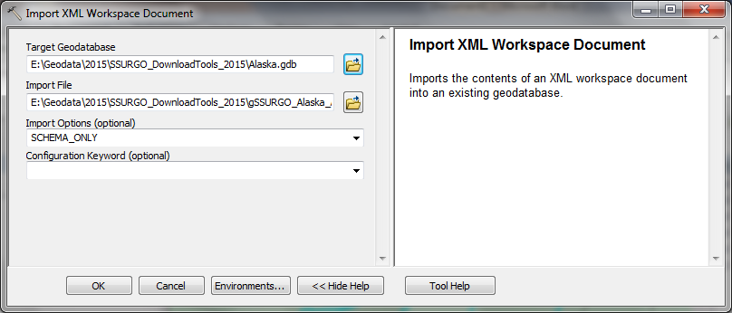4. Use the Data Management\Distributed Database\Import XML Workspace Document ArcTool to import the five XML files into the corresponding geodatabase. This will create the gSSURGO schema for each of the empty geodatabases. Make sure that the “Data” option is selected so that the ‘mdstat*’ tables are imported.

5. Using ArcCatalog, update any metadata items such as publication date, etc for one of the geodatabases and then

6. Export metadata to an XML file using the Export Metadata tool with ArcGIS2ISO1939 option. ImportMetadata

7. Use the Import Metadata tool to import \Metadata_ArcGIS2ISO.xml using the FROM_ISO_19139 option.

8. Using ArcCatalog, check the imported metadata. Please note that place-holder strings in the metadata such as ‘xxSTATExx’ and ‘xxSurveysxx’ should not be edited or removed. These are a required part of the automated metadata update process. Metadata items that need to be manually updated:

a. Citation Publication date 2015-1-15 00:00:00

b. Citation edition FY 2015

c. Extent, Temporal extent, Date and time 2015-10-15

d. Date of next update 2015-10-15 00:00:00

e. When the process occurred 2014-10-15 00:00:00 (several occurrences, may vary slightly)

f. Publication date 2006-01-01 (NLCD could be updated to 2011-01-01)

g. Temporal extent, Date and time 2006-01-01 (NLCD could be updated to 2011 also)

h. Do not change geoprocessing history.

**Steps for Updating gSSURGO-Metadata (XML)**

Normally this process is performed by the gSSURGO developers…