Vitaly Shechenko

FullStack Developer

 Vladivostok, Russia

mail:top.developer0221@gmail.com

With 10+ years software development experience, I have contributed to projects small and large, demonstrating my professionalism with unmatched quality and reliability. Being a professional developer means understanding all the requirements of a project and finding the best way to implement it to a high-quality standard. As a senior full-stack engineer, I am proficient with modern web languages and I always focus on project structures and coding style, and etc. Also I have great experience with cloud architect and when it comes to AWS and GCP, I’m considering myself one of the most qualified engineers.

Projects



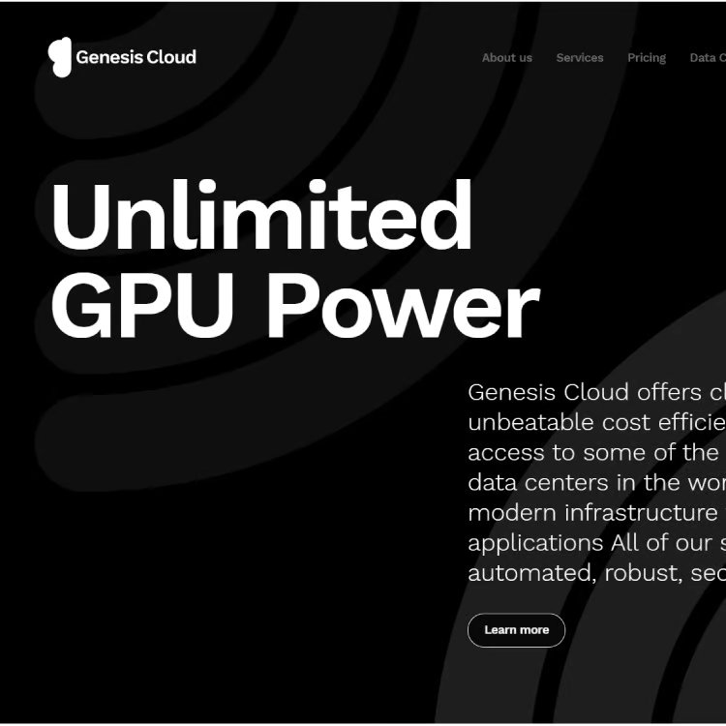

# Cloud computing web-portal and Dashboard

Genesis Cloud offers cloud computing at unbeatable cost efficiency.

<https://www.genesiscloud.com/>

# Django backend

Create or quote a translation job from a variety of service. The backend is capable of ending and receiving assets to an external Translation Management system which handles the actual translation.

<https://www.orders.lionbridge.com/>

# 

# Angular, Vue for Frontend and PHP Laravel 5.2 for Backend and Node.JS for Live Events.

Appointment Booking System for barbering,

<https://www.capellis.com/>

# ASP.NET + MSSQL

Forex rebates are a portion of the transaction cost that is paid back to the client on each trade, resulting in a lower spread and improved win ratio

<https://www.cashbackforex.com/>

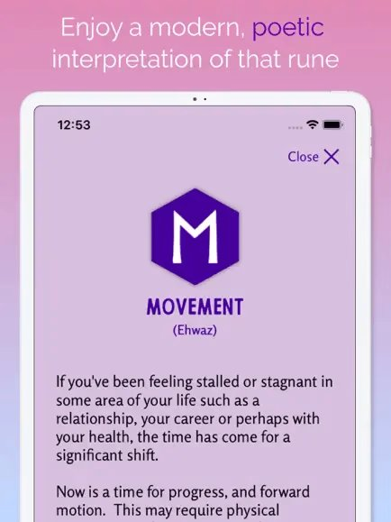

# React Native + Firebase + Realm

Runa: Offers different ways to work with the Runes-messages, journaling.

<https://play.google.com/store/apps/details?gl=US&hl=en_US&id-com.cloud9.runapp>

# React.js + GraphQL + Figma

Manage all your income in one place, Secure the bag, track your income. Visualize your grow using our interactive chart and view trends over time.

<https://securethebag.io/home>

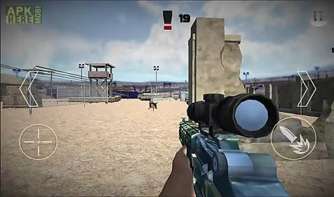

# Unity game

BORN SNIPER ASSASSIN 3D FOR ANDROID, IOS

<https://born-siper-assassin.en.uptodown.com/androiddownload>



# Auto bot in MMORPG

Auto repeat dungeon rush including daily dungeon, group dungeon, and trial arena

<https://www.bladeandsoul.com>

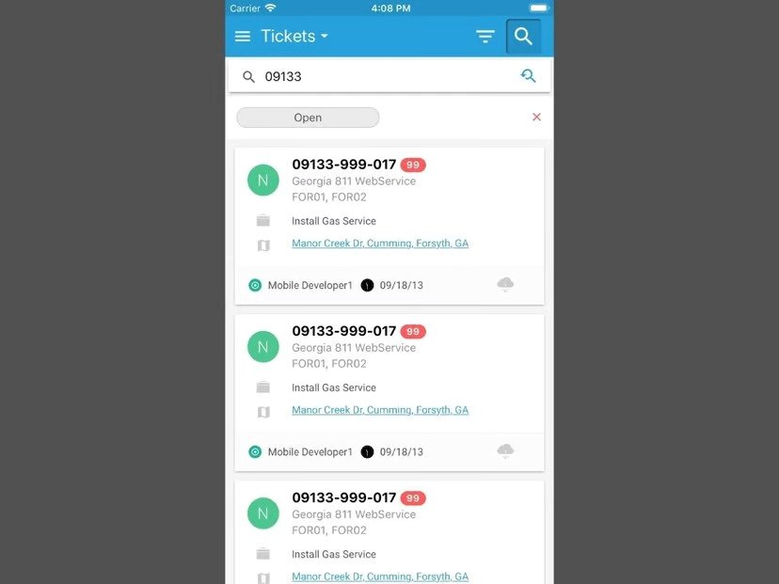

# Ionic + Typescript Mobile App

The app supports touch/face ID, QR scan, geolocation, camera and video capabilities and uses RESTful API on the server side.

<https://play.google.com/store/apps/details?id=com.mobile.boss811>

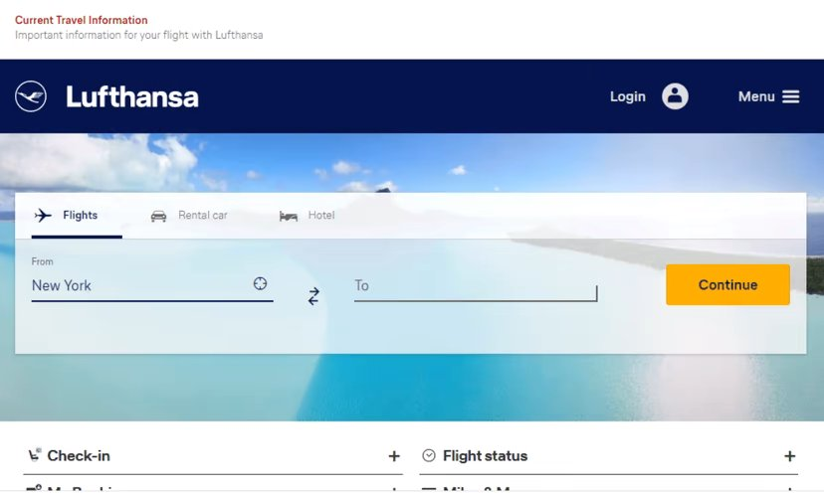

# Spring Boot

Book flights online to worldwide destinations and enjoy a pleasant travel experience in comfort and safety. Look out for great offers and discounts.

<https://www.lufthansa.com>



# Skills

# **Programming Language:**

# C++(12 years), HTML(10), CSS(9), C#(8), JavaScript(7), TypeScript(6), PHP(6), Java(5), Swift(5), Asm(4), Ruby(4), Python(4), Rust(3), Go(3), Solidity(3), GraphQL(2)

# **Platform, Framework, Library:**

# MFC(10 years), Unity(7), Java Spring Boot(7), React.js(7), Node.js(7), Next.js(6), Nest.js(6), Angular.js(5), Vue.js(5),lonic(4),ASP.NET(4), ROR(4), Laravel(3), Django(3), Express.js(3), web3.js(2), TailwindCSS(3), Bootstrap(6), Material UI(5), Ant Design(5)

# **Database Management System:**

# MySQL(10 years), MongoDB(8), MSSQL(8), SQLite(7), PostgreSQL(5), Realm(4)

# **Database Management System:** AWS, GCP, Azure

# **Project Management:** Git, Github, Docker, Azura, DevOps, Kubernetes

# **Testing framework:** JEST, PHPUnit, Junit, PyTest

# **Operating System:** Windows, Android, Linux, Mac OS

# Work Experience



## Software Engineer (Ruby, Node.js, React, React Native) - Remote

### 1ST NATIONS MORTGAGE CORPORATION

Apr 2020 - Nov 2021 (1 year 8 months)

*Maintained multiple live websites & mobile apps developed using Ruby and Node.js, React.js and ReactNative

*Ensured that all websites are bug-free and easy to use.

## Software Engineer II (Ruby on Rails) - Remote

### TourMega

Apr 2018 - Feb 2020 (1 year 11 months)

-Developed a search engine dedicated to tours and activities around the world.

-Integrated Google Maps api, Stripe payment gateway, Facebook apis

-Developed admin dashboard to manage users, bookings

-Developed a messaging app using Socket.io

## MERN Stack Developer (Node.js/MongoDB/React) - Remote

### Legably

Aug 2017 - Mar 2018 (8 months)

Developed a job market platform in Node.js with MongoDB and React.js. Created the "Payment Integration" using Chargebee

Integrated Stripe API to make payments

Developed admin dashboard to manage users, projects Developed a messaging app using Socket.io

## Software Engineer (Ruby on Rails) - Remote

### CoinFalcon

May 2016 - Jun 2017 (1 year 2 months)

Served as the RoR front-end developer for the front-end development of the coinfalcon.com website launched in early 2016.

The build system itself was developed in Ruby and used a listener thread to pull jobs from the PostgreSQL database when they were entered from the website. The website was a full-stack application built on Ruby on Rails and ES2016

# Education



Arizona State University, USA January 2012– Feburary 2016

Bachelor of Science in Computer Science GPA: 4.0/4.0

Relevant Coursework: Cloud Computing, Distributed Database Systems, Foundations of Algorithms