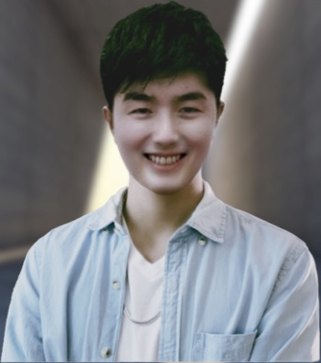Jack Willie

Blockchain Developer & Full-Stack Developer

**I am always ready to interview.**

I am Blockchain developer, specialised in custom cryptocurrency and blockchain based Enterprise solutions. I have extensive experience in ICO's, STO's, Customising Consensus(POS/POW), Cryptoexchange, Wallets and crypto-bot design, DApps, blockchain websites, web portals, & smart contracts applications development. As a full-stack blockchain developer & solidity programmer, I have successfully delivered a wide range of custom cryptocurrency and blockchain development projects using the smart contracts solidity language with eye-catching user-friendly UI design and high-end functionalities. I understand all aspects of developing Blockchain applications: design, architecture, development, and publishing.

Projects



# NFT marketplace with Smart UI and high end functionalities

# Create, discover and sell amazing NFTs on Fantom Opera Network.

<https://www.openhouse.online/>

# 

# Web3.js + Ether.js + Node.js

Raise the fund in terms of crypto wallet.

<https://www.givestation.org/>

# 

# NFT Minting Site

This is NFT mint sites I developed. My role was web designer/builder, smart contract developer.

[https://www. coolsheepnft.com/](https://www.capellis.com/)

# ASP.NET + MSSQL

Forex rebates are a portion of the transaction cost that is paid back to the client on each trade, resulting in a lower spread and improved win ratio

<https://www.cashbackforex.com/>

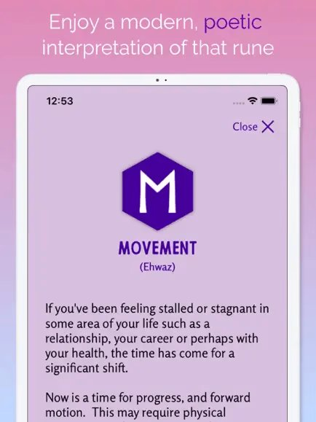

# React Native + Firebase + Realm

Runa: Offers different ways to work with the Runes-messages, journaling.

<https://play.google.com/store/apps/details?gl=US&hl=en_US&id-com.cloud9.runapp>

# React.js + GraphQL + Figma

Manage all your income in one place, Secure the bag, track your income. Visualize your grow using our interactive chart and view trends over time.

<https://securethebag.io/home>

# Skills



# **Programming Language:**

# C++(12 years), HTML(10), CSS(9), C#(8), JavaScript(7), TypeScript(6), PHP(6), Java(5), Swift(5), Asm(4), Ruby(4), Python(4), Rust(3), Go(3), Solidity(3), GraphQL(2)

# **Platform, Framework, Library:**

# MFC(10 years), Unity(7), Java Spring Boot(7), React.js(7), Node.js(7), Next.js(6), Nest.js(6), Angular.js(5), Vue.js(5),lonic(4),ASP.NET(4), ROR(4), Laravel(3), Django(3), Express.js(3), web3.js(2), TailwindCSS(3), Bootstrap(6), Material UI(5), Ant Design(5)

# **Database Management System:**

# MySQL(10 years), MongoDB(8), MSSQL(8), SQLite(7), PostgreSQL(5), Realm(4)

# **Database Management System:** AWS, GCP, Azure

# **Project Management:** Git, Github, Docker, Azura, DevOps, Kubernetes

# **Testing framework:** JEST, PHPUnit, Junit, PyTest

# **Operating System:** Windows, Android, Linux, Mac OS

# Work Experience



## MERN Stack Developer (Node.js/MongoDB/React) – Remote

### Legably

Dec 2019 - Aug 2022 (1 year 3 months)

* Developed a job market platform in Node.js with MongoDB and React.js.
* Created the “Payment Integration" using Chargebee Integrated Stripe API to make payments.
* Developed admin dashboard to manage users, project Developed a messaging app using Socket.io

## Software Engineer (Ruby, Node.js, React, React Native) - Remote

### 1ST NATIONS MORTGAGE CORPORATION

Aug 2017 - Nov 2019 (2 year 8 months)

* Maintained multiple live websites & mobile apps developed using Ruby and Node.js, React.js and React Native.
* Ensured that all websites are bug-free and easy to use.

## Full-stack Software Engineer - Remote

### Almosafer

Feb 2015 - Jan 2016 (2 years)

* Built the first generation of Almosafer website & mobile iOS/Android app.
* Served as the architect and technical lead for the front-end development of the Almosafer hotel booking website & mobile application in early 2015.

## Freelance Frontend Developer

### Upwork

Mar 2014 - Apr 2015 (1 years 2 months)

* Learned front-end technological options (HTML, CSS, JavaScript, and more)
* Developed responsive web applications with JavaScript and AngularJS.
* Built +10 various websites like Ecommerce, Social Dating, Productivity, Real Estate, Education businesses for 10 to 15 individual clients and startups.

# Education



### [Singapore University of Technology and Design (SUTD)](https://sutd.edu.sg/)

2011 – 2014

Bachelor of Technology (BTech)

Information retrieval