Yang Hao Ming

Blockchain Developer | Full Stack Developer

 Singapore, Singapore



I am Blockchain developer, specialised in custom cryptocurrency and blockchain based Enterprise solutions. I have extensive experience in Cryptoexchange, Wallets and crypto-bot design, DApps, blockchain websites, web portals, & smart contracts applications development. As a full-stack blockchain developer & solidity programmer, I have successfully delivered a wide range of custom cryptocurrency and blockchain development projects using the smart contracts solidity language with eye-catching user-friendly UI design and high-end functionalities. I understand all aspects of developing Blockchain applications: design, architecture, development, and publishing.

Specializing in building Front End UI/UX, Web App, website pages, landing pages.  
React is my essential skill so I am enough to do any of your frontend project.

Projects



# NFT marketplace with Smart UI and high end functionalities

# Create, discover and sell amazing NFTs on Fantom Opera Network.

<https://www.openhouse.online/>

# 

# Web3.js + React.js + Node.js

Raise the fund in terms of crypto wallet.

<https://www.givestation.org/>

# 

# NFT Minting Site

This is NFT mint sites I developed. My role was web designer/builder, smart contract developer.

[https://www. coolsheepnft.com/](https://www.capellis.com/)

# ASP.NET + MSSQL + Angular

Forex rebates are a portion of the transaction cost that is paid back to the client on each trade, resulting in a lower spread and improved win ratio

<https://www.cashbackforex.com/>

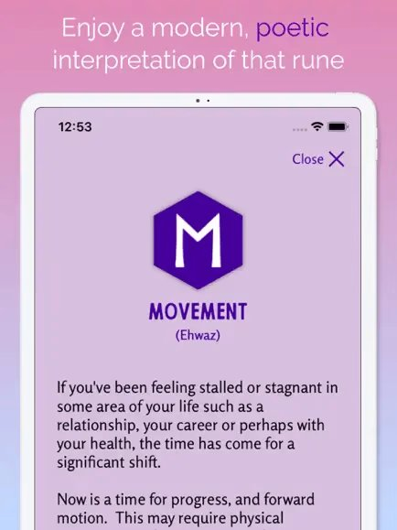

# React Native + Firebase + Realm

Runa: Offers different ways to work with the Runes-messages, journaling.

<https://play.google.com/store/apps/details?gl=US&hl=en_US&id-com.cloud9.runapp>

# React.js + GraphQL + Figma

Manage all your income in one place, Secure the bag, track your income. Visualize your grow using our interactive chart and view trends over time.

<https://securethebag.io/home>

# Skills



# **Programming Language:**

# HTML(10), CSS(9), JavaScript(7), TypeScript(6), PHP(6), Python(4), Solidity(3), GraphQL(2)

# **Platform, Framework, Library:**

# React.js(7), Node.js(7), Next.js(6), Angular.js(5), Vue.js(5), ASP.NET(4), Laravel(3), Django(3), Express.js(3), web3.js(2), TailwindCSS(3), Bootstrap(6), Material UI(5), Ant Design(5)

# **Database Management System:**

# MySQL(10 years), MongoDB(8), MSSQL(8), SQLite(7), PostgreSQL(5), Realm(4)

# **Database Management System:** AWS, GCP, Azure

# **Project Management:** Git, Github, Docker, Azura, DevOps, Kubernetes

# **Testing framework:** JEST, PHPUnit, Junit, PyTest

# **Operating System:** Windows, Android, Linux, Mac OS

# Work Experience



## Blockchain Developer, Full-Stack Developer

### Upwork

Mar 2018 - Present (4 years 4 months +)

-Developed decentralized app with frontend * backend framework options(HTML, CSS, Javascript, Rust, Solidity, jQuery, Typescript, Angular, React, Vue)

-Developed cutting-edge/robust mobile applications using React Native, Flutter

-Built +15 websites & +5 mobile applications for 10 to 15 individual clients and startups

## Blockchain Developer (Web3/Solidity/SmartContracts+React) - Remote

### HedgePay

Aug 2020 - Mar 2021 (1 year 8 months)

-Contributed to develop a new DeFi system called HedgePay.

-Implemented various cryptocurrency functions of HedgePay

-invest, reward, transfer, swap and so on.

-Created a new stable coin called HedgeCoin

-Updated the system to be used in multi network.

-Built structured front end using React hooks and Redux toolkit

## Blockchain Developer (Web3/Ether/Solidity/React/Ethereum) - Remote

### 1ST NATIONS MORTGAGE CORPORATION

Mar 2019 - Aug 2020 (1 year 6 months)

Design and build patterns of chains and mainly developed Cross-Chain by Solidity, Rust & Web3.js.

Developed an analytics engine for the marketing team to help them understand the marketing ROI.

## MERN Stack Developer (Node.js/MongoDB/React) - Remote

### Legably

Aug 2017 - Mar 2019 (1 year 8 months)

Developed a job market platform in Node.js with MongoDB and React.js. Created the "Payment Integration" using Chargebee

Integrated Stripe API to make payments

Developed admin dashboard to manage users, projects Developed a messaging app using Socket.io

## Software Engineer (Mongo/React/Express) - Remote

### CoinFalcon

May 2016 - Jun 2017 (1 year 2 months)

Served as the React front-end developer for the front-end development of the coinfalcon.com website launched in early 2016.

The build system itself was developed in Ruby and used a listener thread to pull jobs from the PostgreSQL database when they were entered from the website. The website was a full-stack application built on Ruby on Rails and ES2016

## Full-stack Software Engineer - Remote

### Almosafer

Feb 2014 - Jan 2016 (2 years)

-Built the first generation of Almosafer website & mobile iOS/Android app

-Served as the architect and technical lead for the front-end development of the Almosafer hotel booking website & mobile application in early 2014.

## Freelance Frontend Developer

### Upwork

Mar 2010 - Apr 2014 (4 years 2 months)

-Learned fron-end technogical options (HTML, CSS, Javascript, and more)

-Developed responsive web applications with Javascript and AngularJS

-Built +10 various websites like Ecommerce, Social Dating, Productivity, Real Estate, Education businesses for 10 to 15 individual clients and startups

# Education



## Osaka University

### Information Technology

Mar 2006 - Jan 2010



## MALAYSIA-JAPAN INTERNATIONAL INSTITUTE OF TECHNOLOGY (MJIIT)

### Non Degree Program, Information Technology

Feb 2007 - Jan 2009

# Language



English: Native or Bilingual

Japanese: Fluent