

Satoru Akiyama (秋山悟)

Senior JAVA Developer

 Tokyo, Japan

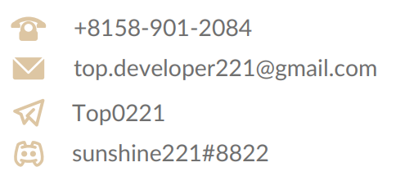

💎💎💎Specializes in JAVA Development.💎💎💎

With 10+ years software development experience, I have contributed to projects small and  
large, demonstrating my professionalism with unmatched quality and reliability regarding to JAVA. Being a professional developer means understanding all the requirements of a project and finding the best way to implement it to a high-quality standard. As a senior JAVA developer, I am proficient with various frameworks such as Spring Boot, Hibernate, PrimeFaces, Spark.

I always focus on project structures and coding style.

Projects



# Job Platform

# (Spring + React.js + Mongo + Stripe)

*Developed a job market platform in JAVA.js with MongoDB and React.js.   
*Integrated Stripe API to make payments.  
*Developed admin dashboard to manage users, projects

<https://www.orders.lionbridge.com/>

# 

# Barbering Booking Website

# (React.js + Hibernate + Socket.IO)

Appointment Booking System for barbering,

<https://www.capellis.com/>

# Trading Tools for forex brokers

# (React.js + JAVA + MSSQL)

Forex rebates are a portion of the transaction cost that is paid back to the client on each trade, resulting in a lower spread and improved win ratio

<https://www.cashbackforex.com/>

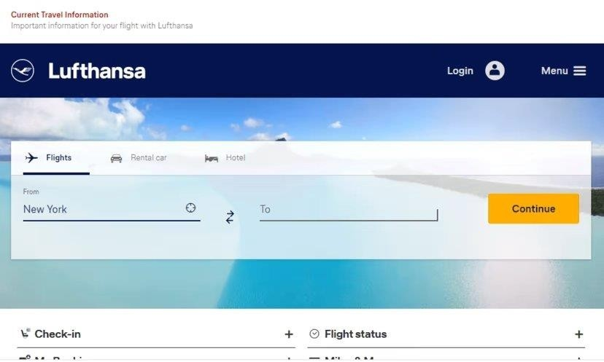

# Flight Booking System

# (Vue.js + Firebase + Spark )

Book flights online to worldwide destinations and  
enjoy a pleasant travel experience in comfort and  
safety. Look out for great offers and discounts.

<https://www.lufthansa.com>

# Spring Boot + Vue.js + MySQL

Manage all your income in one place, Secure the bag, track your income. Visualize your grow using our interactive chart and view trends over time.

<https://securethebag.io/home>



# Skills

# **Programming Language:**

# C++(12 years), HTML(10), CSS(9), JavaScript(7), TypeScript(6), JAVA(6), Java(5), Swift(5), Asm(4), Ruby(4), Rust(3), Go(3), Solidity(3), GraphQL(2)

# **Platform, Framework, Library:**

# React.js(7), Node.js(7), Next.js(6), Nest.js(6), Angular(5), Vue.js(5),lonic(4),ASP.NET(4), Laravel(3), Django(3), Express.js(3), web3.js(2), TailwindCSS(3), Bootstrap(6), Material UI(5), Ant Design(5), Sprint Boot(3), Spark(2), Hibernate(3)

# **Database Management System:**

# MySQL(10 years), MongoDB(8), MSSQL(8), SQLite(7), PostgreSQL(5), Realm(4)

# **Database Management System:** AWS, GCP, Azure

# **Project Management:** Git, Github, Docker, Azura, DevOps, Kubernetes

# **Testing framework:** JEST, JAVAUnit, Junit, PyTest

# **Operating System:** Windows, Android, Linux, Mac OS

# Work Experience



## Software Engineer ( Spring Boot, SocketIO, React.js) - Remote

### 1ST NATIONS MORTGAGE CORPORATION

Apr 2020 - Nov 2022 (2 year 8 months)

*Maintained multiple live websites & mobile apps developed using JAVA, SocketIO, React.js and ReactNative

*Ensured that all websites are bug-free and easy to use.

## Software Engineer II (React.js, GraphQL, Java, SocketIO) - Remote

### TourMega

Apr 2018 - Feb 2020 (1 year 11 months)

-Developed a search engine dedicated to tours and activities around the world.

-Integrated Google Maps api, Stripe payment gateway, Facebook apis

-Developed admin dashboard to manage users, bookings

-Developed a messaging app using Socket.io

## MERN Stack Developer (Hibernate/MongoDB/ React.js) - Remote

### Legably

May 2016 - Mar 2018 (1 year 10 months)

Developed a job market platform in JAVA with MongoDB and React.js. Created the "Payment Integration" using Chargebee

Integrated Stripe API to make payments

Developed admin dashboard to manage users, projects Developed a messaging app using Socket.io

## Full-stack Software Engineer - Remote

### Almosafer

Feb 2014 - Jan 2016 (2 years)

-Built the first generation of Almosafer website & mobile iOS/Android app

-Served as the architect and technical lead for the front-end development of the Almosafer hotel booking website & mobile application in early 2014.

# Education



## Osaka University

### Information Technology

Mar 2010 - Jan 2014