Jack Willie  
FullStack Developer

Professional full stack React/React Native/Node/Laravel web developer with sound knowledge and having 7+ years of experience in front/back-end development. I have been working with US & Canadian Clients for last many years. Helped and complete a lot of projects during my experience from small to mega level ranging from few weeks to years projects and MVPs.

If you need some help with development or if have an idea you want to discuss, or just need to hear a friendly voice, contact me anytime. I will try my level best to satisfy you and demands as per standards utilising my skills.

Contact Me



C:\Users\Administrator\AppData\Local\Microsoft\Windows\INetCache\Content.Word\5968898.png[top.developer327@gmail.com](mailto:top.developer327@gmail.com) morto#8463

C:\Users\Administrator\AppData\Local\Microsoft\Windows\INetCache\Content.Word\3128219.pngC:\Users\Administrator\AppData\Local\Microsoft\Windows\INetCache\Content.Word\2111708.pngC:\Users\Administrator\AppData\Local\Microsoft\Windows\INetCache\Content.Word\597177.png +1 786 347 1994 Top0221

https://www.linkedin.com/in/jackwillie

Projects



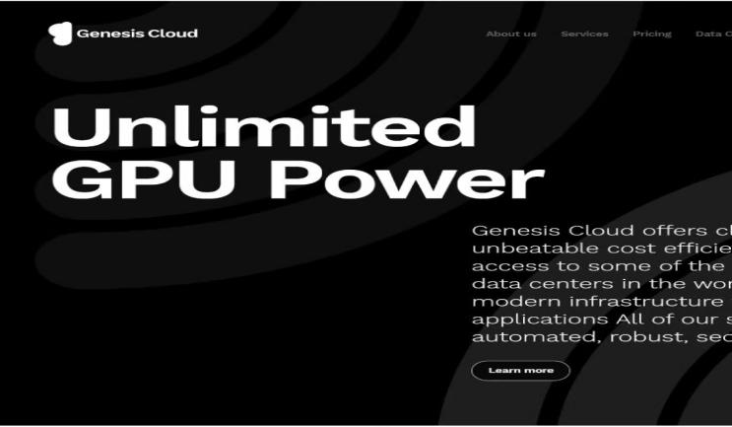

# Cloud computing web-portal and Dashboard

Genesis Cloud offers cloud computing at unbeatable cost efficiency.

<https://www.genesiscloud.com/>

# Django backend

Create or quote a translation job from a variety of service. The backend is capable of ending and receiving assets to an external Translation Management system which handles the actual translation.

<https://www.orders.lionbridge.com/>

# 

# Angular, Vue for Frontend and PHP Laravel 5.2 for Backend and Node.JS for Live Events.

Appointment Booking System for barbering,

<https://www.capellis.com/>

# ASP.NET + MSSQL

Forex rebates are a portion of the transaction cost that is paid back to the client on each trade, resulting in a lower spread and improved win ratio

<https://www.cashbackforex.com/>

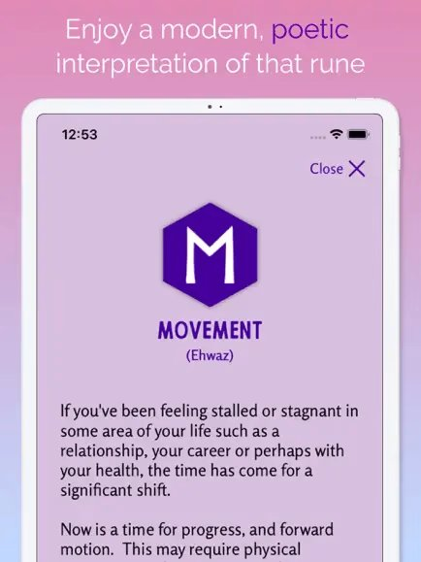

# React Native + Firebase + Realm

Runa: Offers different ways to work with the Runes-messages, journaling.

<https://play.google.com/store/apps/details?gl=US&hl=en_US&id-com.cloud9.runapp>

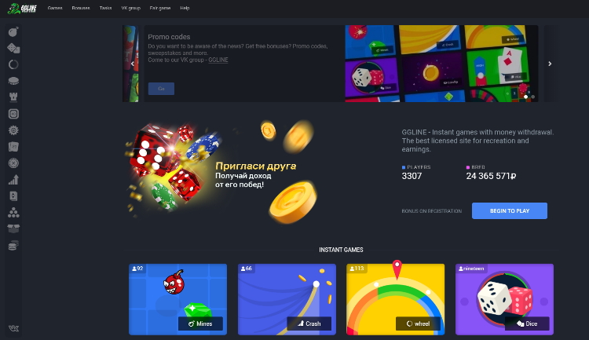

# React + Node.js

Sports betting book website.  
Role: Backend

https://ggline.pro

# React.js + GraphQL + Figma

Manage all your income in one place, Secure the bag, track your income. Visualize your grow using our interactive chart and view trends over time.

<https://securethebag.io/home>

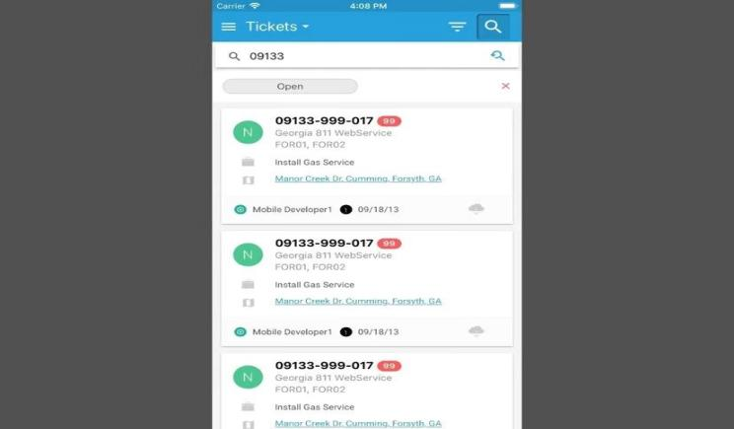

# Ionic + Typescript Mobile App

The app supports touch/face ID, QR scan, geolocation, camera and video capabilities and uses RESTful API on the server side.

<https://play.google.com/store/apps/details?id=com.mobile.boss811>

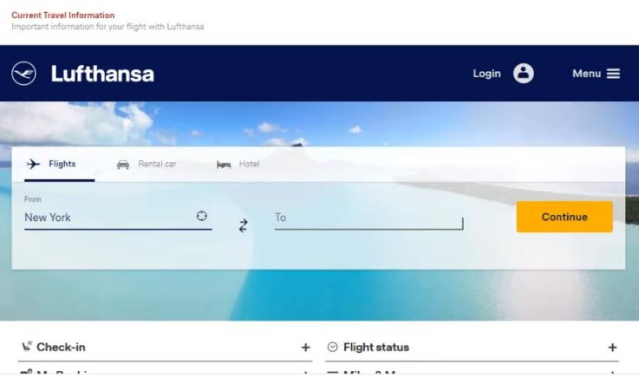

# Spring Boot

Book flights online to worldwide destinations and enjoy a pleasant travel experience in comfort and safety. Look out for great offers and discounts.

<https://www.lufthansa.com>

# Skills

# **Programming Language:**

# C++(12 years), HTML(10), CSS(9), C#(8), JavaScript(7), TypeScript(6), PHP(8), Java(5), Swift(5), Asm(4), Ruby(4), Python(4), Rust(3), Go(3), Solidity(3), GraphQL(2)

# **Platform, Framework, Library:**

# React.js(7), React Native(7), Node.js(7), Next.js(6), Nest.js(6), Angular.js(5), Vue.js(5), lonic(4), ASP.NET(4), ROR(4), Laravel(13), Django(3), Express.js(3), web3.js(2), TailwindCSS(3), Bootstrap(6), Material UI(5), Ant Design(5),Java Spring Boot(7)

# **Database Management System:**

# MySQL(10 years), MongoDB(8), MSSQL(8), SQLite(7), PostgreSQL(5), Realm(4)

# **Database Management System:** AWS, GCP, Azure

# **Project Management:** Git, Github, Docker, Azura, DevOps, Kubernetes

# **Testing framework:** JEST, PHPUnit, Junit, PyTest

# **Operating System:** Windows, Android, Linux, Mac OS

# Work Experience



## MERN Stack Developer (Node.js/MongoDB/React) – Remote

### Legably

Dec 2019 - Aug 2022 (1 year 3 months)

* Developed a job market platform in Node.js with MongoDB and React.js.
* Created the “Payment Integration" using Chargebee Integrated Stripe API to make payments.
* Developed admin dashboard to manage users, project Developed a messaging app using Socket.io

## Software Engineer (Ruby, Node.js, React, React Native) - Remote

### 1ST NATIONS MORTGAGE CORPORATION

Aug 2017 - Nov 2019 (2 year 8 months)

* Maintained multiple live websites & mobile apps developed using Ruby and Node.js, React.js and React Native.
* Ensured that all websites are bug-free and easy to use.

## Full-stack Software Engineer - Remote

### Almosafer

Feb 2015 - Jan 2016 (2 years)

* Built the first generation of Almosafer website & mobile iOS/Android app.
* Served as the architect and technical lead for the front-end development of the Almosafer hotel booking website & mobile application in early 2015.

## Freelance Frontend Developer

### Upwork

Mar 2014 - Apr 2015 (1 years 2 months)

* Learned front-end technological options (HTML, CSS, JavaScript, and more)
* Developed responsive web applications with JavaScript and AngularJS.
* Built +10 various websites like Ecommerce, Social Dating, Productivity, Real Estate, Education businesses for 10 to 15 individual clients and startups.

# Education



### [Singapore University of Technology and Design (SUTD)](https://sutd.edu.sg/)

2011 – 2014

Bachelor of Technology (BTech)

Information retrieval