
Test Report Document
BookStore Application

Version 1.0

Prepare by
Komgrit Sangkapradit 5830213015
Narongrit Bunsaman 5830213040
PkayPreak Ung 5830213047

16 - 20 April 2018

สารบัญ

หน้า

- Test Design 1
- Unit Testing Results 2
- Integration Testing Results 3
- System and Acceptance Testing Results 4-6

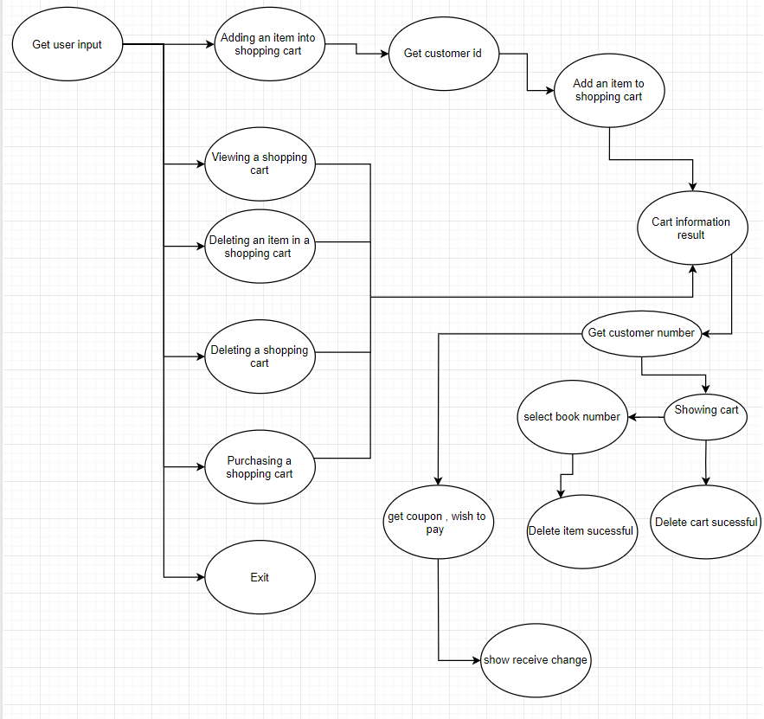
- Test Design

Source code = https://github.com/SupertesterSe-X/CaseTest12

- Unit Testing Results
getBalance
totalOrderPrice | discount | netBalExpected | Summary
100 | 10 | 90 | ✔
1500 | 10 | 1350 | ✔
2500 | 10 | 2250 | ✔
3500 | 10 | 3150 | ✔
4500 | 10 | 4050 | ✔
5500 | 10 | 4950 | ✔
100 | 16 | 84 | ✔
1500 | 18 | 1230 | ✔
2500 | 20 | 2000 | ✔
3500 | 23 | 2695 | ✔
4500 | 28 | 3240 | ✔
5500 | 33 | 3685 | ✔
100 | 18 | 82 | ✔
1500 | 20 | 1200 | ✔
2500 | 22 | 1950 | ✔
3500 | 25 | 2625 | ✔
4500 | 30 | 3150 | ✔
5500 | 35 | 3575 | ✔
100 | 23 | 77 | ✔
1500 | 25 | 1125 | ✔
2500 | 27 | 1825 | ✔
3500 | 30 | 2450 | ✔
4500 | 35 | 2925 | ✔
5500 | 40 | 3300 | ✔
100 | 0 | 100 | ✔
1500 | 0 | 1500 | ✔
2500 | 0 | 2500 | ✔
3500 | 0 | 3500 | ✔
4500 | 0 | 4500 | ✔
5500 | 0 | 5500 | ✔
100 | 6 | 94 | ✔
1500 | 8 | 1380 | ✔
2500 | 10 | 2250 | ✔
3500 | 13 | 3045 | ✔
4500 | 18 | 3690 | ✔
5500 | 23 | 4235 | ✔
100 | 8 | 92 | ✔
1500 | 10 | 1350 | ✔
2500 | 12 | 2200 | ✔
3500 | 15 | 2975 | ✔
4500 | 20 | 3600 | ✔
5500 | 25 | 4125 | ✔
100 | 13 | 87 | ✔
1500 | 15 | 1275 | ✔
2500 | 17 | 2075 | ✔
3500 | 20 | 2800 | ✔
4500 | 25 | 3375 | ✔
5500 | 30 | 3850 | ✔
-600 | 10 | -540 | ✔
600 | -10 | 660 | ✔
600 | 35 | 390 | ✔
600 | 110 | -60 | ✔
600 | 3 | 582 | ✔

getDiscount ***Found bug in Class BookStore line 226

totalOrderPrice | cusType | coupon | discountExpected | Summary
100 | 0 | 10 | 90 | ✖
1500 | 0 | 10 | 1350 | ✖
2500 | 0 | 10 | 2250 | ✖
3500 | 0 | 10 | 3150 | ✖
4500 | 0 | 10 | 4050 | ✖
5500 | 0 | 10 | 4950 | ✖
100 | 3 | 10 | 84 | ✖
1500 | 3 | 10 | 1230 | ✖
2500 | 3 | 10 | 2000 | ✖
3500 | 3 | 10 | 2695 | ✖
4500 | 3 | 10 | 3240 | ✖
5500 | 3 | 10 | 3685 | ✖
100 | 5 | 10 | 82 | ✖
1500 | 5 | 10 | 1200 | ✖
2500 | 5 | 10 | 1950 | ✖
3500 | 5 | 10 | 2625 | ✖
4500 | 5 | 10 | 3150 | ✖
5500 | 5 | 10 | 3575 | ✖
100 | 10 | 10 | 77 | ✖
1500 | 10 | 10 | 1125 | ✖
2500 | 10 | 10 | 1825 | ✖
3500 | 10 | 10 | 2450 | ✖
4500 | 10 | 10 | 2925 | ✖
5500 | 10 | 10 | 3300 | ✖
100 | 0 | 0 | 100 | ✖
1500 | 0 | 0 | 1500 | ✖
2500 | 0 | 0 | 2500 | ✖
3500 | 0 | 0 | 3500 | ✖
4500 | 0 | 0 | 4500 | ✖
5500 | 0 | 0 | 5500 | ✖
100 | 3 | 0 | 94 | ✖
1500 | 3 | 0 | 1380 | ✖
2500 | 3 | 0 | 2250 | ✖
3500 | 3 | 0 | 3045 | ✖
4500 | 3 | 0 | 3690 | ✖
5500 | 3 | 0 | 4235 | ✖
100 | 5 | 0 | 92 | ✖
1500 | 5 | 0 | 1350 | ✖
2500 | 5 | 0 | 2200 | ✖
3500 | 5 | 0 | 2975 | ✖
4500 | 5 | 0 | 3600 | ✖
5500 | 5 | 0 | 4125 | ✖
100 | 10 | 0 | 87 | ✖
1500 | 10 | 0 | 1275 | ✖
2500 | 10 | 0 | 2075 | ✖
3500 | 10 | 0 | 2800 | ✖
4500 | 10 | 0 | 3375 | ✖
5500 | 10 | 0 | 3850 | ✖
-600 | 0 | 10 | -540 | ✖
600 | 0 | -10 | 660 | ✖
600 | 0 | 35 | 390 | ✖
600 | 0 | 110 | -60 | ✖
600 | 0 | 3 | 582 | ✖

getPurchase
balance | paid | discount | purchaseExpected | Summary
100 | 90 | 10 | 90 | ✔
1500 | 1350 | 10 | 1350 | ✔
2500 | 2250 | 10 | 2250 | ✔
3500 | 3150 | 10 | 3150 | ✔
4500 | 4050 | 10 | 4050 | ✔
5500 | 4950 | 10 | 4950 | ✔
100 | 84 | 16 | 84 | ✔
1500 | 1230 | 18 | 1230 | ✔
2500 | 2000 | 20 | 2000 | ✔
3500 | 2695 | 23 | 2695 | ✔
4500 | 3240 | 28 | 3240 | ✔
5500 | 3685 | 33 | 3685 | ✔
100 | 82 | 18 | 82 | ✔
1500 | 1200 | 20 | 1200 | ✔
2500 | 1950 | 22 | 1950 | ✔
3500 | 2625 | 25 | 2625 | ✔
4500 | 3150 | 30 | 3150 | ✔
5500 | 3575 | 35 | 3575 | ✔
100 | 77 | 23 | 77 | ✔
1500 | 1125 | 25 | 1125 | ✔
2500 | 1825 | 27 | 1825 | ✔
3500 | 2450 | 30 | 2450 | ✔
4500 | 2925 | 35 | 2925 | ✔
5500 | 3300 | 40 | 3300 | ✔
100 | 100 | 0 | 100 | ✔
1500 | 1500 | 0 | 1500 | ✔
2500 | 2500 | 0 | 2500 | ✔
3500 | 3500 | 0 | 3500 | ✔
4500 | 4500 | 0 | 4500 | ✔
5500 | 5500 | 0 | 5500 | ✔
100 | 94 | 6 | 94 | ✔
1500 | 1380 | 8 | 1380 | ✔
2500 | 2250 | 10 | 2250 | ✔
3500 | 3045 | 13 | 3045 | ✔
4500 | 3690 | 18 | 3690 | ✔
5500 | 4235 | 23 | 4235 | ✔
100 | 92 | 8 | 92 | ✔
1500 | 1350 | 10 | 1350 | ✔
2500 | 2200 | 12 | 2200 | ✔
3500 | 2975 | 15 | 2975 | ✔
4500 | 3600 | 20 | 3600 | ✔
5500 | 4125 | 25 | 4125 | ✔
100 | 87 | 13 | 87 | ✔
1500 | 1275 | 15 | 1275 | ✔
2500 | 2075 | 17 | 2075 | ✔
3500 | 2800 | 20 | 2800 | ✔
4500 | 3375 | 25 | 3375 | ✔
5500 | 3850 | 30 | 3850 | ✔
-600 | -540 | 10 | -540 | ✔
600 | 660 | -10 | 660 | ✔
600 | 390 | 35 | 390 | ✔
600 | -60 | 110 | -60 | ✔
600 | 582 | 3 | 582 | ✔

- Integration Testing Results

customer_Type | customer_discount | order_price | order_discount | coupon_discount | total_discount | IntegrationTest
0 | 100 | 0 | 10 | 10 | 90 | ✔
0 | 1500 | 0 | 10 | 10 | 1350 | ✔
0 | 2500 | 0 | 10 | 10 | 2250 | ✔
0 | 3500 | 0 | 10 | 10 | 3150 | ✔
0 | 4500 | 0 | 10 | 10 | 4050 | ✔
0 | 5500 | 0 | 10 | 10 | 4950 | ✔
3 | 100 | 3 | 10 | 16 | 84 | ✔
3 | 1500 | 5 | 10 | 18 | 1230 | ✔
3 | 2500 | 7 | 10 | 20 | 2000 | ✔
3 | 3500 | 10 | 10 | 23 | 2695 | ✔
3 | 4500 | 15 | 10 | 28 | 3240 | ✔
3 | 5500 | 20 | 10 | 33 | 3685 | ✔
5 | 100 | 3 | 10 | 18 | 82 | ✔
5 | 1500 | 5 | 10 | 20 | 1200 | ✔
5 | 2500 | 7 | 10 | 22 | 1950 | ✔
5 | 3500 | 10 | 10 | 25 | 2625 | ✔
5 | 4500 | 15 | 10 | 30 | 3150 | ✔
5 | 5500 | 20 | 10 | 35 | 3575 | ✔
10 | 100 | 3 | 10 | 23 | 77 | ✔
10 | 1500 | 5 | 10 | 25 | 1125 | ✔
10 | 2500 | 7 | 10 | 27 | 1825 | ✔
10 | 3500 | 10 | 10 | 30 | 2450 | ✔
10 | 4500 | 15 | 10 | 35 | 2925 | ✔
10 | 5500 | 20 | 10 | 40 | 3300 | ✔
0 | 100 | 0 | 0 | 0 | 100 | ✔
0 | 1500 | 0 | 0 | 0 | 1500 | ✔
0 | 2500 | 0 | 0 | 0 | 2500 | ✔
0 | 3500 | 0 | 0 | 0 | 3500 | ✔
0 | 4500 | 0 | 0 | 0 | 4500 | ✔
0 | 5500 | 0 | 0 | 0 | 5500 | ✔
3 | 100 | 3 | 0 | 6 | 94 | ✔
3 | 1500 | 5 | 0 | 8 | 1380 | ✔
3 | 2500 | 7 | 0 | 10 | 2250 | ✔
3 | 3500 | 10 | 0 | 13 | 3045 | ✔
3 | 4500 | 15 | 0 | 18 | 3690 | ✔
3 | 5500 | 20 | 0 | 23 | 4235 | ✔
5 | 100 | 3 | 0 | 8 | 92 | ✔
5 | 1500 | 5 | 0 | 10 | 1350 | ✔
5 | 2500 | 7 | 0 | 12 | 2200 | ✔
5 | 3500 | 10 | 0 | 15 | 2975 | ✔
5 | 4500 | 15 | 0 | 20 | 3600 | ✔
5 | 5500 | 20 | 0 | 25 | 4125 | ✔
10 | 100 | 3 | 0 | 13 | 87 | ✔
10 | 1500 | 5 | 0 | 15 | 1275 | ✔
10 | 2500 | 7 | 0 | 17 | 2075 | ✔
10 | 3500 | 10 | 0 | 20 | 2800 | ✔
10 | 4500 | 15 | 0 | 25 | 3375 | ✔
10 | 5500 | 20 | 0 | 30 | 3850 | ✔
0 | -600 | 0 | 10 | 10 | -540 | ✔
0 | 600 | 0 | -10 | -10 | 660 | ✔
0 | 600 | 0 | 35 | 35 | 390 | ✔
0 | 600 | 0 | 110 | 110 | -60 | ✔
0 | 600 | 0 | 3 | 3 | 582 | ✔

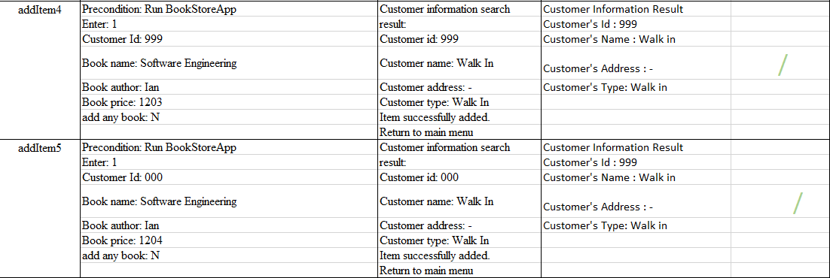
- System and Acceptance Testing Results
