The avatar's motion
What the head actually does, what the ten sliders change, and one defect that matters for a four-hour event.

Where this file lives | ~/avatar_notes.docx on alpha (reachy-cjap). The motion code is in the repo at app/main_voice_robot.py; the controls are dashboard/ui_common.py and dashboard/ui_page_display.py.
Machines | alpha = reachy-cjap (192.168.88.9). beta = reachy-2 (192.168.88.10). Both run the same code.
Date | 14 September 2026
Branch / commits | feat/operator-console — 442c7cf (breath + persisting sliders), bbefae1 (avatar_lag versioned).
Read this as | What is on disk and what was measured. Unverifiable things say UNKNOWN.

Read section 4 before the event.
The breath rate is correct for about the first two minutes of a run and then drifts without bound. Over a four-hour event the rate is inside the intended 12–16 cycles per minute for 2.9 % of the time. The robot as it is running right now, 1 h 52 m in, is at 46.5 cycles per minute — a tremor, not a breath. This is a one-line arithmetic error, it is not fixed, and I have not changed it.

1. What the avatar already exposed, before any of this
This was the first thing asked for, so it is recorded first. Before commit 442c7cf the head motion had five parameters, all of them environment variables read once at import, none of them adjustable while the robot was running:
Parameter | Env var | Default then | What it does
BREATH_HZ | CJ_BREATH_HZ | 30 | update rate of the motion loop, not a breathing rate
BREATH_GAIN | CJ_BREATH_GAIN | 1.3 | amplitude multiplier on the whole drift
BREATH_PITCH | CJ_BREATH_PITCH | 0.75 | how much of the motion is nod rather than sway
HEAD_SWAY_DEG | CJ_HEAD_SWAY_DEG | 4 | degrees of side-to-side yaw
HEAD_SWAY_HZ | CJ_HEAD_SWAY_HZ | 0.07 | how often that swing happens
ENV_DEG | CJ_ENV_DEG | 2.2 | extra nod at full speaking volume

Changing any of them meant editing the root-owned systemd drop-in and restarting the service. There were no presets, nothing survived in git, and there was no way to see the effect of a change while making it.

The thing that was actually wrong
The motion was described as breathing. It was not breathing. Its dominant term was:
app/main_voice_robot.py — the postural drift, unchanged
yaw = 1.9 * s(0.21 * t) + 0.8 * s(0.53 * t + 1.3) + 0.35 * s(1.27 * t + 0.4)
0.21 rad/s is a 30-second period — about 2 cycles a minute. That is a slow settle of the head, which is why a still head still read as frozen: there was nothing at a human breathing rate anywhere in the signal. A person at rest breathes 12–16 times a minute.
The brief was a composed man in his late eighties who spent a career being still in a courtroom. So the answer was not more motion — it was less drift and a real breath underneath it.

2. What changed
Change | Before | After
sway amount | 4.0 deg | 1.6 deg
sway rate | 0.07 Hz (14 s swing) | 0.045 Hz (22 s swing)
voice emphasis | 2.2 deg at full volume | 1.2 deg
a breath layer | none | added under the drift, nominally 14 cycles/min
adjustable live | no — env var + restart | yes — 10 sliders at /tune, no restart
survives a reboot | no | yes — config/avatar_motion.json, in git
presets | none | composed / livelier / still

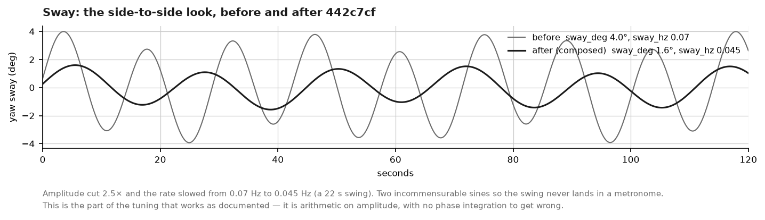
Figure 1 — Sway before and after. This part of the tuning works exactly as documented.
The postural drift itself was left alone. It is what makes the head look like it is settling rather than holding a pose, and it was never the problem — the problem was that it was the ONLY thing there.

3. The ten knobs
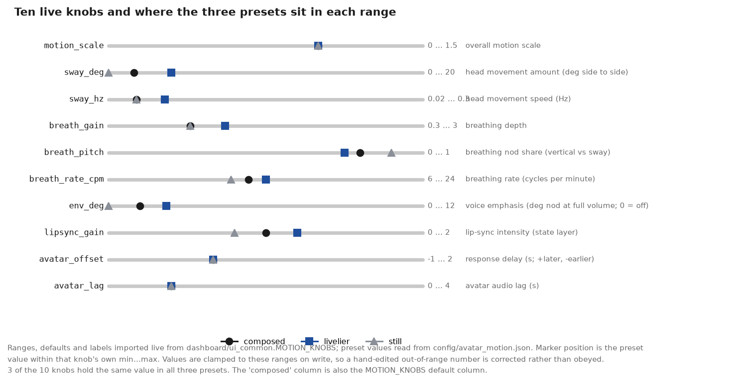
Figure 2 — Ranges imported live from ui_common.MOTION_KNOBS; preset values read from config/avatar_motion.json.
Knob | Range | Default | What it changes | Acts on
motion_scale | 0 … 1.5 | 1 | overall motion scale | robot
sway_deg | 0 … 20 | 1.6 | head movement amount (deg side to side) | robot
sway_hz | 0.02 … 0.3 | 0.045 | head movement speed (Hz) | robot
breath_gain | 0.3 … 3 | 1 | breathing depth | robot
breath_pitch | 0 … 1 | 0.8 | breathing nod share (vertical vs sway) | robot
breath_rate_cpm | 6 … 24 | 14 | breathing rate (cycles per minute) | robot
env_deg | 0 … 12 | 1.2 | voice emphasis (deg nod at full volume; 0 = off) | robot
lipsync_gain | 0 … 2 | 1 | lip-sync intensity (state layer) | browser
avatar_offset | -1 … 2 | 0 | response delay (s; +later, -earlier) | browser
avatar_lag | 0 … 4 | 0.8 | avatar audio lag (s) | browser

Seven act on the robot's own head. Three act only on the browser page — the robot has no mouth, so lip-sync intensity binds to the state layer on /stage and /monitor and to nothing physical.
Nothing here is a parameter the avatar cannot act on. That was an explicit requirement and it was checked knob by knob: every one of the ten is read by code that runs.
Values are clamped to these ranges on write, so a hand-edited out-of-range number in the config file is corrected rather than obeyed.

4. The breath layer — and the defect in it
The intent, written into the code and into the preset file, is a breath at 12–16 cycles a minute, layered under the drift, with a rate that wanders slightly so it never lands in a metronome, and a second harmonic so the out-breath falls faster than the in-breath rises.
app/main_voice_robot.py:1075-1078
rate = _motion_val("breath_rate_cpm", BREATH_RATE_CPM)
wb = 2 * math.pi * (rate / 60.0)
phb = wb * (1.0 + 0.07 * s(0.033 * t + 0.5)) * t
pitch += pitch_k * 1.25 * (s(phb) + 0.16 * s(2 * phb + 0.7))
The shape is right and the amplitude is right: 2.32 degrees peak-to-peak at breath_pitch 0.8, which is visible at two metres without being nameable. The rate is not right.

What goes wrong
The third line sets the PHASE by multiplying a modulated rate by t. That is not how a varying frequency integrates. The instantaneous rate is the derivative of the phase:
phb = wb * (1 + 0.07*sin(th)) * t
d(phb)/dt = wb * [ 1 + 0.07*sin(th) + 0.00231*t*cos(th) ]
^^^^^^^^^^^^^^^^^
grows without bound with elapsed time
The intended ±7 % wander is therefore ±7 % only while t is small. The error term reaches 100 % at t = 433 s, about 7 minutes. After that the breath rate swings further every minute, and it goes negative — the breath runs backwards.
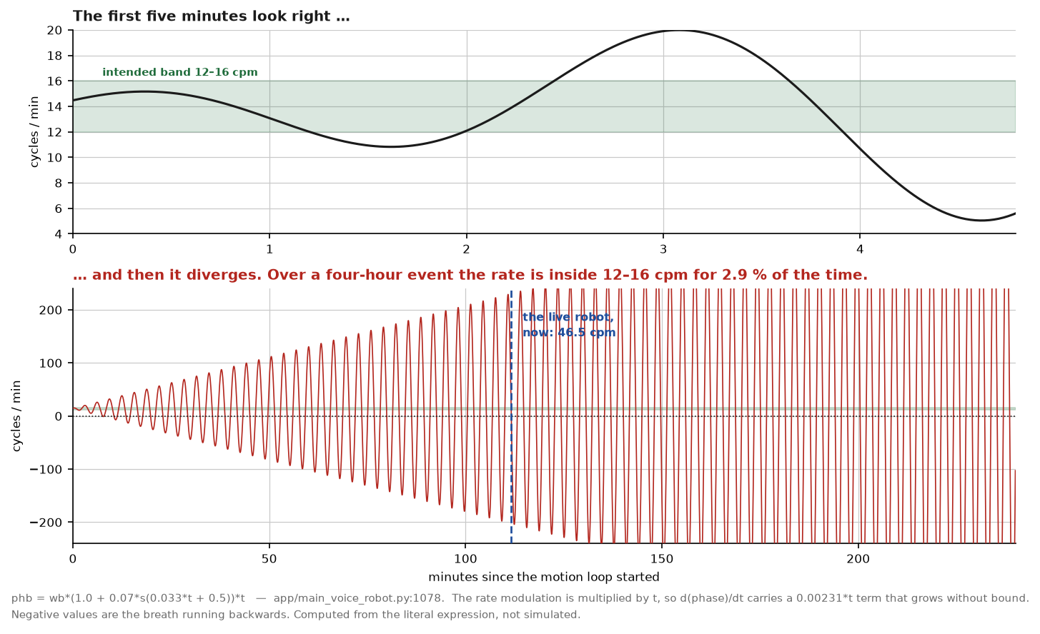
Figure 3 — Computed from the literal expression in the source, not simulated.
Elapsed | Instantaneous rate | Reads as
0–2 min | 12–16 cpm | correct — a calm breath
5 min | 7.7 cpm | too slow, but still a breath
10 min | 17.3 cpm | slightly fast
20 min | −14.0 cpm | running backwards
30 min | −43.1 cpm | a fast reversed tremor
1 h | 130 cpm | a vibration
1 h 52 m (the robot, now) | 46.5 cpm | a visible tremor
4 h | −102.7 cpm | a vibration

Over a four-hour event the rate is inside the intended 12–16 cpm band for 2.9 % of the elapsed time.
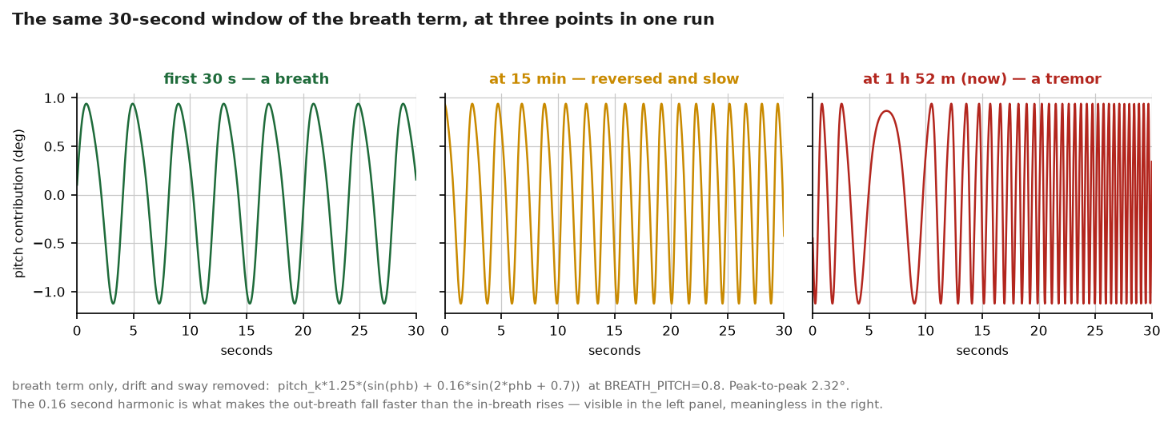
Figure 4 — The same 30-second window of the breath term at three points in one run.

Why nobody noticed
- Every test of the motion was short. The sliders are judged in the first minute or two of watching, which is exactly the window where the maths is still correct.
- The soak measured HTTP status, render time and memory. It did not measure the head.
- tests/test_breath_motion.py asserts on the shape of the offset and on continuity, not on the rate over time. It would pass with this defect present. (That file has its own history — see LL-013.)
- The 40 seconds of silence taken after the restart was, again, inside the good window.

The fix, not applied
It is one line. The phase must be the integral of the rate rather than the rate times t:
# now
phb = wb * (1.0 + 0.07 * s(0.033 * t + 0.5)) * t
# correct — bounded +/-7% wander forever
phb = wb * (t - (0.07/0.033) * (math.cos(0.033*t + 0.5) - math.cos(0.5)))
I have NOT made this change. The brief for this session was to write the two documents, and this touches the motion path on a machine that is running. It needs a decision, a test that fails against the old code first, and a restart of both robots.
Until it is changed, the practical workaround is that restarting supervaise.service resets t. A restart shortly before doors open buys roughly the first two good minutes and a slow degradation after that — which is not a fix, and should not be described as one.

5. Breathing stops when the microphone is muted — on purpose
This is the single most likely thing to be misread as a crash at a venue, so it is in the runbook and it is repeated here.
app/main_voice_robot.py:1296-1302
if mode == "sleep" and _muted():
# Mic muted (2026-08-29): the robot has no LEDs, so the body shows
# it - antennas drooped, head slightly bowed, no idle sway. The
# breath stops too: "muted" has to read as switched off.
self.breath_scale = 0.0
self._move(0, 8, 0, 0.9, antennas=[-0.6, 0.6], wait=False)
A muted robot and a crashed robot look identical from across a room. That is the cost of having no indicator lights, and it was chosen deliberately: silence plus stillness is how the robot says it is muted. Check the mute button on /maintain before concluding anything has failed.
Note the condition: this applies in sleep mode. Breathing continues in all four display states — idle, listening, thinking and speaking — and never stops while the robot is awake and unmuted.
The screen does NOT follow the head here.
The state layer on /stage and /monitor keeps breathing while the robot is muted — its canvas breath is unconditional and ungated. It says 'muted' with a dim grey colour instead of with stillness, because a screen that stops moving reads as a crashed screen. So during a mute the head is still and the screen is not, and both are behaving correctly.
There is a second, unflattering comparison to draw. The browser's breath is a plain fixed-frequency sine at 0.22 Hz — 13.2 cycles per minute, inside the intended band, and it stays there for as long as the page is open. The robot's breath, which is the one that was tuned and written about, does not. That is section 4.

6. Audio and animation sync
Two separate quantities, often confused:
Knob | What it delays | Where it acts
avatar_offset | the measured-audio envelope that drives the state layer's speaking animation | the browser, /stage and /monitor
avatar_lag | the LiveAvatar page's own audio-versus-animation lag | the browser, /face-avatar

Only the internal speaker route has been measured.
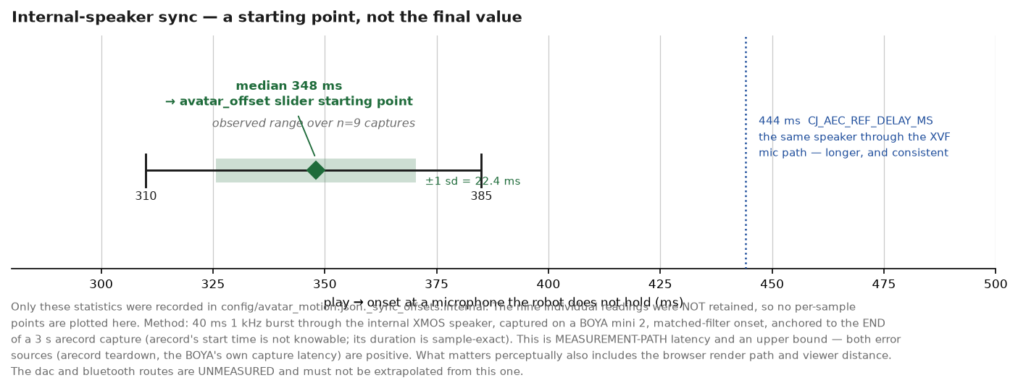
Figure 5 — The recorded statistics. The nine individual readings were not retained, so none are drawn.
STARTING POINT, NOT THE FINAL VALUE. 348 ms is the MEASUREMENT-PATH latency — speaker to a microphone — and it is an upper bound, because both error sources (arecord teardown, the BOYA's own capture latency) are positive. What actually matters perceptually is audio-at-the-ear against mouth-moving-on-screen, which also includes the browser's render path and the viewer's distance. Set the slider here and dial the residual by eye while the robot speaks.
Route | Offset | Status
internal (XMOS, ~5 W) | 0.35 s | measured 2026-09-14, n=9, median 348 ms, sd 22.4 ms, range 310–385 ms
dac (USB) | — | UNMEASURED. No USB DAC is attached. Do not extrapolate from internal.
bluetooth | — | UNMEASURED. Do not extrapolate from internal.

A cross-check that supports the number: CJ_AEC_REF_DELAY_MS=444 in the systemd drop-in is the separately calibrated delay for the same speaker through the XVF's own microphone path, which is a longer path. 348 < 444 is the expected ordering.
Use 348 ms as where the slider starts, then trim by eye while the robot speaks. The measurement is an upper bound on the measurement path, and what matters perceptually — sound at the ear against mouth on screen — also includes the browser's render path and how far away the viewer is standing.

7. Persistence — why a tuned head used to come back wrong
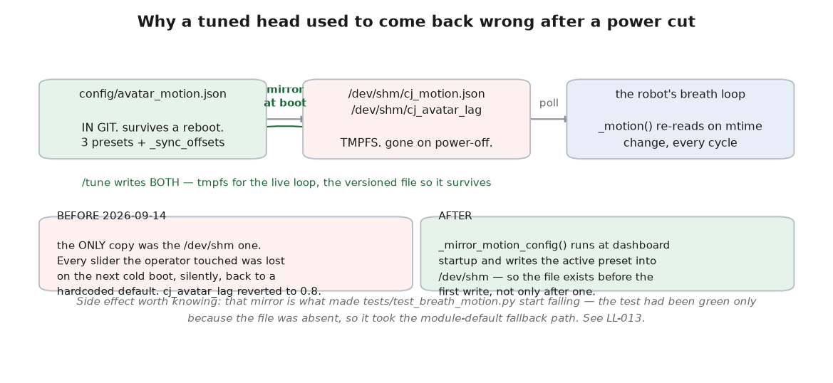
Figure 6 — The tmpfs trap and the mirror that closed it.
The robot's breath loop reads ONE file and only one: /dev/shm/cj_motion.json. /dev/shm is a tmpfs, so it does not survive a power cut. Before 2026-09-14 that was the only copy, and when it was gone the code fell back to the hardcoded CJ_* defaults — not to the config file. A head tuned to sway 1.6 came back at 4.0, silently.
config/avatar_motion.json — _readme
Head motion and avatar sync, versioned. Edited from /tune (live sliders) or by hand. The dashboard writes this file and mirrors it to /dev/shm/cj_motion.json, which is what the robot's breath loop reads every cycle (app/main_voice_robot.py _motion). Before 2026-09-14 the ONLY copy was the /dev/shm one, so every setting was lost on reboot; this file is why they now survive. avatar_lag (the browser's audio-vs-animation lag, /dev/shm/cj_avatar_lag) is carried here too since 2026-09-14: it had the same shape as the mot …
Two things now close it: /tune writes both the tmpfs copy and the versioned file, and _mirror_motion_config() runs at dashboard startup and creates the tmpfs copy from the versioned config before the first request, so the file exists from boot rather than only after someone touches a slider.

Answering the question directly
On a cold boot, is /dev/shm/cj_motion.json recreated from config/avatar_motion.json, or only on first write?
Recreated at boot. _mirror_motion_config() runs at dashboard startup, checks whether the file already exists (so a dashboard restart within the same boot does not clobber live tuning), and if not writes the active preset's values. Verified on disk; the file is present on the running machine at 181 bytes.

What else lives only on tmpfs
Of the 30-odd /dev/shm paths the system uses, most are transient per-turn state and correctly die with the power. Two were operator SETTINGS that silently reverted, and both are now versioned:
Path | Was | Now
/dev/shm/cj_motion.json | the only copy of all motion tuning | mirrored from config/avatar_motion.json at boot
/dev/shm/cj_avatar_lag | reverted to a hardcoded 0.8 every cold boot | carried in config/avatar_motion.json (bbefae1)

Two operator toggles remain tmpfs-only, and that is arguably correct rather than a bug:
- /dev/shm/cj_muted — a cold boot comes up UNMUTED. Defensible: a robot that booted silently muted would look broken and the cause would be invisible. Worth knowing, though, if the mic was muted deliberately before a power cut.
- /dev/shm/cj_gestures_off — the /maintain idle-motion switch. A cold boot comes up with motion ON. If the motors were turned off for a reason, that reason does not survive a reboot.

8. The /tune panel
http://reachy-cjap.local:8080/tune?key=cjap (beta: reachy-2.local)
Ten sliders, the three presets, and Save / Load / Reset. The page itself is served without a key, but it can do nothing without one — both GET and POST /api/motion return 403, verified live, and the page shows “bad key — open this page as /tune?key=…”.

Drag versus release
These are deliberately different, because a slider that saved on every pixel of a drag would write the config file hundreds of times and persist every value you passed through on the way:
dashboard/ui_page_display.py:892-910
el.addEventListener('input', ...) // DRAG: live but UNSAVED, coalesced to one write
// after 120 ms. Message: 'live - release to save'
el.addEventListener('change', commit) // RELEASE: persist=true -> written to the
el.addEventListener('pointerup', commit) // active preset in config/avatar_motion.json
So: drag to hear and see it, let go to keep it. A value tuned by ear survives a reboot only after you release the slider. Both change and pointerup are bound because a touch drag on a tablet does not always fire change.

The presets
composed
The default since 2026-09-14. Sway cut from 4.0 deg to 1.6 and slowed; voice emphasis nearly halved; breathing given a real rate so stillness reads as alive rather than frozen.
livelier
Closer to the pre-2026-09-14 behaviour. For a big room where small movement disappears, or for a camera that flattens motion.
still
Lowest motion that is still alive. Breathing only, no sway, no voice emphasis. Use this to check that the head never reads as a frozen frame.
The active preset is named in config/avatar_motion.json and is currently 'composed'. Save writes the current slider values into a named preset; Load applies one; Reset returns to the active preset's stored values.

9. A second defect, smaller, also not fixed
A malformed value in the systemd drop-in leaves ENV_DEG undefined, and the module still imports.
app/main_voice_robot.py:887-894
try:
HEAD_SWAY_DEG = max(0.0, min(25.0, float(os.environ.get("CJ_HEAD_SWAY_DEG", "4"))))
ENV_DEG = max(0.0, min(12.0, float(os.environ.get("CJ_ENV_DEG", "2.2"))))
except ValueError:
HEAD_SWAY_DEG = 10.0 # <- ENV_DEG is never assigned on this path
Verified empirically. With CJ_HEAD_SWAY_DEG set to a non-numeric value the module imports cleanly and reports HEAD_SWAY_DEG = 10.0 with ENV_DEG absent. The NameError then fires later, inside the breath thread, at the first call to breath_offset (:1084) or _env_level (:993) — so the failure appears after startup looked successful, in a background thread, on a machine with no screen.
Two further oddities on the same path: the except branch sets sway to 10.0 rather than the 4.0 the env default uses, and a malformed CJ_ENV_DEG silently overwrites a perfectly good CJ_HEAD_SWAY_DEG. The drop-in is root-owned and hand-edited, which is exactly where a typo comes from.
Not fixed, for the same reason as section 4: it is a code change to the motion path, outside the brief for this document.

10. What is verified, and what is not
Claim | Status | How
The ten knobs exist with these ranges | VERIFIED | MOTION_KNOBS imported live to build Figure 2
Every knob is read by running code | VERIFIED | traced each to its reader
Sway is 1.6 deg at 0.045 Hz | VERIFIED | config/avatar_motion.json, active preset 'composed'
Breath amplitude 2.32 deg peak-to-peak | VERIFIED | computed from the literal expression
Breath RATE drifts without bound | VERIFIED | differentiated the phase; checked numerically
2.9 % of a 4 h event inside 12-16 cpm | VERIFIED | evaluated over 14,400 s
The live robot is at 46.5 cpm | VERIFIED | computed at the process's actual elapsed time, 6,692 s
Breathing stops when muted | VERIFIED | read the code path
cj_motion.json is recreated at boot | VERIFIED | read _mirror_motion_config; file present on disk
Sliders persist on release, not on drag | VERIFIED | read the event bindings
Writes are key-gated | VERIFIED | POST /api/motion returned 403 with no key, live
Internal-route sync is 348 ms | MEASURED | n=9; an upper bound on the measurement path
ENV_DEG NameError is reachable | VERIFIED | reproduced with a malformed env var
dac and bluetooth sync offsets | UNMEASURED | no DAC attached; must not be extrapolated
That the motion reads as 'a composed man in his late eighties' | UNKNOWN | aesthetic, and it has never been watched by anyone but the person who tuned it
That 1.6 deg is visible at the back of a hall | UNKNOWN | needs the room
Behaviour of the LiveAvatar face itself | UNKNOWN | needs a live paid session; cannot run headless

Recommended order if these get fixed
- 1. The breath-rate integration (section 4). It is one line, it defeats the whole point of the feature, and it is worst exactly at event length. Write a test that asserts the rate stays inside 12–16 cpm over four hours and check it fails against the current code first.
- 2. The ENV_DEG NameError (section 9). Move ENV_DEG into its own try, and make the except branches use the same defaults as the env lookups.
- 3. Decide whether cj_gestures_off should persist. Low stakes either way; it just should be a decision.

Companion documents: ~/display_notes.docx (the /stage and /monitor views), ~/system_reference.docx (the whole system), docs/EVENT_RUNBOOK.md (venue procedure), docs/lessons/LL-013 (why the breath test was green when it should not have been).

