The two display views
/stage and /monitor — what they are, how they work, and what has never been tested.

Where this file lives | ~/display_notes.docx on alpha (reachy-cjap). The code is in the repo at dashboard/ui_page_display.py.
Machines | alpha = reachy-cjap (192.168.88.9), the lease authority. beta = reachy-2 (192.168.88.10).
Date | 14 September 2026
Branch / commit | feat/operator-console — the display work is in bbefae1 and 442c7cf.
Read this as | A record of what is on disk and what was measured. Where something could not be verified it says UNKNOWN rather than a plausible answer.

1. What was asked for, and what the constraint was
Two views on top of the avatar that already existed:
View | Audience | Brief
/stage | the visitor | Full-bleed face only. No text, no operator chrome. The thing a member of the public sees on a screen beside the robot for four hours.
/monitor | the operator | Avatar plus camera plus transcript, with a public_display flag that strips anything a visitor should not read.

The binding constraint was stated plainly, and it shaped everything below:
"Consume existing state. Do not add pipeline calls... if a view needs data that
doesn't exist yet, tell me before adding it."
Nothing needed was missing, so nothing was added to the pipeline. Both views are pure readers. The one thing that goes out over the network beyond the state document is a fetch of the WAV the robot is already playing — and that is decoded for measurement only, never played. Section 4 covers it.
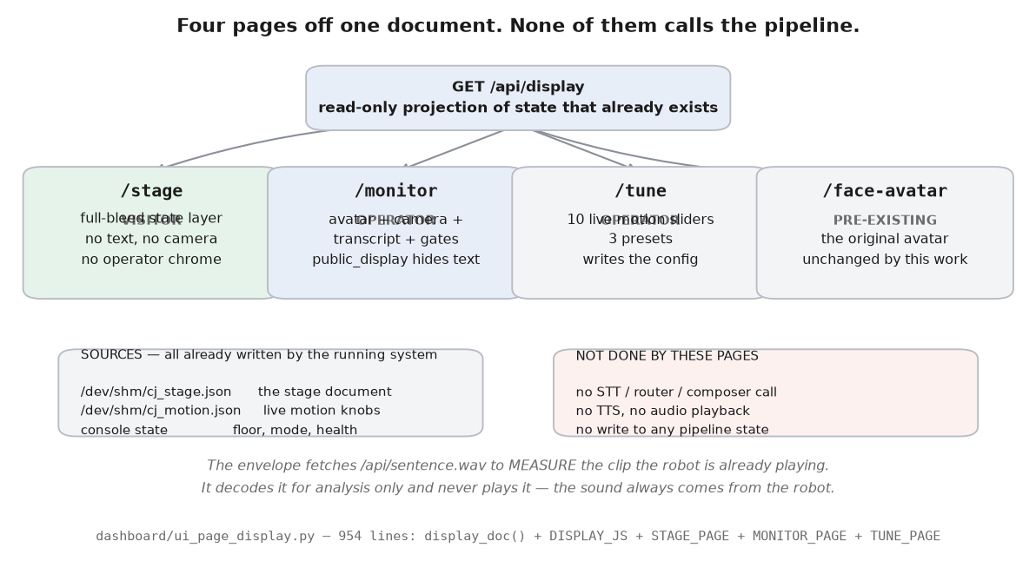
Figure 1 — Four pages served from one read-only document. /face-avatar predates this work and is unchanged.

2. Where everything lives
Path | What it is
dashboard/ui_page_display.py | 954 lines. The whole feature: display_doc(), the shared DISPLAY_JS, and the three page bodies STAGE_PAGE, MONITOR_PAGE and TUNE_PAGE.
dashboard/ui_routes.py:189-201 | Where the four routes are dispatched.
/dev/shm/cj_stage.json | STAGE_DOC — the per-turn pipeline stage document the robot writes.
/dev/shm/cj_speaking.json | SPEAKING — the caption feed, including wav and play_ts.
config/avatar_motion.json | The two browser-side knobs (lipsync_gain, avatar_offset) come from here via /dev/shm/cj_motion.json. Covered in ~/avatar_notes.docx.
dashboard/assets/portrait.* | Optional still or loop behind the state layer. NOT PRESENT on either machine — /assets/portrait returns 404, verified live. The state layer alone is therefore what will actually be shown, and that is the designed case, not a degraded one. The backdrop path has never run.

There is no separate CSS, JS or template file. The pages are Python string constants served directly, which is deliberate: the dashboard is stdlib-only on the system python3 and has no build step, no bundler and no node_modules. A display that needed a build would not survive a venue.

3. The document both views read
One endpoint, GET /api/display. It is a projection of state that already exists — it computes a state name and trims the fields, and that is all.
dashboard/ui_page_display.py:191 — display_doc(public=False, console=None)
"""Everything /stage and /monitor need, and nothing else.
~1-3 KB against /api/state's 11.7 KB, because a wall display polling for
four hours should not pull the whole maintenance document to read six
fields."""
Measured live on 2026-09-14: the operator document is 1,464 bytes and the public one 526 bytes. Across the 101-sample soak the document ranged 1,405–1,939 bytes, so the docstring's 1–3 KB is accurate in practice, not just in intent.

The six robot states
_robot_state() (ui_page_display.py:75) returns exactly one of six names. The page renders four of them as visual states; down and muted are handled separately.
State | Decided by
down | health.supervaise is False — the voice app is not running. Checked first, before anything else.
speaking | a speaking document that is not done and has at least one spoken sentence. since = play_ts, falling back to ts.
listening | the transcribe step is active, the stage document is under 60 s old, and no question has landed yet for this turn.
thinking | the newest user turn is newer than both the speaking document and the newest CJ turn. detail names the last active step of transcribe / route / compose / fidelity.
muted | /dev/shm/cj_muted exists and none of the above applied.
idle | everything else.

Note the ordering: muted is tested AFTER speaking, listening and thinking. A muted robot that is still finishing a sentence reads as speaking, which is correct — it is still speaking.
All six have a colour in the state layer's palette, not four:
State | RGB | Glow
idle | 146, 112, 216 (violet) | 0.42
listening | 72, 190, 210 (cyan) | 0.56
thinking | 236, 166, 74 (amber) | 0.56
speaking | 246, 198, 110 (gold) | 0.78
muted | 120, 120, 130 (grey) | 0.26
down | 120, 120, 130 (grey) | 0.26

muted and down are the SAME colour and the same glow. On the screen they are indistinguishable — which is the same problem the physical robot has, now reproduced on the display. If the screen goes dim grey you cannot tell from it alone whether the mic is muted or the voice app has died; check /maintain for the mute button and /console for a stale row.
An unrecognised state name falls back to idle (PAL[st] || PAL.idle), so a future state added to the robot without a colour here degrades to violet rather than to a blank screen.

What public_display actually strips
Verified live by fetching both forms:
Field | operator (default) | public_display=1
turns | present — q, a, raw, gates, latency_s, ts | ABSENT (0 turns returned)
state_detail | present — e.g. "microphone muted" | absent
muted | present | absent
health | {"supervaise": true} | absent
wake_armed | present | absent
state, speaking, portrait, motion, robot, mode, profile, camera, online | present | present
document size | 1,464 bytes | 526 bytes

So the flag does what it claims. The raw transcript, the gate flags, the latency and every error state are removed for a screen a visitor can see.

A caveat the operator should know
None of /stage, /monitor, /tune or /api/display requires the console key.
Verified live: all four return HTTP 200 with no key, and the default /api/display (no public_display parameter) includes the full transcript, the mute state and the health flag. Anyone who can reach port 8080 on the robot can read what visitors have said and what the robot answered.
Two things limit this, and one does not:
- Limited by: The installation runs on a closed travel router, not the venue network. That is the real mitigation.
- Limited by: Every write is still key-gated. POST /api/motion returns 403 without a key, verified live, and so does GET /api/motion. A visitor who loads /tune sees the message “bad key — open this page as /tune?key=…” and can change nothing.
- Not limited by: This is not the same class of defect as the GET /api/lease hole fixed in d45bae2 — that one MUTATED state on an unauthenticated GET. These routes only read. But reading a transcript is still a disclosure, and it is unauthenticated.
Recommendation: serve the visitor screen as /stage, which carries no text at all, and open /monitor only on the operator's own device. If the venue insists on the robots joining a house network, this should be revisited before the event.

4. The state layer — the whole product for /stage
A visitor must tell idle from listening from thinking from speaking with no labels and no text, at two metres, possibly colour-blind, possibly glancing for half a second. So the four ACTIVE states are carried on three independent channels rather than on colour alone. (muted and down share a sixth, dim grey appearance and carry no motion of their own beyond the breath.)
State | Colour | Motion character | Brightness
idle | deep indigo / violet | slow breath only | dim
listening | cool cyan | breath + a ring expanding outward | medium
thinking | warm amber | breath + an arc orbiting | medium
speaking | warm gold | breath + the envelope of the voice | bright

Breathing runs in all four, including speaking, and never stops. That is a requirement, not a detail: a portrait that stops moving reads as a crashed screen, which is the exact failure this view exists to avoid.
dashboard/ui_page_display.py:317
// BREATHING - every state, always. ~0.22 Hz, and it is never gated.
const breath = 1 + 0.055*Math.sin(t*2*Math.PI*0.22) + 0.014*Math.sin(t*2*Math.PI*0.37);
Worth being explicit about an asymmetry here, because it surprises people: the SCREEN keeps breathing while the microphone is muted, but the ROBOT'S HEAD stops. The head going still is how a robot with no indicator lights says it is muted (see ~/avatar_notes.docx section 5). The screen has a colour to say it with instead, so it keeps moving — a frozen screen would read as a crash.
The canvas breath is 0.22 Hz, which is 13.2 cycles per minute, and it is a plain fixed-frequency sine. It stays at 13.2 cpm for as long as the page is open. The robot's own breath does NOT — see ~/avatar_notes.docx section 4, which is the one defect worth reading before the event.
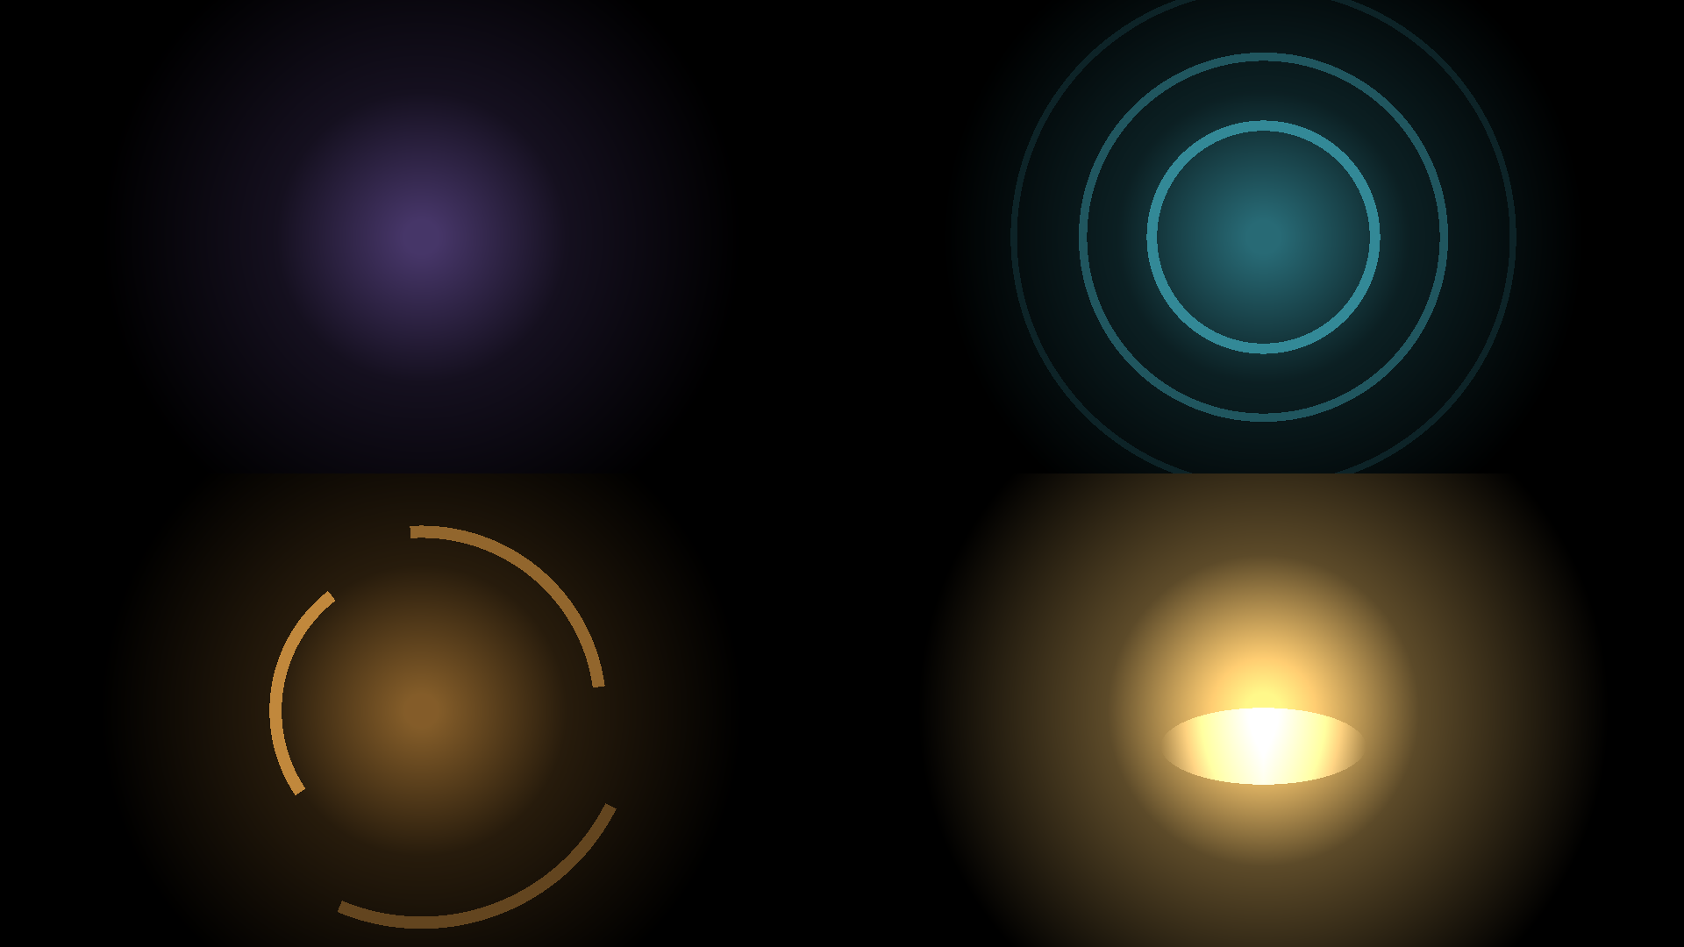
Figure 2 — The four states, rendered headlessly with the same maths as the browser. Clockwise from top left: idle, listening, thinking, speaking.
The palette was tuned against a measurement, not by eye alone. The four states were rendered, blurred and downscaled to approximate what the eye pulls out at a glance, and every pair was compared:
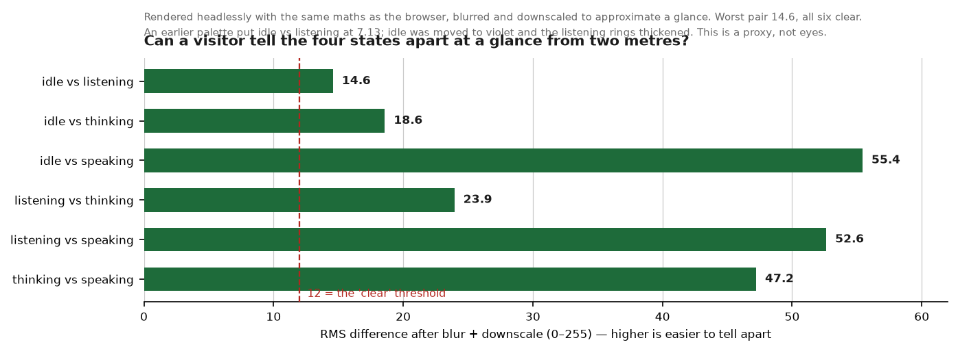
Figure 3 — Pairwise separation. Worst pair 14.6, all six above the 12 threshold.
Two earlier attempts failed this test and were thrown away. The first put idle at a mean luminance of 5.4, which read as a screen that had switched off. The second fixed the brightness but left idle and listening at 7.13 — too close to call apart. Moving idle to violet and thickening the listening rings brought the worst pair to 14.6.
This is a proxy for eyes, not a substitute. It measures that the states are DIFFERENT, not that they are READABLE — that a cyan ring means listening is a convention a visitor has to pick up, and nothing here measures whether they do. UNKNOWN until someone watches a real visitor.

5. The envelope, and the bug that nearly shipped
The state layer's speaking state is driven by the actual loudness of the sentence being spoken. The browser fetches the same WAV the robot is playing from /api/sentence.wav, decodes it, and reduces it to a 60 Hz RMS frame array. No audio is played in the browser — the sound always comes from the robot.
The hard part is not the analysis. It is knowing WHEN the sound started.
The first version started animating the moment a new WAV name appeared in the document. That is wrong, and it was wrong by a lot: the name appears when synthesis finishes, and playback starts later. Caught in a live turn test — the mouth was moving 7.1 seconds before any sound.
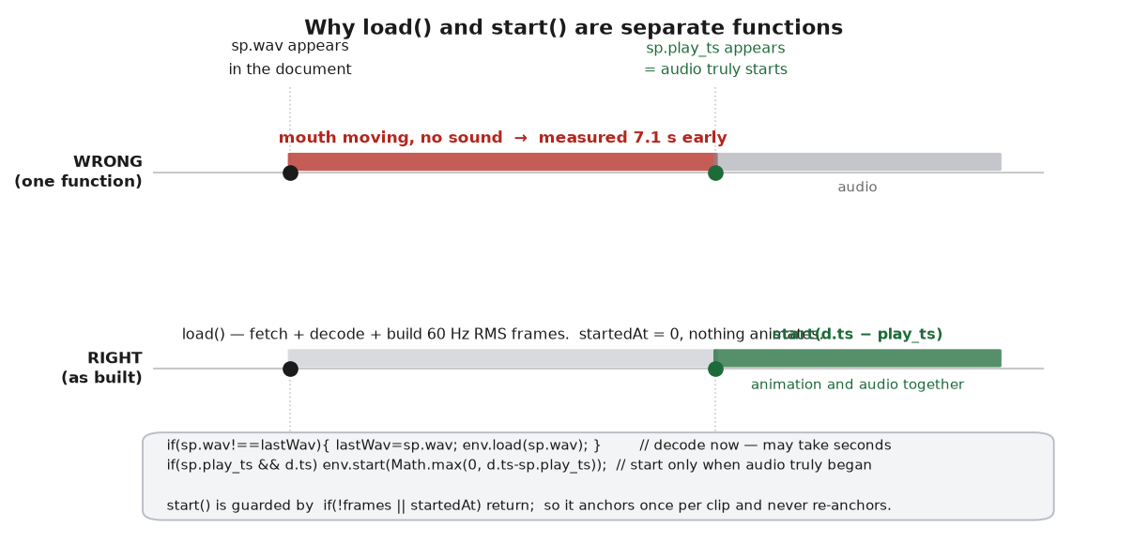
Figure 4 — Why load() and start() are two functions. Measured on a live turn, not estimated.
dashboard/ui_page_display.py — the anchor
if(sp.wav!==lastWav){ lastWav=sp.wav; env.load(sp.wav); } // decode now
if(sp.play_ts && d.ts) env.start(Math.max(0, d.ts-sp.play_ts)); // start on real audio
function start(elapsed){
if(!frames || startedAt) return; // anchor once per clip, never re-anchor
startedAt=performance.now()-Math.max(0,(elapsed||0)*1000);
}
play_ts is the moment audio truly began, on the robot's clock (app/speech_streaming.py:119). The dashboard runs on the same machine as the robot, so doc.ts and play_ts share a clock and the elapsed time is real, not estimated. Before play_ts appears the envelope stays silent rather than running ahead of the voice.
The remaining error is the speaker path, which differs between the internal speaker and an external one. That is not hardcoded — it is the avatar_offset knob, exposed as a slider. See ~/avatar_notes.docx section 6; the measured internal-route figure is 348 ms and it is a starting point, not the answer.

6. Resilience — what happens when things break
A wall display has no keyboard and nobody watching it. Every failure mode had to resolve itself.
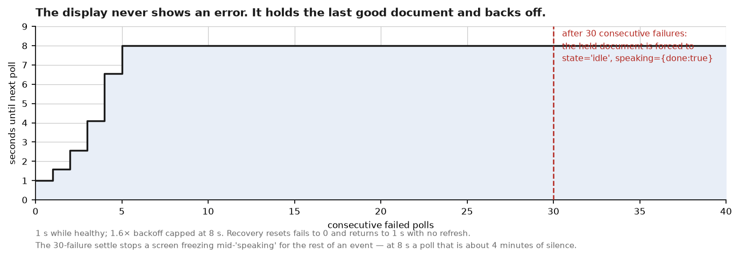
Figure 5 — The polling backoff and the 30-failure settle.
Failure | What the page does
a poll fails | Holds the last good document and renders it unchanged. It never draws an error — a visitor must never see a stack trace or a red banner.
polls keep failing | Backs off 1.6x per failure, capped at 8 s, so a dead backend is not hammered.
31 consecutive failures | Forces the held document to state='idle' and speaking={done:true}. Without this a screen would freeze mid-'speaking' for the rest of the event. Under the backoff that is 231 s of real time, not 30 s — see below.
the backend comes back | fails resets to 0 and polling returns to 1 s. No refresh, no operator action.
the screen tries to sleep | keepAwake re-arms a wake lock; it also re-acquires on visibilitychange, because a tab that is backgrounded loses the lock silently.
the page itself wedges | selfHeal watches for the render loop stalling and reloads the page.

keepAwake and selfHeal behaviour is read from the source. Whether a wake lock actually holds a given venue screen awake for four hours is UNKNOWN — it depends on the browser and the OS power policy of whatever machine drives the screen, and that machine has not been chosen.

Two defects in this machinery, found while writing this document
Neither is fixed. Both are logged here rather than smoothed over.
1. The settle comment is wrong by a factor of eight.
dashboard/ui_page_display.py — the comment says 30 s; the code counts 31 FAILURES
// hold the last good document; after ~30 s with no backend, settle to
// idle rather than freeze on a stale "speaking"
if(fails>30 && last){ ... }
Summing the backoff, 31 consecutive failures take 231 seconds — 3.8 minutes, not 30 seconds. So a screen can hold a stale 'speaking' state for nearly four minutes before it settles. That is still far better than freezing for the rest of the event, and it is not urgent, but the comment should not be trusted as written.
This is the same pattern as the voice_vad docstring swept in e4ff26d — a comment describing behaviour the code does not have. It is a NEW instance, in code written the same week, which suggests the sweep should be a habit rather than a one-off.
2. A render error is counted as a network failure.
dashboard/ui_page_display.py — Feed()
try{
const r=await fetch(...); if(!r.ok) throw new Error('http '+r.status);
const d=await r.json();
last=d; fails=0; onDoc(d); if(onHealth) onHealth(true,0); // <- onDoc INSIDE the try
}catch(e){ fails++; ... }
onDoc(d) is the page's own render callback and it runs inside the try. If rendering throws — a bad field, an undefined turn, anything — the catch treats it as a failed poll and backs off. A rendering bug would therefore present as a backend outage, and would back off to one poll every 8 s while the backend was perfectly healthy. Moving onDoc(d) outside the try would separate the two.

7. What is verified, and what is not
Claim | Status | How
Routes serve 200 and are unauthenticated | VERIFIED | curl against the live dashboard, 2026-09-14
public_display strips turns/health/muted/detail | VERIFIED | both forms fetched and compared live
Document is 1-3 KB | VERIFIED | 1,464 B operator / 526 B public; 1,405-1,939 B over 101 soak samples
The four states are distinguishable at a glance | MEASURED, PROXY | headless render + blur; worst pair 14.6
Envelope anchors to real audio start | VERIFIED | live turn test; the 7.1 s error is what found it
/stage and /monitor return 200 for 4 h | VERIFIED | 101/101 polls returned 200 during the 99-minute soak
Render cost is negligible | VERIFIED | 0.06-0.3 ms per document across the soak
Dashboard memory is stable | VERIFIED | 47 -> 50 MB over 99 minutes, max 51 MB
No pipeline call is added | VERIFIED | read the handler; it only reads files and console state
A visitor understands what the states MEAN | UNKNOWN | needs a real visitor; never tested
A wake lock survives 4 h on the venue screen | UNKNOWN | the screen and its OS are not chosen yet
Behaviour on a real LiveAvatar session | UNKNOWN | needs a live paid session; cannot run headless
Legibility in a bright hall | UNKNOWN | depends on the panel and the room lighting
The pages render correctly in a real browser | UNKNOWN | nothing in the repo records a live render; no screenshot, no browser test
decodeAudioData succeeds on the served WAVs | UNKNOWN | the envelope silently falls back if it does not; never observed in a browser
The backdrop/portrait path works | UNKNOWN | no portrait asset exists; /assets/portrait is a live 404

The bottom block is the honest gap, and it is larger than it looks: there is NO automated test anywhere that touches this feature. Nothing under tests/ references display_doc, /api/display, STAGE_PAGE, MONITOR_PAGE or _robot_state — verified by grep. Every claim above marked VERIFIED was verified by hand this session, which means it is a snapshot, not a regression guard.
The cheapest thing that would change that: a test that calls display_doc(public=True) and display_doc(public=False) against fixture files and asserts the public form contains no turns, no health and no state_detail. That is the property that protects a visitor from reading the transcript, and right now nothing enforces it.

8. Operating them at the venue

The URLs
Replace the key if it has been changed. Both robots serve the same pages; the robot named in the host is the one whose state you see.
alpha (reachy-cjap, the authority)
visitor screen http://reachy-cjap.local:8080/stage
operator view http://reachy-cjap.local:8080/monitor
visitor-safe http://reachy-cjap.local:8080/monitor?public_display=1
motion sliders http://reachy-cjap.local:8080/tune?key=cjap
the raw document http://reachy-cjap.local:8080/api/display
beta (reachy-2)
visitor screen http://reachy-2.local:8080/stage
operator view http://reachy-2.local:8080/monitor
motion sliders http://reachy-2.local:8080/tune?key=cjap
If .local names do not resolve on the venue network, use the addresses:
alpha 192.168.88.9 beta 192.168.88.10

Setting up the visitor screen
- Open /stage on the screen's own browser and put it full screen (F11).
- Check the head is breathing. If the state layer is completely still, the mic is muted — that is deliberate, not a fault. See ~/avatar_notes.docx section 5.
- Leave it. It recovers from a dropped network on its own and needs no refresh.
- Do NOT put /monitor on a screen the public can see unless you add ?public_display=1. Without the flag it shows the raw transcript.

If the screen looks wrong
Symptom | First thing to check
Screen is dark / looks off | That may be the idle state, which is deliberately dim. Wave at the robot: it should go cyan within a second or two.
Everything frozen | Has it been dark for more than ~30 s? The page settles to idle after 30 failed polls, so a frozen non-idle screen means the page itself is stuck — reload it.
Mouth moves but no sound | Audio route, not the display. The internal speaker is ~5 W and inaudible in a hall.
Mouth out of sync with sound | /tune?key=cjap → the response delay slider. Start at the measured 348 ms and trim by eye.
Transcript visible to visitors | You opened /monitor without ?public_display=1.

Companion documents: ~/avatar_notes.docx (the head motion and the tuning panel), ~/system_reference.docx (the whole system), docs/EVENT_RUNBOOK.md (venue procedure).

