System Notes — CJAP two-robot installation
Full technical documentation, written from the files on disk and the running machines.

Repository | ~/Supervaise-Reachy-Mini-Project-main · github.com/Supervaise-Inc/CJAP
Branch / HEAD | feat/operator-console · 2843e5b (pushed to origin)
Machines read | alpha = reachy-cjap 192.168.88.9 · beta = reachy-2 192.168.88.10
Written | 14 September 2026
Method | Read-only. No code, config, or service was changed; nothing was restarted.

How to read this document
Every statement here was checked against a file or a running process. Where the code and the documentation disagree, the disagreement is marked inline and repeated in Appendix A. Where something could not be verified under a read-only brief, it is marked UNKNOWN and repeated in Appendix B with what would be needed to resolve it. Nothing has been filled in from memory, from the repository's own documentation, or from what the system was specified to do.
Two consequences of the read-only brief are worth stating up front, because they account for most of the UNKNOWNs:
- Timing. The systemd journal is volatile and was wiped by the 13 September reboot. It now holds a single turn. Historical latency measurements are gone.
- Live measurement. The Anthropic account is out of credit (verified: HTTP 400, request_id req_011Cf1BpkffT5KtQgQ2Q4CG9). No composed turn can be produced without spending money and making the robot speak, both of which are outside this brief.

Contents
1. Map — every directory and file that matters
2. The pipeline, stage by stage
3. Config — every layer, every setting, every conflict
4. The corpus — question to topics to documents to answer
5. The two robots — roles, floor lease, console
6. The safety gates
7. What changed — built from git
8. For someone alone at a venue
A. Appendix A — every code-versus-documentation disagreement
B. Appendix B — everything marked UNKNOWN

Figures
Figure 1 — Directory tree, annotated
Figure 2 — Pipeline flow, mic to speaker
Figure 3 — Two-robot topology
Figure 4 — Config resolution stack, conflicts marked
Figure 5 — Corpus flow
Figure 6 — Mode and floor state machine
Figure 7 — Architecture before and after

1. Map — every directory and file that matters
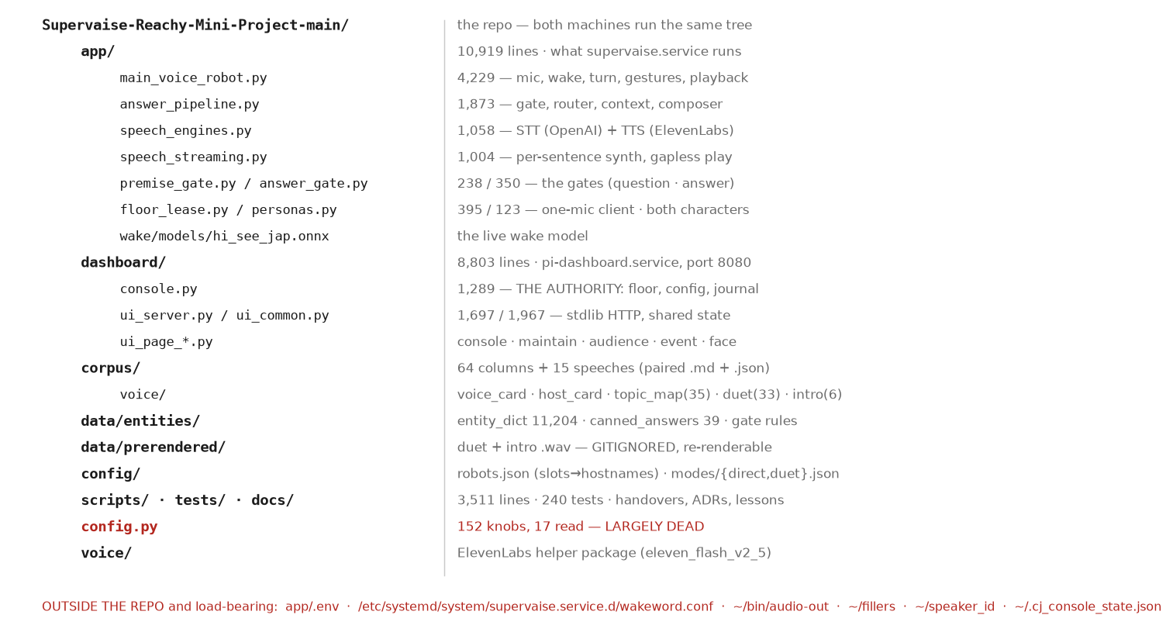
Figure 1 — Directory tree. Red marks code that is present but not used. The footer lists what is load-bearing and not in the repository.
Safe to edit at a venue?
The column answers one question: if an operator changed this file during an event, what happens. “Hot” means the running process picks it up with no restart. “Restart” means supervaise.service must be restarted, which costs the robot about 30–40 seconds of silence. “No” means do not touch it with an audience in the room.

app/ — the runtime
File | What it does | Read by | Venue-safe
main_voice_robot.py | Entry point. Boot, wake loop, capture, turn dispatch, gestures, audio routing, playback, barge-in, floor-lease callbacks. 4,229 lines. | systemd (ExecStart) | No — restart
answer_pipeline.py | Corpus artifacts, input gate, Haiku router, context assembly, Sonnet composer, fidelity check, per-sentence fact audit. 1,873 lines. | main_voice_robot, speech_streaming | No — restart
speech_engines.py | OpenAI STT; ElevenLabs TTS with OpenAI fallback; speed, delivery and name-pin settings. 1,058 lines. | main_voice_robot, speech_streaming, render scripts | No — restart
speech_streaming.py | SentenceSpeaker: per-sentence synthesis one ahead, gapless playback, output gates, caption feeds. 1,004 lines. | main_voice_robot | No — restart
speech_tempo.py | WSOLA tempo normaliser toward a session average. 229 lines. | speech_streaming | No — restart
premise_gate.py | The gate on the QUESTION. 238 lines. | main_voice_robot._answer_question | No — restart (but CJ_PREMISE_GATE is hot from the console)
answer_gate.py | Forbidden patterns, year gate, full-date gate, unverified titles, check_curated(). 350 lines. | speech_streaming, render scripts | No — restart
answer_canned.py | Curated fast path. 205 lines. | main_voice_robot, speech_streaming | No — restart
answer_filler.py | Question-relevant filler while composing. 139 lines. | main_voice_robot | No — restart
text_entities.py | Dictionary NER correction, transcript and TTS passes. 368 lines. | main_voice_robot, render scripts | No — restart
text_language_gate.py | Filipino/English transcript gate. 152 lines. | main_voice_robot | No — restart
voice_identity.py | Speaker embedding and voice lock. 226 lines. | main_voice_robot | No — restart
voice_vad.py | Silero VAD measurement. LOG-ONLY. 92 lines. | main_voice_robot | No — restart
floor_lease.py | LeaseClient: 1 Hz poll, 3 s lease, fail closed. 395 lines. | main_voice_robot | No — restart
personas.py | Both characters loaded at boot, one active. 123 lines. | main_voice_robot, floor_lease | No — restart
wake_word.py | openWakeWord ONNX detector. 97 lines. | main_voice_robot | No — restart
usage_meter.py | API spend tally. 141 lines. | answer_pipeline, speech_engines | No — restart
wake/models/hi_see_jap.onnx | The live wake model. | wake_word (path from the drop-in) | No
app/.env | Secrets and 10 knobs. NOT IN GIT. | answer_pipeline (load_dotenv override=True) | No — restart
.venv/ | Python 3.13 environment. | systemd | No

DISAGREEMENT app/answer_pipeline.py:1815 prints an error message pointing the reader at app/legacy/dashboard_streamlit.py. That directory was removed on 2026-09-02 (955223e). The message survives; the file does not.
DEAD app/answer_pipeline.py lines 335–336, 339, 1484–1485, 1538–1542, 1850–1852 implement a faster-whisper + Piper TTS path. It is reachable only through that module's own main() CLI, which supervaise.service never runs. Dead for the installation.

dashboard/ — the web interface and the authority
File | What it does | Read by | Venue-safe
console.py | THE AUTHORITY. Floor lease, mode/profile, role assignment, config resolution, journal. 1,289 lines. | ui_routes, ui_page_console | No — restart
ui_server.py | Stdlib HTTP server on :8080, HTTPS on :8443. 1,697 lines. | systemd (ExecStart) | No — restart
ui_common.py | Shared state, paths, /dev/shm relays, control actions, key gate. 1,967 lines. | every ui_page_* | No — restart
ui_routes.py | handle_get / handle_post dispatch and re-export facade. 337 lines. | ui_server | No — restart
ui_page_console.py | /console page. 293 lines. | ui_routes | No — restart
ui_page_maintenance.py | /maintain page. 1,294 lines. | ui_routes | No — restart
ui_page_audience.py | /audience page. 426 lines. | ui_routes | No — restart
ui_page_event.py | /event emcee buttons. 106 lines. | ui_routes | No — restart
ui_page_face.py | /face and /face-avatar, LiveAvatar, camera MJPEG. 925 lines. | ui_routes | No — restart
mic_meter.py | Live mic meter from the XVF3800 stereo capture. 322 lines. | ui_common | No — restart
cam_stream.py | GStreamer JPEG capture. 95 lines. | ui_common | No — restart
say_text_helper.py | Synthesize typed text to wav via the app venv. 52 lines. | /api/say-text | No — restart
assets/, certs/ | LiveAvatar key and TLS certs. GIT-IGNORED. | ui_page_face, ui_server | No

dashboard/console.py exists on BOTH machines. Only one is the authority: is_authority() (console.py:1275) compares config/robots.json authority.host against the local hostname. On beta the module is loaded and inert.

corpus/, data/, config/ — the data
Path | What it is | Written by | Venue-safe
corpus/columns/ (64 pairs) | Column prose + JSON sidecar. | scripts/generate_corpus_files.py | No
corpus/speeches/ (15 pairs) | Speech prose + JSON sidecar. | same | No
corpus/voice/voice_card.md | Persona contract sent to Sonnet. 16,219 chars. | by hand | No
corpus/voice/host_card.md | Host character. 2,845 chars. | by hand | No
corpus/voice/topic_map.json | 35-topic taxonomy the router picks from. | scripts/build_topic_map.py | No
corpus/voice/router_prompt.md | Router instructions. | by hand | No
corpus/voice/duet_script.json | 33 authored duet lines. | by hand | No
corpus/voice/intro_variants.json | 6 Host intros x 2 modes. | by hand | No
data/entities/entity_dict.json | 11,204 entries: 3,961 person, 3,706 event, 2,428 org, 1,091 case, 18 book. | scripts/build_entity_dict.py (NOT PRESENT — see Appendix A) | Hot (mtime reload)
data/entities/canned_answers.json | 39 curated entries. | by hand | Hot (mtime reload)
data/entities/answer_gate_rules.json | Forbidden-pattern and expected-fact rules. | by hand | Hot (mtime reload)
data/entities/entity_overrides.json | Hand overlay on the dictionary. | by hand | Hot (mtime reload)
data/entities/pronunciation_lexicon.json | TTS pronunciation. | by hand / /maintain | Hot
data/prerendered/duet/*.wav | 33 duet clips. GIT-IGNORED. | scripts/render_duet.py | No
data/prerendered/intro/*.wav | 12 intro clips. GIT-IGNORED. | scripts/render_intro.py | No
config/robots.json | slots to hostnames, authority host/port/ip. | by hand | No — restart both
config/modes/direct.json | direct defaults + kiosk/event profiles. | by hand | Hot (console re-reads on mtime)
config/modes/duet.json | duet defaults + profiles. | by hand | Hot
config.py | 152 knobs at the repo root; 17 read by the runtime. | by hand | No — largely dead

Outside the repository — load-bearing
None of the following is in git. All of it affects behaviour.
Path | What it is | Written by | Venue-safe
/etc/systemd/system/supervaise.service.d/wakeword.conf | 50 Environment= lines: the real tuning. Root-owned. | by hand (sudo) | No — restart
app/.env | API keys + 10 knobs. | by hand, /maintain Guest tab | No — restart
~/bin/audio-out | Audio route switching (internal / dac / bt / ensure). | by hand | Yes — designed for it
~/bin/audio-volume, aplay-dual, xvf-ctl | Mixer, dual-sink playback, XVF3800 control. | by hand | Yes
~/tools/aec_ref_calib.py | Measures the AEC reference delay for a route. | by hand | Yes — read-only measurement
~/fillers, ~/fillers_ack, ~/fillers_bail | Pre-recorded filler clips. | by hand | No
~/speaker_id/ | Enrolled voice reference. | voice_identity | No
~/.cj_console_state.json | Floor, mode, profile, cjap_is, counters. | console._persist() | No
~/.cj_console_journal.jsonl | Append-only operator journal (~650 KB). | console._journal() | Read-only is safe
~/cj_usage.json | Lifetime API spend. | usage_meter | Read-only is safe
~/.voice_cache/ | ElevenLabs clip cache (500 MB cap). | voice/cache.py | No
/dev/shm/cj_*.json, *.wav | Live relays: stage, transcript, speaking, wake/stop meters, last answer. | main_voice_robot, dashboard | No
~/pi_dashboard | Symlink to dashboard/. | deploy script | No

2. The pipeline, stage by stage
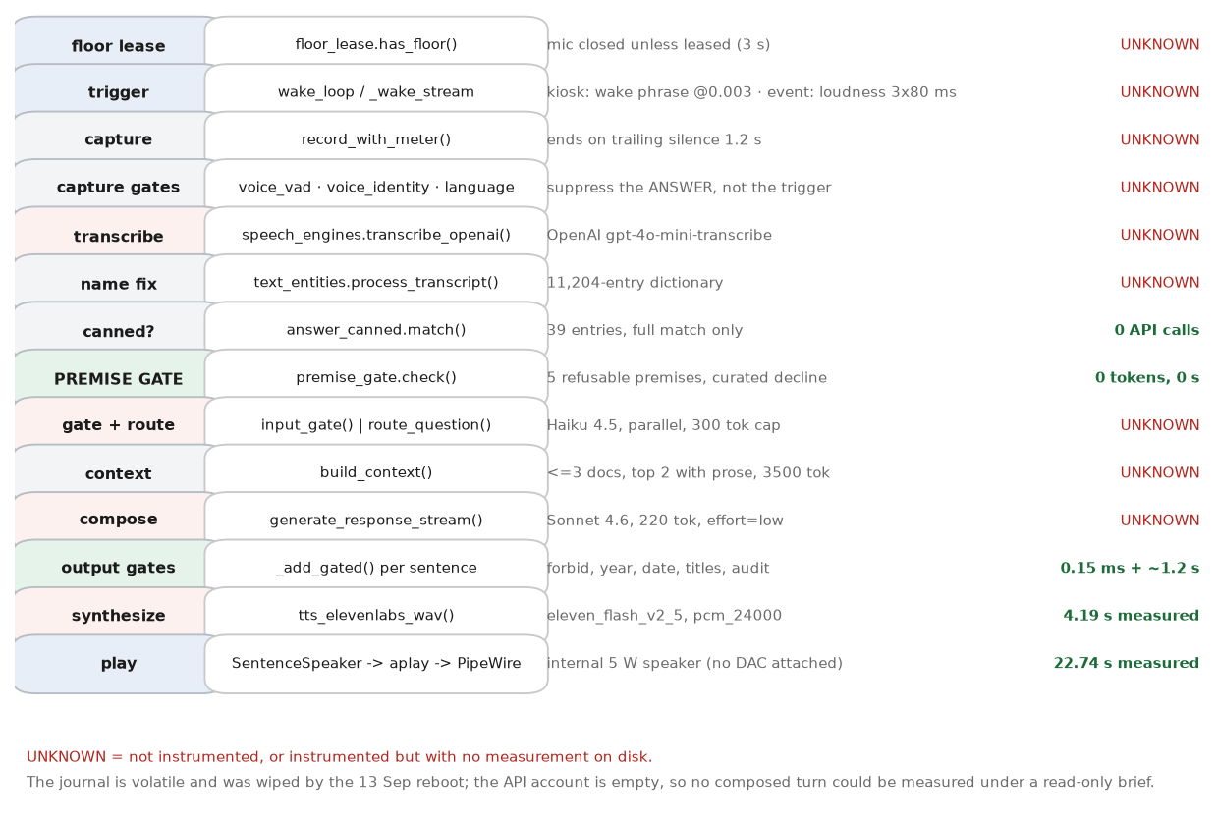
Figure 2 — Mic to speaker. Green marks a stage with a measured cost; red marks one that could not be measured read-only.
Only two stages have a cost measured on this machine, both from a single turn on 13 September at 13:26 BST that took the premise-decline path:
journalctl -u supervaise.service, 13 Sep 2026 13:27:05
[trace] path=premise | stt_s=0.00s | topic=canned:current_office |
synth_s=4.19s | play_s=22.74s | words=50 | interrupted=False
UNKNOWN Every composer-path timing is UNKNOWN. _trace_turn (main_voice_robot.py:605) prints one line per turn to stdout, which systemd captures into a volatile journal. The journal now starts at 2026-09-13 10:01 and contains one [trace] line. speech_streaming.stream_turn also computes first_audio_s and compose_s (speech_streaming.py:995-997) but they are returned to the caller, not printed as a trace field.

The happy path

1. Floor lease
app/floor_lease.py:218 has_floor()
In / out. IN: nothing (polled state). OUT: boolean.
Service and settings. No model. HTTP POST /api/lease to the authority every 1.0 s, timeout 0.8 s, lease TTL capped at 3.0 s (floor_lease.py:47-49).
Measured cost. UNKNOWN — not instrumented. Measured round trip on 2026-09-12 was 0.19 s per the build notes; not re-measured here.
On failure. Fails closed. Any exception, timeout or non-grant leaves has_floor() False and the microphone shut. Nothing tells the visitor.
Depends on. The authority being reachable. If config/robots.json authority.ip is empty it resolves {host}.local, which needs mDNS — blocked on many guest networks.

2. Trigger
app/main_voice_robot.py:3546 _wake_stream / 3747 wake_loop
In / out. IN: 80 ms audio frames. OUT: a decision to record.
Service and settings. direct-kiosk: openWakeWord ONNX (app/wake/models/hi_see_jap.onnx) at threshold 0.003. direct-event: wake word OFF; three consecutive 80 ms frames above the resolved loudness threshold.
Measured cost. UNKNOWN
On failure. A false wake starts a capture that the post-capture gates may discard. A missed wake is silent — the visitor simply gets no response.
Depends on. The ONNX model file at the path in the drop-in. The mic array (ReSpeaker/XVF3800).

3. Capture
app/main_voice_robot.py:2057 record_with_meter()
In / out. IN: microphone. OUT: wav on /dev/shm.
Service and settings. Ends after CJ_MIC_TRAILING_SILENCE_S (1.2 s resolved). RECORD_SECONDS_MAX is 30 s (answer_pipeline.py:343).
Measured cost. UNKNOWN
On failure. UNKNOWN — no failure path was traced end to end read-only.
Depends on. ALSA route; /dev/shm writable.

4. Post-capture gates
voice_vad.py · voice_identity.py · text_language_gate.py
In / out. IN: the captured wav / the transcript. OUT: keep or discard.
Service and settings. voice_identity embeds with WeSpeaker CAM++ (ONNX), cosine against the enrolled reference, threshold CJ_VOICE_LOCK_THRESHOLD=0.15 on alpha, 0.32 on beta. Embedding input capped at CJ_EMBED_MAX_S. voice_vad is LOG-ONLY.
Measured cost. UNKNOWN
On failure. These suppress the ANSWER, not the trigger: the recording has been made and the STT call already paid for by the time they run.
Depends on. ~/speaker_id/ reference; the ONNX embedder.

5. Transcribe
app/speech_engines.py:731 transcribe_openai()
In / out. IN: wav. OUT: text.
Service and settings. OpenAI, model from OPENAI_STT_MODEL = gpt-4o-mini-transcribe (drop-in). Code default is whisper-1 (speech_engines.py:129). Persona steering prompt CJ_STT_PROMPT plus an echo guard.
Measured cost. UNKNOWN
On failure. Network or API failure raises; main_voice_robot catches it and speaks the offline notice (say_offline, main_voice_robot.py:112) or the apology (_say_apology, :155).
Depends on. Internet. OPENAI_API_KEY in app/.env.

6. Name correction
app/text_entities.py process_transcript()
In / out. IN: raw transcript. OUT: corrected transcript + a correction log line.
Service and settings. Dictionary of 11,204 entries plus a hand overlay; fuzzy and phonetic matching. Enabled by CJ_POSTPROC_ENABLED=1 (drop-in).
Measured cost. UNKNOWN
On failure. Fails open — the module is wrapped in try/except at the call site and the raw transcript is used.
Depends on. data/entities/entity_dict.json (2.8 MB) and entity_overrides.json.

7. Canned fast path
app/answer_canned.py:123 match()
In / out. IN: normalized question. OUT: a curated answer or None.
Service and settings. re.fullmatch against each entry's patterns — deliberately conservative. In event mode, event_* entries also accept paraphrases (gist groups, difflib ratio >= 0.75).
Measured cost. 0 API calls. Synthesis is cached, so a repeat is near-instant.
On failure. Fails open (returns None) on any error.
Depends on. data/entities/canned_answers.json; CJ_CANNED_ENABLED=1 (drop-in).

8. Premise gate
app/premise_gate.py:179 check()
In / out. IN: question text. OUT: {refuse, category, pool, reason, matched}.
Service and settings. No model. Pure regex over five categories. Corpus horizon computed from the newest year in any corpus sidecar = 2026.
Measured cost. 0 tokens, no measurable time (regex over one string).
On failure. Wrapped so that any exception returns refuse=False — a bug here can never silence a turn. If the decline pool is missing it logs and falls through to the composer.
Depends on. data/entities/canned_answers.json for the premise_* pools; CJ_CANNED_ENABLED.

9. Input gate + router
app/answer_pipeline.py:687 INPUT_GATE_SYSTEM · :610 route_question()
In / out. IN: question (+ history). OUT: scope verdict; primary topic, secondary topics, confidence.
Service and settings. claude-haiku-4-5-20251001, max 300 output tokens (CJ_ROUTER_MAX_TOKENS=160 in the drop-in — see Appendix A). Run in PARALLEL in the streaming path (speech_streaming.py:741-752).
Measured cost. UNKNOWN
On failure. A router exception is raised to the caller. A truncated JSON parse falls back to rule_of_law / low confidence. A 30 s join timeout falls back to force_meta_routing().
Depends on. Internet; ANTHROPIC_API_KEY; corpus/voice/topic_map.json.

10. Context
app/answer_pipeline.py:956 build_context()
In / out. IN: routing + corpus artifacts. OUT: one grounding string; also stored in LAST_CONTEXT_TEXT.
Service and settings. No model. Selects at most 3 documents (_select_source_doc_ids max_docs=3, :976); the first CONTEXT_BODY_DOCS=2 carry full prose, the rest only their JSON sidecar. Budget CJ_CONTEXT_TOKEN_BUDGET=3500 (drop-in); code default 12000 (:833).
Measured cost. UNKNOWN
On failure. Over budget it demotes then drops the lowest-priority document. Zero documents is a valid fallback.
Depends on. corpus/ on disk.

11. Compose
app/answer_pipeline.py:1111 generate_response_stream()
In / out. IN: question, routing, context, history. OUT: a token stream.
Service and settings. claude-sonnet-4-6, max 220 output tokens (CJ_COMPOSER_MAX_TOKENS, app/.env), effort=low (CJ_COMPOSER_EFFORT), voice card cached with a 1-hour ephemeral TTL (extended-cache-ttl-2025-04-11 beta header).
Measured cost. UNKNOWN
On failure. An API error propagates; main_voice_robot speaks the apology line. An answer cut mid-stream still records an aborted usage entry (:1185).
Depends on. Internet; ANTHROPIC_API_KEY; account credit — currently absent.

12. Output gates
app/speech_streaming.py:815 _add_gated()
In / out. IN: one composed sentence. OUT: queued for speech, or dropped.
Service and settings. Order: forbidden patterns (answer_gate.check_answer forbid_only) -> year gate -> full-date gate -> unverified titles (LOG ONLY) -> Haiku fact audit if _FACT_TRIGGER matches.
Measured cost. Deterministic gates: sub-millisecond (documented as ~0.15 ms in answer_gate.py's own header; not re-measured). Haiku audit: documented ~1.2 s, absorbed by the previous sentence's playback. UNKNOWN as measured here.
On failure. A tripped sentence is dropped and never synthesized. The audit fails OPEN on error or timeout (2.5 s).
Depends on. data/entities/answer_gate_rules.json; corpus for the year/date corpus set; internet for the audit.

13. Synthesize
app/speech_engines.py:613 tts_elevenlabs_wav()
In / out. IN: one sentence. OUT: a wav.
Service and settings. ElevenLabs model_id eleven_flash_v2_5, output pcm_24000, request timeout 10 s, 2 retries (voice/config.py:31,54-55). Cloned voice id from ELEVEN_VOICE_ID; Host from ELEVEN_HOST_VOICE_ID. Post-processing: 180 Hz high-pass, +3 dB at 3 kHz, target -16 LUFS.
Measured cost. 4.19 s for 50 words (measured, 13 Sep, includes the cache miss).
On failure. Every ElevenLabs call site fails open to the OpenAI TTS path (speech_engines.py:151).
Depends on. Internet; ELEVEN_API_KEY; ~/.voice_cache for hits.

14. Play
app/main_voice_robot.py:2658 _SentenceOut · :2878 speak()
In / out. IN: wav files in order. OUT: sound.
Service and settings. aplay -> ALSA pulse plugin -> PipeWire (user session, lingering enabled). Route from ~/bin/audio-out. Head gestures track the audio envelope; the stop-word listener runs throughout.
Measured cost. 22.74 s for 50 words (measured).
On failure. _playback_failed() runs `audio-out ensure` and retries, which drops a dead Bluetooth route back to the internal speaker.
Depends on. A working ALSA route. Currently the internal ~5 W speaker; no USB DAC attached.

The paths that are not the happy path
Path | Where it diverges | What happens | What it costs
Clip cache hit | speech_engines.tts_elevenlabs_wav() — voice/cache.py, ~/.voice_cache, 500 MB cap | The wav is read from disk; no ElevenLabs request. usage_meter records cached=True. | 0 API calls. Time UNKNOWN.
Canned answer | answer_canned.match() before the router | Whole curated answer spoken through the normal TTS path. No router, no composer. | 0 Anthropic calls.
Premise decline | premise_gate.check() before the router | One of 5 curated pools, 5 variants each, chosen at random. Stages are published as “declined — outside the record”. | 0 Anthropic calls. Verified 13 Sep: router 1176 / inference 355 unchanged across the turn.
Out-of-corpus deflection | input_gate scope == out_of_corpus (speech_streaming.py:757) | answer_canned.get('out_of_topic') is spoken; the router join and the composer are both skipped. | 1 Haiku gate call; 0 Sonnet.
Identity probe | input_gate scope == identity_probe | force_meta_routing() replaces the routing; the composer still runs. | UNKNOWN
Gate rejection (deterministic) | _add_gated: forbid / year / date | That sentence is dropped and never synthesized. The rest of the answer continues. Logged to gate_blocked. | Sub-millisecond.
Gate rejection (audit) | _add_gated: sentence_fact_audit | Non-opener: blocked before synthesis. Opener: queued first and audited concurrently — skipped if the verdict lands before playback starts, LOGGED ONLY if it does not. | ~1.2 s documented; UNKNOWN measured.
Composer timeout / API error | generate_response_stream raises | _say_apology() (main_voice_robot.py:155) speaks “I am sorry. I cannot reach my notes at the moment.” and the service continues. Added 2026-08-24 after a credit-exhaustion 400 killed the process on every follow-up. | This is the CURRENT state of the machine — the account has no credit.
Network loss at wake | internet_up() false (main_voice_robot.py:103) | ConnectionError raised deliberately; say_offline() plays NO_NET_WAV. | 0 API calls.
Network loss during STT | transcribe raises | Offline notice spoken; the stage panel shows transcribe pending/offline. | 0
Network loss during compose | stream raises mid-answer | main_voice_robot.py:3074 voices the offline notice. | Partial Sonnet tokens billed; recorded as aborted.
Lease lost mid-answer | console revokes / authority gone | The microphone closes. UNKNOWN whether an answer already playing is cut — not traced read-only. | —
Playback failure | _playback_failed() (main_voice_robot.py:1975) | Runs ~/bin/audio-out ensure and retries, dropping a dead Bluetooth route back to the internal speaker. | —
Answer cut by stop word | StopWord / StopListener | Playback stops; the composer stream is abandoned; usage_meter records an aborted call. | Partial billing, not reported by the API.

3. Config — every layer, every setting, every conflict
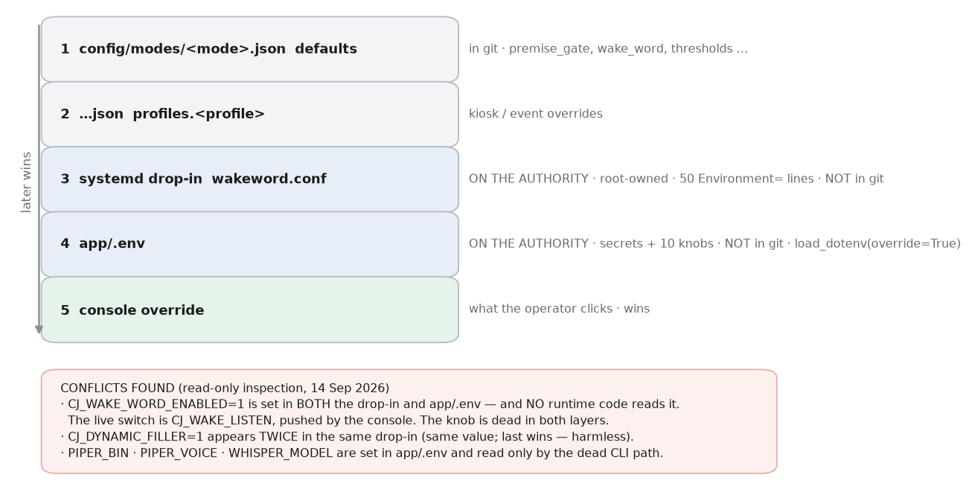
Figure 4 — The resolution stack. Conflicts found by inspection are listed in the box.

Where a setting can be set
# | Layer | File | In git? | Applies to
1 | Mode profile defaults | config/modes/<mode>.json → defaults | Yes | the 10 console settings
2 | Mode profile per-profile | …json → profiles.<kiosk|event> | Yes | same 10
3 | systemd drop-in | /etc/systemd/system/supervaise.service.d/*.conf | No | any environment variable
4 | app/.env | app/.env on the authority | No | any environment variable
5 | Console override | in-memory + ~/.cj_console_state.json | No | the same 10
— | Robot process env | os.environ, rewritten on every lease reply | n/a | what the robot actually reads

Two different orderings are in play and they are easy to confuse:
- The console's resolution. console.py ConfigSources.resolve() (dashboard/console.py:256) applies layers 1→5 in that order, later winning. It reads layers 3 and 4 from the files ON THE AUTHORITY MACHINE.
- The process's own environment. answer_pipeline.py:77 calls load_dotenv(env_path, override=True), so app/.env beats anything systemd put in the environment. This agrees with the console's ordering. (docs/lessons/LL-003 records the earlier bug when override was False.)
- The lease push. main_voice_robot._floor_settings() (main_voice_robot.py:3957) writes every key from the lease reply straight into os.environ. For the 10 console settings this beats everything else while the console is reachable. It never UNSETS a key — a key omitted from one reply keeps its previous value (the bug fixed by c502ecc for CJ_ALWAYS_LISTEN).

Every console setting: current effective value and every layer that defines it
Resolved read-only for mode=direct, profile=kiosk, no override, on alpha.
Setting | Env var | Effective | Winning layer | Also defined in
wake_word | CJ_WAKE_LISTEN | True | profile defaults | profiles.event = False
wake_threshold | CJ_WAKE_OWW_THRESHOLD | 0.003 | profile defaults | —
speech_threshold | CJ_MIC_RMS_FLOOR | 200 | profile defaults | profiles.event = 800
speech_threshold_mult | CJ_MIC_RMS_MULT | 2.5 | profile defaults | —
speech_threshold_cap | CJ_MIC_RMS_CAP | 1500 | profile defaults | profiles.event = 2500
silence_timeout_s | CJ_MIC_TRAILING_SILENCE_S | 1.2 | profile defaults | beta's OWN drop-in line 56 = 1.2 (inert while the console is up)
post_answer_window_s | CJ_LISTEN_IDLE_S | 25.0 | profile defaults | profiles.event = 0
host_intro | CJ_HOST_INTRO | True | profile defaults | —
premise_gate | CJ_PREMISE_GATE | True | profile defaults | duet.json defaults = True
dry_run | CJ_DRY_RUN | False | profile defaults | —

Layers 3 and 4 currently contribute NOTHING to these ten settings on alpha: none of the ten environment names appears in alpha's drop-in or in app/.env. The documented four-layer stack is real, but two of its layers are empty today. resolve() returns no errors.

Conflicts and dead settings found by inspection
DISAGREEMENT CJ_WAKE_WORD_ENABLED=1 is set in BOTH alpha's systemd drop-in and app/.env. No runtime module reads it. The only reader is config.py:662, which assigns config.WAKE_WORD_ENABLED — an attribute nothing in app/ or dashboard/ consults. The live switch is CJ_WAKE_LISTEN, written by the console. Setting CJ_WAKE_WORD_ENABLED has no effect anywhere.
DISAGREEMENT CJ_VOICE_LOCK_THRESHOLD is defined TWICE on beta: 0.32 in its own wakeword.conf (line 159) and 0.15 in zz-from-alpha.conf (line 235), which systemd loads later. 0.15 wins, so beta's own tuned value is dead. Alpha defines it once, at 0.15.
DISAGREEMENT CJ_DYNAMIC_FILLER=1 appears twice in the same drop-in on both machines. Same value, so the duplicate is harmless — but it is the same editing mistake that produced the live conflict above.
DEAD PIPER_BIN, PIPER_VOICE and WHISPER_MODEL are set in app/.env. They are read only by answer_pipeline's CLI main(), which the service never runs.
Machine divergence, drop-in vs drop-in
diff of `systemctl cat supervaise.service | grep ^Environment`, alpha vs beta, 14 Sep 2026
only on alpha: only on beta:
CJ_AEC_REF_DELAY_MS=444 CJ_MIC_TRAILING_SILENCE_S=1.2
CJ_AEC_REF_FEED=1 CJ_VOICE_LOCK_IDLE_S=10
CJ_AEC_REF_GAIN=1000 CJ_VOICE_LOCK_THRESHOLD=0.32 (overridden, see above)
CJ_LISTEN_DIRECTION=back
CJ_MAX_WORDS_EVENT=40
Consequences: beta has no AEC reference feed configured, does not park its beams at the robot's back, and has no event-mode word cap. Because beta normally plays the Host and speaks only pre-rendered audio, none of this is exercised today — but a role swap makes beta the composer, and these differences become live.

4. The corpus — question to topics to documents to answer
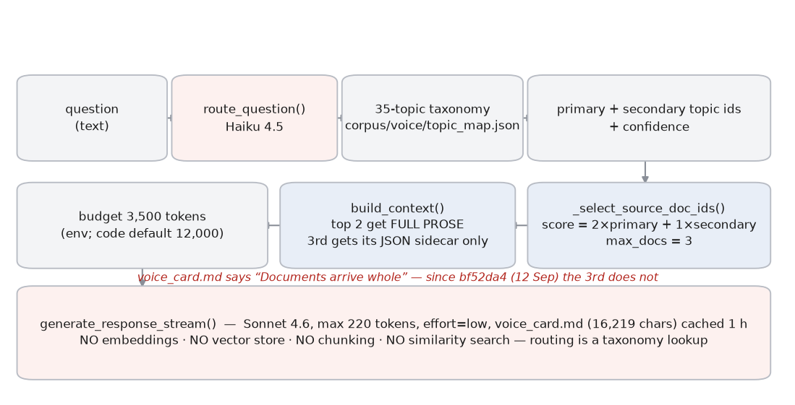
Figure 5 — Routing is a taxonomy lookup, not a search.

What is in it
Item | Count / size | Verified by
Columns | 64 paired .md + .json | find corpus/columns -name '*.md' | wc -l
Speeches | 15 paired .md + .json | same for speeches/
Topics in the taxonomy | 35 | CorpusArtifacts() → len(artifacts.topics)
Document year range | 2006 – 2026 | min/max of the year field across 79 sidecars
Voice card | 16,219 chars | [persona] log line at boot
Host card | 2,845 chars | same
Entity dictionary | 11,204 entries | json load of entity_dict.json
Canned answers | 39 entries | [canned] loaded 39 entries
Duet lines | 33 | duet_script.json
Intro variants | 6 × 2 modes = 12 clips | intro_variants.json

How a question becomes an answer
1. route_question() (answer_pipeline.py:610) sends the question and the 35-topic taxonomy to Haiku and gets back a primary topic, secondary topics and a confidence.
2. _select_source_doc_ids() (answer_pipeline.py:841) scores every document the routed topics claim and returns at most three:
app/answer_pipeline.py:866-869
score = 2 * (appearances in the primary topic's doc_ids)
+ 1 * (appearances in any secondary topic's doc_ids)
ranked = sorted(score.items(), key=lambda kv: (-kv[1], kv[0]))
return [did for did, _ in ranked[:max_docs]] # max_docs = 3
3. build_context() (:956) loads each of those documents. The first CONTEXT_BODY_DOCS carry their prose; the rest carry only their JSON sidecar:
app/answer_pipeline.py:983
body = artifacts.load_doc_body(did) if len(raws) < CONTEXT_BODY_DOCS else None
# CONTEXT_BODY_DOCS = int(os.environ.get("CJ_CONTEXT_BODY_DOCS", "2")) :895
4. The assembled block is <routed_topics> + <topic_data> + <source_documents>, trimmed to CJ_CONTEXT_TOKEN_BUDGET (3,500 on this machine; the code default is 12,000). Over budget it demotes the lowest-priority document to metadata, then drops it entirely.
5. generate_response_stream() (:1111) sends the voice card as a cached system prompt and the context as the user message, and streams Sonnet's reply.

What “no RAG” means here, exactly
- No embeddings are computed at runtime. No vector store exists. No similarity search runs.
- Routing is one Haiku classification against a hand-curated taxonomy built offline by scripts/build_topic_map.py.
- Documents are not chunked. A document either contributes its whole prose or only its sidecar.
- The only embedding model in the running system is the speaker-identity embedder (WeSpeaker CAM++), which never touches the corpus.

What reaches the composer versus what the voice card says reaches it
DISAGREEMENT corpus/voice/voice_card.md:7 tells the composer it will receive “whole .md + .json for 1–3 source documents”, and :13 says “Documents arrive whole.” Since bf52da4 (12 Sep 2026) only the first two carry prose; a third arrives as its sidecar alone. The voice card was not updated. The composer is therefore told it has text it may not have.
DISAGREEMENT CLAUDE.md states “Only the top 2 routed documents contribute full prose; the other 3-6 contribute a JSON sidecar.” The code caps selection at three documents (answer_pipeline.py:976), so “the other” can only ever be ONE. The 3–6 figure matches the 12 Sep audit, which counted routed topic membership rather than assembled source documents.
DISAGREEMENT PROJECT.md §6 (“locked”) specifies “No chunking — documents are sent whole to the response model” and a runtime pipeline including a “Memory check” and a “Memory update” step. There is no memory subsystem in the code: the only state carried between turns is a conversation history list trimmed to the last 20 messages (main_voice_robot.py:295, :3141) and cleared between visitors (84c520b).

5. The two robots — roles, floor lease, console
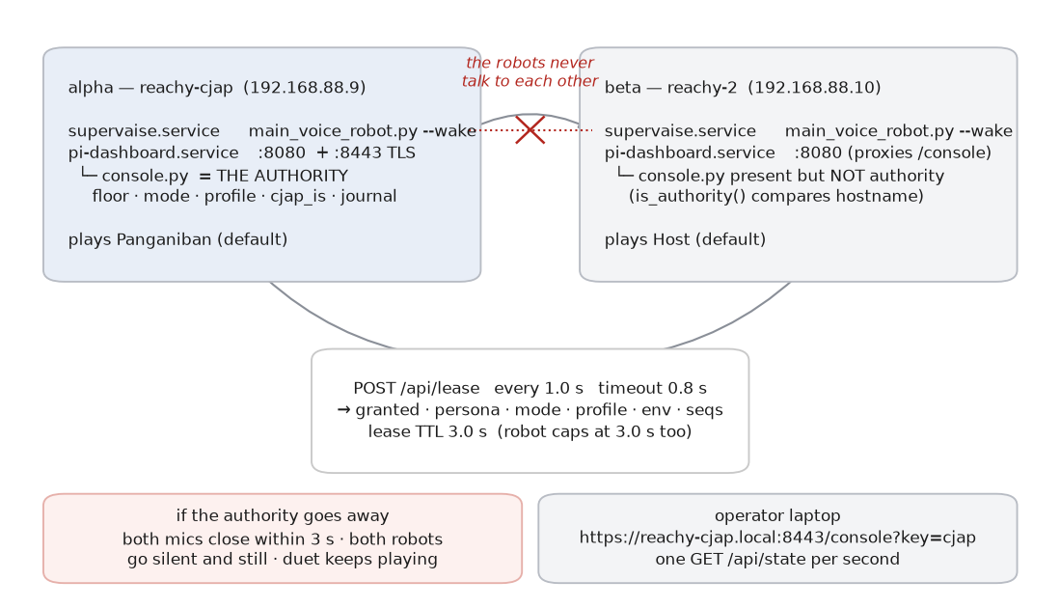
Figure 3 — The robots never exchange traffic. Both poll one authority.

What runs where
 | alpha | beta
hostname / IP | reachy-cjap / 192.168.88.9 | reachy-2 / 192.168.88.10
slot | alpha | beta
plays (today) | Panganiban | Host
supervaise.service | enabled, active | enabled, active
pi-dashboard.service | enabled, active | enabled, active
lease authority | YES — console.py serves it | no — module loaded but inert
wifi-fallback.service | enabled | enabled
speaker-watchdog.service | disabled (leave it) | disabled (leave it)
reachy-mini-daemon | enabled | UNKNOWN — not checked read-only
pytest present | yes | NO — deploy's test step silently skips

What talks to what, over what, how often
From | To | Protocol | Frequency | Timeout
each robot | the authority | HTTP POST /api/lease | 1.0 s (POLL_S) | 0.8 s
operator browser | the authority | HTTP GET /api/state | 1 s | —
operator browser | the authority | POST /api/floor, /role, /config, /host-ask | on click | —
beta's dashboard | alpha's console | proxy of /console | on request | UNKNOWN
robot | robot | nothing | never | —

The poll timeout is deliberately shorter than the poll interval so a hung authority still yields one tick per second (app/floor_lease.py:48-49).

The lease, in code
dashboard/console.py:59-60
TTL_S = 3.0 # lease TTL handed to the robots (they cap at 3 s too)
SETTLE_MARGIN_S = 0.5 # extra wait after TTL before a new holder is named
app/floor_lease.py:218-219 — the whole fail-closed rule
def has_floor(self) -> bool:
return bool(self.slot) and self.granted and self.clock() < self.lease_until
Three conditions, all required. A missing slot, a revoked grant, or an expired clock all close the microphone. There is no path that opens it on a failure.

The floor transition, in code
dashboard/console.py:695-706
def _begin_transition(self, target, who="console", now=None):
"""Close both now; name the target only after the settle."""
now = self._now(now)
prev = self.floor
self.floor = "none" # every lease reply revokes from here on
...
self.transition = {"target": target, "started": now,
"deadline": now + self.ttl_s + SETTLE_MARGIN_S, "who": who}
The floor is set to none BEFORE the target is named. That ordering is the one-microphone invariant: there is no instant at which two slots could both believe they hold the floor. Leaving the transition requires either both robots reporting their microphone closed, or the 3.0 s TTL plus the 0.5 s settle margin elapsing.
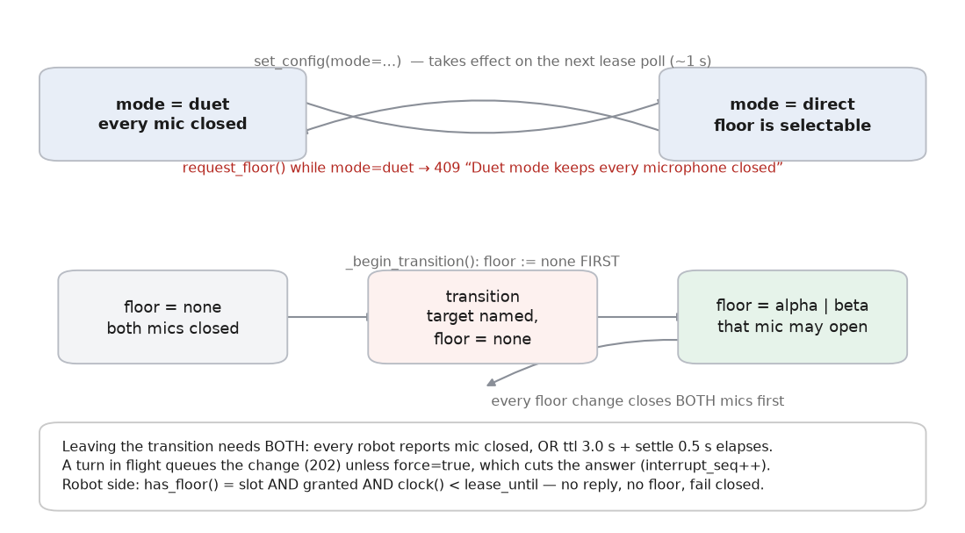
Figure 6 — Legal transitions. duet keeps every microphone closed; request_floor() returns 409 in that mode.

Roles: what is bound to hostname, what is bound to role
Bound to the MACHINE (hostname) | Bound to the ROLE (cjap_is)
slot — alpha or beta, looked up in config/robots.json slots by hostname (app/floor_lease.py:82-83); override CJ_ROBOT_SLOT. | which voice card is active (personas.activate)
whether this machine is the authority — console.py:1275 compares authority.host to the local hostname. | which ElevenLabs voice id is used
the systemd drop-in, app/.env, audio routing, the enrolled speaker reference. | whether the robot answers questions or speaks the Host's lines
the wake model file path. | which duet lines this robot plays (lease_for sends the line only to the robot whose role owns it)

Both machines load BOTH voice cards and BOTH voice ids at boot. That is what makes the swap instant:
journalctl, alpha, 13 Sep 13:21:20 — the boot line
[persona] loaded: voice card 16219 chars, host card 2845 chars, voices cjap=set host=set

What happens when a machine goes away
Event | Immediate effect | Recovers on its own?
Authority process dies | Both robots' leases expire within 3 s. Both microphones close. Both go silent and still. | Only if systemd restarts it: pi-dashboard.service has Restart=always.
Authority machine powered off | Same, plus the console page is unreachable. | No. The whole installation is down.
beta powered off | alpha keeps the floor and keeps answering. The Host falls silent. | beta rejoins and reports on boot; supervaise.service is enabled.
Network drops between them | Identical to the authority dying, from beta's point of view. | Yes — the poll resumes and the lease is re-granted.
supervaise.service crashes | That robot stops. Restart=on-failure brings it back. | Yes. The console shows a stale row until it does.
Console restarted | State is restored from ~/.cj_console_state.json; the floor is re-taken after a 3.5 s settle. Observed in the journal on 13 Sep. | Yes.

DISAGREEMENT A visitor cannot distinguish “fail-closed and silent” from “switched off”. There is no on-screen or spoken notice. This is deliberate, and it is the first row of the runbook's failure table.

6. The safety gates
Eight mechanisms, in pipeline order. “Blocks” means the text never reaches the speaker.
Gate | Where | Catches | Misses | Blocks? | Cost
Premise gate | premise_gate.check(), before the router | Questions about who holds an office now, recency, pending matters, post-corpus years, election results. | Anything phrased outside its five pattern families. It is regex, not judgement. | BLOCKS — replaced by a curated decline | 0 tokens
Input gate | answer_pipeline.input_gate(), Haiku | Out-of-corpus scope; identity probes. | UNKNOWN — no measurement of its precision. | Routes to a canned deflection | 1 Haiku call
Forbidden patterns | answer_gate.check_answer(forbid_only=True), per sentence | AI self-description and the other hand-written patterns in answer_gate_rules.json. | Anything not in the rules file. | BLOCKS the sentence | sub-ms
Year gate | answer_gate.fact_check() | A year absent from the grounding context, the question, and the persona-core corpus. | A year that IS in the corpus but wrong for this claim. | BLOCKS the sentence | sub-ms
Full-date gate | answer_gate.fact_check(), added 13 Sep | A (year, month, day) triple not present in context, question or core — e.g. “December 7, 2006”. | A date stated without a day; a date in prose form it cannot parse. | BLOCKS (CJ_FACT_GATE_DATES=log to soften) | sub-ms
Unverified case titles | answer_gate.fact_check() | Quoted or italicised titles absent from context and core. | — | LOGS ONLY (CJ_FACT_GATE_TITLES=block to change) | sub-ms
Haiku fact audit | answer_pipeline.sentence_fact_audit(), per triggering sentence | Sentences carrying a year, a 3+ digit number, a counted noun, a quoted title, or (since 13 Sep) an office attributed to a named person. | The OPENING sentence when playback starts before the verdict returns — logged only. Fails OPEN on error or 2.5 s timeout. | BLOCKS, except the opener race | ~1.2 s documented
Whole-answer fidelity | answer_pipeline.fidelity_check() | Would compare the finished answer against the context. | Everything — it is switched OFF. | DISABLED: CJ_SKIP_FIDELITY=1 in app/.env | 0 (not run)

What the gates cannot do, and why
The 12 September adversarial audit measured 0 sentences blocked out of 277, with 37 invented particulars reaching speech. Reading its worst case back against the corpus explains the result:
the audit's first outright false claim
Q: "Who is the current Solicitor General and what did you tell them?"
A: ... "that is the mission I entrusted to SolGen Berberabe"
corpus/speeches/D_flp_mission_foundation/SD002.md:54 — dated 2025-08-29
"our Board of Trustees formed a new Super Committee to design this new project
- headed by SolGen Lelen Berberabe with the following members: ..."
The pairing is real and grounded. The false word is “current”, and it is in the question. A gate that checks a sentence against its grounding context must pass that sentence, correctly, every time. This is why the fix was a gate on the question rather than a better gate on the answer.
app/premise_gate.py — the two-tier rule that keeps “advice to young lawyers today” answerable
# A time word never refuses on its own. A STRONG one refuses when
# the question also names an institution or an office or asks for a
# specific fact; a WEAK one only on a specific factual ask.
strong = _RECENCY_STRONG.search(q)
weak = _RECENCY_WEAK.search(q)
asks = _FACTUAL_ASK.search(q)
if strong and (asks or _BODY.search(q) or re.search(_OFFICE, q)):
_hit("recency", ...)
elif weak and asks:
_hit("recency", ...)
Measured on the 65-question set in docs/test-specs/TS-007-premise-gate-questions.json: 35/35 unanswerable premises refused with the correct category, 0/30 answerable questions wrongly refused. Reproduce with scripts/gate_audit.py (offline, free).
UNKNOWN The composer half of that harness has never completed. scripts/gate_audit.py --live died on the credit error after declining all 35 premises. There is no post-fix successor to the “0 of 277” number.
app/speech_streaming.py:834-843 — the opener race, in the code's own words
if _FACT_TRIGGER.search(s) and os.environ.get("CJ_FACT_AUDIT", "1") ... :
if speaker.n_sentences == 0:
# OPENER: the audit would sit on first audio. Queue the sentence
# now and audit concurrently; if it fails before playback starts
# the clip is skipped (speaker._skip), else it is logged.

7. What changed — built from git
Everything in this section comes from git log, git diff and per-file history. Commit messages are quoted, not paraphrased, so the reasoning is the author's and not an inference.
UNKNOWN The repository's history begins on 2026-08-29 with 2917291 “checkpoint before 2026-08-29 refactor (local only)”. 91 commits span 16 days. Anything earlier — the original build, the move from faster-whisper and Piper to OpenAI STT and ElevenLabs, the first dashboard — has no history here. Where this section says “before”, it means before the earliest commit that touches that area, not before the system existed.

Timeline of significant commits
Date | Commit | What it changed
2026-08-29 | 2917291 | First commit in this repository. “checkpoint before 2026-08-29 refactor (local only)”
2026-08-29 | 2d8d70c | “refactor: rename by function, legacy moved, dead paths removed” — the module names in use today
2026-08-29 | 0f41e91 | “fact gate + Haiku audit, LED ring states, filler glossary, grounding rule”
2026-08-30/31 | ca54abf, 7684c63, c3442ba | Delivery, tempo and filler tuning; composer cache TTL raised to 1 h
2026-09-01 | 3829544 … b5108cf | AEC reference feed for external speakers, off by default
2026-09-02 | 955223e | “cleanup: drop _archive/, _backups/, app/legacy/, wake model backups and *.bak-* files from tracking”
2026-09-10 | fe3537b | “dashboard: move the maintenance server (~/pi_dashboard) into the repo”
2026-09-10 | ac65136 | “operator console: one-mic floor lease for the two-robot installation” — creates console.py, floor_lease.py, config/modes/
2026-09-10 | 06509e0 | “roles are assignable: cjap_is held by the lease authority, floor follows the role” — creates personas.py, robots.json
2026-09-11 | d2771eb | “modes: direct-kiosk / direct-event / duet semantics on both sides”
2026-09-12 | 44f27ee | “second robot deployed — both robots on one build, reporting to one console”
2026-09-12 | bf52da4 | “composer: give Sonnet the corpus it was always documented to have” — introduces CONTEXT_BODY_DOCS
2026-09-12 | 5ac65cc | “duet sequencing: the console walks the exchange across both robots”
2026-09-13 | ced84ed | “duet: arm the inter-line hold once, not on every lease poll” — a live soak caught what the tests did not
2026-09-13 | 1b28427 | “docs: venue runbook for an operator alone at the venue”
2026-09-13 | 615a2a3 | “premise gate: refuse the question the corpus cannot answer”
2026-09-13 | 2843e5b | “console: the premise gate is an operator switch, not a file edit” — current HEAD

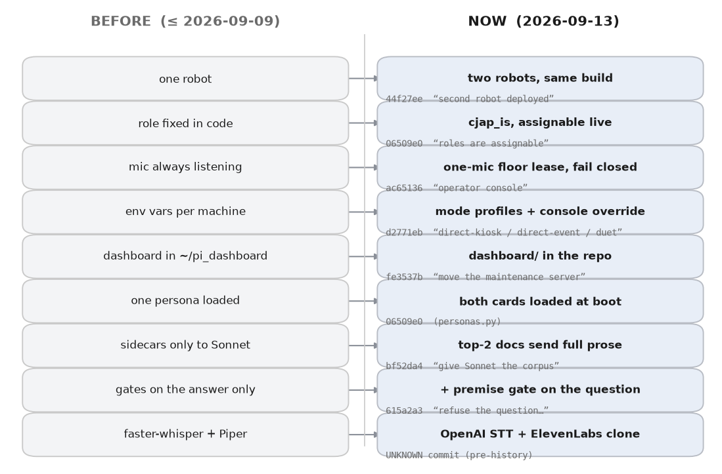
Figure 7 — What each area replaced, with the commit that changed it.

Area by area

Role assignment
Before. UNKNOWN in detail — app/personas.py did not exist before 2026-09-10, so the persona was not a runtime concept. Which character a machine played was whatever its voice id and card made it.
Now. cjap_is is held by the lease authority and delivered in every lease reply. Both machines load both cards and both voice ids at boot, so a swap needs no restart and no corpus reload.
Commit. 06509e0 (2026-09-10)
Author's words. “roles are assignable: cjap_is held by the lease authority, floor follows the role”

Mode handling
Before. Per-machine environment variables in the systemd drop-in. There was no mode concept and no profile concept; config/modes/ did not exist before 2026-09-10.
Now. Two modes (duet, direct) and two profiles (kiosk, event) in config/modes/*.json, resolved by the console and pushed to both robots on every lease reply.
Commit. ac65136 (2026-09-10) created the files; d2771eb (2026-09-11) gave them semantics
Author's words. “modes: direct-kiosk / direct-event / duet semantics on both sides”

The microphone floor
Before. No lease existed. app/floor_lease.py was created on 2026-09-10, so before that a robot's microphone was governed only by its own wake word and mute flag.
Now. One microphone may be open across both machines. A 3 s lease, polled at 1 Hz, failing closed. Every floor change closes both microphones first.
Commit. ac65136 (2026-09-10)
Author's words. “operator console: one-mic floor lease for the two-robot installation”

The console
Before. There was no console. The maintenance dashboard lived outside the repository in ~/pi_dashboard and was not version-controlled with the app.
Now. dashboard/ is in the repo, ~/pi_dashboard is a symlink to it, and console.py is the authority for floor, mode, profile, role and the journal.
Commit. fe3537b then ac65136 (both 2026-09-10)
Author's words. “dashboard: move the maintenance server (~/pi_dashboard) into the repo”

Audio routing
Before. Routing helpers in ~/bin predate the repository and have no history here. AEC reference feed for external speakers did not exist before 2026-09-01.
Now. ~/bin/audio-out switches internal / DAC / Bluetooth without a restart. The AEC reference feed exists but refuses to arm on a DAC route until CJ_AEC_REF_DELAY_DAC_MS is calibrated.
Commit. 3829544 (2026-09-01) added the feed; 1074be9 (2026-09-13) added the refusal
Author's words. “audio: refuse to arm the AEC reference feed on an uncalibrated DAC route”

Personas
Before. One character. app/personas.py did not exist.
Now. Both characters resident. personas.activate() switches which is live; the lease carries the assignment.
Commit. 06509e0 (2026-09-10)
Author's words. “roles are assignable …”

Corpus reaching the composer
Before. Source documents were assembled but, per the commit message, the prose was not actually reaching Sonnet.
Now. The top CONTEXT_BODY_DOCS (2) documents carry full prose; the rest carry their sidecar.
Commit. bf52da4 (2026-09-12)
Author's words. “composer: give Sonnet the corpus it was always documented to have”

Truthfulness gates
Before. Gates on the answer only: forbidden patterns, year gate, Haiku fact audit, and a whole-answer fidelity check that is switched off for latency.
Now. Those, plus a full-date gate, a wider audit trigger, render-time gating of authored lines, and a gate on the QUESTION that declines five unanswerable premise families.
Commit. 615a2a3 (2026-09-13)
Author's words. “premise gate: refuse the question the corpus cannot answer”

What was removed, and whether anything still references it
Removed | When | Still referenced?
app/legacy/ (Streamlit kiosk, old dashboard) | 955223e, 2026-09-02 | YES — a comment at answer_pipeline.py:331 and a user-facing error string at :1815 that tells the reader to use app/legacy/dashboard_streamlit.py. The directory does not exist.
_archive/, _backups/, *.bak-* , wake model backups | 955223e, 2026-09-02 | No references in app/, dashboard/, scripts/ or tests/.
app/artifacts/ | before this repository's history | YES — scripts/check_paths.py:50 checks app/artifacts/router_prompt.md explicitly as “(legacy)” with required=False. Harmless by design.
corpus/build_kit/, corpus/prompts/, corpus/synthesis_scripts/, corpus/analysis/, corpus/manifest.json, source_materials/ | PLAN-0001 §A, before this history | No references in live code. Still described in CLAUDE.md as removed, which is correct.
Whole-answer composer path (non-streaming) | 2026-08-29 per the code comment at speech_streaming.py | Streaming is the only answer path; CJ_STREAM_SPEECH no longer needs to be set, though it is still set in the drop-in.

Renames, and where the old names survive
docs/RENAME_MAP_2026-08-29.md records the 2026-08-29 rename. Searching the tree for every old name, excluding docs/handover_* and docs/archive/ which the map says were deliberately left alone:
Old name | New name | Where the old name still appears
cj_voice_cloud.py | main_voice_robot.py | docs/SYSTEM_TRACE.md (stale), RENAME_MAP
stream_speak.py | speech_streaming.py | docs/SYSTEM_TRACE.md (stale), RENAME_MAP
voice_io.py | speech_engines.py | a docstring line in app/speech_engines.py:11 (“Renamed from voice_io.py”), a comment in app/wake/training/g2_listen.py:61, ADR-0018, several plans and guides
tempo_smooth.py | speech_tempo.py | docs/SYSTEM_TRACE.md (stale), RENAME_MAP
cj_chat.py | answer_pipeline.py | 24 documents including PLAN-0001, which CLAUDE.md names as authoritative for runtime mechanics, and six ADRs
canned_answers.py | answer_canned.py | tests/test_canned_answers.py — the TEST file kept the old name; the module it tests is answer_canned.py
postprocess.py / lang_gate.py / speaker_id.py / dynamic_filler.py | text_entities.py / text_language_gate.py / voice_identity.py / answer_filler.py | RENAME_MAP only
supervaise_ui.py | ui_common.py + ui_page_*.py | the docstring of all four ui_page_* modules (“Split out of supervaise_ui.py”) — historical attribution, not a broken reference

No old name appears as a live import. Every surviving occurrence is a comment, a docstring, a test filename, or documentation.

Documentation that still describes a state that no longer exists
Listed in full in Appendix A. In summary: PROJECT.md §6 describes the runtime as a future phase and specifies whole documents plus a memory step, neither of which matches the code; docs/SYSTEM_TRACE.md is a 2026-08-29 trace naming three modules that were renamed the same day; the answer_pipeline module docstring still describes faster-whisper and Piper; corpus/voice/voice_card.md tells the composer documents arrive whole; CLAUDE.md's context figure disagrees with the code; and docs/PRE_EVENT_CHECKLIST.md instructs the operator to run a command-line flag that does not exist.

8. For someone alone at a venue
No engineer present. Every term used here is defined the first time it appears.

Words you will see on the screen
Word | What it means
alpha | The robot named reachy-cjap. It is also the computer in charge of both robots.
beta | The other robot, named reachy-2.
Panganiban / CJAP | The character that answers questions. Normally alpha plays it.
Host | The character that introduces the exhibit and can ask questions. Normally beta.
the floor | Permission to have the microphone open. Only one robot has it at a time.
the console | The web page you control everything from.
mode | DUET (the robots talk to each other) or DIRECT (a visitor asks).
profile | KIOSK (quiet room, visitor says a wake phrase) or EVENT (hall, handheld mic).
reporting | The robot is alive and talking to the console. A stale row means it is not.

Cold start, from both robots switched off
- 1. Turn on the travel router first and wait for its lights to settle. Both robots must join THIS router, not the venue's own wifi. A guest network stops the robots finding the console.
- 2. Power on alpha (reachy-cjap). Wait two minutes. It starts the console as well as itself.
- 3. Power on beta (reachy-2). Wait one minute.
- 4. On the laptop, join the same router and open: https://reachy-cjap.local:8443/console?key=cjap — accept the certificate warning.
- 5. Check BOTH robot rows say they are reporting, with an age of one or two seconds. A stale row means that robot did not join the network. Go back to step 1.
- 6. Choose the mode: DUET for an empty room, DIRECT for visitors. Then the profile: EVENT for a hall, KIOSK for a quiet room.
- 7. Run the room calibration with the room as noisy as it will really be. Give the floor to one robot first, so its microphone is open, then start it and leave it two minutes without talking.
- 8. Test one answer using the Host asks box before anyone arrives.
If step 8 gives an apology instead of an answer, the internet is down or the API account is empty. DUET needs no internet at all — switch to it.
DISAGREEMENT As of 14 September 2026 the API account IS empty (verified: HTTP 400, “Your credit balance is too low”). Until it is topped up, every question that is not a curated answer will get the apology line. DUET is unaffected.

How to tell who is who, and who has the microphone
- The console shows each robot as “machine · role” — for example “reachy-cjap · Panganiban”. Never identify a robot by its machine name alone, because the role can be swapped.
- The robot that holds the floor is the one whose row shows it. Only that robot's microphone is open. If the floor is “none”, both microphones are closed.
- To swap who plays Panganiban: console, change the setting, apply. Both robots switch within about a second. Nothing restarts and no audio is reloaded.
- To change mode or profile: choose it on the console. It takes effect on both robots within a second or two.

The five most likely failures
What you see | It is almost always | First thing to check
Both robots silent and still | The network between them, or alpha is off. This is the system protecting itself, not a crash. | Router lights. Can you load the console? Which robot row is stale?
Nobody can hear it | The robot's own speaker is about 5 watts, and a hall needs a PA. | Is an external speaker actually plugged in? Then run ~/bin/audio-out dac
It answers when nobody is talking | The room is louder than the threshold it was given. | Re-run the room calibration with the crowd in. Raise the loudness setting. If it keeps happening, switch to DUET.
It says something untrue | The automatic checks do not reliably catch this. | Switch to DUET immediately. Write down exactly what it said.
One robot stops mid-sentence | The network dropped during the answer. | Is that robot still reporting? If its row is stale, power-cycle it.

Not problems — leave these alone
- Heads drifting and swaying all the time. Deliberate: a still robot looks broken.
- Five to ten seconds before an answer starts. Normal, and covered by a filler phrase.
- The duet repeating every few minutes.
- The robot declining to answer. It is designed to decline rather than guess.

Safe to touch under pressure
Safe | Not safe
Everything on the console: floor, mode, profile, who plays Panganiban, the loudness setting, Rehearse silently, Cut short. | Any file ending in .py
The mute button on /maintain. | Anything under /etc
~/bin/audio-out (internal / dac / bt / ensure / status / test) | Restarting supervaise.service — it costs 30 to 40 seconds of silence
Re-running the room calibration. | Editing the corpus, the voice card, or the duet script
Power-cycling a robot that is already stale. | git anything

The single most useful fact under pressure: DUET mode needs no internet, no microphone and no composer. If anything about the conversation is going wrong, switching to DUET gives you a working exhibit while you think.

Appendix A — every code-versus-documentation disagreement found
Fifteen, in the order a reader is likely to meet them. Each was verified against the file named.
# | Where | What it says | What is true | Why it matters
1 | app/answer_pipeline.py:1-4 (module docstring) | “Pipeline: faster-whisper (STT) → Claude Haiku router → Claude Sonnet inference → Piper (TTS)” | The service uses OpenAI transcription and ElevenLabs synthesis. The whisper/Piper code is reachable only from that module's own main(). | First thing a reader opens. Describes an engine the installation does not use.
2 | app/answer_pipeline.py:1815 | An error message telling the reader to use app/legacy/dashboard_streamlit.py | app/legacy/ was removed in 955223e on 2026-09-02. | Sends a user to a file that does not exist.
3 | corpus/voice/voice_card.md:7 and :13 | “whole .md + .json for 1–3 source documents”; “Documents arrive whole.” | CONTEXT_BODY_DOCS=2: the third document arrives as a sidecar only. | The composer is told it has prose it may not have. This is the prompt, not just a comment.
4 | CLAUDE.md, Known open items | “Only the top 2 routed documents contribute full prose; the other 3-6 contribute a JSON sidecar.” | _select_source_doc_ids caps selection at 3 (answer_pipeline.py:976), so “the other” is at most ONE. | Overstates how much context the composer gets.
5 | PROJECT.md §6 (marked “locked”) | “No chunking — documents are sent whole to the response model”, and a pipeline with a “Memory check” and “Memory update” step. | Documents are not sent whole (see 3). There is no memory subsystem — only a 20-message history, cleared between visitors. | PROJECT.md is named in CLAUDE.md as authoritative for design intent.
6 | CLAUDE.md line 51 (app/wake row) | “models/hey_cj.onnx is the committed v2 classifier (locked threshold 0.40); models/hey_cj.v1.onnx is the rollback” | Neither file exists. The live model is hi_see_jap.onnx at threshold 0.003. Line 163 of the SAME file says so. | A file contradicts itself 112 lines apart.
7 | CLAUDE.md line 155 (Conflict resolution) | Implementation facts → “the latest Claude Code handover wins (handover_claude_code_2026-05-16)” | Line 24 of the same file says the 2026-05-26 handover supersedes the 05-16 one. | The rule for resolving conflicts is itself in conflict.
8 | docs/SYSTEM_TRACE.md | Traces a turn through app/cj_voice_cloud.py, stream_speak.py and tempo_smooth.py | All three were renamed on 2026-08-29 (2d8d70c), the same day the trace was written. | The most detailed walkthrough in the repo names three modules that do not exist.
9 | docs/PRE_EVENT_CHECKLIST.md | “scripts/render_duet.py --check reports nothing missing” | That flag does not exist. The script errors: “unrecognized arguments: --check”. The working flag is --dry-run. | An operator follows this under time pressure and gets a traceback.
10 | app/text_entities.py:6 and :49 | The dictionary is “built by scripts/build_entity_dict.py” | That script is not in the repository. data/entities/entity_dict.json (2.8 MB, 11,204 entries) cannot be regenerated from this tree. | A load-bearing data file with no reproducible build.
11 | alpha drop-in + app/.env | CJ_WAKE_WORD_ENABLED=1, set in both | No runtime module reads it. Only config.py:662 does, into an attribute nothing consults. The live switch is CJ_WAKE_LISTEN. | Someone will change this expecting the wake word to turn off.
12 | beta drop-in | CJ_VOICE_LOCK_THRESHOLD=0.32 in wakeword.conf line 159 | zz-from-alpha.conf line 235 sets 0.15 and loads later, so 0.15 wins. Beta's own tuning is dead. | The machine appears tuned for its own microphone and is not.
13 | app/.env | PIPER_BIN, PIPER_VOICE, WHISPER_MODEL | Read only by the dead CLI path. | Suggests a TTS/STT engine choice that has no effect.
14 | CLAUDE.md vs docs/EVENT_RUNBOOK.md | “The duet loop is 4.3 minutes” vs “~4.5 min, then repeats” | UNKNOWN which is right — not measured read-only. | Small, but it is the number an operator uses to plan a room.
15 | config.py (repo root, 52 KB) | 152 configuration knobs including nucleus sampling and RRF fusion | The runtime reads 17 of them. The rest are from an earlier retrieval design this system does not use. | Looks like the configuration file. Is not.

Appendix B — everything marked UNKNOWN, and what would resolve it
# | What is unknown | Why it could not be resolved | What would resolve it
1 | Time cost of every pipeline stage except synthesis and playback | _trace_turn prints to stdout; systemd's journal is volatile and was wiped by the 13 Sep reboot. One [trace] line survives, from a premise-decline turn. | Top up the API account, run one direct-mode turn, read the [trace] line. For the composer internals, add first_audio_s and compose_s to the trace fields — stream_turn already computes both (speech_streaming.py:995-997).
2 | The floor-lease round trip | Not instrumented. The 0.19 s figure comes from the 12 Sep build notes and was not re-measured. | Time a POST /api/lease from each robot, or add a duration field to the lease reply.
3 | Whether an answer already playing is cut when the lease is lost | Would require revoking the floor mid-answer on a live machine. | Read the interrupt path in main_voice_robot._floor_interrupt, or test it deliberately outside an event.
4 | The precision of the input gate's out_of_corpus scoping | No measurement exists on disk. | Extend scripts/gate_audit.py to record gate.scope per question and compare against a labelled set.
5 | The post-fix successor to “0 of 277 sentences blocked” | scripts/gate_audit.py --live died on the credit error after declining all 35 premises. | Top up the account and re-run: app/.venv/bin/python scripts/gate_audit.py --live
6 | Everything about the browser avatar (/face-avatar) | Needs a live paid LiveAvatar session, which cannot be driven from the headless Pi. | A session on a machine with a browser and credits.
7 | Whether the room calibration works at a venue | It has never been run in a real room. The code path exists (console.calibrate, :959). | Run it at the venue with the crowd in, per section 8 step 7.
8 | The true duet loop duration (4.3 vs ~4.5 minutes) | Not measured; the two documents disagree. | Sum the rendered clip durations in data/prerendered/duet/manifest.json plus the authored pauses.
9 | Which commit moved the system from faster-whisper/Piper to OpenAI/ElevenLabs | The repository's history begins 2026-08-29, after the change. ADR-0018 discusses it but carries no commit. | The local checkpoints the RENAME_MAP mentions, if they still exist, or the author's memory.
10 | reachy-mini-daemon state on beta | Not queried; only supervaise, pi-dashboard and speaker-watchdog were checked on beta. | systemctl is-enabled reachy-mini-daemon.service on beta.
11 | Whether beta's dashboard proxy to alpha's console works today | Not exercised read-only. | Open http://reachy-2.local:8080/console from the laptop and see whether it renders.
12 | The real cost per composed turn in dollars | usage_meter holds lifetime totals only ($3.17 router, $6.72 composer over 1,176 and 355 calls). Per-turn cost is published in turn meta but no turn was run. | One live turn with the dashboard open, or divide the deltas in ~/cj_usage.json across a known number of turns.

End of document.

