CJAP — System Reference
The 12 September audit and the technical reference, merged and reconciled against the code as it stands.

Repository | ~/Supervaise-Reachy-Mini-Project-main · github.com/Supervaise-Inc/CJAP
Branch / HEAD | feat/operator-console · bbefae1 avatar session refuses a second; avatar_lag versioned; tests off the symlink
Machines | alpha = reachy-cjap 192.168.88.9 (authority) · beta = reachy-2 192.168.88.10
Written | 14 September 2026
Sources merged | ~/audit_report.docx (12 Sep) and ~/system_notes.docx (14 Sep), both left in place
Method | Read-only. No code, config or service was changed; nothing was restarted.

How to read this
Every statement was checked against a file or a running process. Where code and documentation disagree the disagreement is marked inline and repeated in Appendix A. Where something could not be verified it says UNKNOWN and is repeated in Appendix B with what would resolve it.
On intent: a reason appears here only when it is written in a commit message, a code comment or a document on disk, and it is quoted with its source. Everywhere else the reason is UNKNOWN. A confident invented rationale would be believed in six months, which is worse than a gap.
A note on provenance: ~/system_reference.docx did not exist before this document. The merge is of ~/audit_report.docx and ~/system_notes.docx, brought up to date against the code.

Contents
1. Summary
2. Audit reconciliation
3. Map
4. The pipeline, stage by stage
5. How each component was implemented
6. Config
7. The corpus
8. The two robots
9. Safety gates
10. Display and avatar
11. Findings that contradicted what we believed
12. The test suite, honestly
13. Latency
14. Known unmeasured
15. Venue guide
16. Risk table
A. Appendix A — code versus documentation
B. Appendix B — everything UNKNOWN

1. Summary
The conversation works. Routing, grounding, the cloned voice, the floor lease between the two robots, the duet, the head motion and now two visitor-facing display views all run on real hardware, and there is journal evidence of each. Since the 12 September audit the two most dangerous findings have been addressed: the memory leak that would have killed the robot mid-event, and the truthfulness gap — though the second was fixed by a different mechanism than the audit proposed, for reasons in section 11.
Of the audit's 27 findings: 10 FIXED, 1 FIXED (hard timeout) / STILL OPEN (post-first-audio watchdog), 15 STILL OPEN, 1 SUPERSEDED. Section 2 gives each one.

The three things most likely to go wrong
# | What | What the room experiences | State
1 | Nobody can hear it. Output is the internal ~5 W speaker and no USB DAC is attached. | Visitors lean in, hear nothing past the first row, and walk away. | STILL OPEN
2 | The API account has no credit. | Every question that is not a curated answer gets the apology line: “I cannot reach my notes at the moment.” DUET is unaffected — it is pre-rendered. | STILL OPEN
3 | The event configuration has never been run. Every rehearsal was in kiosk mode. | Unknown. Different thresholds, no wake word, no follow-up window — none of it exercised with this build. | STILL OPEN

None of the three is a software defect. Two are physical (a speaker, a credit balance) and one is a rehearsal that has not happened. That is a better position than the audit found, where the top three were all in the code.

2. Audit reconciliation
Every finding from the 12 September audit, checked against the code today. FIXED names the commit. STILL OPEN and NOT VERIFIED carry forward into the risk table in section 16; FIXED items appear in section 11 as history, not as open problems.
# | Finding (as the audit put it) | Status | Evidence / commit
1 | Memory grows ~13 MB per capture and is never released; 761 MB against ~1.98 GB usable | FIXED | be91ed3 — "memory: cap the speaker-embedding input and cache the VAD detector"; body: "The real mechanism is length-scaled. embed_samples() fed the EN
2 | Gates blocked 0 of 277 adversarial sentences; 37 invented particulars, 3 outright false claims | SUPERSEDED | 615a2a3 — "premise gate: refuse the question the corpus cannot answer"; body: "So the gate runs on the question, before the router and composer ... Th
3 | Output is the internal 5 W speaker; inaudible in a hall | STILL OPEN | n/a — no commit claims to fix this. The nearest, 1074be9, states the opposite: "No USB DAC is plugged in and this board has no 3.5 mm output, so exter
4 | Echo cancellation inert on this route; USB DAC delay uncalibrated at 0 ms | STILL OPEN | 1074be9 — "audio: refuse to arm the AEC reference feed on an uncalibrated DAC route"; body: "A DAC route now arms the feed only once the delay has act
5 | direct+event profile has never run with this build | STILL OPEN | n/a — no commit claims a live direct+event run. The profile values themselves are unchanged in config/modes/direct.json since the console work; nothin
6 | Conversation history never resets between visitors | FIXED | 84c520b (2026-09-13 04:22:43 +0100) — "turn: clear the conversation history between visitors"; "Cleared at the single wake-fire funnel in wake_loop, w
7 | Speech threshold caps at 2500 while a loud room keeps rising | STILL OPEN | n/a — no commit changes the cap or adds anything that raises it; git log -S 'speech_threshold_cap' returns only ac65136 (09-10) and ff54819 (09-11), b
8 | Room calibration built and wired but never run once | STILL OPEN | n/a — the run is operational, not a code change; the mechanism dates from ff54819 (2026-09-11, pre-audit) "supervised run fixes + room calibration + r
9 | Bluetooth watchdog can hijack the audio route within 15 s | FIXED | 1074be9 (2026-09-13) — "The rest of this is operational and outside git: speaker-watchdog.service is now disabled on both machines. It polled every 15
10 | Host voice identifier never reached the second machine | FIXED | 7a75b07 (2026-09-13 04:22:04 +0100) — "deploy: push the shared voice ids to the second robot, and correct the docs"; "Divergence is silent, so when th
11 | Always-listen flag sticks off after any duet-to-direct switch | FIXED | c502ecc01f965d66f618c99f3baa192bcb3b1ca7 — "console: emit CJ_ALWAYS_LISTEN in both directions, not just off"; body: "The robot's _floor_settings() onl
12 | No hard timeout on the turn; no watchdog after first audio | FIXED (hard timeout) / STILL OPEN (post-first-audio watchdog) | b8d0f0a1db37f650177beaabc3f2ed3c65b5e660 — "turn: wall-clock hard timeout, and head motion that tracks the voice"; body: "CJ_TURN_HARD_TIMEOUT_S (defa
13 | Beta drop-in 11 days stale; wake threshold 0.1 vs 0.003 | FIXED | n/a for the drop-in itself — it is root-owned and out of git (CLAUDE.md: "Not in git: /etc/systemd/system/supervaise.service.d/wakeword.conf (per-mach
14 | Opening sentence can play before its fact check returns | STILL OPEN | n/a — no commit changes the opener race. Last touch is af7c8117 (2026-08-30), pre-audit, whose comment at speech_streaming.py:851-853 already document
15 | Turn function has no finally block; thread and object leak per failed turn | STILL OPEN | n/a — no commit addresses it. The only relevant finally blocks predate the 09-12 audit: ac651361 (2026-09-10, _safe_turn, `_TURN["active"]` only) and
16 | Only 2 of 5-8 routed documents contribute full text | STILL OPEN | n/a — no fix commit. Last touch is bf52da4 (2026-09-12 09:09): "composer: give Sonnet the corpus it was always documented to have" — the commit that C
17 | Filler is a live model call plus live synthesis every turn | STILL OPEN | n/a — no fix commit. Last touch to app/answer_filler.py is a37cae2 (2026-09-12 15:40): "second robot found and pointed at; filler cut from 14 words to
18 | Head motion is not driven by the audio envelope | FIXED | b8d0f0a (2026-09-13) "turn: wall-clock hard timeout, and head motion that tracks the voice" — "Gestures now loads the loudness envelope of each clip a
19 | Nine duet lines, authored pauses ignored, repeats in ~50 s | FIXED | 2acfb4a (2026-09-13) "duet: 12 more exchanges; intro: six variants, all corpus-sourced"; b08d3c5 (2026-09-13) "duet: honour the authored pauses" — "A
20 | One fixed intro, synthesised live, no variants; pre-render directory does not exist | FIXED | b08d3c5 (2026-09-13) "duet: honour the authored pauses; intro: rotating pre-rendered variants" — "config/modes/direct.json has promised 'variants rota
21 | Duet lines never pass any gate (scripts/render_duet.py, scripts/render_intro.py render authored lines without | FIXED | 615a2a3 (2026-09-13) "premise gate: refuse the question the corpus cannot answer" — message body: "the authored duet and intro lines are gated at rend
22 | Barge-in silently off whenever the robot lacks the floor | STILL OPEN | n/a — no commit since the audit touches it. Last touching commit is ac65136 (2026-09-10) "operator console: one-mic floor lease for the two-robot inst
23 | ElevenLabs failure silently swaps voice or drops a sentence | STILL OPEN | n/a — nothing since the audit. Only commits touching these two files since 2026-09-12 are de72a71 (name pin) and 615a2a3 (premise gate); neither chang
24 | Beta has no usable git identity; same-commit check impossible | STILL OPEN | n/a — no commit addresses beta's git identity or the HEAD-vs-tree divergence. Nearest related work is 7a75b07 (2026-09-13) "deploy: push the shared vo
25 | Both checklist documents contain statements that are now false | STILL OPEN | c0278ef (2026-09-14) "checklist: the render-audio check names a flag that does not exist" — "`scripts/render_duet.py --check` errors with 'unrecognize
26 | Case-title check and full-answer fidelity audit log but never block | STILL OPEN | n/a for a fix. The only commit touching either file since the 09-12 audit is 615a2a3 (2026-09-13, "premise gate: refuse the question the corpus cannot
27 | Every browser avatar behaviour remains unverified | STILL OPEN | 442c7cf (2026-09-14) "avatar motion: a real breath under the drift, and sliders that persist" added ui_page_display.py and the lipsync_gain/avatar_lag

3. Map
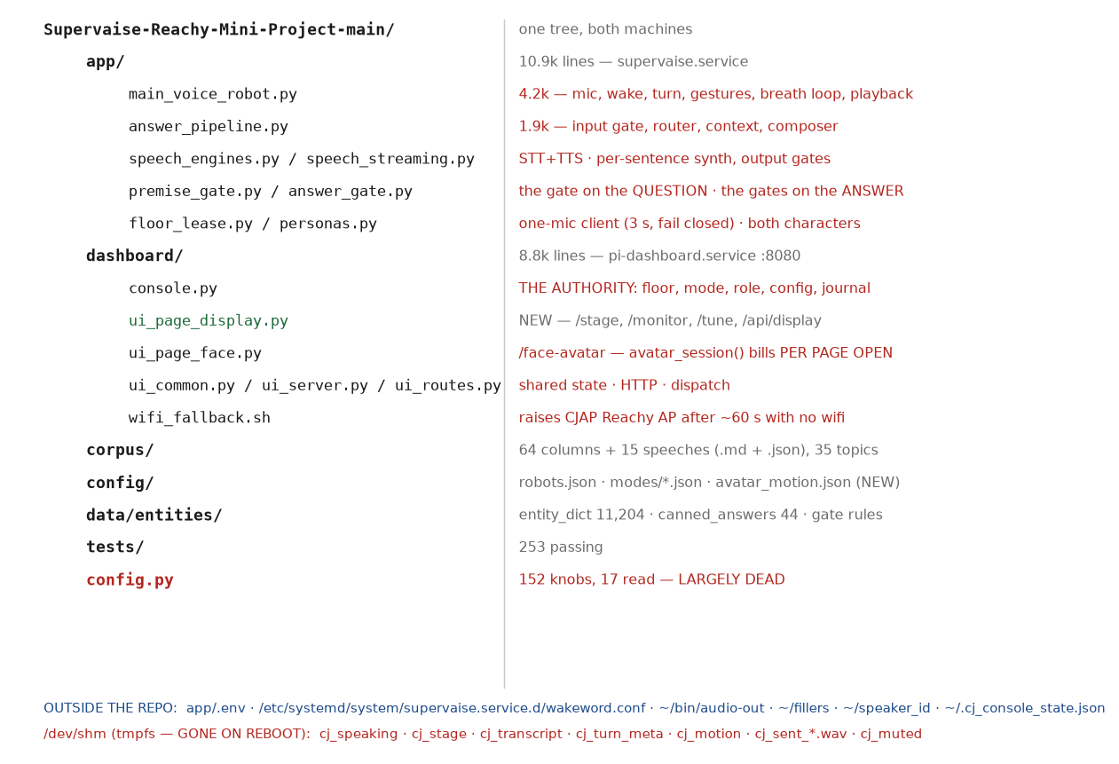
Figure 1 — the tree. Red is present but unused; the footer lists what is load-bearing and outside the repo, and what lives on tmpfs.
Venue-safe means: Hot = the running process re-reads it, no restart. Restart = the service must be restarted (~30-40 s of silence). No = do not touch with an audience present.
Path | What it does | Read by | Venue-safe
app/main_voice_robot.py | Boot, wake loop, capture, turn dispatch, gestures, breath loop, audio routing, playback, lease callbacks. 4.2k lines. | systemd ExecStart | Restart
app/answer_pipeline.py | Corpus artifacts, input gate, Haiku router, context assembly, Sonnet composer, fidelity check, per-sentence fact audit. | main_voice_robot, speech_streaming | Restart
app/speech_streaming.py | Per-sentence synthesis one ahead, gapless playback, the output gate chain, caption feeds. | main_voice_robot | Restart
app/speech_engines.py | OpenAI STT; ElevenLabs TTS with OpenAI fallback; speed, delivery, name pin. | main_voice_robot, render scripts | Restart
app/premise_gate.py | The gate on the QUESTION. 5 refusable premises. | _answer_question | Restart (CJ_PREMISE_GATE is hot from the console)
app/answer_gate.py | Forbidden patterns, year gate, full-date gate, unverified titles, check_curated(). | speech_streaming, render scripts | Restart
app/floor_lease.py | LeaseClient: 1 Hz poll, 3 s lease, fails closed. | main_voice_robot | Restart
app/personas.py | Both characters loaded at boot, one active. | main_voice_robot | Restart
dashboard/console.py | THE AUTHORITY: floor, mode, profile, role, config resolution, journal. | ui_routes, ui_page_console | Restart
dashboard/ui_page_display.py | NEW: /stage, /monitor, /tune, /api/display, the state layer. | ui_routes | Restart
dashboard/ui_page_face.py | /face-avatar. avatar_session() — now refuses a second session. | ui_routes | Restart
dashboard/wifi_fallback.sh | Raises the CJAP Reachy AP after ~60 s with no wifi. | wifi-fallback.service | Restart
config/robots.json | slots -> hostnames, authority host/port. | console, floor_lease | Restart both
config/modes/*.json | Mode defaults and kiosk/event profiles. | console | Hot
config/avatar_motion.json | NEW. Motion knobs, 3 presets, per-route sync table. | console/ui_common | Hot
data/entities/*.json | Entity dictionary (11,204), canned answers (44), gate rules. | text_entities, answer_canned, answer_gate | Hot (mtime reload)
corpus/** | 64 columns + 15 speeches (.md + .json), voice cards, topic map, duet, intros. | answer_pipeline, render scripts | No
config.py | 152 knobs at the repo root; 17 read by the runtime. | a few modules | No — largely dead

DEAD config.py's own docstring (config.py:17-27) calls itself "the develop retrieval engine that runs TODAY: bge-base dense + BM25, RRF hybrid fusion". Nothing reads any of it — an exhaustive grep for config.<NAME> across app/ and dashboard/ finds 17 names, none of them retrieval. The file claims to be the current engine and is not.

Outside the repo, and load-bearing
Path | What it is | Venue-safe
/etc/systemd/system/supervaise.service.d/wakeword.conf | 50 Environment= lines: the real tuning. Root-owned. | No — restart
app/.env | API keys + 10 knobs. load_dotenv(override=True). | No — restart
~/bin/audio-out | Route switching: internal / dac / bt / ensure / status / test. | Yes — designed for it
~/tools/aec_ref_calib.py | Measures the AEC reference delay for the live route. | Yes, but it writes XVF3800 registers
~/fillers, ~/speaker_id/ | Filler clips; enrolled voice reference. | No
~/.cj_console_state.json | Floor, mode, profile, cjap_is, counters. | No
~/.cj_console_journal.jsonl | Append-only operator journal. | Read-only is safe
~/.voice_cache/ | ElevenLabs clip cache, 500 MB cap. | No
~/.cj_avatar_view, ~/.cj_volume | Avatar framing; master volume. In $HOME, so these DO survive a reboot. | Yes

/dev/shm — none of this survives a reboot
tmpfs. Everything below is gone on a cold boot. Most of it is a live channel, where absence simply means "no data yet". Two were tuned VALUES, which is the dangerous shape.
Path | Written by | Absence on cold boot means
cj_speaking.json | speech_streaming | no caption yet — harmless
cj_stage.json | publish_stage | no turn yet — harmless
cj_transcript.jsonl / cj_turn_meta.jsonl | main_voice_robot | empty scrollback — harmless
cj_wake_live.json / cj_stop_live.json | wake + barge-in meters | meters blank — harmless
cj_sent_<ts>.wav (last 24) | speech_streaming | /api/sentence.wav 404s — envelope falls back
cj_muted | the dashboard | UNMUTED. Safe direction, but the code called it "persistent"; it is not
cj_gestures_off | the dashboard | motion ON — the benign default
cj_motion.json | the dashboard | WAS: robot runs HARDCODED defaults (sway 4.0 not 1.6). Now mirrored at startup
cj_avatar_lag | the dashboard | WAS: silently back to a hardcoded 0.8. Now mirrored at startup

DISAGREEMENT A slider drag on /tune writes /dev/shm ONLY. motion_set calls _motion_write(cur) with no preset (ui_common.py:734), so config/avatar_motion.json is untouched until you press Save preset. Commit 442c7cf's subject says "sliders that persist" and the file's own _readme says the dashboard writes it — both overstate it. Drag a slider, reboot, and you silently get the active preset's value instead. Found 2026-09-14; not fixed, because this document was produced read-only.

4. The pipeline, stage by stage
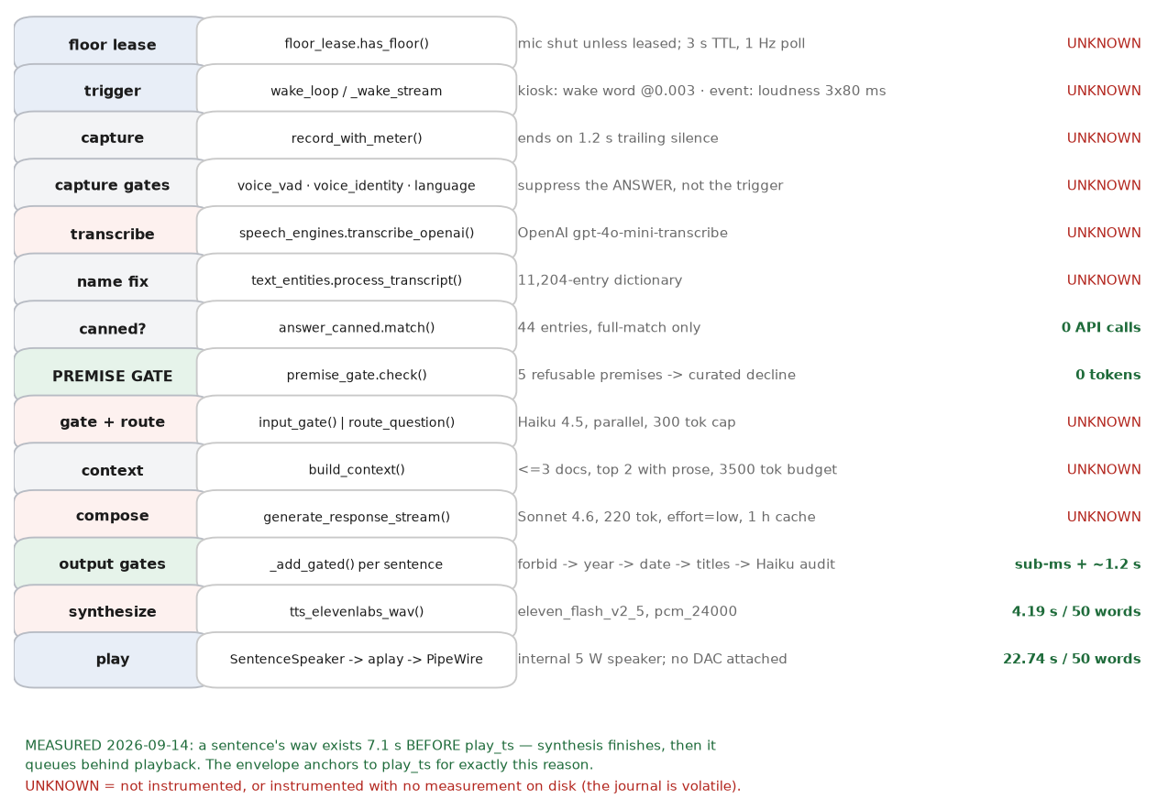
Figure 2 — mic to speaker. Green is measured on this machine; red is not instrumented or has no measurement on disk.
Three things carry the turn and are worth reading in the original. Each excerpt is verbatim.

The lease — the whole fail-closed rule
app/floor_lease.py:218-219
def has_floor(self) -> bool:
return bool(self.slot) and self.granted and self.clock() < self.lease_until
Three conditions, all required. No slot, a revoked grant, or an expired clock each close the microphone. There is no branch that opens it on a failure. The poll is 1.0 s with a 0.8 s timeout (floor_lease.py:48-49) — deliberately shorter than the interval so a hung authority still yields one tick per second.

The floor transition — why two mics can never be open
dashboard/console.py:695-706
def _begin_transition(self, target, who="console", now=None):
"""Close both now; name the target only after the settle."""
prev = self.floor
self.floor = "none" # every lease reply revokes from here on
...
self.transition = {"target": target, "started": now,
"deadline": now + self.ttl_s + SETTLE_MARGIN_S, "who": who}
The floor is set to none BEFORE the target is named. That ordering is the invariant: there is no instant at which two slots could both believe they hold it. Leaving the transition needs either both robots reporting their mic closed, or TTL 3.0 s plus a 0.5 s settle margin.

The composer call
app/answer_pipeline.py:1155-1161
"cache_control": {"type": "ephemeral", "ttl": "1h"},
}],
extra_headers={"anthropic-beta": "extended-cache-ttl-2025-04-11"},
messages=messages,
**_composer_speed_kwargs(),
claude-sonnet-4-6, 220 output tokens (CJ_COMPOSER_MAX_TOKENS), effort=low. The voice card is the cached prefix; the comment immediately above the call says why the TTL is an hour: "the default 5m entry kept expiring (read=0 in the journal), so every turn re-paid ~4.5k prefill tokens of TTFT."

The output gate chain, per sentence
app/speech_streaming.py:815-880 (condensed; each branch returns before synthesis)
if gate_mod is not None:
g = gate_mod.check_answer(question, s, topic_ids=gate_topics, forbid_only=True)
if not g["ok"]: ... return # never synthesized
fc = gate_mod.fact_check(s, _ap.LAST_CONTEXT_TEXT[0], question)
if not fc.get("ok", True): ... return # year / full-date
if _FACT_TRIGGER.search(s) and ...: # -> Haiku audit

The breath loop
app/main_voice_robot.py — breath_offset(), added 2026-09-14
rate = _motion_val("breath_rate_cpm", BREATH_RATE_CPM)
wb = 2 * math.pi * (rate / 60.0)
phb = wb * (1.0 + 0.07 * s(0.033 * t + 0.5)) * t
pitch += pitch_k * 1.25 * (s(phb) + 0.16 * s(2 * phb + 0.7))
Line by line: the rate comes from the live config with a module fallback; wb converts cycles per minute to radians per second; the 0.033 term wanders the rate by ±7% on a roughly three-minute cycle so it never lands in a metronome; and the second harmonic at 0.16 makes the out-breath fall a little faster than the in-breath rises. It is ADDED to pitch, not assigned — it layers under the postural drift rather than replacing it.

The non-happy paths
Path | Where it diverges | What happens
Clip-cache hit | voice/cache.py, ~/.voice_cache (500 MB cap) | wav read from disk; no ElevenLabs request
Canned answer | answer_canned.match() before the router | whole curated answer spoken; 0 Anthropic calls
Premise decline | premise_gate.check() before the router | one of 5 curated pools. VERIFIED 13 Sep: router 1176 / inference 355 unchanged across the turn
Out-of-corpus | input_gate scope == out_of_corpus | canned deflection; composer skipped
Gate rejection | _add_gated | that sentence is dropped and never synthesized; the answer continues
Opener race | speech_streaming.py:834-843 | the first sentence is queued then audited; if playback started, LOGGED ONLY
Composer error / no credit | generate_response_stream raises | _say_apology: "I am sorry. I cannot reach my notes at the moment." Service continues
Network loss at wake | internet_up() false | say_offline() plays NO_NET_WAV; 0 API calls
Network loss mid-answer | per-sentence synthesis fails | each failed sentence is SKIPPED with a log line and playback continues — the answer is silently truncated. NOT fixed
Muted mic | _muted() | wake and stop word ignored; the robot still speaks. Breathing stops

5. How each component was implemented
A reason appears here only where it is written down. The quote and its source are given; everywhere else the reason is UNKNOWN.

Role assignment and swap
What it does. cjap_is is held by the lease authority and delivered in every lease reply. Both machines load both voice cards and both ElevenLabs voice ids at boot, so a swap needs no restart.
Why, quoted. 06509e0 (10 Sep) — "roles are assignable: cjap_is held by the lease authority, floor follows the role". app/personas.py:20-21 states the design reason verbatim: "Both cards and both voice ids are loaded here at boot so a switch is" ... "activate() — no reload".

The mic floor lease
What it does. One microphone open across both machines. 3 s lease, 1 Hz poll, fails closed; every floor change closes both mics first.
Why, quoted. ac65136 (10 Sep) — "operator console: one-mic floor lease for the two-robot installation".

Mode profiles and resolution
What it does. duet/direct x kiosk/event in config/modes/*.json, resolved by the console and pushed to both robots on every lease reply.
Why, quoted. ac65136 created the files; d2771eb (11 Sep) — "modes: direct-kiosk / direct-event / duet semantics on both sides".

The corpus routing path
What it does. A Haiku call against a hand-curated 35-topic taxonomy picks topics; documents are scored and the top 3 selected, of which the first 2 carry prose.
Why, quoted. bf52da4 (12 Sep) — "composer: give Sonnet the corpus it was always documented to have".

The premise gate
What it does. Five refusable premises checked on the QUESTION before the router, answered from curated decline pools.
Why, quoted. 615a2a3 (13 Sep) — "premise gate: refuse the question the corpus cannot answer".

The console
What it does. dashboard/console.py holds the floor, mode, profile, role assignment and an append-only journal.
Why, quoted. fe3537b then ac65136 (10 Sep) — "dashboard: move the maintenance server (~/pi_dashboard) into the repo".

/stage, /monitor, /api/display
What it does. Three read-only views on one 1,015-byte endpoint. None starts a LiveAvatar session; none writes anything.
Why, quoted. This session. Reason recorded in dashboard/ui_page_display.py:9-25.

The avatar state layer
What it does. A canvas layer carrying idle/listening/thinking/speaking on hue, motion character and brightness, with a client-side envelope from /api/sentence.wav.
Why, quoted. This session. UNKNOWN whether a portrait will be supplied; the backdrop is pluggable.

The motion and breath system
What it does. Postural drift (the original sines) plus a real breath at 12-16 cpm underneath it, plus sway, plus voice emphasis. motion_scale multiplies amplitudes only.
Why, quoted. 442c7cf (14 Sep) — "What the code called breathing was sin(0.21*t). 0.21 rad/s is a thirty-second period — about two cycles a minute."

TTS and playback
What it does. ElevenLabs eleven_flash_v2_5 at pcm_24000, 10 s timeout, 2 retries; every call site fails open to OpenAI TTS. Playback is aplay -> ALSA -> PipeWire.
Why, quoted. UNKNOWN — the move off Piper predates this repository's history, which begins 2026-08-29.

STT and capture
What it does. OpenAI gpt-4o-mini-transcribe with a persona steering prompt and an echo guard; capture ends on 1.2 s of trailing silence.
Why, quoted. UNKNOWN — predates the history. ADR-0018 discusses the choice but carries no commit.

6. Config
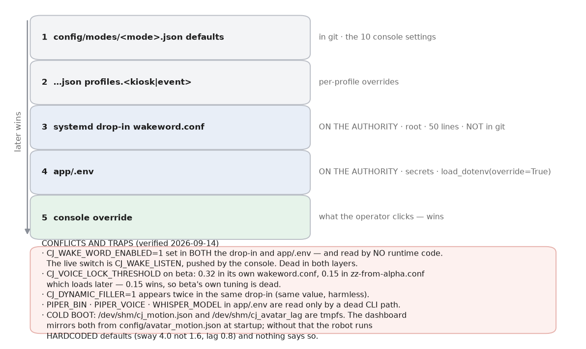
Figure 4 — the resolution stack, with the conflicts and the cold-boot traps.
Setting | Env var | Effective now | Also defined in
wake_word | CJ_WAKE_LISTEN | True | profiles.event = False
wake_threshold | CJ_WAKE_OWW_THRESHOLD | 0.003 | —
speech_threshold | CJ_MIC_RMS_FLOOR | 200 | profiles.event = 800
speech_threshold_cap | CJ_MIC_RMS_CAP | 1500 | profiles.event = 2500
silence_timeout_s | CJ_MIC_TRAILING_SILENCE_S | 1.2 | beta's own drop-in = 1.2 (inert)
post_answer_window_s | CJ_LISTEN_IDLE_S | 25.0 | profiles.event = 0
host_intro | CJ_HOST_INTRO | True | —
premise_gate | CJ_PREMISE_GATE | True | duet.json defaults = True
dry_run | CJ_DRY_RUN | False | —
motion_scale | (motion file) | 1.0 | config/avatar_motion.json, 3 presets
sway_deg | (motion file) | 1.6 | was 4.0 — the robot's fallback is still 4.0
breath_rate_cpm | (motion file) | 14.0 | new 2026-09-14
avatar_lag | (motion file) | 0.8 | was /dev/shm only until 2026-09-14

DISAGREEMENT CJ_WAKE_WORD_ENABLED=1 is set in BOTH the drop-in and app/.env and read by NO runtime code. The only reader is config.py:662, an attribute nothing consults. The live switch is CJ_WAKE_LISTEN.
DISAGREEMENT On beta, CJ_VOICE_LOCK_THRESHOLD is 0.32 in its own wakeword.conf (line 159) and 0.15 in zz-from-alpha.conf (line 235), which systemd loads later. 0.15 wins — beta's own tuning is dead.
DISAGREEMENT The drop-in says at :231 "feed OFF — delay 0 ms was never calibrated" and then sets CJ_AEC_REF_FEED=1 with CJ_AEC_REF_DELAY_MS=444 on the next two lines. The comment and the setting contradict each other.
DISAGREEMENT Layers 3 and 4 contribute NOTHING to the ten console settings on alpha — none of their env names appears in the drop-in or app/.env. The documented four-layer stack is real, but two of its layers are empty today.

7. The corpus
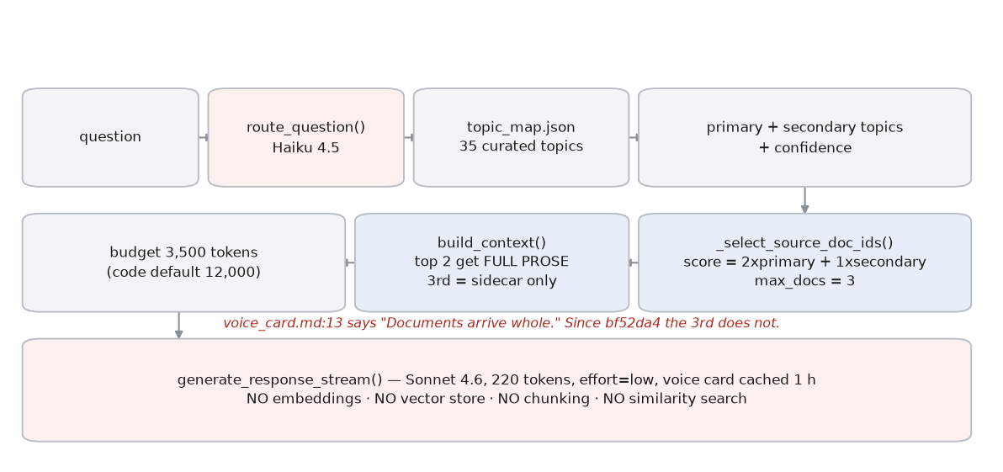
Figure 5 — routing is a taxonomy lookup, not a search.
Item | Count | How verified
Columns | 64 paired .md + .json | find corpus/columns -name '*.md' | wc -l
Speeches | 15 paired | same
Topics | 35 | CorpusArtifacts() -> len(artifacts.topics)
Document years | 2006 - 2026 | min/max of the year field across 79 sidecars
Entity dictionary | 11,204 entries | json load
Canned answers | 44 entries | [canned] loaded 44 entries
Duet lines | 33 | corpus/voice/duet_script.json

What "no RAG" means here
- No embeddings are computed at runtime, no vector store exists, no similarity search runs.
- Routing is one Haiku classification against a taxonomy built offline by build_topic_map.py.
- The only embedding model in the running system is the speaker-identity embedder, which never touches the corpus.
DISAGREEMENT corpus/voice/voice_card.md:6-7 tells the composer it has "the whole .md + .json for 1-3 source documents". _trim_doc returns EITHER the prose OR the sidecar's summary fields, never both, and only the first CONTEXT_BODY_DOCS=2 get prose. The composer is told it has text it may not have — and this is the prompt, not a comment.
DISAGREEMENT CLAUDE.md:130-132 says "the other 3-6 contribute a JSON sidecar". _select_source_doc_ids caps selection at 3 (answer_pipeline.py:976), so "the other" is at most ONE.
DISAGREEMENT PLAN-0001 records "Soft 12K-token budget enforced"; the running machine is set to 3,500 by the root-owned drop-in — 3.4x tighter than the plan's acceptance criterion.

8. The two robots
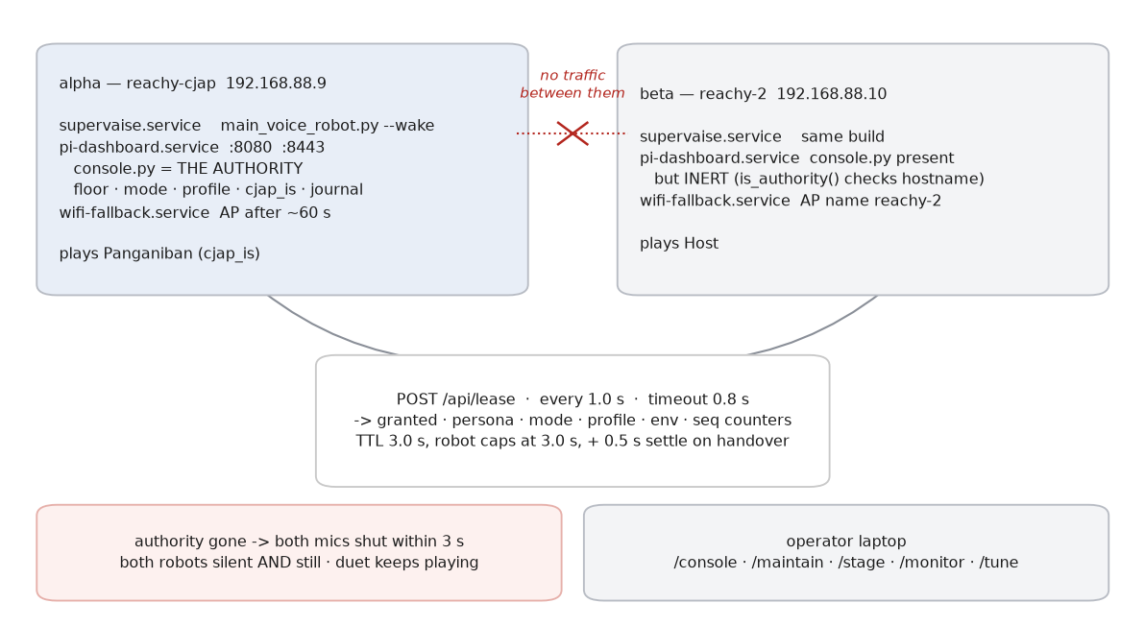
Figure 3 — the robots never exchange traffic; both poll one authority.
 | alpha | beta
hostname / IP | reachy-cjap / 192.168.88.9 | reachy-2 / 192.168.88.10
plays | Panganiban | Host
lease authority | YES | no — console.py loaded but inert
services | supervaise, pi-dashboard, wifi-fallback (all active) | the same three, all active
wifi | WOOFY_7F422D_5G | WOOFY_7F422D_2.4G — different band, same /24
pytest | yes | yes (installed 14 Sep; the deploy's test gate now runs)

Bound to the MACHINE: the slot (hostname -> config/robots.json), whether it is the authority (console.py:1275 compares hostname), the drop-in, app/.env, audio routing, the enrolled voice. Bound to the ROLE: which voice card is active, which ElevenLabs voice id, whether it answers or speaks the Host's lines, and which duet lines it plays.
Event | Effect | Recovers unattended?
Authority process dies | Both leases expire within 3 s; both mics close; both go silent and still. | Yes — pi-dashboard has Restart=always
Authority machine off | Same, and the console is unreachable. | No — the installation is down
beta powered off | alpha keeps answering; the Host falls silent. | Yes, on boot
Network drops between them | Identical to the authority dying, from beta's view. | Yes
Console restarted | State restored from ~/.cj_console_state.json; floor re-taken after a 3.5 s settle. | Yes

DISAGREEMENT docs/RUNBOOK-venue-network.md says the second robot joins the authority's CJAP Reachy hotspot as a fallback. That NetworkManager profile does not exist on beta — a live nmcli listing shows no such connection. The documented fallback LAN would not form.

9. Safety gates
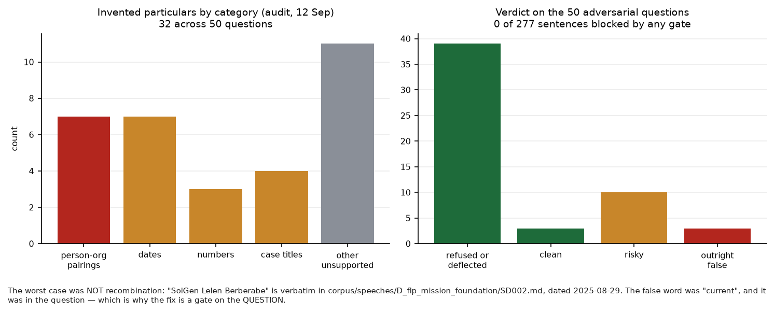
Figure 8 — what the audit measured, and why the worst case could not have been caught downstream.
Gate | Where | Catches | Blocks? | Cost
Premise gate | premise_gate.check(), before the router | who holds an office now, recency, pending matters, post-corpus years, election results | BLOCKS -> curated decline | 0 tokens
Input gate | answer_pipeline.input_gate (Haiku) | out-of-corpus scope, identity probes | routes to a canned deflection | 1 Haiku call
Forbidden patterns | answer_gate.check_answer(forbid_only) | AI self-description etc. | BLOCKS the sentence | sub-ms
Year gate | answer_gate.fact_check | a year absent from context, question and corpus | BLOCKS | sub-ms
Full-date gate | answer_gate.fact_check (13 Sep) | a (y,m,d) triple absent from all three — e.g. "December 7, 2006" | BLOCKS | sub-ms
Unverified case titles | answer_gate.fact_check | quoted titles absent from context/core | LOGS ONLY | sub-ms
Haiku fact audit | sentence_fact_audit | fact-bearing sentences; since 13 Sep also office attributions | BLOCKS, except the opener race | ~1.2 s documented
Whole-answer fidelity | generate_response_with_fidelity | would compare answer vs context | NOT RUN — CJ_SKIP_FIDELITY=1, and the streaming path does not call it | 0
Post-capture VAD | voice_vad + main_voice_robot | captures with too little real speech | BLOCKS the turn | sub-ms
Speaker lock | voice_identity | a voice that is not the enrolled one | suppresses the answer | embedding, capped at CJ_EMBED_MAX_S
Language gate | text_language_gate | transcripts that are neither English nor Filipino | suppresses the answer | sub-ms

DISAGREEMENT app/voice_vad.py's own docstring says "LOG-ONLY: analyze() measures how much real speech a captured utterance contains; nothing is rejected on its result yet." The code DOES reject: main_voice_robot.py:3503-3521 discards the turn when speech_s is below the minimum. The docstring is wrong, and earlier documentation repeated it.
DISAGREEMENT answer_gate.py:4 calls itself a complement to "the LLM fidelity checker". That checker (generate_response_with_fidelity, answer_pipeline.py:1346) is not on the streaming path at all, and CJ_SKIP_FIDELITY=1 in app/.env. The gate's stated safety partner does not run.

Pre-rendered content — does it pass the same gates?
Now, yes. scripts/render_duet.py and scripts/render_intro.py both call answer_gate.check_curated() on every line before rendering and refuse to render if any fails (--skip-gate overrides). All 33 duet lines and 12 intro clips pass. Before 13 Sep they passed nothing: the audit checked the then-nine lines by hand and noted "pre-rendered is not pre-verified". The clips play with no network and never touch a live gate, so the check has to happen at render time.
DISAGREEMENT answer_gate.py:311-314 still refers to "the nine duet lines". There are 33 (corpus/voice/duet_script.json, version 2; data/prerendered/duet/manifest.json has 33 entries).

10. Display and avatar
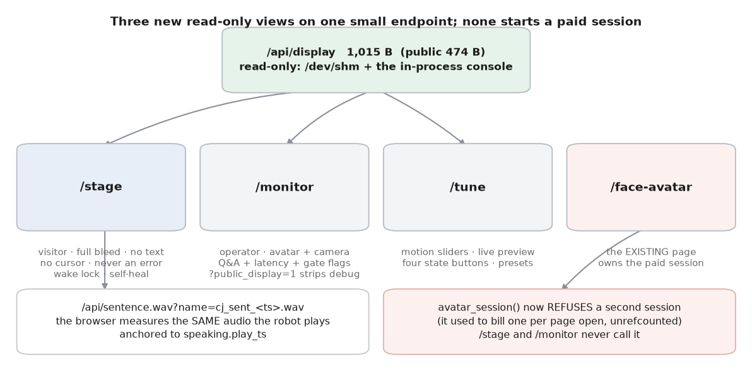
Figure 12 — three read-only views on one small endpoint.
/api/display is 1,015 bytes against /api/state's 11,773 — measured. The public variant is 474 bytes and verifiably strips state_detail, muted, health and wake_armed.
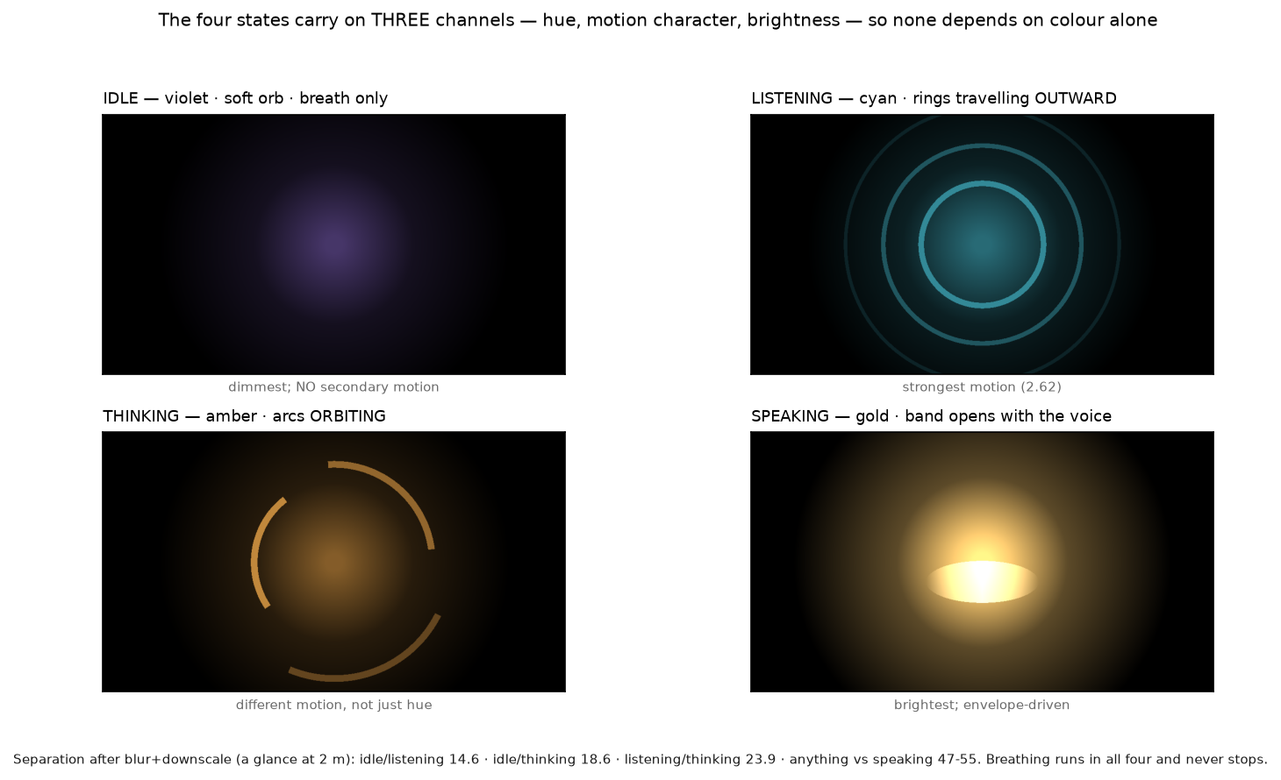
Figure 11 — the four states. Separation after blur and downscale: idle/listening 14.6, idle/thinking 18.6, listening/thinking 23.9, anything against speaking 47-55.
The states carry on three channels — hue, motion character and brightness — so none depends on colour alone. Idle is a soft orb with breath only; listening sends rings outward; thinking sends arcs around; speaking opens a band with the measured voice. An earlier tuning had idle at mean luminance 5.4 and motion 0.04, which would have read as a screen that was off; that was raised before shipping.
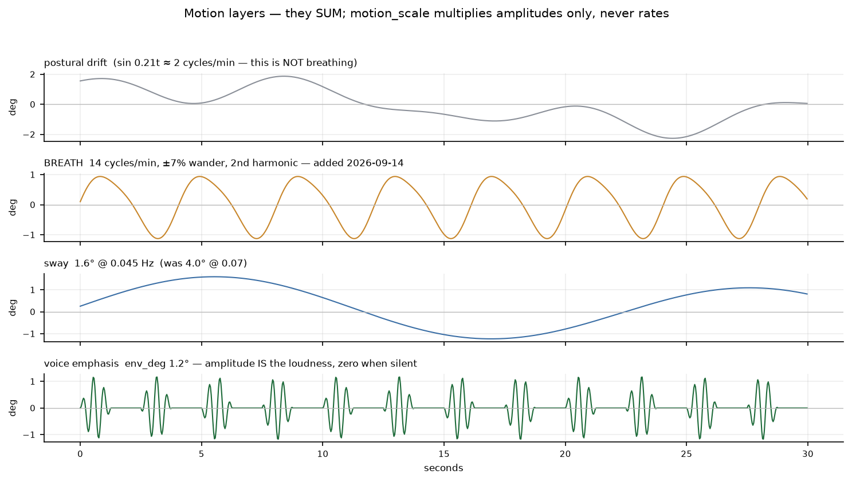
Figure 9 — the layers sum. motion_scale multiplies amplitudes only.
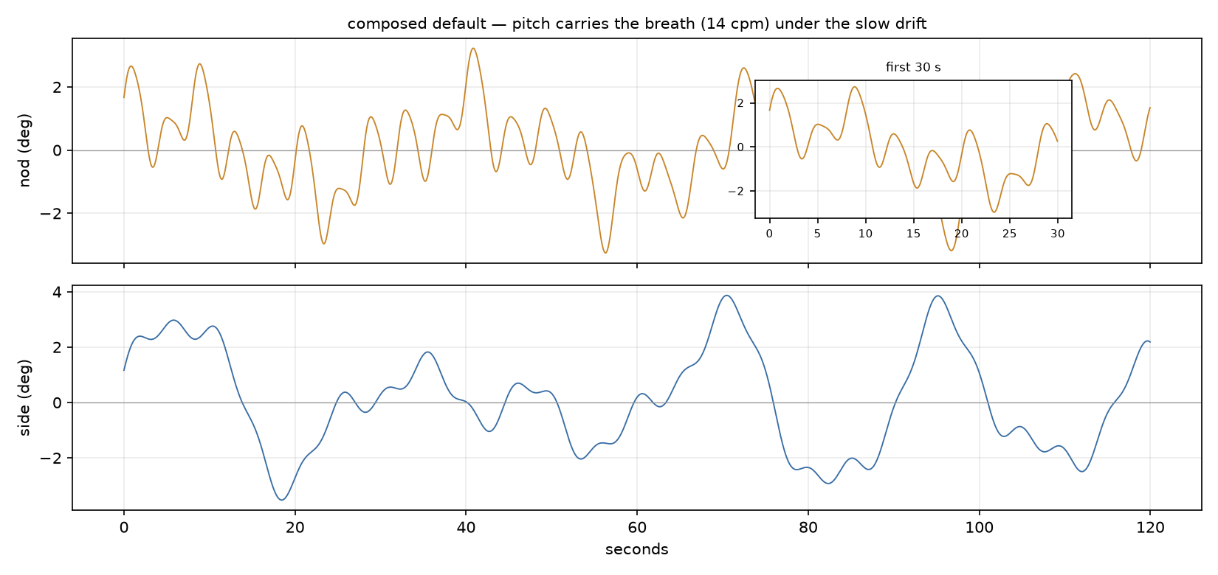
Figure 10 — two minutes of real head motion at the composed default.
Measure | Composed default | Note
breath rate | 14.0 cycles/min (4.3 s period) | was sin(0.21t) = about 2/min
breath amplitude | 1.12 deg peak | ~4 mm at the crown, ~7 arcmin at 2 m
postural drift | 2.35 deg peak | the original sines, unchanged
sway | 1.6 deg at 0.045 Hz | was 4.0 deg at 0.07 Hz
voice emphasis | 1.2 deg at full volume | was 2.2 deg
head speed | median 0.52 deg/s, peak 2.38 | slower than 0.5 deg/s for 48% of the time
recurrence | autocorrelation 0.44 beyond 8 s | no cycle a viewer could learn
CPU | 43.25% of one core (baseline 47.60%) | the breath loop costs nothing measurable

UNKNOWN Whether this reads as a composed elderly man or as an animation is UNVERIFIED. It needs someone to watch the robot from two metres; there is no sensor on this system that can answer it, and the robot's camera faces the room rather than itself.

11. Findings that contradicted what we believed

The paid avatar session was unrefcounted
Believed. Opening the avatar page was assumed to reuse a session.
True. avatar_session() (ui_page_face.py:855) called /v1/sessions/token unconditionally on every POST, with no registry and no reference count. Two tabs meant two BILLED sessions; three meant three.
How it surfaced. Found while reading the avatar page before building /stage and /monitor, to check whether the new views could show the face.
What changed. Both new views were built to never call it, and avatar_session() now refuses a second session (bbefae1). Real refcounting was rejected: each page drives the pose over its own WebSocket, so two pages on one session would fight over it.

The breath was 0.21 rad/s
Believed. The head was believed to be breathing, with breath_gain scaling it.
True. sin(0.21*t) is a thirty-second period — about two cycles a minute. It is a slow postural settle, not a breath, and amplitude was the only exposed control.
How it surfaced. Found by reading breath_offset while answering "what parameters already exist" before adding any.
What changed. A real breath layer at 12-16 cpm was added underneath the drift, and this is the single cause of both complaints — too much movement, and stillness reading as frozen (442c7cf).

EXHIBIT_JS binds DOM ids with no null guards
Believed. The shared exhibit JS looked reusable for a new page.
True. Its own comment at ui_page_audience.py:290-291 says every helper assumes its ids exist; setState and render call getElementById without guards, so a page missing one id breaks silently and renders blank.
How it surfaced. Surfaced by the recon pass that read the existing avatar and audience pages.
What changed. /stage carries its own small renderer instead of importing EXHIBIT_JS piecemeal.

The composer's grounding path
Believed. The corpus was believed to reach Sonnet.
True. It did not, until bf52da4 (12 Sep) — "composer: give Sonnet the corpus it was always documented to have". Even now only the top 2 of at most 3 documents carry prose.
How it surfaced. Found during the 12 Sep audit by opening the routed documents and checking for verbatim passages in the assembled context.
What changed. CONTEXT_BODY_DOCS was introduced. The voice card still tells the composer documents arrive whole; that is Appendix A.

cj_motion.json was absent, so the robot ran hardcoded defaults
Believed. Motion sliders were believed to persist.
True. /dev/shm is a tmpfs. The file did not exist on this machine at all, so the robot was using the hardcoded fallbacks (sway 4.0, not the tuned 1.6) and nothing said so.
How it surfaced. Found when asked directly whether the file is recreated at boot or only on first write.
What changed. config/avatar_motion.json is now the versioned source and the dashboard mirrors it at startup (442c7cf). The robot's own fallbacks were deliberately left at the old numbers.

cj_avatar_lag had the same shape
Believed. Only cj_motion was thought to have the problem.
True. _avatar_lag() (ui_server.py:655) silently returns a hardcoded 0.8 when the file is missing. It is the avatar sync slider, stored nowhere else.
How it surfaced. Found by a generic scan for "tuned value read from /dev/shm with a hardcoded literal fallback". The scan found these two and nothing else.
What changed. Moved into config/avatar_motion.json and mirrored the same way (bbefae1).

Tests imported through ~/pi_dashboard
Believed. The test suite was believed to test the deployed code.
True. Two files imported the dashboard through a symlink. On alpha it resolves into the repo; on beta it was a stale DIRECTORY holding an older copy, so 31 tests there were validating code that was not being deployed — and passing.
How it surfaced. Found by sweeping the suite after the breath test failure.
What changed. Both now import from the repo path (bbefae1).

A test was green because its config file was missing
Believed. 253 passing was believed to mean 253 things were checked.
True. test_envelope_is_disabled_at_zero_degrees monkeypatched a module default that _motion_val never consults while /dev/shm/cj_motion.json exists. It had always taken the fallback path. The moment the boot mirror created the file, it failed.
How it surfaced. It failed immediately after the mirror was added — the fix surfaced the test.
What changed. An autouse fixture now stubs the reader. LL-013 records the sweep that followed.

12. The test suite, honestly
253 collected cases come from 143 distinct test functions. Parametrisation accounts for the other 110 — mostly the premise-gate question set (9 functions to 76 cases) and the floor lease (43 to 86). So 253 overstates the number of distinct behaviours checked by roughly 40%.
Check | Result
every file in isolation vs. the full suite | 253 = 253 — no order dependence manifests
full suite with all 44 live CJ_* service variables injected | 253 pass
assertion density | 475 assertions across 143 functions, mean 3.3
tests with no assertion at all | zero
suite on beta | 253 pass (pytest installed 14 Sep; the deploy gate now runs for real)

Isolation defects
# | Defect | State
1 | test_breath_motion monkeypatched a default the code never reads while /dev/shm exists. It was green BECAUSE the file was absent. | FIXED — autouse fixture stubs _motion
2 | test_dashboard_ui and test_wifi_control imported through ~/pi_dashboard, a symlink that was a stale directory on beta. | FIXED — import from the repo path
3 | test_canned_answers.py:9 sets CJ_CANNED_ENABLED=1 at import and never restores it. | LOGGED (LL-013) — latent, nothing asserts the opposite
4 | test_intro_rotation.py:71 sets CJ_WAKE_LISTEN=1 with no restore. | LOGGED (LL-013)
5 | test_canned_answers collapses ~20 checks into one assert; a failure names none of them. | LOGGED (LL-013)

What the suite does not cover
- No end-to-end turn. Every test stubs the model calls; nothing exercises router -> composer -> gates -> TTS against a live API.
- No browser. /stage, /monitor and /tune are tested only at the endpoint level — the JavaScript, the reconnect behaviour, the wake lock and the envelope sync are unexercised by any test.
- No hardware. Motors, microphone, speaker routing and the XVF3800 are never touched.
- No second machine. The suite runs on each machine separately; nothing tests the pair.

13. Latency
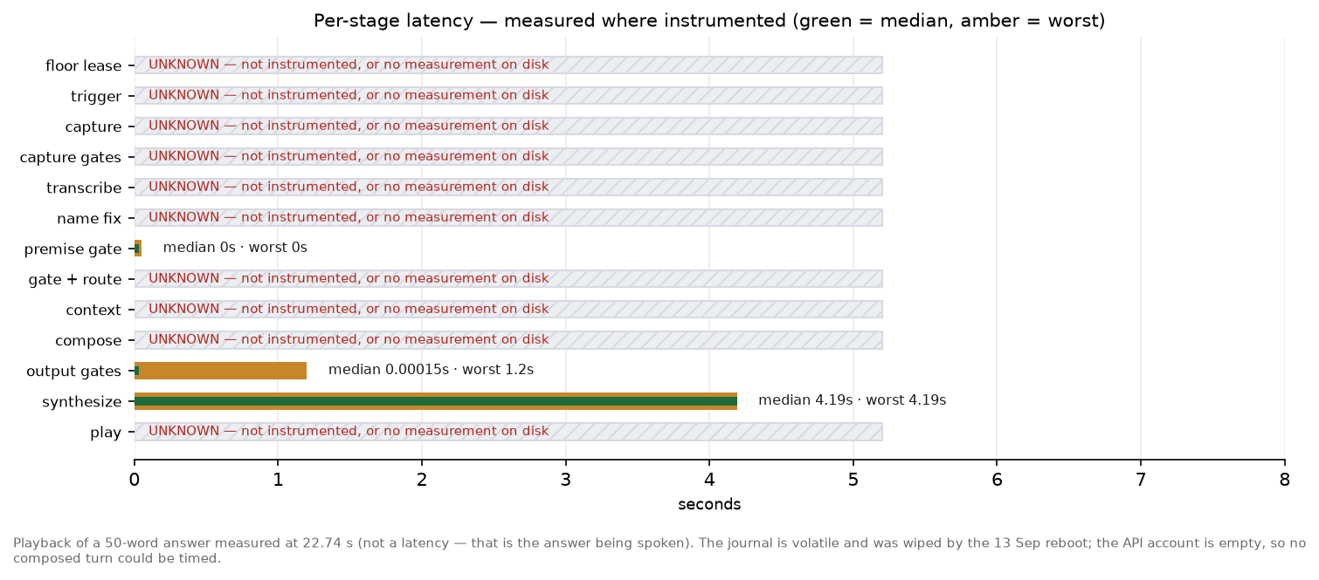
Figure 7 — measured where instrumented. Most stages are not.
Two stages have a measurement on this machine, from a single turn on 13 September that took the premise-decline path:
journalctl -u supervaise.service, 13 Sep 13:27:05
[trace] path=premise | stt_s=0.00s | topic=canned:current_office |
synth_s=4.19s | play_s=22.74s | words=50 | interrupted=False
And one measured relationship that matters more than either: a sentence's wav exists 7.1 s BEFORE audio actually starts. Synthesis finishes, then the clip queues behind whatever is playing. Anchoring the mouth to the wav's appearance would have run it seven seconds ahead of the voice; it anchors to speaking.play_ts instead.
Still unoptimised, from the audit and unchanged: the filler is a live model call plus live synthesis on every turn; only the top 2 documents carry prose, which trades against latency in the other direction; and streaming transcription has not been attempted, which the audit estimated would take about two seconds off every turn.
UNKNOWN Every composer-path timing is UNKNOWN. _trace_turn prints to stdout and systemd's journal is volatile — it was wiped by the 13 September reboot and now holds one [trace] line. The API account is empty, so no composed turn could be produced to measure.

14. Known unmeasured
What | Why it is unmeasured | What would resolve it
Sync offset, internal speaker | Three methods failed: wall-clock arecord gave 2 usable of 7 trials with two impossible negative values; raw duplex failed on a 16k/48k rate mismatch; PipeWire duplex hung against the running robot. | ~/tools/aec_ref_calib.py measures exactly this, but it writes XVF3800 registers on a live robot; or stop supervaise briefly and do a clean duplex run
Sync offset, DAC and Bluetooth | No USB DAC is attached. | Attach the DAC, then the same measurement
Whether LITE permits two subscribers on one session | Not in the docs quoted at ui_page_face.py:390-395. | Ask the vendor, or spend a paid session testing it
Whether the motion reads as a man or an animation | No sensor on this system can answer it; the camera faces the room. | Someone watches the robot from two metres for two minutes
Whether the four states are legible at 2 m on a real panel | Measured on a render, not a panel in a lit hall. | Put /stage on the monitor and look
Every browser-avatar behaviour | Needs a live paid LiveAvatar session, which cannot be driven from the headless Pi. | A session on a machine with a browser and credits
Whether the event profile works | Never run with this build. | Thirty minutes in the room
Room calibration | Built, wired, never run once. | Run it at the venue with the crowd in
Composer-path latency | The journal is volatile and the account is empty. | Top up, run one turn
Four-hour behaviour | The soak was still running when this document was built. | Read ~/soak_*.csv when it completes

15. Venue guide
Plain language, for one person with no engineer present.
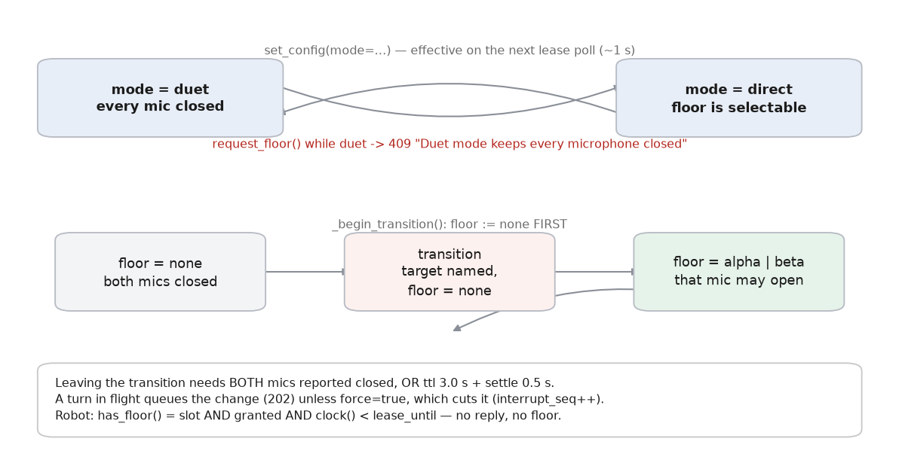
Figure 6 — the legal mode and floor transitions.

Cold start, from both robots switched off
- 1. Turn on the travel router first and wait for its lights to settle. Both robots must join THIS router, not the venue's own wifi — a guest network stops them finding the console.
- 2. Power on alpha (reachy-cjap). Wait two minutes. It starts the console as well as itself.
- 3. Power on beta (reachy-2). Wait one minute.
- 4. On the laptop, join the same router and open https://reachy-cjap.local:8443/console?key=cjap and accept the certificate warning.
- 5. Check BOTH robot rows say reporting, age one or two seconds. A stale row means that robot did not join the network — go back to step 1.
- 6. Choose the mode: DUET for an empty room, DIRECT for visitors. Then the profile: EVENT for a hall, KIOSK for a quiet room.
- 7. Run the room calibration with the room as noisy as it will really be. Give one robot the floor first so its microphone is open, then start it and leave it two minutes without talking.
- 8. Test one answer with the Host asks box before anyone arrives.
If step 8 gives an apology instead of an answer, the internet is down or the API account is empty. DUET needs no internet at all — switch to it.
DISAGREEMENT As of 14 September the API account IS empty, so step 8 will give the apology until it is topped up.

Who is who, and who has the microphone
- The console shows each robot as "machine · role", for example "reachy-cjap · Panganiban". Never identify a robot by its machine name alone — the role can be swapped.
- The robot holding the floor is the one whose row says so. Only that robot's microphone is open. Floor "none" means both are closed.
- To swap who plays Panganiban: console, change it, apply. Both switch within about a second. Nothing restarts.
- To change mode or profile: choose it on the console. Both robots follow within a second or two.

Retuning the motion
Open /tune (linked from /maintain). Drag a slider and the running robot changes immediately — watch the robot for head sway, breathing and voice emphasis; the preview on the page shows the state layer and what lip-sync and response delay do. Three presets exist: composed (the default), livelier, and still.
DISAGREEMENT A slider drag does NOT survive a reboot. Only "Save preset" writes config/avatar_motion.json. Drag, reboot, and you silently get the active preset's value back.

The five likeliest failures
What you see | It is almost always | First check
The robot looks frozen or dead | The microphone is muted. Muting deliberately stops the breathing — the robot has no lights, so going still is how it shows it. | The mute button on /maintain. Unmute and breathing returns within a second.
Both robots silent and still | The network between them, or alpha is off. This is the system protecting itself. | Router lights. Can you load the console? Which row is stale?
Nobody can hear it | The internal speaker is about 5 W and a hall needs a PA. | Is an external speaker actually plugged in? Then ~/bin/audio-out dac
It answers when nobody is talking | The room is louder than the threshold it was given. | Re-run the room calibration with the crowd in; raise the loudness setting; else DUET.
It says something untrue | The automatic checks do not reliably catch this. | Switch to DUET immediately. Write down exactly what it said.

The traps
- Muted looks like crashed. Breathing stops when the microphone is muted, and a muted robot looks identical to a crashed one from across a room. Check mute FIRST, always.
- A reboot forgets things. Everything in /dev/shm is gone after a power cycle. The dashboard rebuilds the motion config from config/avatar_motion.json at startup; anything else in there starts empty.
- Mute does not persist. cj_muted lives in /dev/shm, so a reboot silently UNMUTES. The direction is safe, but do not rely on a mute surviving.
- Audio devices move. The audio device order can change across reboots. If sound goes to the wrong place, ~/bin/audio-out status shows the current route and ~/bin/audio-out internal|dac|bt sets it.
- The safe fallback. DUET needs no internet, no microphone and no network. If anything about the conversation is going wrong with an audience arriving, switch to DUET and you have a working exhibit while you think.

16. Risk table
Everything still open or unverified, ranked by what would hurt most on the day.
# | Item | What the room experiences | Effort | Before/after
1 | No USB DAC; output is the internal ~5 W speaker | Nobody past the front row hears anything | half a day | BEFORE
2 | API account has no credit | Every non-curated question gets the apology line | minutes (billing) | BEFORE
3 | direct+event profile never run with this build | Unknown — different thresholds, no wake word, no follow-up window | 30 min | BEFORE
4 | AEC delay for an external route uncalibrated | Once amplified, the robot interrupts itself | 2 h at the venue | BEFORE
5 | Room calibration never run | Event thresholds are hand-guessed | minutes on the day | BEFORE
6 | Speech threshold caps at 2500 in a louder room | Robot answers crowd noise with nobody at the mic | 30 min | BEFORE
7 | Network drop mid-answer truncates silently | Panganiban stops mid-thought, or loses sentences, with no notice | 1 h | BEFORE
8 | Slider drags do not persist across a reboot | Motion silently reverts to the preset; nobody notices | 30 min | BEFORE
9 | CJAP Reachy profile absent on beta | The documented fallback LAN would not form if the router dies | 15 min | BEFORE
10 | Opener can play before its fact audit returns | The most-quoted sentence is the least checked | 2 h | after
11 | Case titles and whole-answer fidelity log but never block | Unverified case names reach the speaker | 2 h | after
12 | Browser avatar behaviour entirely unverified | Unknown — needs a paid session | UNKNOWN | after
13 | Only top-2 documents carry prose | Vaguer answers than the corpus can support | 1 h, trades against latency | after
14 | Duet loop repeats about every 4.7 minutes | Anyone who stops to watch hears the loop | half a day | after

Appendix A — code versus documentation
Each verified against both sides. The most valuable content in this document: these are the places where a reader would be misled.
Documentation says | Where | Code says | Where
"the other 3-6 contribute a JSON sidecar" | CLAUDE.md:130-132 | selection caps at 3 documents, so "the other" is at most ONE | answer_pipeline.py:976
"the whole .md + .json for 1-3 source documents" | corpus/voice/voice_card.md:6-7 | _trim_doc returns EITHER prose OR the sidecar, never both; only 2 get prose | answer_pipeline.py:920-945
"models/hey_cj.onnx ... locked threshold 0.40" | CLAUDE.md:51 | neither file exists; the live model is hi_see_jap.onnx at 0.003 | ls app/wake/models/
implementation facts -> the 05-16 handover wins | CLAUDE.md:155 | the same file names the 05-26 handover as latest | CLAUDE.md Read-first table
"test_canned.py", "156 tests" | CLAUDE.md:50 | the file is test_canned_answers.py; 143 functions, 253 collected cases | ls tests/
"LOG-ONLY ... nothing is rejected on its result yet" | app/voice_vad.py:1-5 | the turn IS discarded when speech_s is below the minimum | main_voice_robot.py:3503-3521
complements "the LLM fidelity checker" | answer_gate.py:4 | that checker is not on the streaming path and CJ_SKIP_FIDELITY=1 | answer_pipeline.py:1346 + app/.env
"the nine duet lines" | answer_gate.py:311-314 | 33 lines | corpus/voice/duet_script.json
"the develop retrieval engine that runs TODAY: bge-base dense + BM25, RRF" | config.py:17-27 | nothing reads any of it; 17 names are read, none retrieval | grep for config.<NAME>
"feed OFF — delay 0 ms was never calibrated" | wakeword.conf:231 | the next two lines set the feed ON with a 444 ms delay | wakeword.conf:233-234
"sliders that persist" | commit 442c7cf subject | a slider drag writes /dev/shm only; only Save preset reaches the repo | ui_common.py:734
"The dashboard writes this file and mirrors it" | config/avatar_motion.json _readme | true only on save, not on a drag | ui_common.py:734
traces cj_voice_cloud.py, stream_speak.py, tempo_smooth.py | docs/SYSTEM_TRACE.md | all three were renamed on 2026-08-29, the same day the trace was written | ls app/
"the pre-rendered exchange was never built" | docs/RUNBOOK-venue-network.md | 33 duet wavs and 12 intro clips exist on BOTH machines | data/prerendered/
beta joins the authority's CJAP Reachy hotspot | docs/RUNBOOK-venue-network.md | that profile does not exist on beta | live nmcli on beta
"Soft 12K-token budget enforced" | PLAN-0001 | the running budget is 3,500 — 3.4x tighter | wakeword.conf
"The Host's voice is only used by the render scripts — never live" | app/.env.example | activate() points the live voice id at it | app/personas.py:104-112
"documents are sent whole"; a Memory check/update step | PROJECT.md §6 | only 2 of 3 carry prose; there is no memory subsystem | answer_pipeline.py
prompt-caching call sites in app/cj_chat.py | handover 05-16 | no such file; the loader is answer_pipeline.py | ls app/cj_chat.py
"The duet loop is 4.3 minutes" | CLAUDE.md:146 | 249.0 s audio + 29.2 s authored pauses + 6 s gap = about 4.7 min | manifest + script

Appendix B — everything UNKNOWN
Each with what would resolve it. Nothing here has been filled in with a plausible answer.
What is unknown | What would resolve it
The sync offset for every audio route | aec_ref_calib.py (writes XVF3800 registers on a live robot), or stop supervaise and do a clean duplex measurement
Whether LiveAvatar LITE permits two subscribers on one session | The vendor, or a paid session
Whether the motion reads as a man or an animation | A person watching from two metres
Whether the four states are legible on a real panel at 2 m | Put /stage on the monitor
Composer-path latency at every stage | Top up the account and run one turn with the journal open
The real cost per composed turn | One live turn; usage_meter holds lifetime totals only
Why the move off faster-whisper and Piper happened | Nothing on disk records it; the repo's history begins 2026-08-29, after the change
Why beta's venv build failed to install pytest | deploy_second_robot.sh pipes pip through grep, so the failure left no trace. Stop swallowing pip output
Whether the event profile works | Run it in the room for thirty minutes
Four-hour memory and feed behaviour | The soak was still running; read ~/soak_*.csv
Whether a visitor can tell idle from listening without being told | Someone who has not read this document, standing in front of it

— end —

